昌平区2011 - 2012学年第二学期初三年级第二次统一练习
英 语 试 卷 2012.6.
考  生  须  知 | - 本试卷共11页，满分120分， 考试时间120分钟。  - 在答题卡上准确填写学校名称、姓名和考试编号。  - 试题答案一律填涂或书写在答题卡上，在试卷上作答无效。  - 在答题卡上，选择题用2B铅笔作答，其他试题用黑色字迹签字笔作答。  - 考试结束后，请将答题卡交回。

听力理解 (共26分)
一、听对话，选择与对话内容相符的图片。每段对话读两遍。 （共4分，每小题1分）
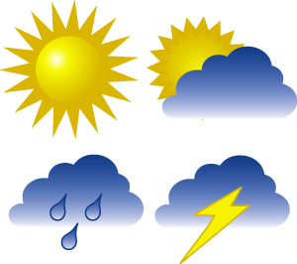
1.

A B C





2.

A B C
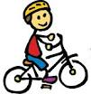


3.

A B C
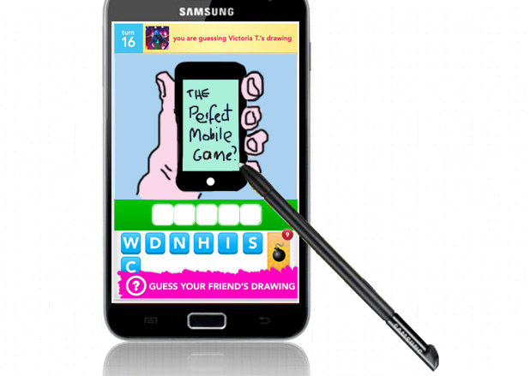


4.

A B C
二、听对话，根据对话的内容，选择正确答案。每段对话或独白读两遍。（共12分，每小题1分）
请听一段对话，完成5—6小题。
5. What’s the man’s hobby?
A. Riding bikes. B. Taking photos. C. Drawing pictures.
6. Where’re they now?
A. At the bus stop. B. At the park. C. At the beach.

请听一段对话，完成7—8小题。
7. Who’s the T – shirt for?
A. The woman’s sister. B. The woman’s mom. C. The woman.
8. How much is the T – shirt?
A. 38 yuan. B. 68 yuan. C. 88 yuan.

请听一段对话，完成9—10小题。
9. How will the man go to Tianjin?
A. By plane. B. By car. C. By ship.
10. What’re they talking about?
A. Summer travelling. B. Summer classes. C. Summer plans.

请听一段独白，完成11-13小题。
11. How many chances can listening be easier according to the man?
A. 3. B. 4. C. 5.
12. Which suggestion did he NOT mention?
A. Listen to some slow speech.
B. Listen to English for learning.
C. Listen to the news very often.
13. What’s he talking about?
A. How to live a better and enjoyable life in Britain.
B. How to study better and get understood in Britain.
C. How to get through one difficult skill in Britain.
请听一段对话，完成14-16小题。
14. What’re they talking about?
A. Driving. B. Safety. C. Feeling.
15. Why didn’t David listen to Mary at first?
A. He liked to be comfortable.
B. He did not know the law.
C. He couldn’t breathe with it.
16. What’s David hoping?
A. To have an accident. B. To meet a policeman. C. To have no trouble.
三、听独白，记录关键信息。独白读两遍。（共10分，每小题2分）
Lesson | Room | Time | Teacher | Booking place
Chinese painting | 108 | 8:30 - 9:10 | Mrs. 17 | Hall
18 poems | 203 | 9:30 - 19 | Mr. Black | Library
Paper - cutting | 20 | 11:00 – 12:00 | Miss Clark | Chinese Teacher’s 21

知识运用 (共25分)
四、选择填空 （共13分，每小题1分）
从下列各题所给的A、B、C、D四个选项中，选择可以填入空白处的最佳选项。
22. Quiet down. Let’s listen to _________ teacher.
A. we B. our C. us D. ours
23. We’ll have a trip to Britain ________ July.
A. in B. at C. on D. of
24. It’s my last year in this school _________ I’ll meet some new friends soon.
A. but B. or C. because D. and
25. - ________ did you stay in Hangzhou?
- Only one week.
A. How much B. How often C. How long D. How far
26. ________ dream of mine is to become a scientist.
A. Big B. Bigger C. Biggest D. The biggest
27. - Must I recite all of these?
- No, you _______.
A. mustn’t B. can’t C. may not D. needn’t
28. Come on, ________! Let’s start!
A. everybody B. anybody C. somebody D. nobody
29. It’s necessary for us _______ with each other.
A. get on well B. getting on well C. to get on well D. got on well
30. Watch out! The box _________________!
A. fall B. fell C. have fallen D. is falling
31. We _______ our study here in the last 2 years.
A. enjoy B. enjoyed C. enjoys D. will enjoy
32. – What were you doing this time last summer?
– I _________ hard with all my classmates.
A. was studying B. am studying C. study D. studied
33. We won’t __________ down because we’re a team.
A. beat B. be beaten C. have beaten D. will beat
34. Excuse me, will you tell me _____________________?
A. how can I improve my English B. how did I improve my English
C. how I can improve my English D. how I improved my English
五、完形填空 （共12分，每小题1分）
阅读下面的短文，掌握其大意，然后从短文后各题所给的A、B、C、D四个选项中，选择最佳选项。
One day while Jenny was walking in the forest she found two little songbirds. It seemed that they had been very hungry for long so they looked very 35 . She took them home and put them in a small cage. She cared them very well and felt great love for the birds.
Every day after school, she went to see them for the first thing. Milk, rice, bread and even candies, she offered them almost everything, 36 to see them become stronger and they might sing someday. But the 37 was not.
Another day when Jenny came home she found that the ___38____ and stronger of the two birds flew out from the cage. ____39___ he flew close, Jenny caught him ___40____. She felt glad, but suddenly she felt the bird go limp（四肢无力）. She opened her hand and ___41____ in horror at the dead bird. She became very sad and felt sorry for the bird.
At the same time, she noticed the other bird moving back and forth on the edge of the cage. She could feel his great need wanting to be ___42___. She lifted him from the cage and ____43___ him softly free into the air. The bird circled once, twice, three times.
Jenny watched happily at the bird's enjoyment. Her heart was not much ___44____ with her losing of the other bird. Suddenly the bird flew closer and ___45____ softly on her shoulder. It sang the sweetest melody(旋律) that she had ever heard.
The fastest way to ___46___ love is to hold on it too tightly; the best way to keep love is to give it WINGS!
35. A. weak B. small C. tiny D. lovely
36. A. starting B. hoping C. pointing D. referring
37. A. way B. food C. fact D. song
38. A. weaker B. taller C. larger D. shorter
39. A. Because B. As C. If D. Since
40. A. softly B. freely C. easily D. hard
41. A. shouted B. looked C. rocked D. sang
42. A. free B. safe C. happy D. confident
43. A. dropped B. pulled C. put D. set
44. A. beating B. hurting C. destroying D. resting
45. A. landed B. sat C. slept D. stood
46. A. gain B. give C. lose D. show
阅读理解 (共44分)
六、阅读下面的四篇短文，根据短文内容，从短文后各题所给的A、B、C、D四个选项中，选择最佳选项。（共26分，每小题2分）
A.
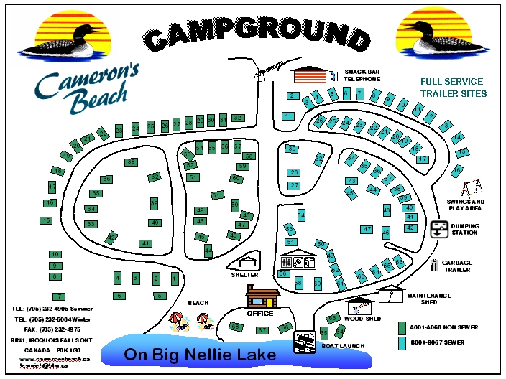
Tel: 705 232 4905 Summer
Tel: 705 232 6084 Winter
Fax: 705 232 4975
IROQUOISFALLSONT.
CANADA POK1GO
www. cameronbeach.com

47. Where’s the camp?
A. At Cameron’s Beach. B. In a school. C. Next to a park. D. Near the small lake.
48. What’s the phone number in summer time?
A. 705 232 6084. B. 705 232 4905. C. 705 232 4975. D. 705 232 6080.
49. What is NOT there at the camp ground?
A. A lake. B. A toilet. C. A little moving car. D. A snack bar telephone.

B. Two Beautiful Cherry Gardens
When you think about the things that make millions of visitors interested in Washington, D.C., each year, you probably think about the White House in USA. But have you ever thought about the living things that are also a major tourist attraction?  Many Americans and international tourists make a special visit to Washington, D.C., in the spring to see the blooming pink and white Japanese cherry trees. The trees were originally planted as a gift from the people of Tokyo, Japan, in 1912. In 1910, a previous donation of 2,000 cherry trees had been destroyed because of the insect problem. Each spring, the National Cherry Blossom Festival, a two-week-long celebration, attracts tens of thousands of visitors from around the world to see the magnificent trees in full bloom.  Have you ever seen these magnificent blossoms? | 

 | Located in Haidian District, Beijing, Yuyuantan Park is easy to get to with many convenient traffic choices. Diaoyutai State Guesthouse is to its eastern gate, China Central Radio and Television Tower to its west, Navy General Hospital to its north and China Millennium Monument to its south. With 1,820 meters wide from west to east and 1,106 meters long from north to south, Yuyuantan Park covers an area of 136.69 hectares and the water surface spans an area of 61 hectares.  Back in Jin Dynasty (1115-1234), Yuyuantan Park was already a famous scenic spot. Today, celebrated for its "Cherry Blossom Festival" every spring, Yuyuantan Park attracts tourists from all over the world. The cherry trees were also planted as a gift from the people of Japan.  I guess you must have been there for many times and have got hundreds of beautiful photos, have you?
50. How many cherry trees were destroyed years ago in Washington D.C.?
A. 1912. B. 2000. C. 1820. D. 1106.
51. Where is Yuyuantan Park?
A. Diaoyutai State Guesthouse is to its western gate.
B. China Central Radio and Television Tower is to its east.
C. Navy General Hospital and Haidian are to its north.
D. China Millennium Monument is to its south.
52. The cherry trees in Washington D.C. and Yuyuantan Park are both _____ according to the passage.
A. famous of the Cherry Blossom Festival
B. planted twice because of the insect problem
C. blooming in colors as white, pink and red
D. blooming in each spring and summer time
C.
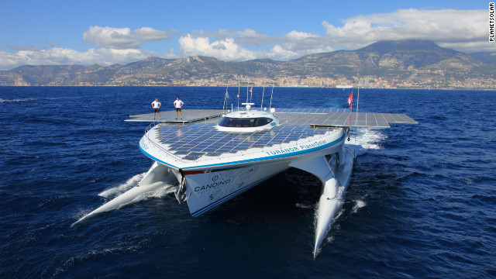
I remember sitting on my grandfather's knee listening to him reading 'Around the world in 80 days' by Jules Verne. It made me want to go out and explore just like Phileas Fogg.
Raphael, a sailor
The beauty is that you never get nothing from the sun, she is always giving us energy. Not once did we run out of power
Erwann, a captain
For 584 days, Swiss adventurer Raphael braved storms, pirates and cloudy skies to finish the sailing around the whole world on a boat. The boat was powered by nothing but sun lights.
The boat, called "Turanor" after a word meaning “power of the sun”, as heavy as a whale and 30 meters long, is as large as two tennis courts. It made history on May 4th, 2012, when it finally sailed into Port Hercules, Monaco, completing the first ever round-the-world journey by a solar-powered boat.
“The aim of this journey was to show the world that this technology is not science fiction, it is very real and it can help us change how we do things now rather than in the future,” said Raphael, “I remember sitting on my grandfather's knee listening to him reading 'Around the world in 80 days' by Jules Verne. It made me want to go out and explore just like Phileas Fogg. Everywhere we went people would gather around the boat. They had never seen such a strange boat before," he added.
For 40-year-old Raphael, whose youth was spent reading through pages of adventure books, the sailing around the whole world this year was also a fruition of boyhood dreams.
“Most people think that if the sun doesn't shine the boat wouldn't work, but it is impossible to sail for one year and only have good weather. The beauty is that you never get nothing from the sun, she is always giving us energy. Not once did we run out of power,” said the captain. The boat is capable of storing enough power to allow it to travel for five full days without sunlight.
Raphael has reason to be proud. Having completed the 50,000 kilometer journey, the “Turanor” returns with five Guinness World Records to its name: Longest solar journey; first solar circumnavigation; fastest solar crossing of the South China Sea; fastest solar crossing of the Atlantic and -- no surprises here -- a record for the world's largest solar-powered boat.
“I really hope our journey will make people realize the big power of solar energy and that it can be used for long – time travel,” he said.
Now back in Europe, Raphael is taking some time off to recharge his own batteries, before getting back to work, thinking of new ways to spread the solar power message to the world.

53. What helped Raphael finish this long, hard and even impossible sail?
A. The storms and cloudy skies. B. Five full days without sunlight.
C. His strong childhood dreams. D. The large number of pirates.
54. What does the underlined sentence in the 3rd paragraph mean?
A. It’s the time to think and do differently. B. It’s a chance to surprise the whole world.
C. It’s time for us to use the energy of sun. D. It’s a chance to change ways of traveling.
55. Which of the following is TRUE to the boat – Turanor?
A. It has five records as fastest, largest, and sailed longest.
B. It used the power of sun and traveled very long and fast.
C. It’s so strange that many people gave lots of laugh at it.
D. It’s now back in Europe ready for the second brave sail.[来
D.
Each person has different learning preferences and ways which do good to them, including visual, auditory, logical, social, solitary or tactile. It is useful for people to discover some learning styles that work best for them or ways that are better in certain situations. It is also possible for people to work out new ways of learning in the near future.
Visual Learning Style
Visual learners learn better with the help of pictures, videos, tables, and books. These people benefit when information is presented on ppt or white board, on a piece of paper, or in a book. Visual learners often make sure they have enough notes and spend more time reviewing information from textbooks. Visual learners also often draw pictures when trying to understand a subject.
Auditory Learning Style
Auditory learners better get information presented in lectures (讲座) and public speeches, audio recordings, etc. While a visual learner would prefer to read a book or watch a video, auditory learners would prefer to sit in a lecture.
Tactile Learning Style
Tactile Learners learn best through hands-on participation (参与). These types of people are also known as kinesthetic learners. For example, a tactile learner in a car repair class would learn better by working on cars rather than sitting through a lecture or reading a book. They also show excellent achievement in classes where students are able to study in labs.
Logical Style
People who are good at math and reasoning skills are usually logical learners. They notice overall rules quickly and have the ability to relate information to what they learned before. Logical learners understand things better by drawing connections to what they know.
Social Style
Social learners usually have excellent written and oral communication skills. These people feel no trouble at all to speak with others and often understand others easily. For this reason, others usually get suggestions from social learners. Social learners also learn best working with groups and try to meet individually (单独地) with teachers for help.
Solitary Style
Solitary learners usually prefer to work by themselves alone. They usually do not depend on others for help when solving a problem or studying. Solitary learners can work out their learning preferences and methods. Since solitary learners prefer to work alone, it is possible for them to waste time on a difficult problem before looking for help.
To get the most out of your time studying, it is very helpful to find out your personal learning preferences and styles. It is very beneficial to know the learning styles that are best for you when selecting a major, preparing for a test and even selecting a future job.
56. What’s the best name for this passage?
A. Discover Your Learning Style B. Understand All Learning Styles
C. Get Help from Yourself and Others D. Work out New Ways for Yourself
57. Who might be the writer of this passage?
A. Someone who studies at people. B. Someone who studies at testing.
C. Someone who studies at maths. D. Someone who studies at language.
58. Where can people probably find this passage?
A. In a public newspaper. B. In a short storybook.
C. In a school magazine. D. In a personal diary.
59. What’re kinesthetic learners like?
A. People who learn better by writing. B. People who learn better by listening.
C. People who learn better by drawing. D. People who learn better by doing.
七、阅读短文，根据短文内容，从短文后的五个选项中选出能填入空白处的最佳选项。选项中有一项为多余选项。（共8分，每小题2分）
Long time ago, four men were asked to send letters to another country far away. The first one to get there would be named a hero by the king. They started out for several days and walked very far. One day, in the road, there stood a very big rock next to a river. ___60 .
One of them tried hard to climb over the rock. 61 . He fell down for many times. One returned back and found a boat, sailing across the river. The sail was not easy at all. 62 . It cost him so much time to swim in the river.
The last one was trying with his two hands to push the rock into the river. He tried and tried and finally he made it. It moved! The open road was out there. 63 .
Do you sometimes meet a rock in your road? Do you walk around it or do you fight with it?

A. But the rock was so big and so difficult to climb on
B. One jumped into the river and swam to the other bank
C. And the last man became the first one to finish his job
D. So all of them stopped for a while and thought for ways
E. Because they all have the big and heavy letters to send

八、阅读短文，根据短文内容回答问题。（共10分，每小题2分）
A young woman is waiting for her plane to board at a large airport. In order for the time to go by a bit more quickly, she decides to buy a book and a small bag of biscuits. She takes a seat in the VIP waiting area so that she could enjoy the quietness.
Next to her is a small table with the bag of biscuits, and next to that sits a man reading a newspaper. When she's about to take a biscuit, the man takes one.
She's surprised but doesn't say anything and continues to read her book. She thinks to herself, "Wow, look at this. If I were a bit braver, I would have hit him by now." Every time she takes a biscuit, the man, not caring at all, also takes one.
This continues until there is only one biscuit left, and the woman thinks "I wonder what'll happen now!" The man takes the last one and divides it in two! "This is really too much!" she begins to say, angrily, and takes her things and makes her way towards the exit of the waiting area. When she feels a bit better, after the anger has passed, she sits down at an empty place to avoid having another uncomfortable person sitting next to. She closes her book and opens her handbag to throw it in...and in that moment sees the small bag of biscuits she had bought, unopened.
Ashamed and feeling like a thief(小偷), she finally got that the biscuits were not hers, but that they belonged to the man sitting next to her, who had calmly offered to share his last biscuit with her, totally unlike her, who was hurt by her own pride and feelings.
64. Is the young woman waiting for her plane?
65. Is the man reading a book or a newspaper?
66. What do they eat while reading?
67. How does the man do with the last biscuit?
68. What does the last paragraph mean?
书面表达 （共25分）
九、完成句子 （共10分，每小题2分）
根据中文意思完成句子。
69. 我叔叔曾经是一名电脑工程师。
My uncle _______________ be a computer engineer.
70. 我会在考前最后一个月尽力多读英语。
I’ll try hard to read English __________________ in the last month.
71. 我听说他现在正忙着冲浪呢。
I heard that he ____________________________surfing now.
72. 要认识到我们的长处和短处是需要时间的
______________ to realize our advantages and disadvantages.
73. 我的父母每天累得不想吃饭，不想说话，但他们仍然坚持辅导我的功课
Every day my parents ________________________________ my homework.

十、文段表达 （共15分）
74. 初中三年的学习和生活即将结束。在此期间，相信你肯定帮助过别人，也同样接受过别人的帮助。请以Thank You, My __________为题，写一篇不少于60词，意义连贯，逻辑清晰，积极向上的记叙文。
要求：请将题目补充完整，描述对方的形象，记述她/他是如何帮助你的，你将如何表示谢意。
昌平区2011-2012第二学期初三年级第二次统一练习
参考答案评分标准及听力原文
英 语 2012. 6
听力理解 (共26分)
一、听对话选图（共4分，每小题1分）。
1-4 ACBC
二、听对话或独白选择答案（共12分，每小题1分）。
5-6 BC 7-8 AC 9-10 BC 11-13 BAC 14-16 BAC
三、听对话记录关键信息（共10分，每小题2分）。
17. Green 18. English 19. 10:10 20. 417 21. Office
知识运用 (共25分)
四、选择填空 （共13分，每小题1分）。
22-34 BADCD DACDB ABC
五、完形填空 （共12分，每小题1分）。
35-46 ABCCB DBADB AC
阅读理解 (共44分)
六、阅读短文，选择最佳选项（共26分，每小题2分）。
47-49 ABC 50-52 BDA 53-55 CCB 56-59 AACD
七、阅读短文，还原句子（共8分，每小题2分）。
60-63 DABC
八、阅读短文，回答问题（共10分，每小题2分）。
64. Yes. (Yes, she is.)
65. A newspaper. (He’s reading a newspaper.)
66. Biscuits. (They both eat biscuits.)
67. He divides it in two.
68. 1 分答案: A. The woman is so sorry for the man and feels herself like a thief.
或B. The man is very calm and likes to share with others.
或C. There’re often some times that we misunderstand others.
2分: 事实总结+哲理提炼，A+C或B+C的角度，或者 “How many times in our lives will we or have we eaten someone else's biscuit, but didn't know it? Before draw out the ending or thinking something bad, check it carefully. Very often the situation isn't the way it looks at the first look!
书面表达 （共25分）
九、完成句子（共10分，每小题2分）。
69. used to
70. as much as possible
71. is busy with
72. It takes time
73. are too tired to feel like eating or talking, but they still keep helping me with
/are so tired that they don’t want to eat or talk, but they still keep helping me with
/are so tired that they neither want to eat nor want to talk, but they still keep helping me with
十、文段表达（共15分）。
74. 参考范文。
Thank You, My Teacher
I really want to express thanks to my English teacher, Miss Wang!
She’s so smart and fair and friendly. She’s got big eyes and long dark hair. I enjoy her each lesson every day.
With her kindness, she gets my attention. Every day she’s planting a seed, helping all of us. I still remember the day that when I had a low mark in English, I hid away from all my classmates because I was shy and afraid to be laughed at. Miss Wang noticed that and spent her whole afternoon helping with my test questions and my worries.
She’s a teacher like spring who encourages and leads us to a bright future. I’ll write a poem for her to show all my thanks. I’ll let everyone know she’s great and I’m grateful to have her as my teacher.
文段表达评分标准：
第一档：（15~13分）
完全符合题目要求，观点正确, 要点齐全。句式多样，词汇丰富。语言准确，语意连贯，表达清楚，具有逻辑性。
第二档：（12~9分）
基本符合题目要求，观点正确, 要点齐全。语法结构和词汇基本满足文章需要。语言基本通顺，语意基本连贯，表达基本清楚。虽然有少量语言错误，但不影响整体理解。
第三档：（8~5分）
部分内容符合题目要求，要点不齐全。语法结构和词汇错误较多，语言不通顺，表达不够清楚，影响整体理解。
第四档：（4~0分）
与题目有关内容不多，只是简单拼凑词语，所写内容难以理解。
昌平区2011-2012第二学期初三年级第二次统一练习听力原文
一、听对话，选择与对话内容相符的图片。每段对话读两遍。
1. W: Do you know the weather tomorrow?
M: It says it will be sunny.
2. M: Where're you going tomorrow, Betty?
W: I'm staying with my family at home.
3. W: How do you go to school every day, Mike?
M: On foot. I'm trying my best to be green, you know.
4. M: Hi, Kate! What are you doing?
W: I'm playing the hot game on my phone.
二、 听对话，根据对话的内容，选择正确答案。每段对话或独白读两遍。
请听一段对话，完成5—6小题。
W: Great to see you here, Peter!
M: Yeah, it’s nice to see each other again.
W: How’re you these days? Still very busy?
M: Not really. I’ve taken a lot of photos today. That’s my favorite hobby.
W: Wow, that’s great. Can you take a photo for me at the beach?
M: Sure! Cheese!
请听一段对话，完成7—8小题。
M: Can I help you, Miss?
W: Yes, please. Can I try on this T – shirt?
M: Of course. … It looks nice on you!
W: Thanks. But it’s not for me. It’s for my sister, Linda. How much is it?
M: It’s on sale now. 88 yuan.
W: OK. I’ll take it.
请听一段对话，完成9—10小题。
W: You look so excited! What’s up?
M: I’m thinking of the coming vacation. I’ll go to Tianjin for travelling.
W: Really? How are you going there?
M: I’m driving my car to enjoy the sight along the road.
W: Hope I could go with you. But this summer I have to finish some classes.
M: You always work so hard, even in the vacation!
W: Yeah. My plan is always about study.
请听一段独白，完成11-13小题。
M: Good morning, everyone. Welcome to London, Britain. I’ve got hundreds of things to share with you, but I think listening is perhaps one of the most difficult and depressing of all skills for new international students arriving in Britain for the first time. And of course, it is even harder for anyone who is learning English outside an English speaking country.
Everyone seems to speak quickly and it is hard to get what is said. But there’re some chances to make listening easier. One, when there is only one speaker, such as the News, a lecture; two, when there’s a reading text; three, when you are interested in the topic; four, when you know some of the words that will be used.
After hearing this, you will also want some suggestions to develop your listening skills:
First, listen to the News every day.
Second, listen to English for learning information.
Last but not least, listen to some fast speech.[来源:学科网]
Good luck for you. Wish you an enjoyable life here in Britain.
请听一段对话，完成14-16小题。
W: It’s going to rain soon. Get in my car, David.
M: Oh. Thank you, Mary. It’s so kind of you.
W: That’s nothing. But please put your seatbelt on.
M: Why? I’m not the driver. It’s no need to put the belt on.
W: Wow, David. Because it will protect you when there’s an accident.
M: I understand, but it’s not comfortable.
W: It’s the law. Watch the police!
M: Oh, my God. It’s so much trouble.
W: It’s common sense. Everybody does this.
M: Okay, my seatbelt is on. But it’s so tight that it’s hard for me to breathe.
W: I’m glad you put it on. Hold your breath until we get there.
M: I’m ready for an accident.
W: David! What’re you saying?![
M: I’m joking
三、听独白，记录关键信息。独白读两遍。
Attention! Boys and girls! Our school is starting a new program from this week. All of you could come and choose a lesson to help develop your hobby every Saturday morning.
There will be 3 different lessons. Our teacher Mrs. Green will be helping with your Chinese painting in Room 108 from 8:30 to 9:10. Teacher Mr. Black is going to share with us hundreds of beautiful English poems in Room 203 from 9:30 to 10:10. The popular star among us, Miss Clark, will show out her golden magical scissors to make cute paper – cutting in Room 417 from 11:00 to 12:00. Remember to book your favorite lesson soon before this Thursday. The booking place for Chinese painting is in the hall downstairs, the English Poems, is in our library, Paper – cutting, in our Chinese Teacher’s Office! Ready? Go for now!

