三年级第一学期Unit2 测试题
听力材料
听音,选出正确的图形,圈其编号.(10分)
- Good morning, Misschen.
- let’s go to school, together.
- Touch your nose.
- Touch your ears.
- Stamp your foot.
二.听录音判断对错,对的打 √,错的打 ×.(20分)
1.Nice to meet you.
2.This is Sarah.
3.Stamp your foot.
4.Touch my ear.
5.Touch my head.
6.Let’s play .
7.Hello！
8.Goodbye.
9.This is my crayon.
10.Touch my face.
三.听录音标号,把数字填在圆圈里.(10分)
Hi I am zip . I have a mouth and a nose,I have eyes. I have two small ears .My arm is long. My hand is big. This is my finger. I have short legs. My foot is big. Look my body is big , too.
四.听录音选出你听到的单词,将其遍号填在括号里.(10分)
1.Look at my big nose.
2. My face is red.
3.My head is big.
4.My leg is long.
5.Shake my body.
五.听录音,选出你听到的图形,在括号里打√.(10分)
1.Look at my puppet . This is its arm.. that is its eye and nose. This is its face .that is my body.
六.听音完成下面脸谱.(10分)
I want to have a nice face. Dr aw two big eyes. A big nose . draw a small mouth . draw out two big ears.
七.听录音选出正确的答语.(10分)
1.A:Good night.
2.A:What’s your name?
3.Byebye.
4.Hi.
5.Let’s go to school together.

三年级第一学期待Unit2 测试题答案.
听音,选出正确的图形,圈出其编号.
- A
- A
- B
- A
- A
二.听录音判断对错,对的打 √,错的打 × .
1.√ 6.×
2.√ 7.√
3.× 8.√
4.× 9.√
5.× 10.×
三.听录音标号,把数字填在圆圈里.
1.mouth
2.nose
3.eye
4.ear
5.arm
6.hand
7.finger
8.leg
9.foot
10.body
四.听录音,选出你听到的词,将其编号填在括号里.
1.C
2.A
3.B
4.A
5.A
五．听录音，选出你听到的图形，在下列（ ）里打“√”。
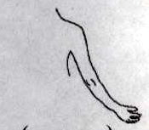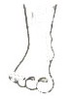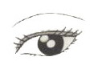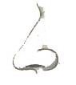
（ √ ） （ ） （ √ ） （ √ ）
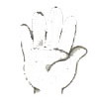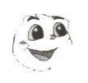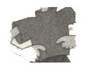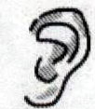
（ ） （ √ ） （ √ ） （ ）
六．略。
七、听录音选出正确的答语。
1．B
2．B
3．A
4．A
5．B
八、看图连线。
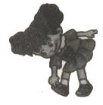 Hi, this is Mike.
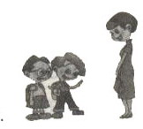
Nice to meet you.
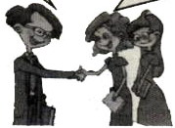 Good afternoon.
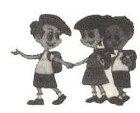 Let’s go to school.
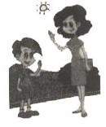 Touch your foot.
九、看图完成下列句子，把该填空词的编号.
1. I have a big ____⑤___.
2. I have 2 __③___ s.
3. I have a small __②___ .
4. My ___⑦___ is big .
5. I have a ___⑧____ .
6. I have 2 _____⑩_____s .
8. My __⑥___s are long.
9. Stamp my __④___ .
10. Clap my __①___s.

