牛津小学英语三年级Unit1-2单元测试题
听力部分
一、听录音，填序号。10’
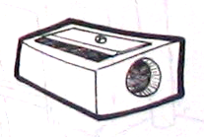
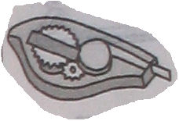
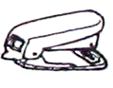
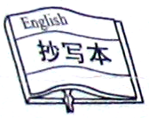
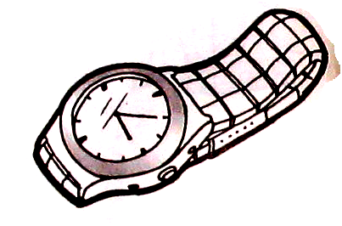

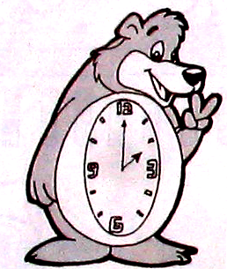
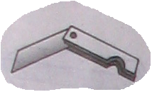
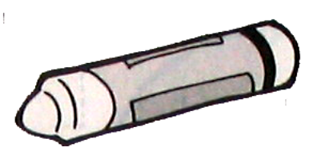
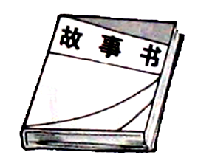
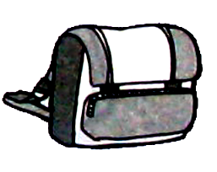

二、听录音，选出你所听到的，把序号填在（）内。10’
( )1. A Storybook B copybook C. desk D book
( )2. A crayon B tape C. ruler D rubber
( )3.A school bag B clock C. knife D stapler
( )4.A. my computer B your computer C. her computer
( )5 A. What’s this? B What’s that? C.What’s this in English?
( )6A .How nice! B How pretty! C .What a nice watch!
( )7 A. Is this a camera? B Is that a camera? C .This is a camera.
( )8. A. in English B in Chinese C. in the box D in the bag
( )9.A.come here B come in C.pencil box D.pencil sharpener
( )10.A. on the desk B on the chair C .on the ruler D on the book
三、根据所听内容选择正确的中文和英文。10’
( )1. A.过来. B.进来.
( )2. A.课桌上这是什么? B .铅笔盒里这是什么?
( )3. A.用英语说这是什么? B.用英语说那是什么?
( )4. A.哦,我不知道 B.哦,我明白了
( )5. A.我可以进来吗? B.我可以看一看吗?
( )6. A.Is this a telephone? B.What a nice telephone!
( )7. A.Is this a computer? B.Is this a camera?
( )8. A.Look,this is my clock. B.Look,this is my key.
( )9. A.Yes,it is. B.No, it isn’t.
( )10. A.That is a knife. B.Is that a knife?
四、听录音，判断。（对的打√，错的打x）10’

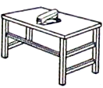

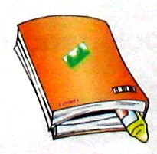
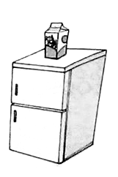
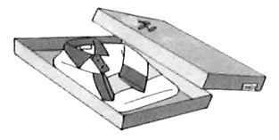

五、根据所听句子选择正确应答。10’
( )1.A. Yes,it is. B.It’s a knife. C.It’s a clock
( )2.A. It’s a crayon. B.No,it isn’t. C.Thank you.
( )3.A. OK. B.I’m sorry. C.Excuse me.
( )4.A. It’s a toy train. B. Yes,it is. C.Oh, I see.
( )5.A. Come in,please. B. Thank you. C.How are you.
( )6.A. No,it isn’t. B. Sure.Here you are. C.Thank you.
( )7.A. Thank you. B. No,it isn’t. C.Good afternoon
( )8.A. Yes,he is. B. Yes,she is. C.Yes ,it is.
( )9.A. How nice! B. Yes,it is. C.Thank you.
( )10.A. Yes,he is. B. He’s my father. C.No, it isn’t

笔试部分
六、从A栏中找出B栏的正确答语，把序号填在括号内。10’
A B
( )May I come in? 1.Sure.Here you are.
( )Can I have a look? 2.Yes,it is.
( )What’s this in English? 3.Thank you.
( )Is this telephone? 4.It’s a copybook
( )What a nice watch! 5.Come in,please.
七、写出下列所给字母的邻居。(注意区分大小写)10’
D G
m s j
八、将下列所给单词的大写变成小写,小写变成大写。10’
COMPUTER CLOCK RADIO COPYBOOK WATCH

crayon storybook cinema knife fridge

九、根据情景，选择填空。14’
（ ）1、当你去拜见朋友，想进房间时，应说：
A.May I come in? B. Come in, please. C. Oh, I see.
（ ）2、看见一个漂亮的照相机，你会说：
A. How old are you? B. Thank you. C. How nice!
（ ）3、询问某件东西是否是电脑，别人应答：
A. Is this a computer? B. Yes, it is . C. How pretty!
（ ）4、你想看一看某件东西，别人会说：
A. Can I have a look? B. No, it isn’t. C. sure.
（ ）5、在打扰别人时，你应说：
A. Here you are. B. Excuse me. C. Hello!
（ ）6、别人告诉你桌上是蜡笔时,你可以说:
A. Thank you . B. How are you? C.This is a crayon.
（ ）7、Is that your tape?
A. Yes, it isn’t. B. No, it isn’t. C. Yes, it is.
（ ）8—Can I have a ? — Sure
A.book B.look C.good
（ ）9、May I come in?
A. Yes. B. Come in, please C. Sure.
（ ）10、What’s that in English?
A zebra. B. Yes, it is a stapler. C. It’s a sharpener.
（ ）11、当别人叫你过来，他要说：
A. Come in ,please . B. Come here ,please. C.May I come in?
（ ）12、当你想知道远处桌上的物体是什么时，你会问：
A. What’s this on the desk ? B. What’s that on the desk ?
C. What’s that in the desk ?
（ ）13、当别人问你这是什么，你回答：
A. It’s a ….. B . Yes , it is . C. No, it isn’t.
（ ）14、你想说朋友的手表好看，可以说：（ ）
A. How a nice watch ! B. What a nice clock ! C. What a nice watch !
十、根据所给中文写出相应单词。6’
1. 2. 3 .
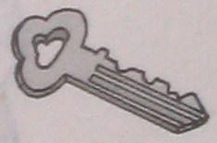

4 . 5. 6.

