小学新标准英语三年级期末学力检测
Class ________ Name _________
Listening （听力部分）
I. Listen and circle (听音，画圈)
1. shy why 2. quiet quite 3. wide ride
4. nineteen ninety 5. hard farm 6. say day
7. grandparent granddad 8. first fast 9. plus policeman
10. Thursday Tuesday

II. Listen and match (听音，连线)
Monday
Thursday
Sunday
Friday
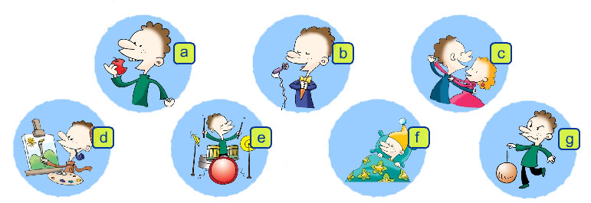

Tuesday
Saturday
Wednesday

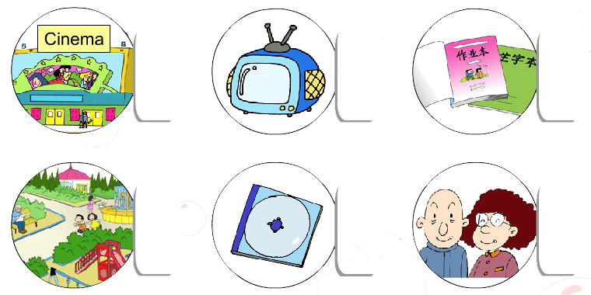
III. Listen and tick or cross (听音，打“√”或“×”)

IV. Listen and write (听音，写单词)
1. Maomao is very ________. She always helps people.
2. Maybe I’ll be a _________ in the future.
3. My grandparents weren’t old ________. They were very ________.
4. The milk was on the ________ floor.
5. He works _______. He isn’t lazy.
6. We’ll pick lots of ________ tomorrow.

Reading and writing（笔试部分）
I. Copy the sentences (用正确的格式抄写以下的句子)
1. And it’s very long. It’s the River Thames.

2. I’ll visit my grandpa in the countryside.

II. Choose the best answer (选择最佳答案)
1. -What will you _______?
-We’ll see lions, tigers and pandas.
A. do B. eat C. see
2. -Will you go to the cinema?
- _______________.
A. Yes, he will. B. Yes, I will. C. Yes, they will.
3. I’ll be a ________. Because I like films.
A. footballer B. policeman C. film star
4. Ms Smart is very happy _______ your work.
A. / B. be C. with
5. –Ahh, you _______ very cute.
- And I _________ naughty, too.
A. was, were B. were, was C. wasn’t, weren’t
6. She runs fast at _______.
A. Art B. Science C. PE
7. This CD is ______ you. Happy Mother’s Day.
A. on B. for C. to
8. -What day is after Tuesday?
- It’s ____________.
A. Wednesday B. Thursday C. Friday
9. What’s seventy plus thirty? It’s _________.
A. one hundred B. sixty C. eighty
10. -How many tangerines are there?
- ____________ fourteen tangerines.
A. It’s B. There are C. I can see

III. Look and choose (读一读，选择合适的代号填入圈内)
A. Were you on the second floor? B. Is Daming naughty in class?
C. No, I won’t D. What will you be , Daming?
E. Oh, will you take your ball tomorrow? F. Yes, we were.
G. No, he isn’t. H. A footballer.

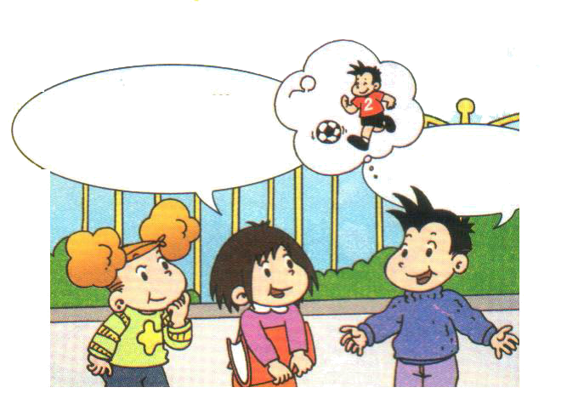
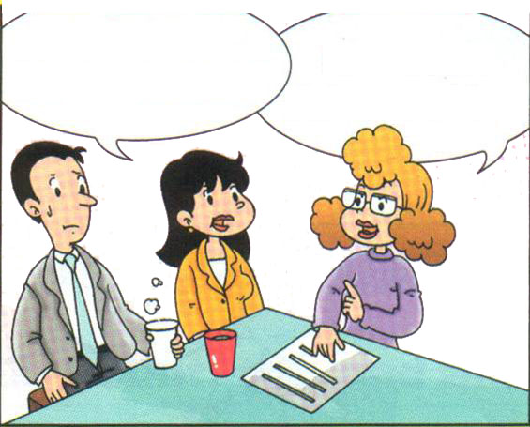

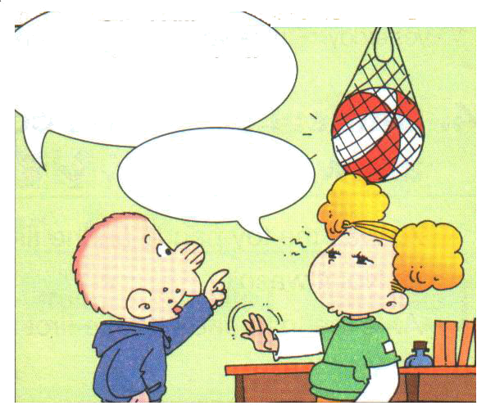
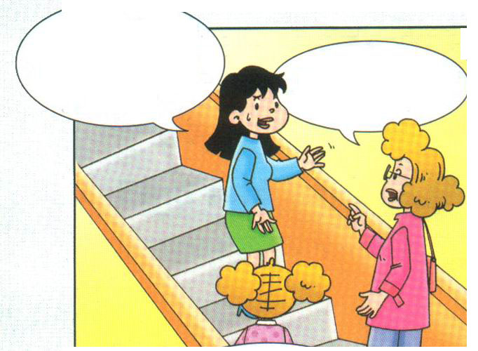

IV. Look and count, then write. (看一看，数一数，并写一写)
thirteen fourteen sixteen twenty
nineteen fifteen eighteen seventeen

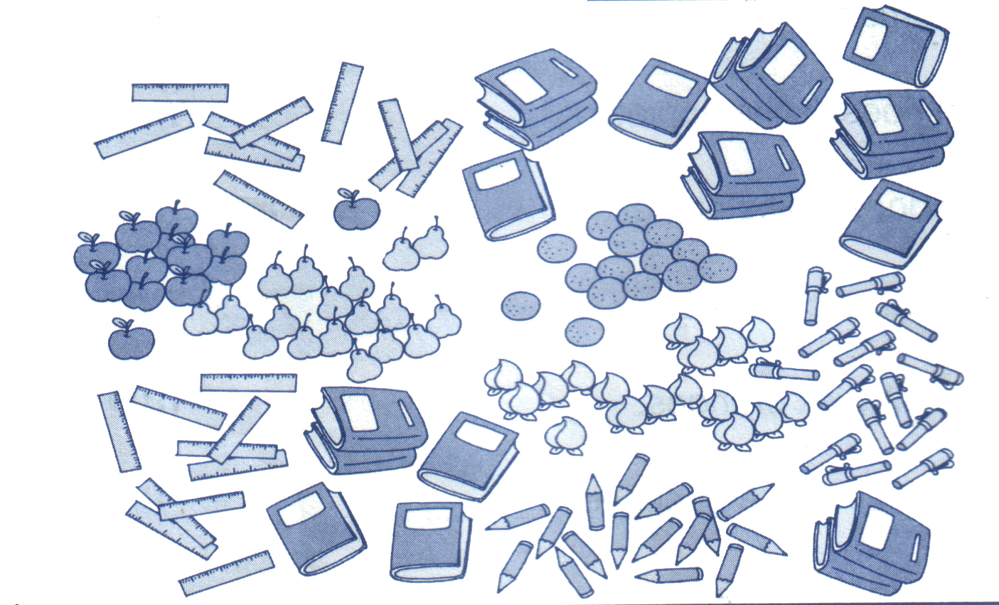

1. There are ____________ apples. 2. There are ____________ peaches.
3. There are ____________ pears. 4. There are ____________ oranges.
5. There are ____________ pens. 6. There are ____________ pencils.
7. There are ____________ books. 8. There are ____________ rulers.

V. Read and circle the correct words (读一读，圈出正确的单词)
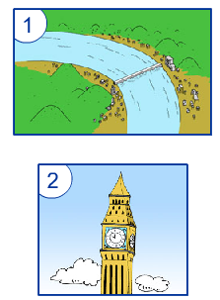
1. This river is very long / short.
2. This clock is very short / tall.
3. This bridge is wide / tall.
4. This school is old / new.
5. This station is old / new.
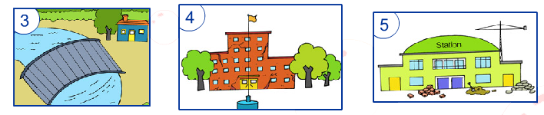

VI. Look and write (看图，写一写)
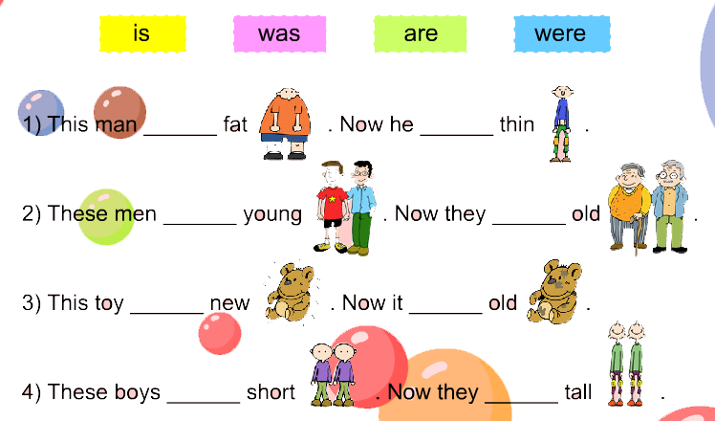

VII. Word search (找一找，圈一圈)

D | T | A | L | L | X | R
I | F | O | R | T | Y | O
F | I | I | N | X | X | U
F | N | X | F | Q | N | N
E | D | W | F | T | E | D
R | R | B | X | W | Y | E
E | H | I | G | H | H | A
N | H | G | S | C | E | R
T | X | S | P | E | A | K
H | E | L | P | F | U | L

听力材料
I. Listen and circle.
1. She’s a big shy.
2. He’s quite good at English.
3. Look, this bridge is very wide.
4. There are nineteen girls in my class.
5. We are going to the fruit farm. We’ll pick fruits.
6. What does the report say?
7. I’ll visit my grandparent tomorrow.
8. She runs very fast.
9. What’s ten plus ten?
10. What day is after Tuesday?
II. Listen and match
Solomon Grundy, will eat fruit on Monday, will play ball on Tuesday, will sing on Wednesday, will dance on Thursday, will play drums on Friday, will paint on Saturday, will sleep on Sunday. That’ll be the week, for Solomon Grundy.
III. Listen and tick or cross
Narrator: Hi, Wang Fei. What are you going to do this weekend? Will you go to the cinema?
Wang Fei: No, I won’t.
Narrator: Will you watch TV?
Wang Fei: Yes, I’ll watch TV. And I’ll do my homework.
Narrator: Will you go to the park?
Wang Fei: No, I won’t go to the park this weekend. I’ll listen to music. I’ve got a new CD.
Narrator: And will you visit your grandparents?
Wang Fei: Yes, I will. We’ll go on Sunday.
Narrator: Thank you, Wang Fei.
IV. Listen and write
1. Maomao is very nice. She always helps people.
2. Maybe I’ll be a writer in the future.
3. My grandparents weren’t old then. They were very young.
4. The milk was on the second floor.
5. He works hard. He isn’t lazy. 6. We'll pick lots of pears tomorrow.

