2007—2008学年第二学期四年级英语期中试卷
班级 姓名

第一部分 听力部分(共40分)
一、听录音，标序号(13分)
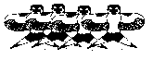
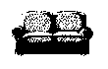

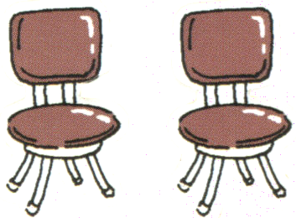
( ) ( ) ( ) ( )
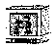
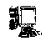


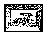
( ) ( ) ( ) ( )

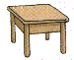
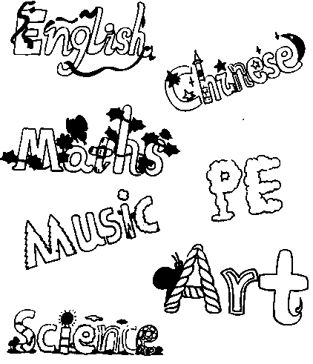
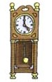
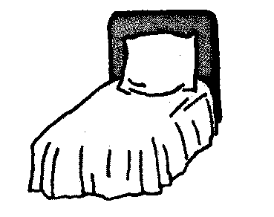
( ) ( ) ( ) ( ) ( )
二、听录音,把听到的单词序号填在左边的括号里。(10分)
（ ）1.A.twelve B eleven C. seven
（ ）2. A.3:00 B.5:00 C.11:00
（ ）3.A.living room B.bedroom C.classroom
（ ）4. A.fourteen B.thirteen C.eighteen
（ ）5. A.floor B.wall C.ball
（ ）6.A．English B．Chinese C．science
( )7. A. cup B. mug C. put
( )8. A. fifteen B. sixteen C. seventeen
( )9. A. kichen B. chicken C. listen
( )10.A. thirty B. forty C. fifty
三、听录音，标出序号并连线 (10分)]
起床 brush my teeth and wash my face( )
洗脸刷牙 get up( )
吃早饭 have my lunch( )
上学 have my breakfast( )
吃午饭 go to school( )
回家 have my dinner( )
吃晚饭 watch TV( )
看电视 go home( )
整理学习用具 put things away( )
上床睡觉 go to bed( )
四 听录音，涂色。（7分）

第二部分 笔试部分（共60分）
找出不同类的单词，把序号填在题前括号内（5分）
( )1、A. lunch B. noodle C .dinner D. breakfast
( )2、A. milk B.coke C. egg D.juice
( )3、A. sofa B. desk C.chair D. TV
( )4、A. kitchen B.pork C.chicken D.beef
( )5、A. music B. pizza C.PE D.art
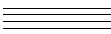
二、 英汉互译（20分）
1.计算机 2.汉堡包 3. 铅笔
4.桌子 5. 气球 6. forty-three
7.Frnch fries 8.science
9.mopthe floor 10.twenty-five
三、据汉语意思填空。10％
1.There are (十一)oranges and (十二) bananas in the box.
2.He is a (老师),She is a (学生).
3.Mimi likes (数学)class, (美术)class and
音乐) class. Micky likes PE.
4.What subjects do you like? I like (语文) and
(英语)
5.It’s time for lunch. I’d like (热狗)and
(可口可乐).
四、根据问句,找出正确的答案。12％
( )1.How many students are there in your class ?
( )2.How many books do you have?
( )3.How many classes do you have today?
( )4.Will you come to my birthday party?
( )5.What subjects do you like?
( )6.Lets go to school together!
( )7.May I ask you some questions ?
( )8.What can I do for you ?
( )9.Here you are !.
( )10.Do you like English?
( )11.Mum,I’m hungry.
( )12.What do you do im English class?
( )13.What`s the time?
A.Yes, I do B. Ok, Lets go. C.I like Chinese and English D. There are fifty-six students. E.I have forty books. F.We have six classes. G. We listen and do , speak and sing, H. It`s seven o`click I. Yes, please. J. Plaese hang the clock on the wall.
K. I’d love to . L. Thank you! M. OK, Let’s have dinner.
五、分类写出单词12分
1.食物:
2.数字:
3.家具:
4.课程:

