京翰主编导语：本试题是本学年度三年级上册期中考试试题，分为听力和笔试两部分，听力部分设计活泼，笔试部分题目适当。
三年级上册期中试题

Class ______ Name __________ Number _______ Score ______
听力部分 50%
Ⅰ. Listen, draw and colour. ( 听音、画画、涂色 ) 10%

Ⅱ. Listen, tick or cross . ( 听音, 打钩或画叉 ) 10%
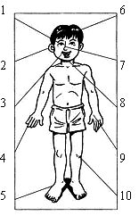

Ⅲ . Listen and number. ( 听音标号，并把动物的两部分连起来 ) 10%
（ ） （ ） （ ） （ ） （ ）
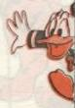
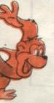
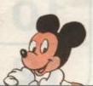

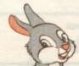

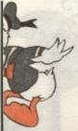
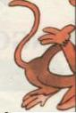
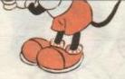
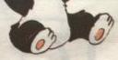
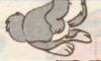

Ⅳ. Listen and match. (听音连线) 10%
1. a nose | red
2. a ruler | orange
3. a big book | green
4. a little bag | blue
5. a little sharpener | white
Ⅴ. Listen and choose. ( 听音选择 ) 10%
（ ）1. A. I’m Sarah. | B. I’m fine, thanks. | C. Me too.
（ ）2. A. Great! | B. Ok. | C. See you.
（ ）3. A. Here it is. | B. Bye! | C. Very well, thank you.
（ ）4. A. Good afternoon. | B. Good morning. | C. Goodbye.
（ ）5. A. I’m Mike. | B. I like blue. | C. This is Wu Yifan.
笔试部分 50%
Ⅰ. Read and choose. (读一读，选择不同类的单词) 10%
（ ）1、A、red | B、mouse | C、black | D、purple
（ ）2、A、school | B、bag | C、book | D、crayon
（ ）3、A、Zoom | B、ruler | C、Sarah | D、Chen Jie
（ ）4、A、Canada | B、China | C、USA | D、panda
（ ）5、A、bear | B、squirrel | C、dog | D、pig
Ⅱ. Read and choose. (读一读，选择拼写正确的单词) 8%
( )1. A. epn | B. pen | C. nep
( )2. A. face | B. afce | C. fece
( )3. A. inpk | B. pink | C. pnik
( )4. A. yellow | B. yollew | C. yellew
Ⅲ. Read and choose. (读一读，选择正确答句) 12%
______
Really？
_______
Thank you!
OK!

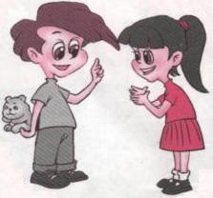
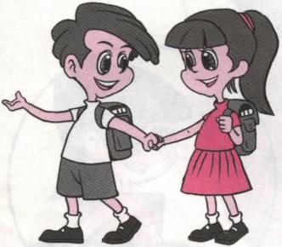

_____

A. I have a bear. A. Here you are. A. Let’s go to school.
B. May I have a look? B. How are you? B. Good afternoon.
This is Sarah.
_____
Sure!
_______
Fine.
_____

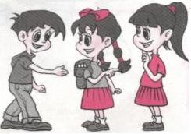
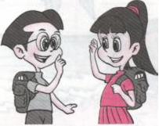
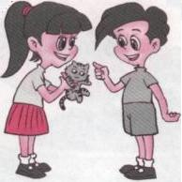

A. Nice to meet you. A. Nice to meet you. A. May I have a look?
B. What’s your name? B. How are you? B. I have a cat.
Ⅳ. Read and choose. ( 读一读，选择恰当的答句。) 10%
( ) 1. Good afternoon. | A. Good morning!
( ) 2. What’s your name? | B. I’m Mike.
( ) 3. Hello! | C. Fine, thank you.
( ) 4. Goodbye! | D. Great!
( ) 5. Let’s go to school! | E. Nice to meet you, too.
( ) 6. Good morning! | F. My name’s John.
( ) 7. How are you? | G. See you!
( ) 8. Nice to meet you. | H. Good afternoon.
( ) 9. Let’s paint! | I. Hi!
( )10.Who are you? | J. OK!
Ⅴ. Read and choose. ( 读一读，选择恰当的答句) 5%
（ ）1、有一天，你在街上遇见一位很久没有见面的同学，你应该如何问候？
A. Who are you? | B. How are you? | C. Here you are.

（ ）2、你第一次认识Mike，感到十分高兴，你应该这样说：
A. Me too. | B. Nice to meet you. | C. Good afternoon.

（ ）3、John说：“I like yellow.”你的爱好跟他一样，你可以说：
A. Great! | B. My name’s Bai Ling. | C. Me too.

（ ）4、老师请你拍手，用英语该这样说：
A. Clap your hands. | B. Clap my hands. | C. Snap your fingers.

（ ）5、Sarah是班长，老师走进教室准备上课，她应该这样说：
A. Sit down. | B. Good morning. | C. Stand up.
Ⅵ. 判断下列说法是否正确。5%
1. 在10月9日的时候，我们都会向老师说：Happy Teacher’s Day! ( )
2. 英国国旗是由red, blue和white这三种颜色组成的。 ( )
3. 10月31日的Halloween是西方孩子们最喜欢的节日之一。 ( )
4. Kangaroo是澳大利亚有代表性的动物之一。 ( )
5. UK是英国的简称，USA是美国的简称。 ( )

