卷首语：亲爱的同学们，第一学期即将过去，在这里为期末考试练练兵，京翰教育预祝你期末考个好成绩！
三年级英语上册期末试卷

第一部分 听力（４０分）
一．选出你所听到的字母、单词。（１０分）
( )1.A.Bb B.Pp C. Dd D. Tt
( )2.A.Ii B.Aa C.Hh D.Yy
( )3.A.nose B.nine C.name D.No
( )4.A.sing B.sick C.son D.sit
( )5.A.two B.ten C.toe D.tea
- 选出你所听到的句子。（１０分）
( )1.A.How are you? B.How old are you? C.How do you do?
( )2.A.Close the window.B.Close the door.C.Close your book.
( )3.A.That’s cat.B.That’s cool.C.That’s cold.
( )4.A.They’re crying.B.They’re singing.C.They’re talking.
( )5.A.I live in China.B. I live in Canada C. I live in Gansu.
- 听句子，选择相应的答语。（１０分）
( )1.A.My name is Jenny.B.I’m ten.C.I’m a student.
( )2.A.Yes,I am. B.No, I’m not. C.I’m sad.
( )3.A.Yes, I’m sad.B.Yes,I feel happy.C.Yes,I’m ten.
( )4.A.They are working.B. They are students.C. They are yellow.
( )5.A.My eyes are short.B. My eyes are black.C. My eyes are hurts.
- 根据你所听到的内容，画画。（１０分）
(1) (2) (3) (4) (5)
第二部分 笔试（7０分）
一．按书写格式，把下列大写字母的小写形式，小写字母的大写形式写在下面的四线格内。（10分）
G H E I Y P FAMILY ELBOW TWO GIRL

r d q j m f sing body juice door

二.看图，看图连线。（10分）
girl 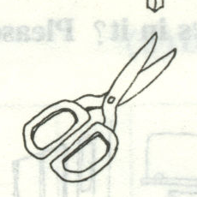 She is singing. 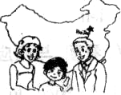
scissors 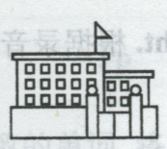 My family lives in China . 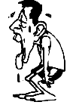
family 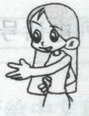 My mother is a doctor. 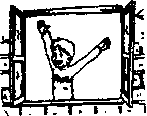
school 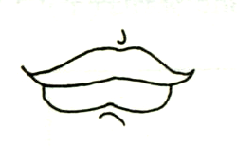 I’m tired. 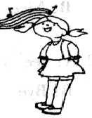
mouth 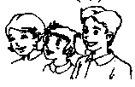 Open the window. 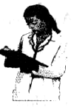
三．看图，填入所缺的字母。（10分）
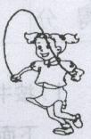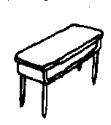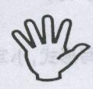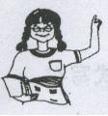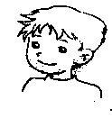
Pl__y d__sk h__nd t_ _cher b__y
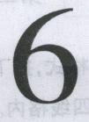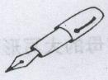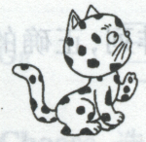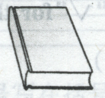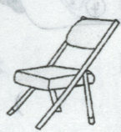
S__x p__n c__t b_ _k ch_ _r

四．给下列反义词连线。（10分）
cold laugh short right
cry young stand cool
in happy left big
old hot warm tall
sad out little sit
五．找答语。（10分）
( )1.How are you? A.She’s at school.
( )2.What colour is it? B.No,I have a headache.
( )3.How many pencils do you have? C.It’s a chair.
( )4.What’s her name? D.I cut my knee.
( )5.How old are you? E.I’m fine.Thanks.
( )6.Do you feel happy? F.It’s green.
( )7.Where is Lynn? G.I have two.,
( )8.What’s this? H.Her name is Jenny.
( )9.Are you okay? I.I’m ten years old.
( )10.What’s the matter? J.Yes,I feel happy.
六．阅读下列短文，按要求完成练习。（10分）
Hello!My name is Tom.I’m a boy.I’m ten years old.Look!This is a picture of my family.They are my father、my mother、my little sister and I.My father is very tall.He is handsome.He is a doctor.My mother is short.She has long、curly hair.My little sister is only three years old.She has two big eyes.
- 根据短文内容，判断下列句子正误，对的在（√）内打“”，错的打“×”。
( )1.Tom is ten years old.
( )2. Tom is a daughter.
( )3.Tom’s father is very tall.
( )4.Tom’s mother has short black hair.
( )5.Tom’s sister has two big ears.
( )6.Tom’s sister is only three years old.
B.根据短文内容，画出家的全家照。（4分）

七、看图，与相应的对话用“——”连起来。（10分）
1.A:Nine to meet you! 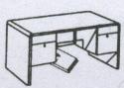
B:Nine to meet you,too!
2.A:Goodbye.See you later! 
B:Bye!
3.A:Where is my book? 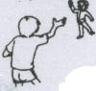
B:It’s under the desk.
4.A:How do you feel? 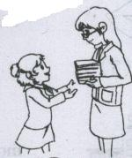
B: I’m very cold.
5.A: What are they doing? 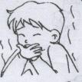
B:They are playing.
6.A:May I have two books? 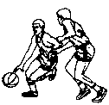
B:Thanks.

