2010—2011学年度上学期小学阶段教学质量检测

三年级英语试题


时间：40分钟 等级
细心点，相信你能行！

Listening part

一、Listen and choose (听录音, 选出你所听到的单词)
( ) 1. A. pen B. pencil C. pencil-case
( ) 2. A. head B. hand C. hello
( ) 3. A. blue B. pink C. purple
( ) 4. A. bird B. bear C. boat
( ) 5. A. cake B. Coke C. coffee

二、Listen and number (听录音，排顺序)


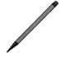
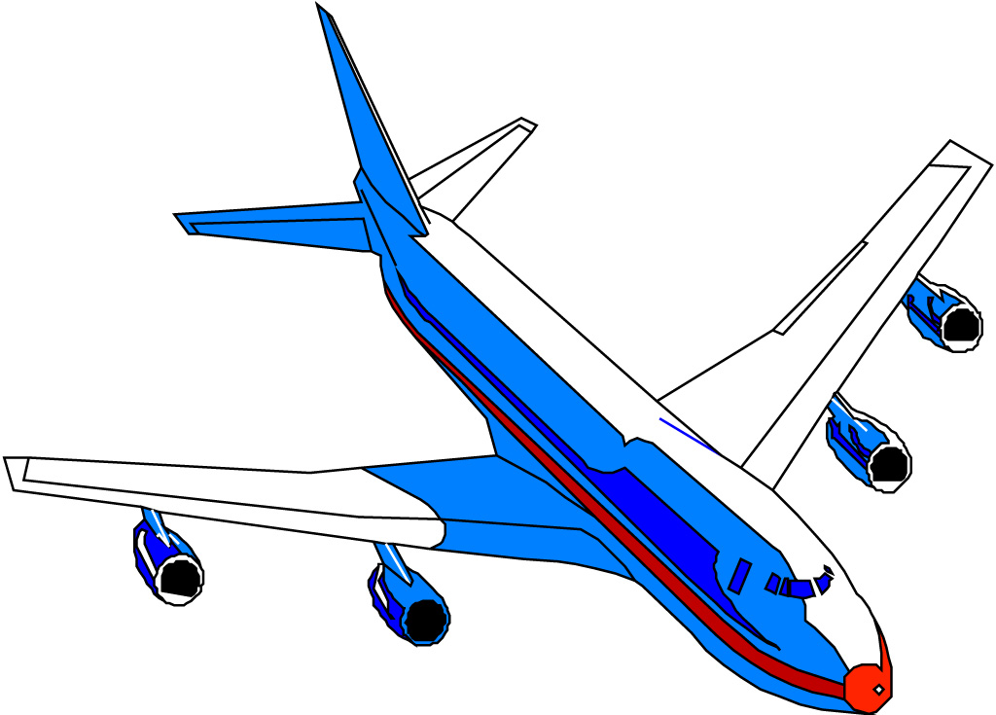


( ) ( ) ( ) ( ) ( )

三、Listen and choose the right answer (听录音,根据问句选答语)
( ) 1. A. thank you. B. I’m fine, thank you.
( ) 2. A. Fine, thank you. B. I’m nine.
( ) 3. A. Nice to meet you, too. B. Hello.
( ) 4. A. OK! B. Me, too.
( ) 5. A. Good afternoon. B. Good morning.

四、Listen and colour(听录音, 涂颜色)






五、Listen and number(听录音, 排顺序)
( ) Nice to meet you.
( 1 ) Hi, Mom!
( ) Good afternoon.
( 2 ) Hi!
( ) Nice to meet you, too.
( ) Good afternoon, Mike.
( ) Mom, This is Mike.
Writing part
六、Read and choose the right answer(找出下列每组单词中不同类的单词)
( ) 1. A. face B. foot C. five
( ) 2. A. mouth B. mouse C. monkey
( ) 3. A. body B. blue C. black
( ) 4. A. bread B. crayon C. cake
( ) 5. A. pink B. purple C.plane
七、Look and choose the right word(看图, 根据身体部位选择正确单词的序号)
mouth
eye
head
foot
foot

A B C D E

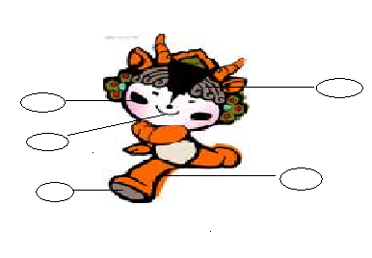

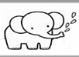
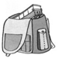

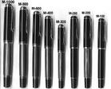
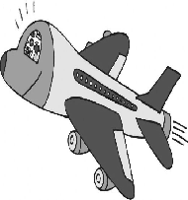
八、Look and match（读一读, 连一连）

ellephant
pen
bag
plane
balloon

九、Read and choose the right answer(单项选择)
( ) 1. —Can I have some chicken?
— .
A. Sure. Here you are. B. Very well, thank you.
( ) 2. —What’s your name?
— .
A. This is Bai Ling. B. My name is Bai Ling.
( ) 3. —This is Li Lei,Mom.
— ?
—Good morning!
A. Good morning, Li Lei. B. What’s your name?
( ) 4. 我国国旗的颜色有：
A. red and white B. red and yellow
( ) 5. 当你与新朋友John遇到Sarah时，你应该介绍说：
A. Good morning, Sarah. B. This is Sarah.
( ) 6. 要把某样东西给别人，通常应该说：
A. Here you are. B. May I have a look?
( ) 7. 别人赞扬你的东西很漂亮时，你应该说：
A. Thank you. B. No.
( ) 8. 询问别人的年龄，你应该说：
A. How old are you? B. How are you?
( ) 9. 当别人感谢你时，你应该说：
A. Thank you. B. you are welcome.
( )10. 要邀请别人喝牛奶，可以说：
A. Have some milk! B. I like milk.

十、Look and choose（看一看, 选一选, 只填序号）
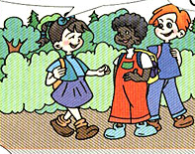
Let’s paint!
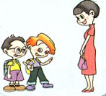
Hello!



A. Hi.
B. Thank you.
C. Great.
Happy birthday!
This is sarah.
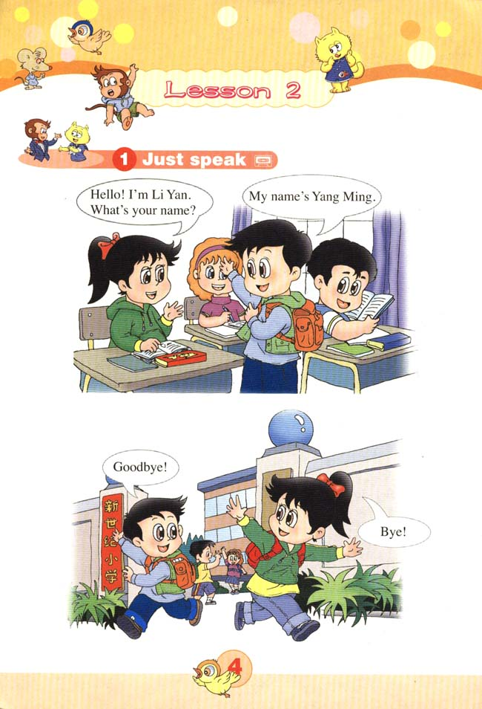
D. Nice to meet you .
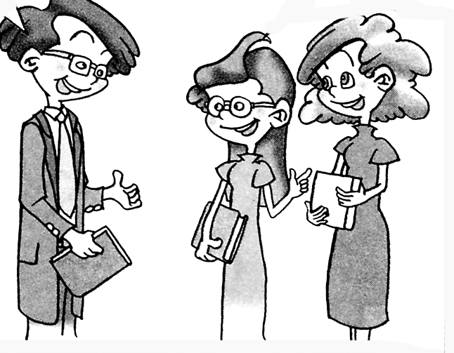

听力原材料
一、Listen and choose
1. pencil-case; 2. head; 3. purple; 4. bear; 5. coffee
二、Listen and number
1. Pencil; 2. monkey; 3. I’m Mike.; 4. plane; 5. Coke
三、Listen and choose the right answer
1. Here you are.
2. How old are you?
3. Nice to meet you.
4. Let’s go to school!
5. Good afternoon.
四、Listen and colour
1. Colour 7 red;
2. Colour 1 yellow;
3. Colour 9 black;
4. Colour 3 green;
5. Colour 10 Purple.
五、Listen and number
A: Hi, Mom!
B: Hi!
A: Mom, This is Mike.
B: Good afternoon, Mike.
C: Good afternoon.
A: Nice to meet you.
C: Nice to meet you, too.

