小学四年级（上）英语期末试卷
一.选出不同类的单词.(10%)
( )1. A.teacher B. fanther C. brother D. mom
( )2 A.milk B. water C. soup D. coffee
( )3. A.kitchen B. bathroom C. classroom D. study
( )4.A. driver B. doctor C.nurse D. music
( )5.A. thin B. tall C. eye D. short
( )6.A. noodles B. chopsticks C.spoon D. plate
( )7. A. phone B. fork Cfridge D.TV
( )8. A. window B. math book C.door D. floor
( )9. A. science B.schoolbag C. sports D. painting
( )10.A.vegetable B.jucie C.hamburger D. beef
二. 读句子,给图标序号. (5%)
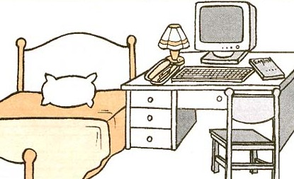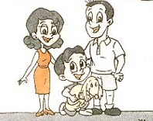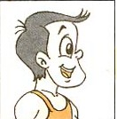
( ) ( ) ( )
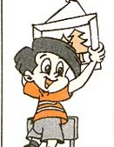
（ ） （ ）
――Mike. Please put up the picture. ――OK!
Look.He is my friend. He is so strong. He has short black hair and big eyes
This is my bedroom. You can see a bed , a computer a desk and a chair.
My family has 4 members.My father.my mother ,me and my little puppy.
My uncle is a driver.
三．选择正确的答句(10%)
( )1.Are they in the living room? A. Yes, he is.
( )2.Is this your father? B. I’d like some chicken.
( )3. What’s his name? C. No, they aren’t.
( )4. Can I have some noodles? D. His name is Mike.
( )5. What would you like for dinner? E. Sure. Here you are.
四．看图片，补全单词(18%)
He’s a tall b _ _.
I can see a d_ _ _ in the picture.
I’d like some f_ _ _ and r_ _ _ .
My uncle is a f_ _ _ _ _.
Welcome to our s_ _ _ _ _.
This is a d_ _ _.
My f_ _ _ _ _ is a d_ _ _ _ _.
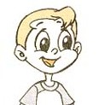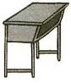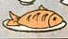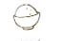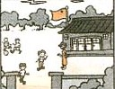
（１） （２） （３） （４） （５）
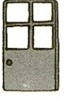
（６） （７）
五．阅读理解,判断下列句子是否正确(10%)
My name is Amy. I’m a thin girl. There are three members in my family. My parents and me. I have a good friend. She is Miss Li, my Chinese teacher. She likes music. She is from China.
( )1. Amy is strong.
( )2. There are 4 members in Amy’s family.
( )3. Miss Li is Amy’s friend.
( )4. Miss Li likes painting.
( )5. Miss Li is from China.

