PEP小学英语四年级上册Unit2测试题
听力部分
- 听一听，圈一圈。将下面每组中符合录音内容的图片下面的字母圈住。（１０分）
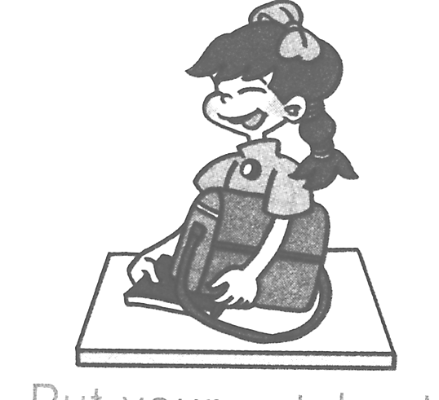
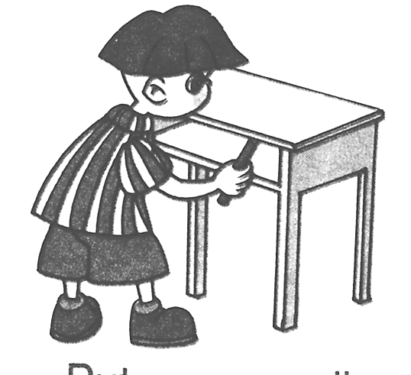
1. 2.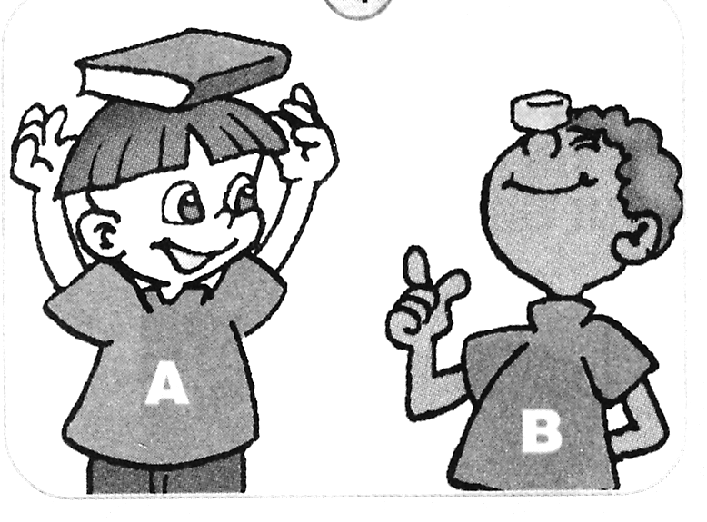 3.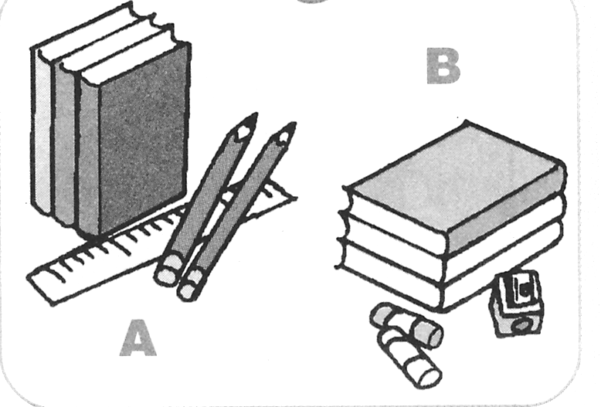
A B A B A B
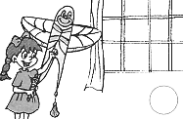
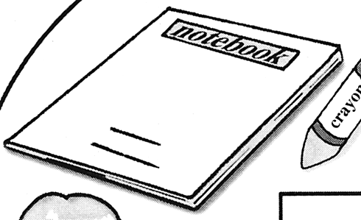
4.  5.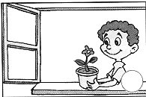
A B A B

- 听一听，辨一辨。辨别相应的图片内容是否与录音内容相符，相符的打“√”，不 符的打“╳”。（１０分）
1.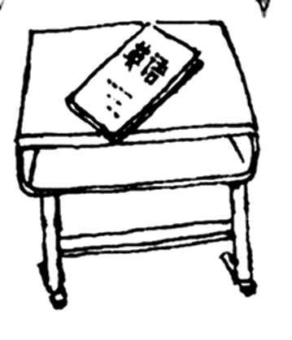 2. 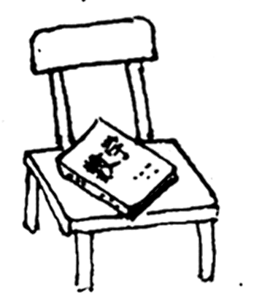 3. 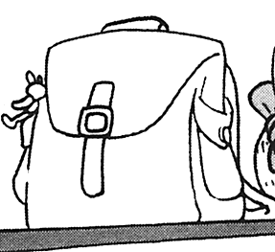 ￥50
( ) ( ) ( )
4.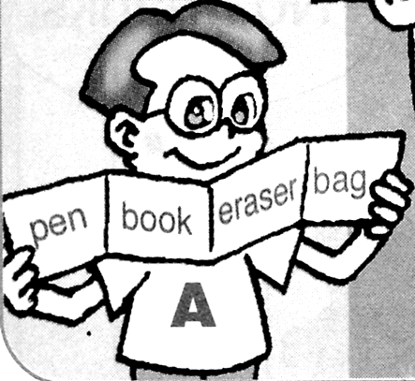 5.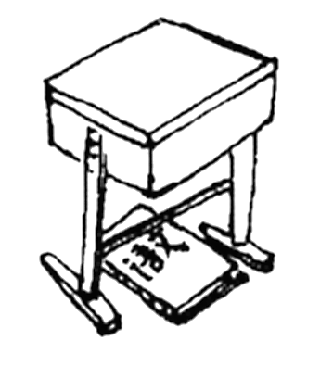
( ) ( )

- 听一听，涂一涂。根据录音中的指令，将下面图片中的物体涂上颜色。（１０分） 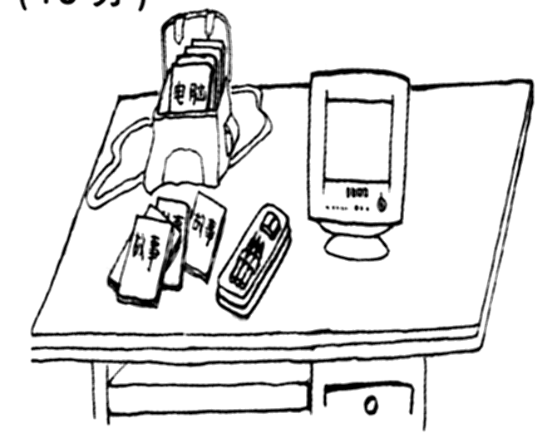
- 听一听，连一连。根据录音内容，将左边的图与右边的图连起来。（１０分）
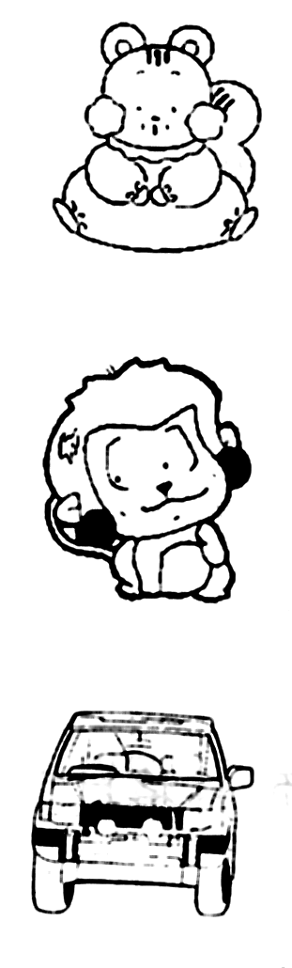
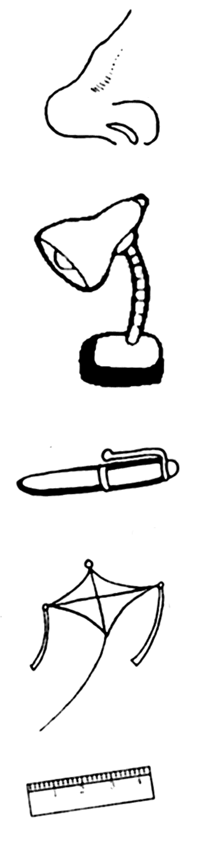

￥23

- 听一听，写一写。根据你在录音中听到的问题将答案用数字填在下面相应的括号里。（１０分）
1.( ) 2.( ) 3. ( ) 4.( ) 5. ( )

- 听一听，选一选。选出与录音内容相符的图片，并在你所选图片下面的括号里打 “√”。（１０分）
1. 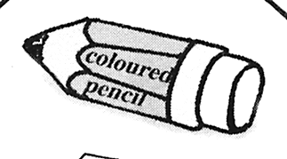 2. ￥15 ￥50
( ) ( ) ( ) ( )

3.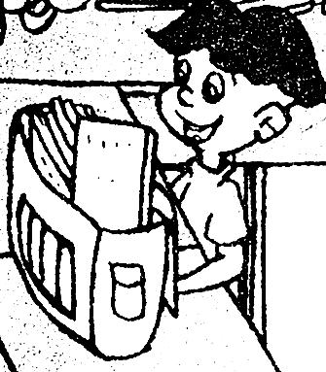 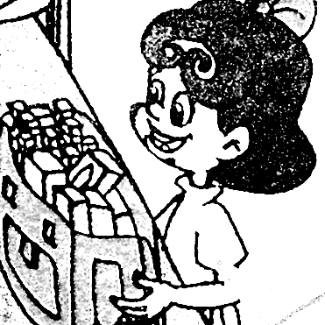 4. 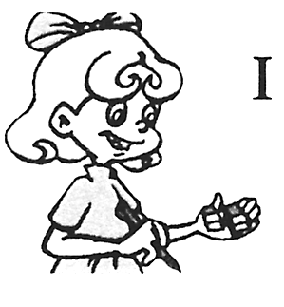 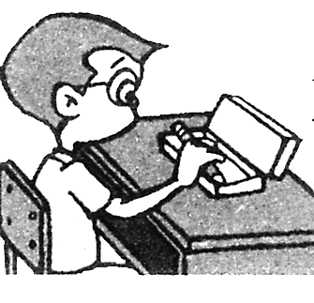 5. M F N H
( ) ( ) ( ) ( ) ( ) ( )

- 听一听，排一排。根据录音内容的顺序将下面的五张图片排序，并将数字序号填在图片下面的圆圈里。（１０分）
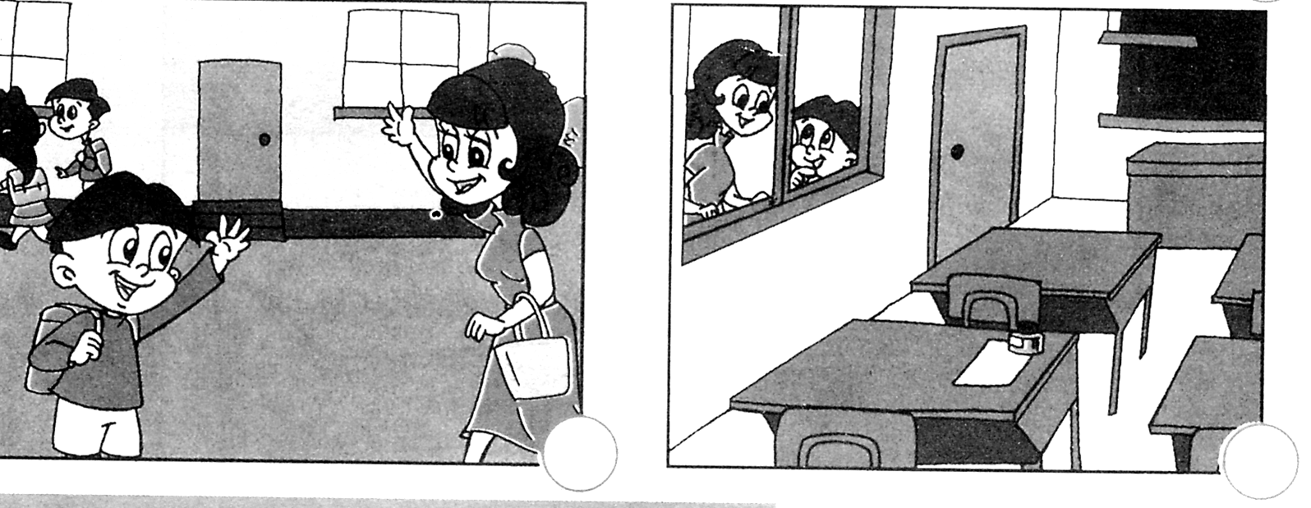
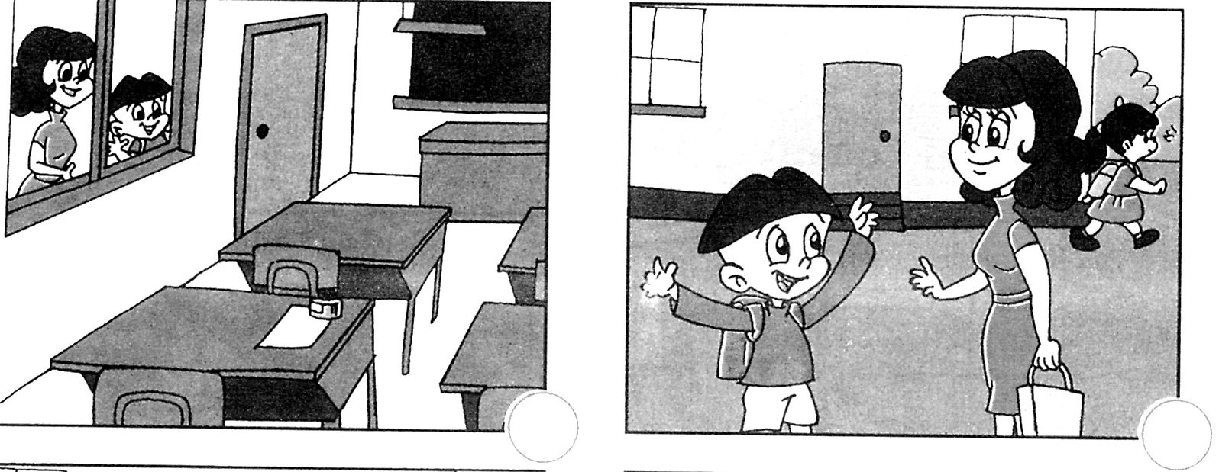

读写部分

- 请将下面的英语单词中所缺的字母补充完整。（１０分）
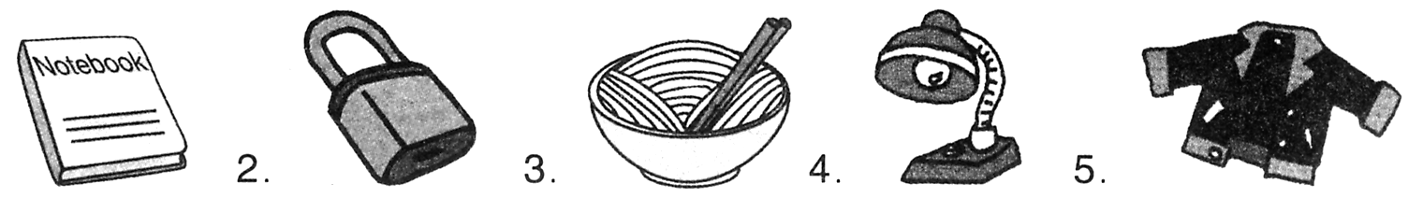 n__teboo__ __o __ k __oodle__ l__m__ __acke__
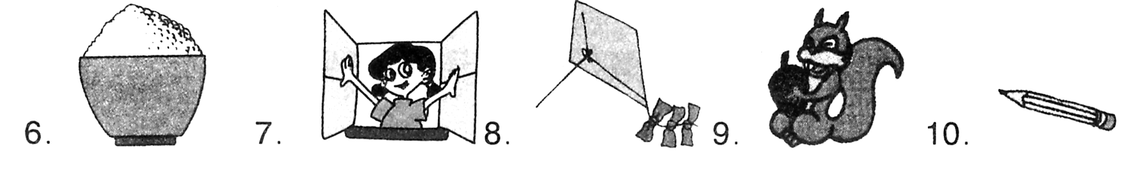
r__c__ __ p__n k__t __ __ __uirrel __ enci__

- 根据下面每句话的意思和图片的提示，在空格中填上适当的单词，使句子完整。（１０分）
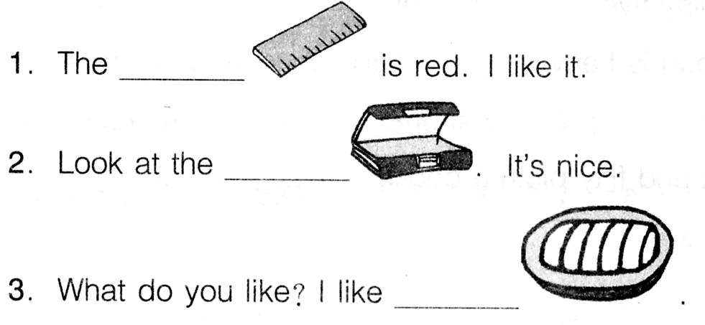

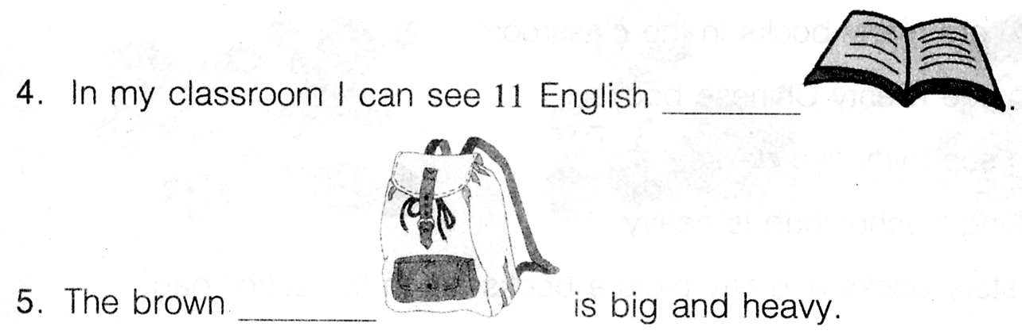

- 选句填空。将下面各个句子的标号填到图中的适当位置上。（１０分）
A. Oh! Sorry.
B. Wait, Zoom. Put away your books.
C. Oh, my schoolbag is heavy.
D. Take out your book, please.
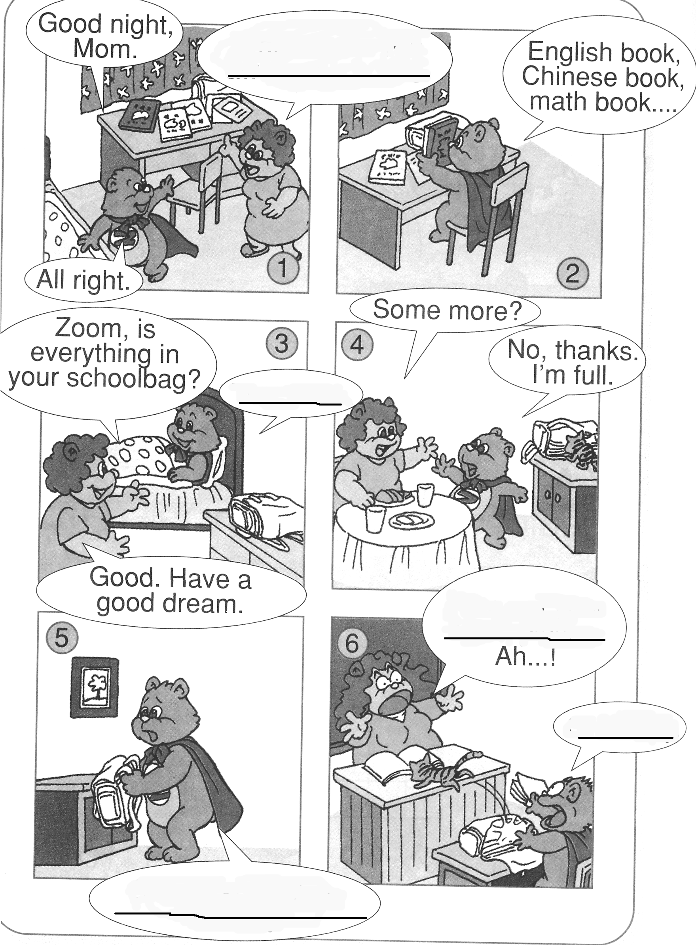
E. Yes, Mom.

English book3 Unit2
一、
1. Put your notebook under your bag.
2. Put your eraser on your nose.
3. What’s in your schoolbag? 3 books, 2 pencils and a ruler.
4. What are books made of? Paper.
5. Put the kite near the window.
二、
1. There’s an English book on the desk.
2. The math book is under the chair.
3. How much is the schoolbag?
4. Show me the words: pen, book, eraser and bag.
5. Where is the Chinese book? It’s under the desk.
三、
1. Colour the computer blue.
2. Colour the pencil-case green.
3. Colour the story-books purple.
4. Colour the schoolbag red.
5. Colour the desk yellow.
四、
1. I’m a cat. I have a kite.
2. How much is the lamp? It’s 23 yuan.
3. The monkey has a small nose.
4. There is a ruler and a pen in the schoolbag.
五、
23 45 31 52 38
六、
1. Do you have a story book? Yes, I do.
2. How much is the schoolbag? 50yuan.
3. What’s in your schoolbag? Many books.
4. I have a pen and 2 erasers.
5. Big letters N H.
七、
1. B: Mom!
M: Hi! Zhang Peng, let’s go home.
2. B: Mom, we have a new classroom.
M: Really? Let’s go and have a look!
3. M: Wow! It’s so big.
B: It’s very nice. I like my classroom.
4. M: What’s your seat?
B: Look! It’s near the window.

