小学四年级英语期末模拟试卷
考试时间：60分钟 满分：100分
听力部分 （50%）
一 、听句子，选出你所听到的单词。（10%）
A B C
1.( ) bread red brown
2.( ) chair where sure
3.( ) beef fish farmer
4.( ) people pencil pass
5.( ) milk music mouse
6.( ) Science Chinese English
7.( ) she shelf short
8.( ) math man many
9.( ) bathroom bedroom classroom
10.( ) twenty thirty fifty
二、听录音，填单词，使句子意思完整。(10%)

1. I’d like some ____________________and _________________for dinner.

2.Welcome to my _____________________. This is my ____________________.

3.What’s in your schoolbag? There is a _____________________ and a __________________ .

4.The boy is my ______________________. He is a _________________________.

5.Put your ____________________ on your _________________________.

三、听录音，选出你所听到句子的答语。（10%）
1. ( )A . He’s a teacher. B . Yes, she is. C . Yes, she’s my teacher.

2. ( ) A . My name is Tom. B . Her name is Sarah. C .This is Sarah.

3. ( ) A. No, they aren’t. B. Yes, they aren’t. C. No, they are.

4. ( ) A. It’s a schoolbag. B. Some books and pens. C. It’s red.

5.( ) A. There are 9. B. They’re in the room. C. They are 9.

四、听录音，判断对错，对的打“√”，错的打“ × ”。（10%）
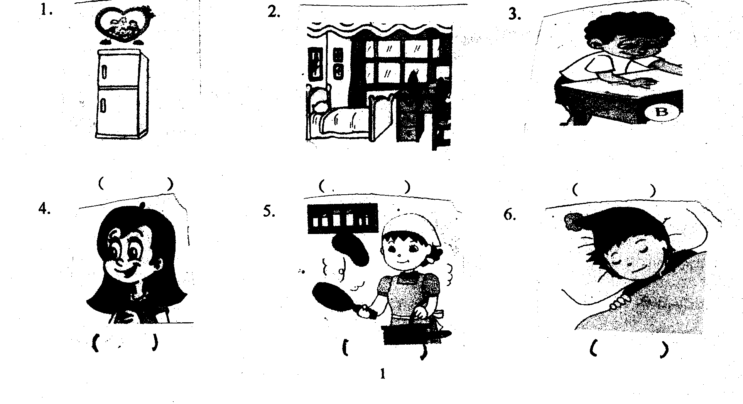

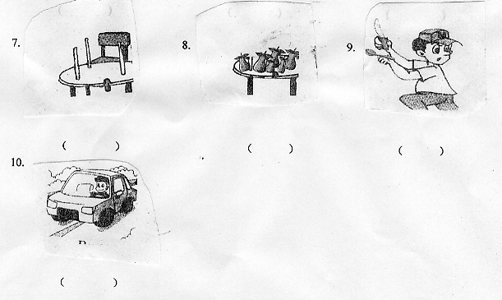

五、听短文，判断对错，对的打“√”，错的打“ × ”。（10%）
( ) 1. Mike would like rice and soup for dinner.

( ) 2. Amy would like rice and soup, too.

( ) 3. Amy is full.

( ) 4. Mike likes ice-cream.

( ) 5. Mike has apples for lunch.

读写部分（50%）
六、写出所给字母的相邻字母，注意大小写。（5%）

1. ______ Q ______ 2. _______ r _______ 3. _______s _______

4. _____ j _______ 5. ______ H ______

七、选词填空，将正确答案的序号写在题前括号内。（10%）
( ) 1. How many ________ can you see?
A. apple B. cats C. dog

( ) 2. Give me ________ pens.
A. two B. an C. a

( ) 3. Can I ___________ some noodles, please?
A. like B. has C. have

( ) 4. Let ________ clean the blackboard.
A. I B. me C. our

( ) 5. What’s ________ name? His name is Zhang Peng.
A. his B. her C. your

( ) 6. What colour is your English book?
A. 9 B. It’s big. C. It’s yellow.

( ) 7. Do you like sports?
A. Yes, I don’t. B. Yes, I do. C. No, I do.

( ) 8.What would you like for lunch?
A. Yes, I like. B. I’d like some chicken. C. I don’t like rice.

( ) 9. What can you see in my room?
A. I can see a bed. B. It’s nice. C. I have two windows.

( ) 10. Where are the keys?
A. It’s on the desk. B. they’re on the table. C. They’re on the table.

八、将问句的编号写在相应答句前面的括号里。（5%）
A. What’s this ? ( ) He’s a doctor.

B. May I have a banana. please? ( ) Hello, Tom.

C. What’s your brother? ( )No, it isn’t.

D. Hello, I’m Tom. ( ) Yes, here you are.

E. Is this a big pig? ( ) It’s a light.

九、找出下列单词不同类的单词。 （10% ）
1. ( ) A. rice B. soup C. light D. bread
2. ( )A. thin B. long C. short D. sports
3. ( ) A. thirty B. pencil C. twenty D. fifty
4. ( ) A. bedroom B.door C. wall D. window
5. ( ) A. spoon B. water C. plate D. fork

十、根据图片写与上下文的提示，写出所缺的单词。(10%)
Welcome to my_______________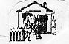 . Look, this is my family photo. This
woman is my _______________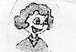 . She is a _____________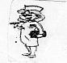.
She likes __________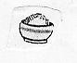. This is my father, he is a _____________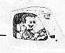.
He likes chicken and ____________ 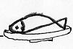. This is my sister. And this is her
English_________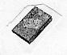. Who is this ___________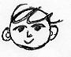? It’s me . I like
my ______________ 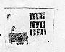. Let’s make __________________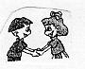.

十一、阅读短文，判断对错，对的打“√”，错的打“ × ”。（10%）

Hello! This is the photo of my family. It’s on the wall. Look! This is my grandpa and
grandma . They are farmers. My father is here. He’s a doctor. He’s strong. My mother
is a teacher. She’s thin. Oh, this is my sister. She’s quiet. She’s 10. She’s a good student.
Who is he? Guess! Yes, it’s me. I like music and books.
1. I am a girl. ( )

2. My father is tall and strong. ( )

3. My sister is a good teacher. ( )

4. I like reading books and listening to the music. ( )

5. There are 5 members in my family. ( )

