人教版小学英语第三册第一单元复习测试题

- 选出你听到的。（18分）
(1) box fox frog (2) rose nose no (3) peacock peach pig
(4) fruit flower face (5) vase vest violin (6) cake snake apple
(7) low slow go (8) kite nine right (9) d b e
二、根据句子选择正确的图片。（8分）
1、    
2、  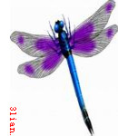  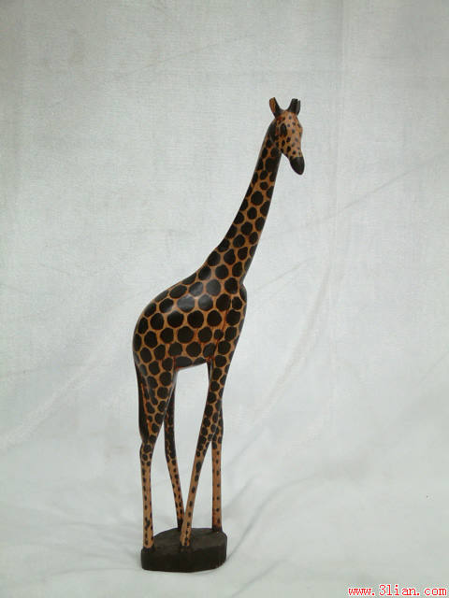
3、 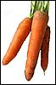 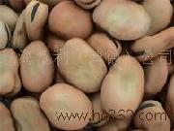 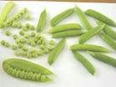 
4、 
三、根据你听到的连线。（16分）
Mr. Yang America sunflowers
Mrs. Wu Australia lilies
Miss Green France roses
Mr. Brown Canada carnations
四、听短文后判断。（正确的打“T”，错误的打“F”。）（10分）
- The people is a girl . ( )
- She is from Macao . ( )
- She likes carnations . ( )
- She doesn’t like panda . ( )
- Panda is very fat . ( )
五、选择。（12分）
1、This is orange . A. a B. an C. some
2、What are . They are rose . A. this B. these C. those
3、What is . It’s a football . A. this B. these C. those
4、I coffee . A. am B. like C. likes
5、He butterfly . A. is B. like C. likes
6、A: I don’t like litchis . B:
A. Yes I am . B. Not . I like it . C. Me too .
六、把方框内的单词或句子的正确填入下列的对话中。(16分)
ant that is Yes , I do . You’re welcome Nice to meet you too . My name’s Li Lei . Thank you !
A: Hi ! What’s your name , please ?
B:
A: Hollow , Li Lei . I’m Lucy . How nice to meet you !
B:
A: Li Lei , look ! What this ?
B: This is an .
A: What’s ?
B: That is a dragonfly .
A: Do you like dragonfly ?
B:
A: I have some comfits . Here you are .
B:
A：
七、照例子连线并任意选择其中两个单词各写一句话。（20分）
short big good stand low yucky

bad sit long yummy slow high small

