全国小学生英语竞赛(NECPS)四年级组竞赛样题
(时间:60分钟 总分:100分)
听力部分(共四大题,计40分)
I. 听辨单词(Words)(共10小题,计10分)
A) 听音,选出你听到的单词所代表的图片。每个单词读两遍。(答案涂在答题纸上)
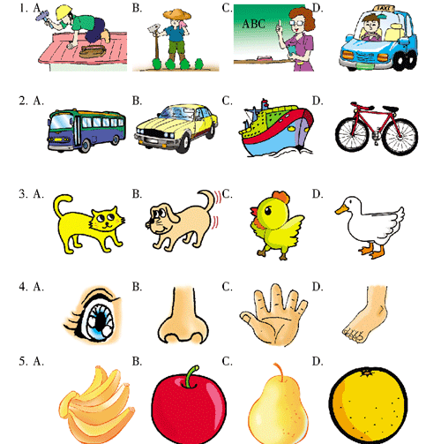
B) 听音,选出你所听到的单词。每个单词读两遍。(答案涂在答题纸上)
6. A. red B. read C. egg D. bag
7. A. camp B. jump C. jeep D. climb
8. A. hair B. ear C. chair D. hear
9. A. five B. have C. fine D. fun
10. A. bee B. me C. my D. he
II. 句子理解(Sentences)(共10小题,计10分)
A) 听音,选出你所听到句子中涉及到的单词。每个句子读两遍。(答案涂在答题纸上)
11. A. pencil B. book C. ruler D. eraser
12. A. for B. to C. fox D. too
13. A. box B. nest C. best D. next
14. A. kite B. sky C. ski D. skate
15. A. cap B. shoes C. dress D. tie
B) 听音,判断所给图片与所听句子是(Y)否(N)相符。每个句子读两遍。(答案涂在答题纸上)
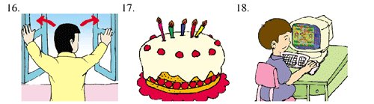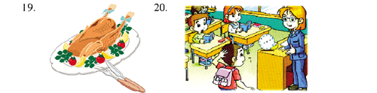
III. 对话理解(Dialogues) (共10小题,计10分)
A) 听音,看图,选择与所听内容相符的图片。每组对话读两遍。(答案涂在答题纸上)
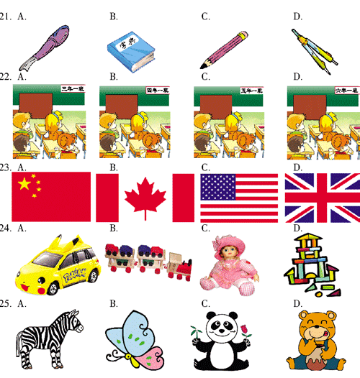
B) 听音,根据所听内容为相关的图片按英文字母(A, B, C, D, E)的顺序标号。每组对话读两遍。(答案写在答题纸上)
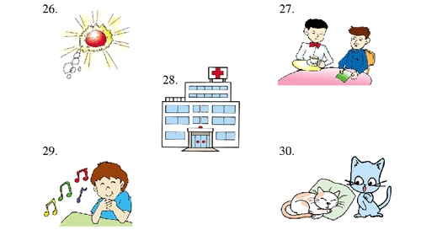
IV. 短文理解(Passages) (共10小题,计10分)
A) 听音,根据所听短文内容判断下列句子正(T)误(F)。短文读两遍。(答案涂在答题纸上)
31. David is nine years old.
32. He is short.
33. He has some milk and bread for his breakfast.
34. He goes to school on foot.
35. He is very happy today.
B) 听音,填单词,补全短文(每空一词)。短文读两遍。(答案写在答题纸上)
Mrs. White is a manager (经理). She is 35 years old. She has a 36 car. It is 37 . She likes it very much. On weekends she often drives her car to the seaside.
One day, she drives very fast 38 the street. After five minutes, a policeman comes. He says, “Sorry, madam. You must give me 20 dollars because you are driving 39 fast.”
“Oh, I’m sorry. I don’t want to drive so fast. But I have just washed my hair. It’s very 40 . I want to make it dry.”
笔试部分(共六大题,计60分)
I. 单词(Words) (共10 小题,计10分)
A) 按要求完成下列各题。(答案写在答题纸上)
1. tall ________ (反义词)
2. have ________ (变换一个字母变成动物名词)
3. one ________ (序数词)
4. listen ________ (现在分词形式)
5. play the ________ (弹钢琴)
B) 根据所给句子及首字母提示完成下列单词。(答案写在答题纸上)
6. You can use my umbrella. Here you a________.
7. It’s very k________ of you.
8. The sun is shining in the s________.
9. It’s cloudy. It’s going to r________.
10. The classroom is dirty. Who’s on duty t________?
II. 句子(Sentences) (共10 小题,计10分)
A) 从A,B,C,D四个选项中选择最佳的一项完成下列句子。(答案涂在答题纸上)
11. What’s ________ the picture?
A. in B. off C. at D. up
12. The box is too heavy. Please let ________ help you.
A. I B. my C. me D. mine
13. Who’s that boy ________?
A. in green B. in the green C. in a green D. with green
14. Look!Andy is ________ a kite on the playground.
A. fly B. flies C. flying D. to fly
15. ________ fine the weather is!
A. How B. What C. It’s D. Its
B) 按要求完成下列各题。(答案写在答题纸上)
16. Susan cleans the classroom every day. (对划线部分提问)
________________________________________________
17. I go to school by bus. (对划线部分提问)
________________________________________________
18. Do you have a cap? (作否定回答)
________________________________________________
19. is, an, Australian, she, girl (.) (连词成句)
________________________________________________
20. She can speak English. (变成一般疑问句)
________________________________________________
III. 情景会话(Dialogues) (共10 小题,计10分)
A) 根据所给的情景,选择合适的句子完成下列各题。(答案涂在答题纸上)
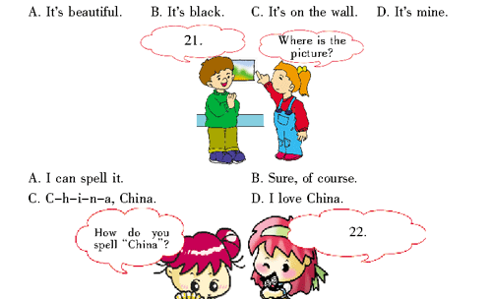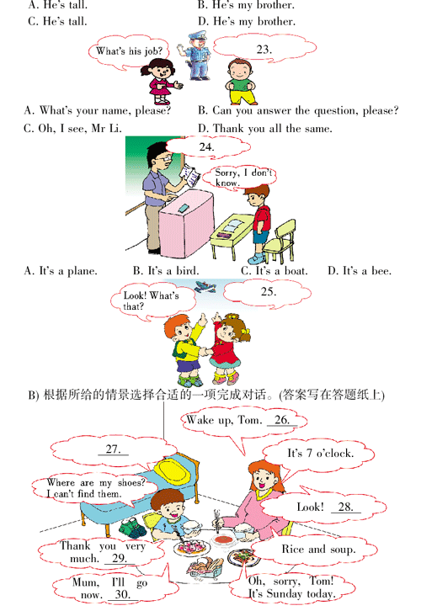
A. They are under your bed. B. Bye-bye! C. It’s late for school.
D. What are we having for breakfast? E. What time is it?
IV. 阅读理解(Reading comprehension) (共10 小题,计10分)
A) 阅读短文,根据短文内容填写单词,完成文后句子。(答案写在答题纸上)
Andy, Peter, Jack and Lucy are my good friends. We’re in the same class. We like different kinds of sports. Andy likes football, Peter likes basketball, Jack likes volleyball, Lucy likes tennis and I like ping-pong. Look!We are having a good time today.
31. I have ________ good friends.
32. We’re in the ________ class.
33. Andy likes ________.
34. ________ likes basketball.
35. We are ________ a good time today.
B) 阅读短文, 完成文后问题。 (答案写在答题纸上)
Everything is very cheap in a store today. The store opens at eight o’clock. It is seven in the morning, and many people are standing in front of the door. It is a long queue (队).
At seven fifty-five, a small man tries to push his way(挤) to the front of the queue. But he can’t. He tries many times but he still can’t go to the front. And everybody is angry with him. A strong man says, “If you try again, I will hit you.”
The small man says, “I just want to open the door for all of you.”
36. What time does the store open?
37. Are there many people in front of the store at seven o’clock?
38. Who tries to push his way to the front of the queue?
39. Is everyone angry with the small man?
40. What does the small man want to do?
V. 智力测试(IQ test)(共5 小题,计5分) (答案涂或写在答题纸上)
41. William is a manager in a company. He is a VIP. VIP是什么意思?
A. 高个子的人 B. 重要的人
42. I am an animal. I can climb the tree quickly. I like bananas very much. I am clever. My face looks like a man’s. What am I? I am a(n) ________.
43. Look at the pictures, please. Find the missing one. (看图,找出缺失的那一个。)
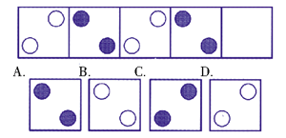
44. Look at the picture, please. A CAT SAT (坐) on the MAT (席子) and a BAT SAT on the CAT. What SAT on the BAT?
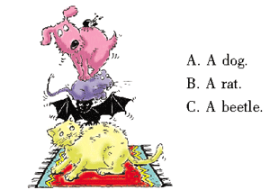
45. The duck is thinking about the following question. Please help it move a match and get the right answer. (小鸭子正在思考下面的问题,请帮它挪动一根火柴,得出正确答案。)
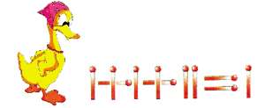
VI. 小作文(Composition) (共1小题,计15分)
提示:以“My Brother”为题写一篇小作文。
要求:1. 条理清楚,意思连贯,语句通顺,用词得当,语法正确,书写清晰、规范;
2. 不得少于45个单词;
3. 将作文写在答题纸上。

