小学英语四年级综合测试题
一、听力。(共20小题，每小题2分，计40分)
A、听单词。选出你所听到单词，将其序号填入到题前的括号内。每个单词读两遍。
( )1、A. mangoes B. lemons C. fruits
( )2、A. bus B. minibus C. train
( )3、A. hamburgers B. juice C. books
( )4、A. notice board B. blackboard C. cupboard
( )5、A .cup B. cap C. cat
B、听句子。下面你将听到五个句子，请选出与所听句子一致的选项，将其序号填入到题前括号内。每句读两遍。
( )1、The looks at the zebra in the zoo.
A. policeman B. woman C. postman
( )2、His socks , jackets and clock are .
A. white B. green C. black
( )3、Here’s some for Gao Shan.
A. water B. tea C. milk
( )4、The English teacher’s watch is on the .
A. desk B. wall C. table
( )5、The violin is near the .
A. piano B. window C. photo
C、听句子。下面你将听到五个句子，请你判断所听句子与所给图的内容是否一致，一致的在图下括号内写“T”，不一致的则写“F”。每句读两遍。
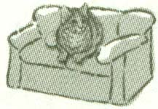
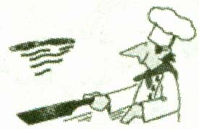
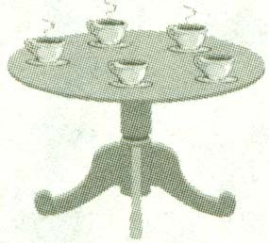
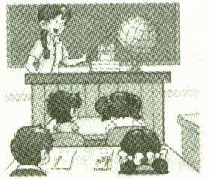
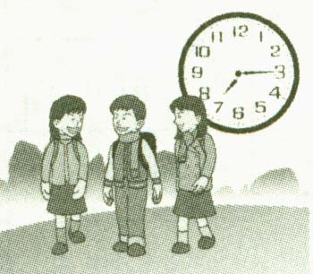
1、 2、 3、 4、 5、

( ) ( ) ( ) ( ) ( )
D、听对话。下面你将听到五小段对话，请根据录音中的顺序给每幅图编号，将其序号填在图下面括号内。每段对话读两遍。
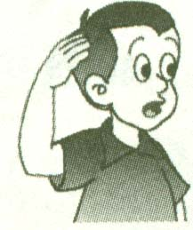
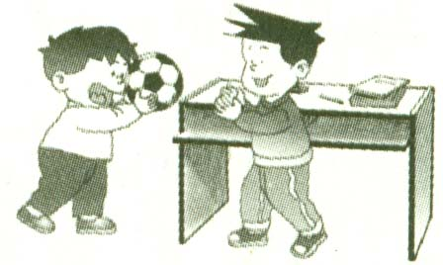
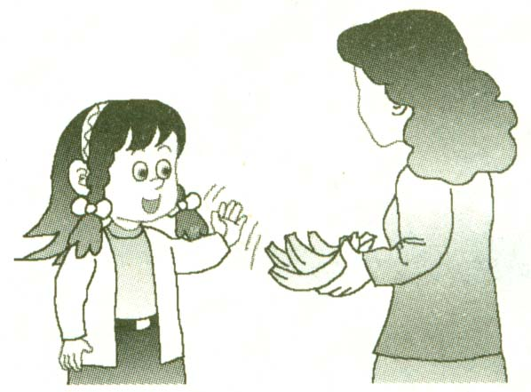
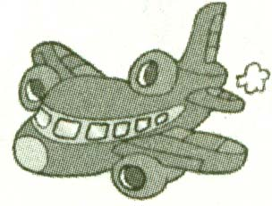
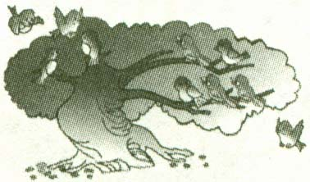
a b c d e

( ) ( ) ( ) ( ) ( )
二、词汇。(共10小题，每题2分，计20分)
A、将下列中文翻译成英语。
一只苹果 一张大嘴巴 我的朋友
步行 乘出租车
B、将下列英语翻译成中文。
a tape recorder an ice-cream
at a party a carton of milk
watch TV
三、单项填空。(共15小题，每小题1分，计15分)
从A、B、C三个选项中选出一个最佳答案，将其序号填入题前的括号内。
( )1、－Welcome to our classroom !
－ .
A. Your classroom is big B. Your classroom is bright
C. Thank you
( )2、－Get up , Helen !
－ .
A .All right B. Thank you C. Great
( )3、－ . Is this bus for Yancheng ?
－No, it isn’t . It’s for Xuzhou .
A. Hi B. Excuse me C. Sorry
( )4、－Shall we play football ?
－ .
A. Yes , sir B. Good idea C. Me , too
( )5、－I’m thirsty . I’d like some .
A. sandwiches B. noodles C. water
( )6、－It’s 7:00 in the morning . It’s time to .
A. have lunch B. go to bed C. go to school
( )7、－ is this dress ?
－Sixty yuan .
A .How much B. What color C. Whose
( )8、－I go to Lianhua Supermarket .
A .by a bike B. by the bike C. by bike
( )9、－What’s breakfast ?
－Milk and bread .
A. on B. for C. in
( )10、We can see lots of books in the .
A. library B. station C. theatre
( )11、Look , there is a nice bird the tree .
A. on B. in C. at
( )12、There some songbooks and a guitar in the music room.
A. am B. is C. are
( )13、－What do you want to be ?
－I want to be a .
A. girl B. boy C. policeman
( )14、The man over there is teacher .
A .our B. you C. they
( )15、Harry· Potty (哈利·波特)is English boy .
A. a B. an B. the
四、用所给的词和标点符号连词成句。(共5小题，每小题3分，计15分)
1、watermelons like I’d some (.)

2、at woman that look (.)

3、be again late don’t (.)

4、airport go you to do how the (?)

5、coffee no in there cup is the (.)

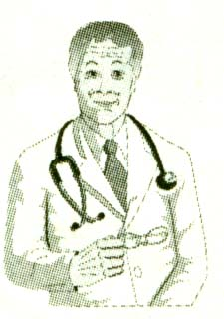
五、看图完成对话。(计10个空格，每格限填一词，每格1分，计10分)
1、－What’s his ?
－He’s a .
图一
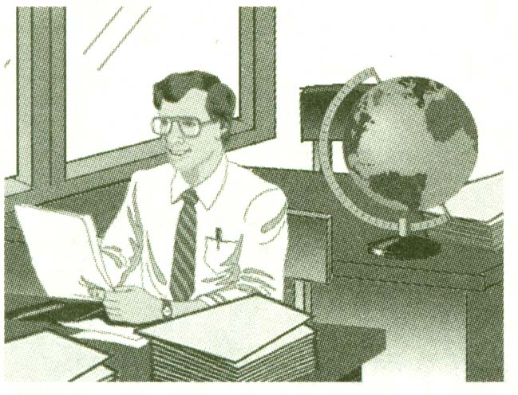
2、－ is Mr Zhang ?
－He’s in the .
图二
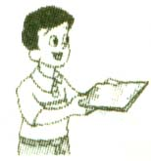
3、－Who’s that boy a T-shirt ?
－He’s my , Wang Bing .

4、Look at the , please .
图三
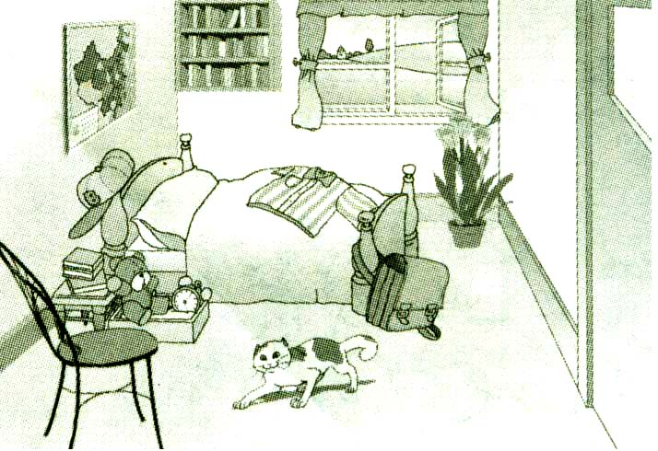
There is a near the window
and there are lots of books on it .
There is a Chinese map the wall.
The cat is near the .
图四

