新标准小学英语第二册期末检测题
听力（50%）略

笔试（50%）
六、迷路的小写字母们正在寻找到他们的大写字母妈妈们。请你通过连线帮助他们找到自己的妈妈。
D M E T Y
d t m e y
七、请你帮助Sam把这些单词进行归类。

apple T-shirt teddy bear jigsaw mango coat pear dress toy car banana
Fruit: __________ ___________ ___________ ____________
Clothes: __________ ____________ ____________
Toy: ___________ ____________ _____________

八、你需要为学校俱乐部制作张贴画，下面的图与句子能帮助你完成张贴画的制作。请你根据图片，将句子补充完整。
1．The girl _____ dancing. 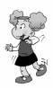
A. is B. are C. am
2． She _______a book. 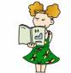
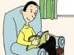
A. read B. is reading C. reads
3． They _______ singing. 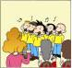
A. are B. is C. am
4． They are __________. 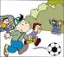
A. play football B. playing basketball C. playing football
5． We _______ learning English. 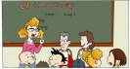
A. am B. are C. is

九、Daming爱照相，请你帮他圈出恰当的图片说明。
1.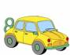 A. It’s my toy car.
B. It’s my toy ship.

2.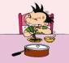 A. I have breakfast at half past seven.
B. I go to school at half past seven.
3.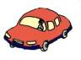A. My mother goes to work by bike.
B. My mother goes to work by car.
4.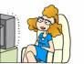 A. I play football at the weekend.
B. I watch TV at the weekend.
5. A. My father is reading a book.
B. My father is riding a bike.

十、请你帮助Amy把打乱顺序的句子重新排列。

1. don’t, I , milk, like
_________________________________.
2. the, time, What’s
_________________________________？
3. am, I, writing, letter, a
_________________________________.
4. five, nine, Four, is, and
_________________________________.
5. Where’s, please, the, school
_________________________________?

