小学英语四年级英语(下)期末学力评价参考试卷
（一）听力部分(50分) 略
（二）读写部分（50分）


五．看图片，将单词补充完整。12%
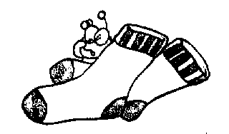

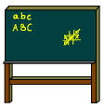

s __ nny __ oar__ so__ __ s __ __ __ ture






m __ th __ __ enty w__ __ m j __ __ s六．根据句子的意思，选出正确的答案，并将答案写在括号中。9%
1．Let’s go to the _______, have some chicken.
A: TV room B: canteen C: art room
2. Can I wear my _____ today? Yes, you can. It’s very hot.
A:T-shirt B: jacket C: sweater
3. It’s ________ today. Let’s make a snowman.
A: sunny B: snowy C: cloudy
4. Look at the pants. They are 10 yuan. They are ________。
A: cheap B: pretty C: expensive
5. I don’t like ______. They are smelly and white.
A: tomatoes B: potatoes C: onions
6. Put your Chinese book in your bag. We have the ________ today!
A: English class B: music class C: Chinese class
七．读句子，连线。9%
What time is it? No，they aren’t
Is this the washroom? It’s 99 yuan.
How much is it? It’s sunny.
What’s the weather like today? I have 100.
Are they cows？ Yes, it is.
How many donkeys do you have? It’s 10 A.M.
八．用书写体抄写下列句子。5%

It’s 8:30. It’s time for English class.

What color is it? It’s white.

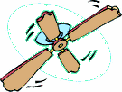
九、看图片完成句子。9%

1．I can see a and a in the room.




2. It’s o’clock. It’s time for class.



3. Oh, the ball is so .




4. I like s and s. They are yummy!

十、根据短文判断下面的句子是否正确，对的打√ ,错的打 。6%

Dear Jack,
It’s hot in London. I wear my yellow T-shirt and pretty white skirt. It’s sunny today. I go to the farm with my mother. The farm is beautiful. There are twelve cows, fifteen hens, eleven sheep and thirteen lambs at the farm.
How about you?
Love,
Jenny

- It’s sunny and hot in London. ( )
- Jenny wears a white T-shirt. ( )
- Jenny’s skirt is pretty. ( )
- There are fourteen hens and eleven sheep at the farm. ( )

