四年级下册英语Recycle 1质量评估题

学校__________ 班级_______ 姓名_____________ 得分_______

Listening Part（听力部分）50分略
Writing Part（笔试部分）50分

- Read and choose.（读一读，选出不属于同一类的一项）10分
( ) (1) A. gym B. computer room C. board
( ) (2) A. bread B. dinner C. lunch
( ) (3) A. nine B. fine C. five
( ) (4) A. pants B. shoes C. short
( ) (5) A. small B. yellow C. green

- Look and write.（看图，写单词）10分
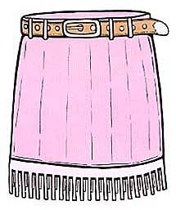
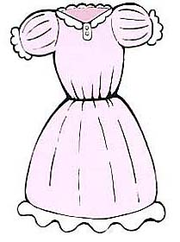
(1) (2)

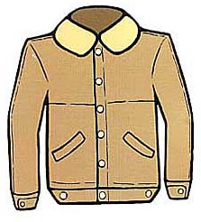
(3)

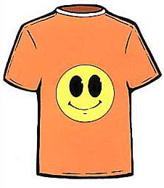
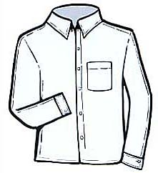
(4) (5)

- Read and match.（读一读，连线）10分
(1) Where is the art room? They are brown.
(2) What time is it? No, it isn’t.
(3) What colour are your jeans? It’s on the second floor.
(4) Is this your jacket? These are your baby pants.
(5) What are they? It’s eleven o’clock.

- Read and arrange.（读一读，连词成句）10分
(1) at look clock my

(2) are red my socks

(3) blue the sweater I like

(4) time for breakfast it is

(5) go to art room let’s the

- Read and judge.（读短文，判断正误，用“T”或“F”表示）10分
Dear Grandma,
How are you? Thank you for the new shirt. It’s beautiful. I like it. Now I am writing（写） at the new school. This is a nice school. The trees are green, the flowers are red and yellow. We have a music room, an art room, a computer room, a canteen and a library. The playground is so big. We can play football there.
Oh, it’s time to go home now. Let me stop here. Welcome to my school and welcome to my home.
( ) (1) John is writing to his mother.
( ) (2) John has a new jacket.
( ) (3) John’s school is nice.
( ) (4) The playground is big.
( ) (5) They can play football on the playground.

附：听力材料及参考答案
（一）听力材料
1．(1) What time is it? It’s seven o’clock.
(2) What time is it now? It’s ten o’clock.
(3) It’s twelve o’clock. It’s time for lunch.
(4) It’s 3:30. Let’s play football.
(5) It’s 4:20. It’s time to go home.
2. (1) A. bag B. cake C. cat
(2) A. face B. snake C. apple
(3) A. egg B. he C. she
(4) A. bed B. me C. desk
(5) A. bike B. kite C. milk
3. (1) Where is Mike? He is in the library.
(2) Where is Sarah? She is in the canteen.
(3) Where is Amy? She is in the garden.
(4) Hi, John! Let’s go to the playground.
(5) Zhang Peng, go to the teacher’s office, please.
4. (1) It’s 8:30. It’s time for music class.
(2) It’s 9:45. It’s time for math class.
(3) It’s 2:50. It’s time for Chinese class.
(4) It’s 11:05. It’s time for English class.
(5) It’s 3:50. It’s time for P.E. class.
5. -We have a show today.
-What show?
-A fashion show.
- Where is the show?
-On the playground.
- What time?
-At three o’clock.
- What time is it now?
-It’s two forty.
-Let’s go to the playground.

（二）参考答案
听力部分
1. (1) seven o’clock (2) ten o’clock (3) twelve o’clock (4) 3:30 (5) 4:20
2. (1) B (2) C (3) A (4) B (5) C
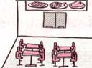
3.
(1) Mike

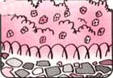
- Sarah

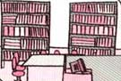
- Amy

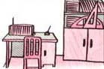
- John

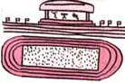
- Zhang Peng

4. (1) music (2) math (3) Chinese (4) English (5) P.E.
5. 6-4-2-8-1 3-5-7-9-10
笔试部分
1. (1) C (2) A (3) B (4) C (5) A
2. (1) skirt (2) dress (3) jacket (4) T-shirt (5) shirt
3. (1) Where is the art room? They are brown.
(2) What time is it? No, it isn’t.
(3) What colour are your jeans? It’s on the second floor.
(4) Is this your jacket? These are your baby pants.
(5) What are they? It’s eleven o’clock.
4. (1) Look at my clock.
(2) My socks are red.
(3) I like the blue sweater.
(4) It is time for breakfast.
(5) Let’s go to the art room.
5. (1) F (2) F (3) T (4) T (5) T

