人教版小学四年级英语上册第五单元检测题.
听力部分（30分）
- 单词辨音，每个单词读三遍。（10分）
( ) 1、 A、 rice B、 fish C、 pass
( ) 2、 A、 bread B、 food C、 noodles
( ) 3、 A、 for B、 fork C、 food
( ) 4、 A、 beef B、 knife C、 chicken
( ) 5、 A、 soup B、 spoon C、 show
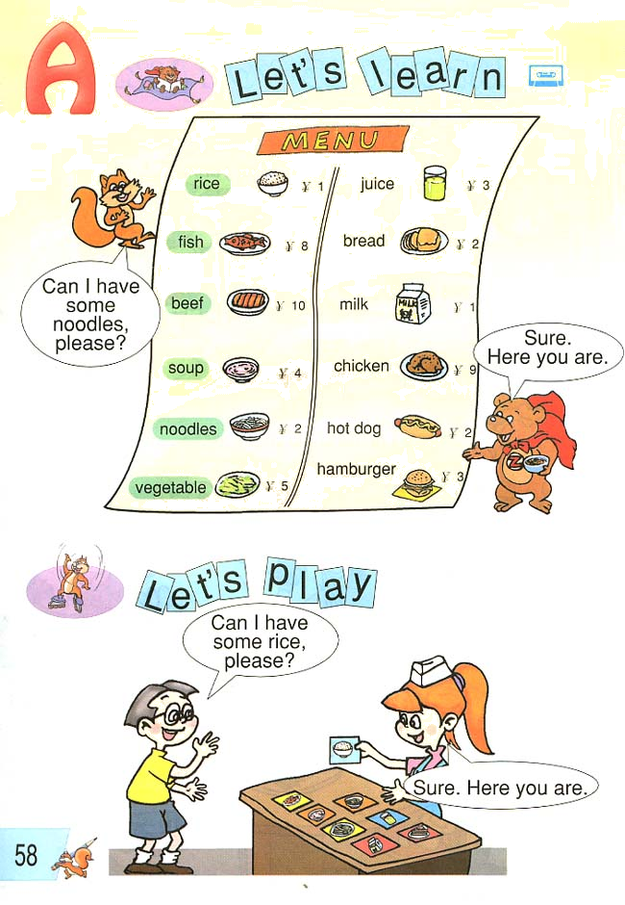
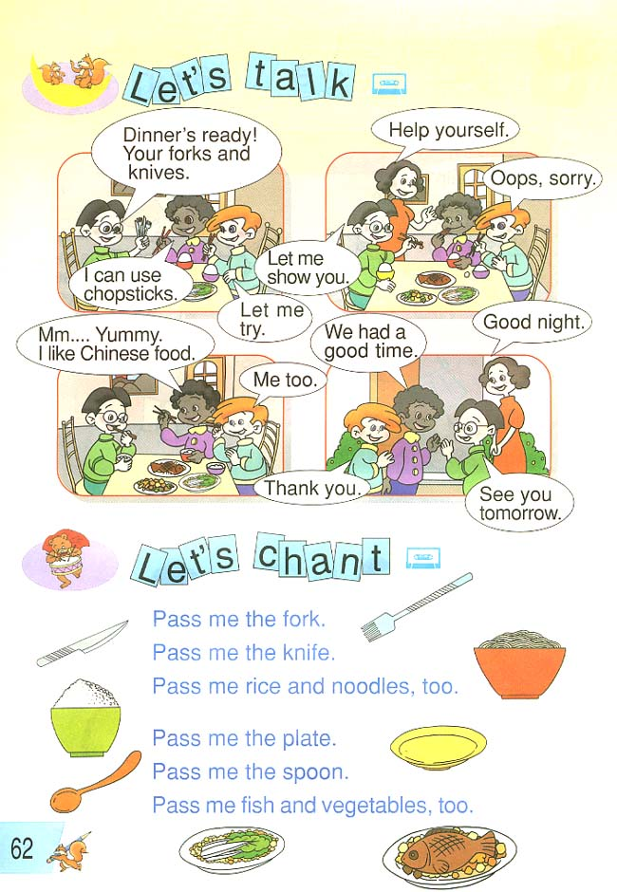
- 听一听，为下面图片排列顺序，每个句子读三遍。（10分）

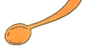
1、（ ） 2、（ ）

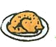
3、（ ）
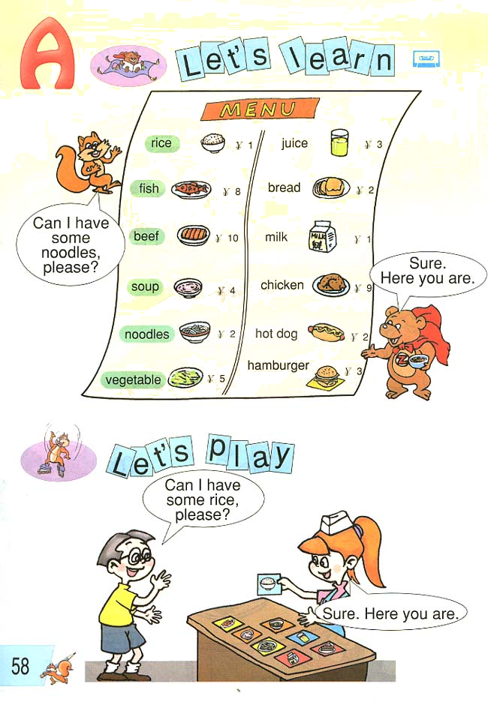

4、（ ） 5、（ ）
三、听一听，与听到的内容相同打对号√，不同打错号×，每个句子读三遍。（10分）
（ ）1、I’d like some vegetables and soup.
（ ）2、I can use chopsticks now.
（ ）3、Pass me a plate, please.
（ ）4、What would you like for dinner?
（ ）5、I like Chinese food, too.
笔试部分（70分）
- 根据图片把下列单词补充完整。（16分）
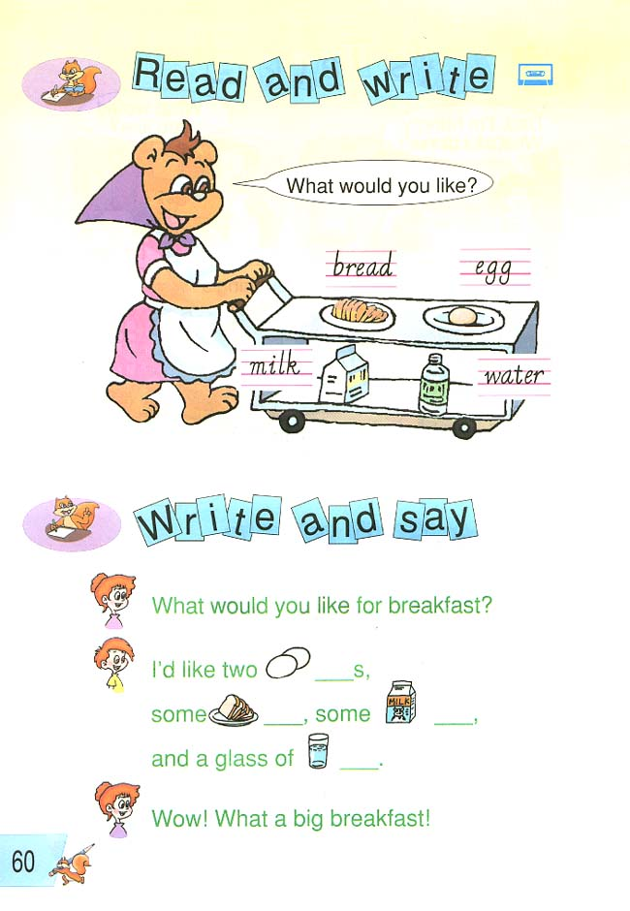
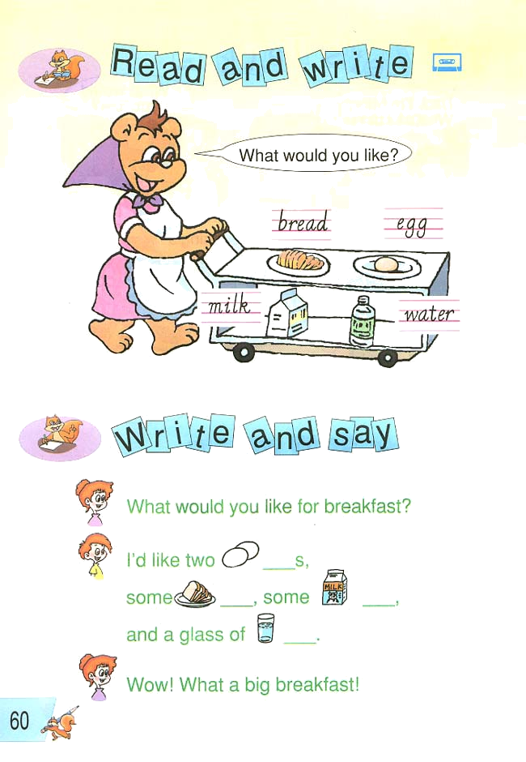

1、br__d 2、_gg 3、m_lk 4、w_t_r
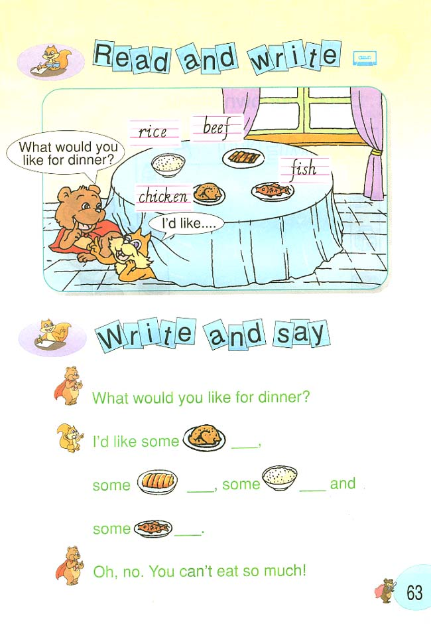

5、r_c_ 6、b__f 7、ch_ck_n 8、f_sh
- 单项选择题。（10分）
（ ）1、What would you like?
A、I’d like some beef. B、Let me try. C、Help yourself.
（ ）2、How much?
A、Here’s a fish. B、Great. C、Five yuan.
（ ）3、Can I have some rice, please?
A、Thanks. B、Sure. C、Let me try.
（ ）4、Mom, can I help?
A、Yes. Pass me a fork. B、Me too. C、I’d like an egg.
（ ）5、See you tomorrow.
A、Thank you. B、Good night. C、See you.
- 认真看一看，为下面单词选择相应的汉语。（20分）
A、蔬菜 B、筷子 C、叉子 D、面条 E、汤
F、谢谢你 G、饥饿的 H、 刀 I、盘子 J、勺子
1、( ) hungry 2、( ) thank you 3、( ) fork
4、( ) soup 5、( ) chopsticks 6、( ) knife
7、( ) vegetable 8、( ) plate 9、( ) noodles
10、 ( )spoon
- 认真读一读，为下面的句子选择相应的答语。（14分）
（ ）1、What would you like for dinner?
（ ）2、Can I have some noodles, please?
（ ）3、I like Chinese food.
（ ）4、Is this your bedroom?
（ ）5、What can you see in my room?
（ ）6、How much?
（ ）7、Where are the keys?
A、They’re in the door.
B、Yes, it is.
C、I’d like an egg, some milk and a hamburger.
D、Six yuan.
E、Sure. Here you are.
F、Me too.
G、I can see a chair and a desk.
- 阅读理解,根据对话内容判断正误（√或×）。（10分）
Mike: Mom, I’m hunger. What’s for dinner?
Mom: Wait and see. What would you like?
Mike: I’d like some noodles, some beef, some fish and soup.
Mom: What would you like for dinner, Amy?
Amy: I’d like some fish and vegetables, please.
Mom: What would you like, dear?
Dad: I’d like some noodles and some fish.
Mom: Everything’s ready.
Amy: Thank you, Mom.
Mike: Great!
Dad: Thanks.
（ ）1、Mom: What would you like?
Mike: I’d like some noodles and some vegetables.
（ ）2、Mom: What would you like?
Amy: I’d like some fish and vegetables.
（ ）3、Mom: What would you like?
Dad: I’d like some rice and some fish.
（ ）4、Mom: Everything’s ready.
Mike: Great.
（ ）5、There are five people in Mike’s family.

听力答案
fish, bread, food, knife, spoon.
二、1、I’d like some chicken.
2、Give me a plate.
3、I’d like some rice.
4、I’d like some beef.
5、Give me a spoon.
三、1、I’d like some vegetables and water.
2、I can use chopsticks now.
3、Pass me a knife, please.
4、What would you like for breakfast?
5、I like Chinese food, too.
笔试部分答案
略
二、A C B A C
三、G F C E B H A I D J
四、C E F B G D A
五、× √ × √ ×

