2009年小学四年级英语上册期中试卷

听力部分（60分）
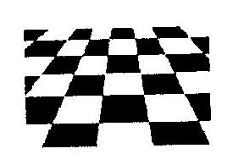
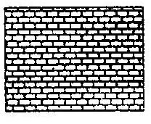
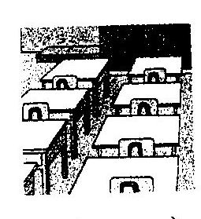


- Listen and circle.根据你所听到的录音内容，将下列每组中符合录音内容的图片下面的字母画一圆圈圈住。（10分）
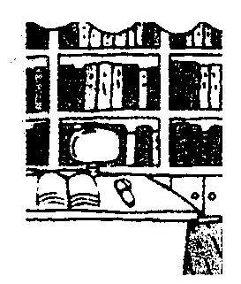
1. 2. 3.

A B A B A B

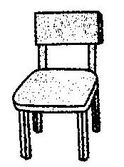
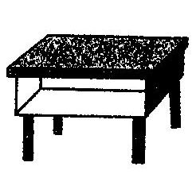
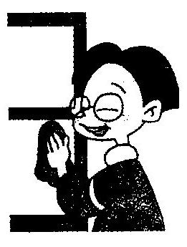
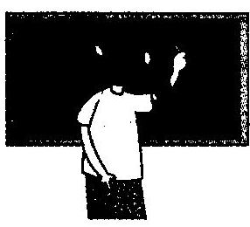
4. 5.

、

A B A B
- Listen and judge. 根据你所听到的录音内容，判断下面的图片是否与录音内容相符，相符的请打“√”，不相符请打“×”。（10分）
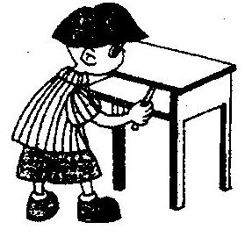
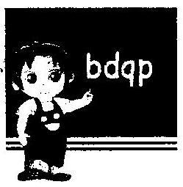
1. 2.

（ ） （ ）

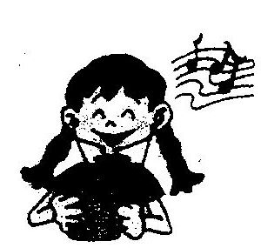
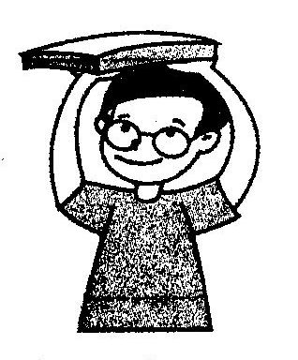

3. 4. 5.

（ ） （ ） ( )

- 下列图画标上正确的序号。（10分）
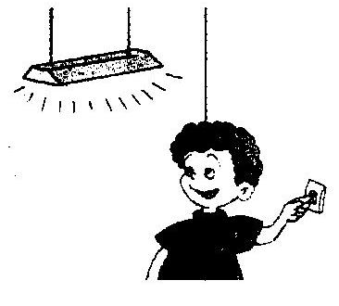

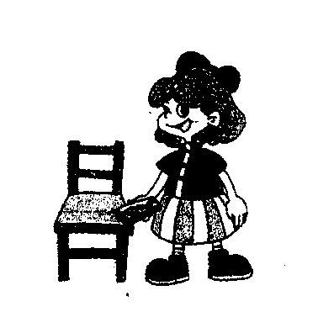
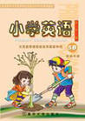
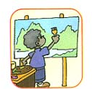

（ ） （ ） （ ） （ ） （ ）
- Listen and tick.根据录音内容，在表格相应的地方打“√”，勾出下列人物的外貌特征和爱好。（10分）
Name | thin | strong | quiet | long hair | short hair | music | English | sports | painting
Jack
Fangfang
- 听一听,写一写。根据录音中提到的数字或提出的问题,将答案用阿拉伯数字填在下面相应的括号里（10分）
1、（ ） 2、（ ） 3、（ ） 4、（ ） 5、（ ）
六、Listen and choose. 根据你所听到的句子，找出下列每题中正确的答句，并将其字母编号填在题前的括号内。（10分）
( ) 1. A. It’s on the book. B. It’s a desk. C. It’s near the window.
( ) 2. A. Thank you ！ B. All right! C. You are welcome!
( ) 3. A. A pen, a pencil and an eraser.
B. A board, 8 fans, 10 lights.
C. A Chinese book, a math book, 4 story-books.
( ) 4. A. My name’s John. B. His name’s John. C. Her name’s Amy.
( ) 5. A. Sorry, I don’t know. B. Thank you so much!
C. Sure, here you are.
笔试部分（40分）
七、填一填。根据所给的图片的提示，在四线格上写出适当的小写字母，将单词补充完整。（10分）
alkman nake amp ouse bo
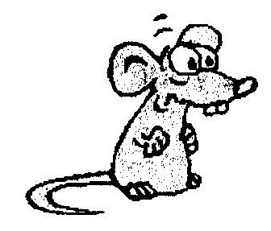
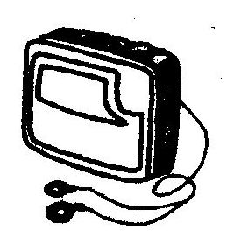
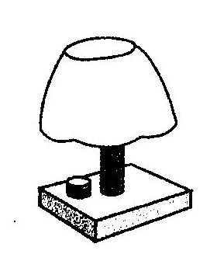
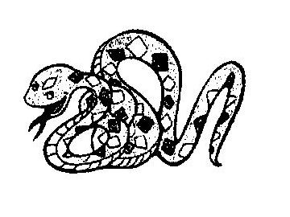
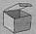

s oon win ow t ger s uirrel pen

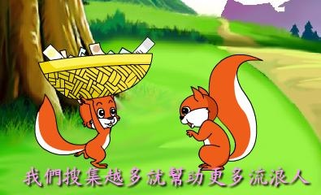
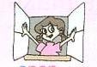
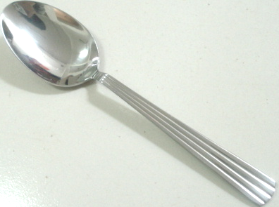
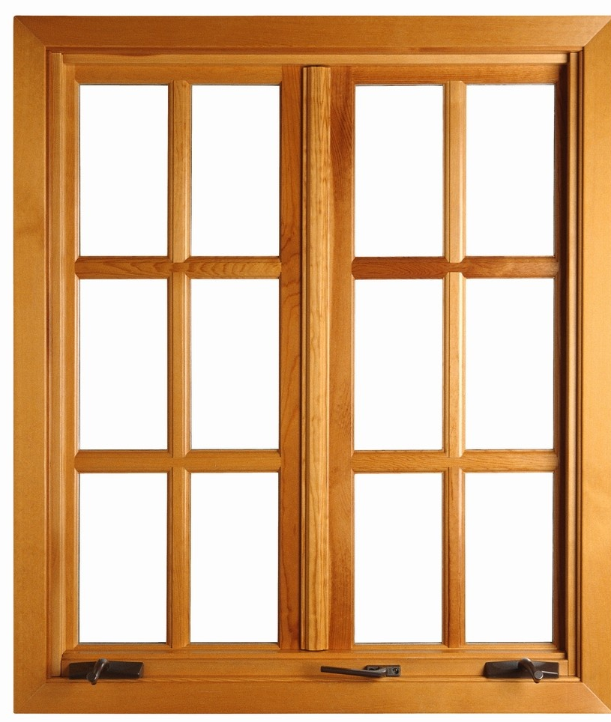

八、根据上下文和图画，填上句子所缺的单词，使句子完整。（10分）
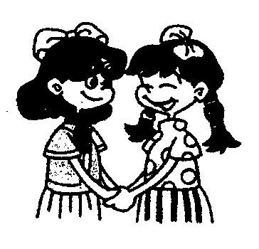
1. We are .
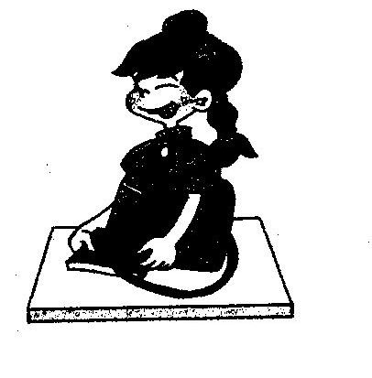
2. Chen Jie is a . She’s quiet.
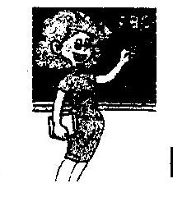
3. This is my English . Her name is Miss White.
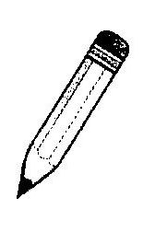
4. The is in the desk.
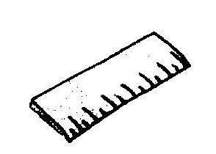
5. Look, I have a long .

九、读一读，选一选。根据上下文的意思，从方框内选择适当的句子，将正确句子的编号填在横线上。（10分）
John: Hello, Bai Ling. _______________________.
Bai Ling: Really? _________________?
John: Sure. Here you are.
Bai Ling: Wow! It is a squirrel. I like it.
John: Thank you! My bag is orange. _________________?
Bai Ling:It’s pink. My schoolbag is heavy.
A.What’s in it?
B.What colour is your schoolbag?
C.May I have a look?
D.How many story-books do you
have?
E.I have a new schoolbag
John: _________________?
Bai Ling: Look, I have many books.
John: ____________________?.
Bai Ling: One, two, three…, sorry, too many.
十、阅读理解。（10分）
Hello! I have a friend. She is tall and thin. She has big eyes and a small red mouth. She has long black hair. She is very beautiful. She is a good student. She likes music, science and sports. She likes beef, fish and rice for lunch. Who is she? Guess! That’s right! She is Susan.
根据上下文的意思，判断下列句子是否正确，正确的在题前的括号里打“√”，不正确的打“×”。
( ) 1.My friend is Susan.
( ) 2.She is short and thin.
( ) 3.She likes music and sports.
( ) 4. She likes beef , milk and rice for lunch.
( ) 5. Susan has small eyes and a big mouth.

