牛津小学英语4B期末复习卷
班级 姓名 得分
听力部分（30分）
- 选出你所听到的单词。（10分）
（ ） 1、 A. nose B. nurse C. not
（ ） 2、 A. which B. watch C. with
（ ） 3、 A. piano B. pear C. pie
（ ） 4、 A. chopsticks B. chocolate C. chips
（ ） 5、 A. our B. hair C. chair
- 听音，判断。（10分）
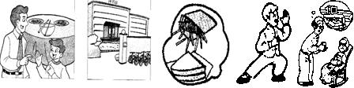
- 听问句，找出正确的应答。（10分）
( ) They’re in the cupboard.
( ) Forty-four yuan, please.
( ) By car.
( ) I’d like some noodles.
( )He’s an office worker.
笔试部分（70分）
- 看图，写出下列单词。（15分）

- 选择。将正确答案的序号填入题前括号内。（20分）
( )1．This is apple. It’s red apple.
A. a, a B. an ,a C. an, an
( )2. Who is the woman white hair?
A. of B. in C. with
( )3. your mother a policewoman?
A. am B. is c. are
( )4. Are you here? Yes, I am.
A. a cook B. cooks C. the cook
( )5. Excuse me, is this train Beijing?
A. to B. for C. on
( )6. Let’s go to the supermarket .
A. by foot B. on foot C. foot
( )7. What are those in the box? mangoes.
A. They’re B. It’s C. There are
( )8. is it? Thirty yuan, please.
A. How old B. How many C. How much
( )9. a knife and two pencils in the pencil case.
A. This is B. There are C. There is
( )10. Where the juice? In the fridge.
A. are B. is C. am
三、 读句子，选择正确的应答，写在前面的括号里。（10分）
( )1. Who’s the girl in yellow? A. By taxi.
( )2. How old are you? B. There are some songbooks.
( )3. What are their jobs? C. I’d like some sweets.
( )4. How many kilos? D. She’s my sister.
( )5. How do we go to the hospital? F. Some noodles.
( )6.What would you like ? G. Three kilos.
( )7. How much are they? H. They’re old workers.
( )8. What’s on the piano? I. They’re in the cupboard.
( )9. Where are the bowls? J. I’m fifteen.
( )10. What’s for breakfast? K. Twenty-eight yuan.
四、将下列单词重新排列成句。（10分）
1. are of lots books library in There the

2. have and Come dinner

3. a chopsticks you Here’s of pair for

4. we bus theatre Shall to the go by

5. with woman big Who’s that eyes

五、看图，完成下列对话。（15分）
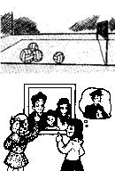
1. What’s in the ?
. some volleyballs .
2. Sandy, is that your father?
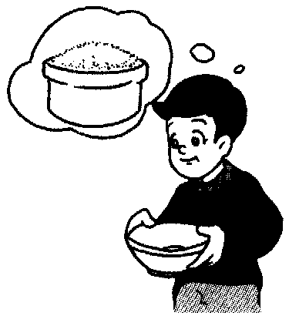
Yes, is.
. is ?
thirty
a , I think.
Yes, is.
3.There is in the .
牛津小学英语4B期末测试 听力材料
- 选出你所听到的单词。
1. nurse 2. which 3. picture 4. chopsticks 5. now
- 听音，判断。
  - Come and have dinner, Dad.
OK, but where are my chopsticks?
They’re near the bowl.
  - There are lots of cars near the library.
  - What would you like? Some chips and a cup of coffee.
  - Who’s that old woman? She’s my grandmother.
  - What’s the matter? I’m ill.
Shall we go to the hospital by bike? OK.
- 听问句，找出正确的应答，将序号填在题前的括号内。
- How do we go to the airport?
- Where are the plates?
- How much are they?
- What’s your uncle’s job?
- What would you like?

