Exercises for Unit 3
Name_________ Class_________ Mark_________
一、根据上下文意思，补充句子。
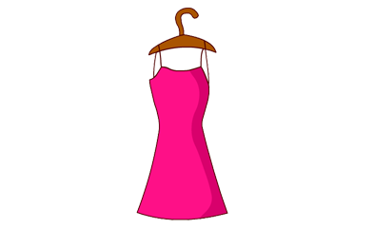
1. A: Is this your______?
B:_________________.
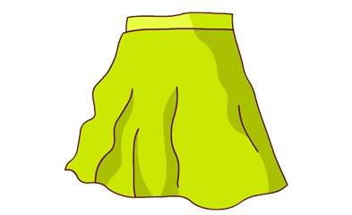
2.A: What ______is the______.
B: It is_______.(绿色的)
3. I like the_______(黄色的) _______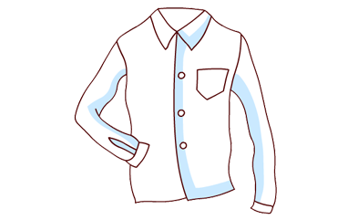with the
________(蓝色的)________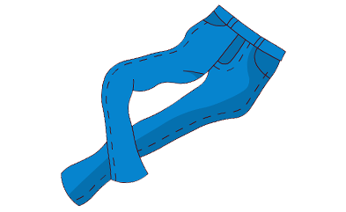。
4.A: What are they?
B: They are my_______(白色的)________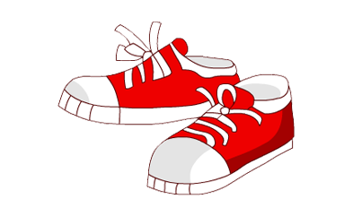and
__________（棕色的）_________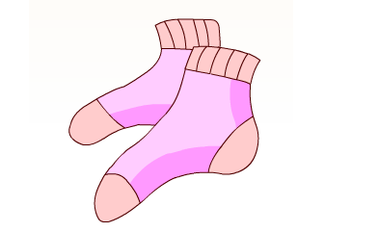.
5.Where are my brother’s_______(红色的)________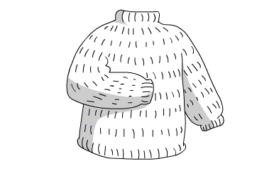 and______(棕色的)_______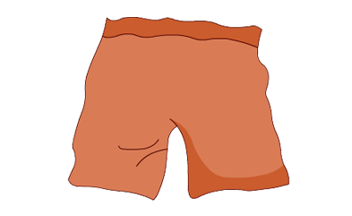.
6. Is this your________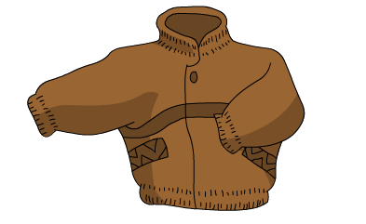?
No, ______ ________.
二、根据所给的图片书面回答所提的问题（答案需要完整）。

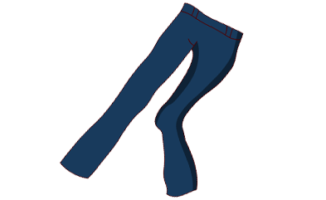
1.What are they?

2.What colour is the T-shirt?(黄色的)
3.Is this your jacket, Amy?
(John’s)
4.What colour are the socks?(黑色的)
5.Is this a dress?

三、选择填空。
（ ）1. Look! These_____my green socks.
A. is B. are C. have
( ) 2. _______is it? It’s orange.
A. What time B. What colour C. Whose
( ) 3. Is that your________?
A. shoes B. dresses C. jacket
( ) 4.I have a new skirt ____my birthday party.
A. on B. to C. for
( )5. Whose is the dress? It’s______
A. me B. Chen Jie’s C. she

四、补全对话：根据上下文的意思在下面对话的横线上填上适当的词，将对话补充完整。
(1) .A: ____________________________, Jack?
B: It’s 4:45.
A: Oh, it’s time____ my birthday party. Where is my dress?
B:_____________________________?
A: It’s blue and white.
B:_____ ______your dress?
A: _______________. Thank you.
(2). A: What ____these?
B: These are my pants.
A: Where are my shorts?
B: What_______are they?
A: ________black and white.
B: Look , they are _____the bed.

