2009学年第一学期四年级英语期中试卷 2009-11
姓名_______学号_______得分_______
Part I 听力部分40%
I. Listen and choose the words (选出你听到的单词，用A、B或C表示，将答案填在前面的括号) 6%
( ) 1. A. head B. hand C. read
( ) 2. A. Who’s B. Who C. Whose
( ) 3. A. His B. He’s C. He
( ) 4. A. sheep B. shoe C. ship
( ) 5. A. policeman B. postman C. policewoman
( ) 6. A. drive B. dive C. draw
II. Listen and choose the opposite words (圈出你听到的单词的反义词，用A、B或C表示,将答案填在前面的括号内) 4%
( )1. A. tall B. long C. big ( ) 2. A. black B. brave C. sad
( )3. A. hear B. here C. where ( ) 4. A. strong B. thirsty C. hungry
III. Listen and choose the sentences. (选出听到的句子，用A、B或C表示，将答案填在前面的括号内) 5%
( ) 1. A. Bill’s father is a policeman.
B. Bill’s mother is a policewoman.
C. Bill’s brother is a policeman.
( ) 2. A. Telephone one, one, nine. B. Telephone one, two, one.
C. Telephone one, two, zero.
( ) 3. A. Mike has a little sister. B. May has a little brother.
C. Mike has a little brother.
( ) 4. A. I can see my long brown ruler.
B. I can’t see my long brown rubber.
C. I can’t see my long blue ruler.
( ) 5. A. How do you feel? I’m tired. B. How do you feel? I’m tall.
C. How are you? I’m very well.
IV. Listen and choose the answers (选出正确的应答句，用A、 B或C表示，将答案填在前面的括号内) 5%
( ) 1. A. She likes flying. B. She can drive. C. I can swim.
( ) 2. A. It’s my kite. B. It’s Ben. C. It’s Ben’s.
( ) 3. A. A doctor． B. A fireman． C. A shop assistant.
( ) 4. A. He’s a policeman. B. She’s a nurse. C. Yes, she is.
( ) 5. A. He likes oranges. B. He likes orange. C. She likes orange.
V. Listen and write. ( 听录音，填入所缺单词) 10%
Look at the ________ over there. She is Eddie’s________. She has got a nice ___ . She rides her bicycle in the park. There is a small ___ on her bike. There are some _________ in her bag. She likes to sandwiches. But she ________ like eggs. Oh, ________ that? That’s Kitty. She has a ___ in her hand. Now she is flying it. She is ___ .
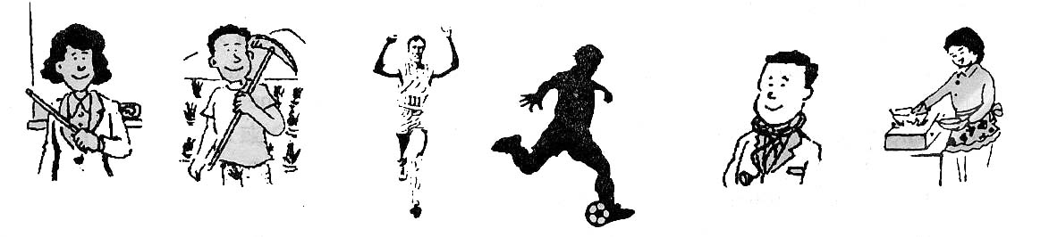
VI. Listen and choose (根据图片内容和你听到的句子，找出所描绘的人，用A，B或C表示,将答案填在前面的括号内) 5%

( ) 1. A. A teacher B. A pupil C. A player
( ) 2. A. A farmer B.A fisherman C. A fireman
( ) 3. A. A fireman B. A runner C. A dancer
( ) 4. A. A nurse B. A doctor C. A waiter
( ) 5. A. A waitress B. A cook C. postman
VII. Listen and judge（听对话做判断题，正确的用“T”表示，不正确的用“F”表示）5%
( ) 1. Eddie and Danny want to have a picnic in the City Park today.
( ) 2. Danny wants to buy some fruit and Eddie wants some food.
( ) 3. Now they are in the toy shop.
( ) 4. The oranges and apples are fifteen yuan.
( ) 5 The sweets and the biscuits are nine yuan.
Part II 笔试部分60%
I. Read and write（正确抄写下列句子，注意大小写和标点符号）7%
what has she got alice she has got some hamburgers mum

II. Read and judge（判断下列句子中两个单词的划线部分发音是否相同，相同的用“√”表示，不同的用“×”表示）5%
1. The girls like the yellow ice-cream and brown bread. ( )
2. There is a thin man near our garden. ( )
3. The clock is in the classroom. ( )
4. Ming likes milk. But Sam doesn’t. ( )
5. Have farm animals got sharp teeth? ( )
III. Read and write（用单词的适当形式填空）10%
1. Look at _________ (this) young women. They are _________ (postwoman).
2. The fat man ________ (have) some ________ (sheep) on his farm.
3. My uncle can __________ (dive). He is a _________ (dive).
4. I ________ (be) a new pupil. _________ (I) name is Lily.
5. There ________ (be) some_________（fly）around the cake.
IV. Read and choose（选择填空）10%
( ) 1. _______ do you feel? I am hungry. I want some biscuits.
A. What B. How C. Whose
( ) 2. Where is Alice? She’s ____ the swing.
A. in B. on C. under
( ) 3. I have ____ exercise book in my hand.
A. a B. an C. the
( ) 4. Do you like _________?
A. a apple B. apple C. apples
( ) 5. ________ is a sketch-book? Twenty yuan.
A. How many B. How much C. How old
( ) 6. _________ sandwiches have you got?
A. How many B. How much C. How
( ) 7. The cat _________ like dogs.
A. doesn’t B. don’t C. not
( ) 8. I am tired. I _______ play football now.
A. can B. can’t C. like
( ) 9. The cat is _______ the chair. I can’t sit there.
A. in B. on C. under
( )10. Whose balloons are those？ _______Alice’s balloons.
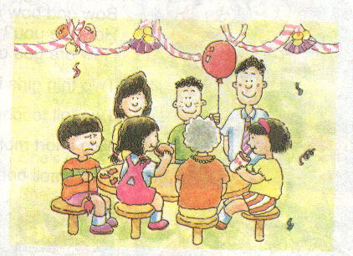
A. Their B. They C. They’re
V. Complete the sentences. (看图完成下列句子) 7%
1. Alice, Peter, Kitty and Eddie are classmates.
They’re ( Ben ) pupils.
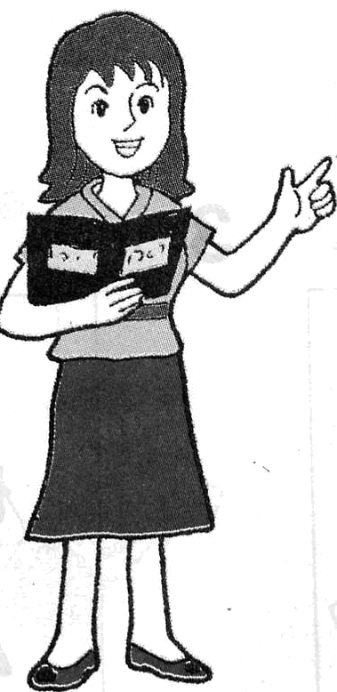
2. This is Mrs Wang .
She ( have )a book in her hand.
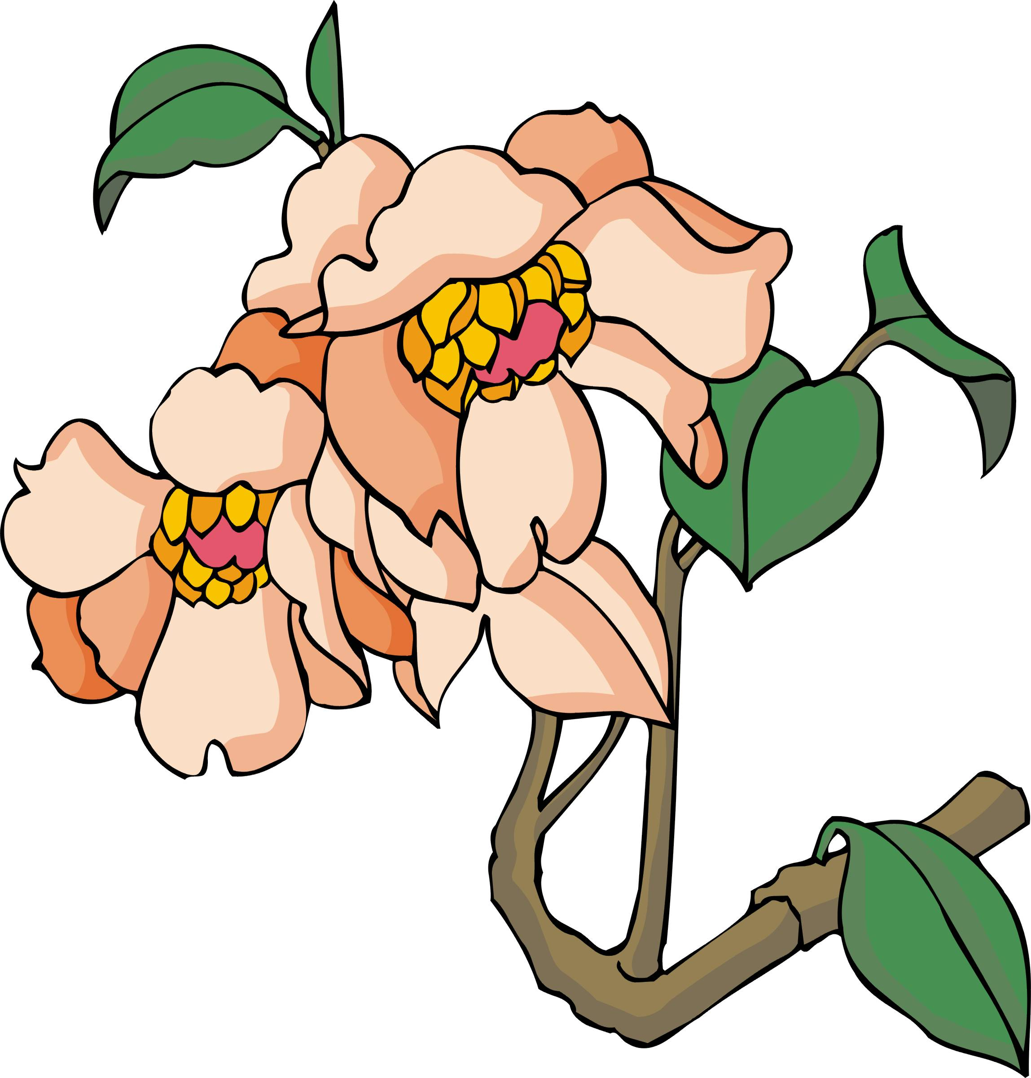
3. Are those ( flower ) ?

Yes, they are.


4. This is Bobby. He can _________ ( cook ).
But he can’t (dance).

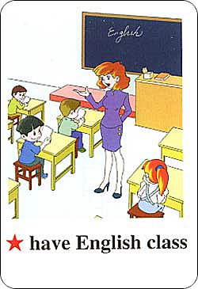
5. Where ( be ) the boys ?
They ( be ) in the classroom.
VI. Rewrite the sentences. (按要求改变下列句子) 6%
1. My name is Kally. （对划线部分提问）
is your name?
2. I’m on the playground. （一般疑问句 ）
Are on the playground?
3. The boys like dogs. （否定句）
The boys ___ dogs.
4. What is your brother? （换一句，意思不变）
What your brother ?
5. That’s Kitty’s skateboard. （对划线部分提问）
skateboard is that?
6. This is Jim. His eyes are big. （合一句）
Jim big eyes.
VII. Reading comprehension（阅读理解）10%
A. Read and choose. (阅读并选出最合适的答案) 5%
Bob, Henry and Jim are in the park. They can see spiders, bees, rabbits and a spaceship. The bees are yellow and brown. The spiders are black. The rabbits are white. The spaceship is blue. They can see some flowers and some trees, too. Some flowers are red, some are purple and violet（紫罗兰）. The trees are brown. They are all tall. Their leaves are green.
( ) 1. Bob is in the _______________.
A. spaceship B. park C. zoo
( ) 2. They can see_________ .
A. spiders, bees, rabbits and a spaceship.
B. some trees, some flowers, spiders, bees, rabbits and a spaceship.
C. Some bees, spiders, flowers and trees.
( ) 3. The spiders are_________. The spaceship is _________.
A. small, big B. blue, black C. black, blue
( ) 4. The trees are _______.
A. brown and tall B. green and big C. tall and big.
( ) 5. The flowers are _________.
A. red and yellow B. violet and purple C. beautiful
B．Reading comprehension.(阅读，根据短文内容回答问题) 5%
Jack and Tom are brothers. Jack is tall and fat. Tom is thin and short. They are twins(双胞胎)，so they’re in the same class. Jack likes playing football. Tom likes swimming. Today is Tom’s birthday. Their mother buys (买) a big cake for them. They are very happy.
1. Is Tom short and fat? __________________________.
2. Whose birthday is today? ______________________________.
3. Are they in the same school? __________________________.
4. What does Jack like? _______________________.
5. How do they feel today? __________________________.
VIII. Describe your best friend.（用四到五句话描述你最好的朋友）5%
____________________________________________________________________________
____________________________________________________________________________
____________________________________________________________________________
____________________________________________________________________________
____________________________________________________________________________
____________________________________________________________________________

听力文字
Part I 听力部分40%
I. Listen and choose the words(选出你听到的单词，用A、B或C表示，将答案填在前面的括号) 6%
1. Look at the puppet’s hand. There are ten fingers on it. B
2．Whose ball is that? That’s mine. C
3．Where is the boy? He’s on the chair. B
4．How many sheep are there? Five. A
5．I’m a postman. I work in a post office. B
6．What can he do? He can dive in the swimming pool. B
II. Listen and choose the opposite words(圈出你听到的单词的反义词，用A、B或C表示，将答案填在前面的括号内)4%
1. I have a cake. It’s small. (C)
2. The insects are on the bed. I’m afraid. (B)
3. Go there, my little dog. (B)
4. He is not full. She needs some noodles. (C )
III. Listen and choose the sentences.(选出听到的句子，用A、B或C表示，将答案填在前面的括号内)5%
1．Bill’s mother is a policewoman. B
2．Telephone one, one, nine. A
3．Mike has a little brother. C
4．I can’t see my long brown rubber. B
5．How do you feel? I’m tired. A
IV. Listen and choose the answers(选出正确的应答句，用A、 B或C表示，将答案填在前面的括号内) 5%
1. What can Amy’s mother do? ( B)
2. Whose bicycle is this? ( C )
3. Jane works in a shop. What does Jane do? ( C )
4. That woman is young. Is she a nurse? ( C )
5. What colour does Ben like? ( B )
V. Listen and write. ( 听录音，填入所缺单词) 10%
Look at the girl over there. She is Eddie’s sister. She has got a nice ball. She rides her bicycle in the park. There is a small bell on her bike. There are some books in her bag. She likes to eat sandwiches. But she doesn’t like eggs. Oh , who’s that? That’s Kitty. She has a kite in her hand. Now she is flying it. She is happy.

VI. Listen and choose (根据图片内容和你听到的句子，找出所描绘的人，用A，B或C表示,将答案填在前面的括号内)5%
1. My mother likes her students very much. What does she do? (A)
2. Uncle Wang grows plants on the farm. What does he do? (A)
3. The man runs very fast. What does he want to be? (B)
4. I am not very well. I want to see a man. Who is the man? (B)
5. The woman can make some nice food. What’s her job? (B)
VII. Listen and judge（听对话做判断题，正确的用“T”表示，不正确的用“F”表示）5%
Eddie and Danny want to have a picnic in the City Park tomorrow. So Danny wants to buy some oranges, apples, bananas and grapes. Eddie wants to buy some drinks. Now they are in the supermarket. There are many fruit there. The oranges and apples are fifteen yuan. The bananas and grapes are sixteen yuan. And the sweet juice and nice biscuits are nine yuan. They buy these things. And they will go to have the picnic.
F F F T F

