卷首语：亲爱的同学们，第一学期即将过去，在这里为期末考试练练兵，京翰教育预祝你期末考个好成绩！
小学英语四年级（下）期末检测试卷（一）
学校__________ 班级_______ 姓名_____________ 得分_______
Listening Part（听力部分）50分
  - Listen and number.（听音，标号）8分

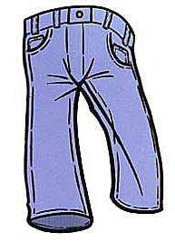
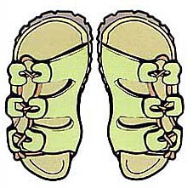
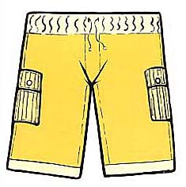
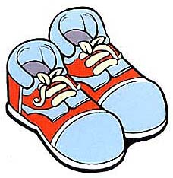

( ) ( ) ( ) ( )

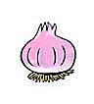
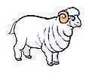


( ) ( ) ( ) ( )

  - Listen and tick or cross.（听音，判断正误，用“√”或“×”表示）12分

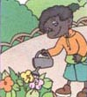
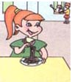


( ) ( ) ( )


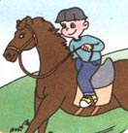
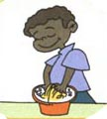

( ) ( ) ( )

  - Listen and choose.（听音，选择正确的一项）10分
( ) (1) What time is it? It’s _________.
A. 8:45 B. 3:35
( ) (2) What’s the weather like today? It’s _________ today.
A. cloudy B. windy
( ) (3) What are these? They are __________.
A. donkeys B. hens
( ) (4) Is that the art room? ____________.
A. Yes, it is. B. No, it isn’t.
( ) (5) How many horses are there? There are ____________.
A. twelve B. twenty
  - Listen and write.（听音，写出正确的数字）8分
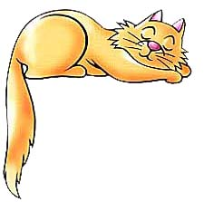
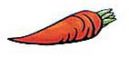
(1) (2)

___________ ___________

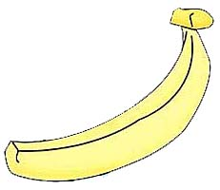
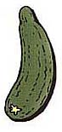
(3) (4)

____________ ____________

  - Listen and arrange.（按听到的顺序给下列句子排序）12分
( ) I want two watermelons.
( ) OK. I’ll take them.
( ) Can I help you?
( ) How about these?
( ) They look good. How much are they?
( ) They are twenty yuan.

Writing Part（笔试部分）50分
- Read and tick or cross.（读一读，判断下列单词画线部分的发音是否相同）6分
(1) hat grapes ( ) (2) home nose ( )
(3) egg pen ( ) (4) fish bike ( )
(5) student cup ( ) (6) milk this ( )
- Read and circle.（读一读，圈出不属于同一类的一项）12分
(1) A. art room B. music room C. Chinese
(2) A. breakfast B. math C. dinner
(3) A. short B. shirt C. skirt
(4) A. socks B. shoes C. kite
(5) A. cat B. hot C. warm
(6) A. rainy B. wind C. snowy
(7) A. cheap B. jacket C. expensive
(8) A. potato B. boots C. slippers
- Look and write.（看图，写单词）10分
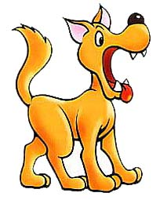
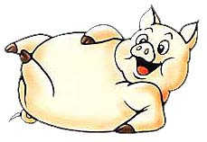
(1) (2)

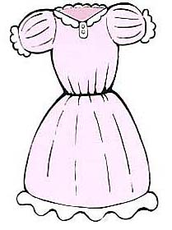
(3)


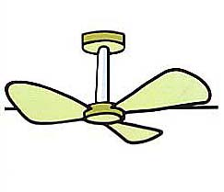
(4) (5)

- Read and choose.（读一读，选择正确的一项）12分
( ) (1) -Do you have lunch at school?
- ________________
A. Yes, it is. B. Yes, I do.
( ) (2) –Where is the TV room?
- ___________________
A. It’s on the second floor. B. It’s a TV room.
( ) (3) –Whose is this shirt?
- ___________________
A. Yes, it is. B. It’s my mother’s.
( ) (4) –Can I wear my new skirt today?
- ___________________
A. Yes, you can’t B. No, you can’t.
( ) (5) –How much is this T-shirt?
- __________________
A. It’s thirty yuan. B. Fine, thank you.
( ) (6) –Are those cucumbers?
- __________________
A. Yes, they are. B. No, they are.
- Read and judge.（读短文，判断正误，用“T”或“F”表示）10分
Mike is a good student. He gets up at six thirty every day. He likes to wear his blue sweater. He goes to school at seven fifteen. He has English class at eight o’clock. He likes English very much. He has lunch at home. In the afternoon, he always plays football on the school playground. He does homework after dinner. He goes to bed at nine o’clock.
( ) (1) Mike gets up at 6:20 every day.
( ) (2) Mike has a blue sweater.
( ) (3) Mike has lunch at school.
( ) (4) Mike likes to play football.
( ) (5) Mike does homework after school.

