卷首语：亲爱的同学们，第一学期即将过去，在这里为期末考试练练兵，京翰教育预祝你期末考个好成绩！
四年级英语期末试卷
班级＿ ＿＿ 姓名＿＿ ＿＿ 评分＿＿＿＿＿
- 听录音，选出与录音内容相符合的一项，并将其字母编号填在题前的括号里。（每小题1分，共10分）
( )1、A. o’clock B. clock C. class
( )2、A. what B. where C. whose
( )3、A. picture B. teacher C. sweater
( )4、A. pair B. pears C. wear
( )5、A. 12 B. 20 C. 22
( )6、A.slippers B. sneakers C. sandals
( )7、A. go to school B. go to bed C. go home
( )8、A. white shirt B. green skirt C. blue T-shirt
( )9、A. What are there B. What are those C. What are these
( )10、A. That is a horse B. That is a house C. That is a mouse
- 听录音,圈出你所听到的图片的字母编号。（每小题2分,共10分）


1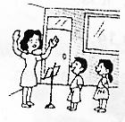 2 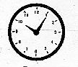 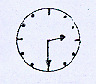 3
A B A B A B

4 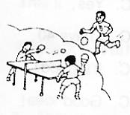 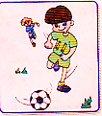 5 
A B A B


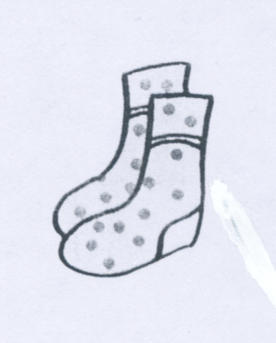
- 根据录音内容，判断下面的图片是否与录音内容相符，相符的在图片下面的括号里打“ √”，不符的打“×”。（10分）
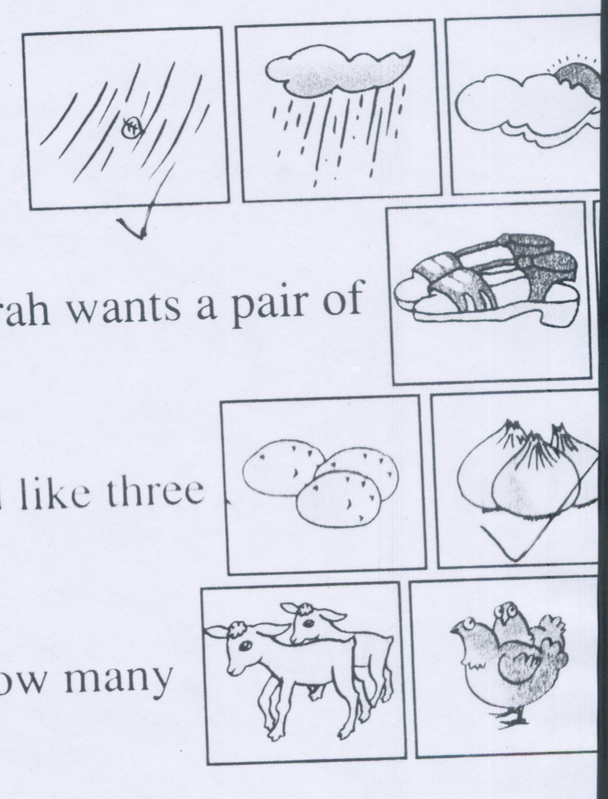
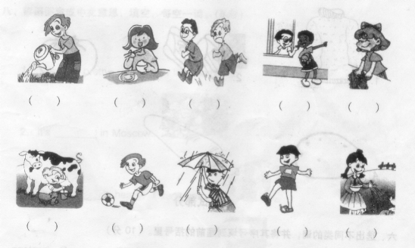


1、（ ） 2、（ ） 3、（ ） 4、（ ） ５、（ ）
四、听录音，补充句子，每空一词。(每空1分，共10分)
1. What _____ is it now? It’s _______.
2. Is that a ___________? No, it’s a ________.
3.I like the _______T- shirt with the green ______.
4. _______ the weather like in Beijing? It’s sunny and _____.
5. These are _______. Those are ________.
五、听录音，选出最佳答案。（每小题2分，共10分）
（ ）1、A、Yes, it’s . B. No, it’s not. C. No, it’s white.
( ) 2. A. It’s on the first floor. B. It’s Ben’s. C. It’s in the tree.
( ) 3. A. I have eighteen. B. There are eighteen. C. There is one. ( ) 4. A. No, you can’t. B. Great. C. Here’s your dress..
( ) 5. A. It’s snowy. B. It’s red. C. No, it’s warm.
六、根据录音内容，判断下面句子是否与录音内容相符，符的在括号里打 “ √”.不符的打“×”（共10分）
（ ）1、There is a garden in Chen jie’s school.
（ ）2、 Our playground is small.
（ ）3、 We have a computer room.
（ ）4、The library is on the second floor.
（ ）5、We go to the gym.

笔试部分
七、根据所给的图片，回答所提的的问题。（答案要完整）（每小题2分，共10分）
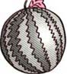
1、Is that a watermelon?
____________________________________________________
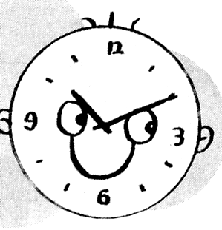
2、What time is it now?
___________________________________________________
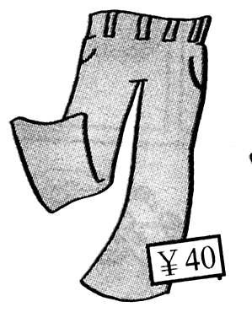
3、How much are the pants?
_____________________________________________________
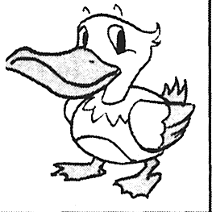
4、What are those?
__________________________________________________
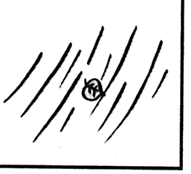
5、 Is it snowy?
__________________________________________________
八．从B中选择合适的答案回答A的问题，把字母编号填到前面的括号中。(10分)
A B
（ ）1. Where are my shoes? A：It’s white。
（ ）2、What ’s the weather like today? B：They are in the shoe box.
（ ）3、What colour is the clock? C：They are 65 yuan.
（ ）4. How much are the jeans？ D：It’s Ben’s.
（ ）5. Whose is the T-shirt? E：It’s windy today.
九、根据上下文意思，选词填空，每词只能用一次。（每空1分，共10分）
( time white Monday art room cheap like warm T-shirt floor nice)
Today is ___________. It’s _________. I can wear my new__________.
It’s __________. It’s __________. It’s only fifteen yuan. It’s ________. I ______it
very much.
It’s 2:50 in the afternoon. It’s _________for art class. I go to the ________.
It’s on the second _________.
十．根据上面短文的意思判断下面的句子是否正确，正确的在句子前面的括号里打“√”，不正确的打“×”。（10分）
It’s a sunny day. I don’t go to school. I get up at 6:30. I have breakfast at 7:00. I eat noodles. Then I go shopping. I want a pair of sandals. They are size 6. They are black . They’re cheap. They’re only twenty-seven yuan. I like the sandals.
( )1、Today is a fine day.
( )2、It’s 7:00. It’s time to get up.
( )3、I wear my sandals today.
( )4、My sandals are black.
( )5、My sandals aren’t cheap.

：

