京翰主编点评：
同学们，这个学期很快就要结束了，想知道你英语学的怎么样吗？那就认真完成这张试卷吧，记得要仔细审题哦，祝你考出好成绩.
四年级上学期英语期末试题

一、听音，完成单词。(10分)
1．tw_ _ ty 2.N_ v_ mber 3.b_ sc_ it 4.f_ _ t 5.Jan_ a_ y

6. ch_ ldr_ n 7.ch_ ps_ icks 8.h_ ngr_ 9.Au_ u_ t 10.v_ get_ble

二、听录音，排列以下图片的顺序。（16分）






( ) ( ) ( ) ( )

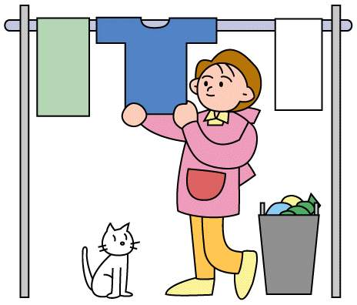




( ) ( ) ( ) ( )

三、听录音，写出听到的数字，并找出相应的颜色连线。（10分）

1. 2. 3. 4. 5.

blue purple white orange pink

四、听录音，判断下列图片与所听内容是否相符，相符的画“”，不符的画“”。（10分）




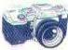
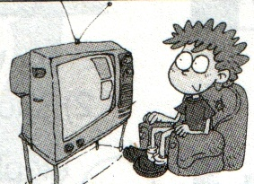

（ ） （ ） （ ） （ ） （ ）

五、听音，用“”勾出小朋友们在运动会中参加的项目。（4分）

 | 100-metre | 200-metre | High jump | Long jump
Amy
Sam
Lingling
Daming

六、听音，在你所听到的句子后面打“✓”。(10分)

1. The car is under the tree. ( )

The car is near the houses. ( )

2. How many cats? Nineteen. ( )

How many cats? Eighteen. ( )

3. I can wash clothes. ( )

I can’t row a boat. ( )

4. He’s taking pictures. ( )

He’s talking to his friend. ( )

5. There are five birthdays in July. ( )

There are five birthdays in June.( )

七、听音，选词填空，将句子补充完整。(10分)

July June December March September

1. It’s cold in .

2. It’s warm in .

3. Children’s Day is in .

4. Teaches’ Day is in .

5. In ,we can swim in the sea.

八、看图，圈出正确句子。（10分）

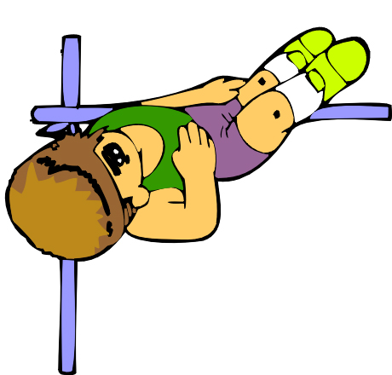
1. A. He’s doing the long jump.
B. He’s doing the high jump.
C. He’s running.

2. A. The ball is under the box.
B. The ball is on the box.
C. The ball is next to the box.

3. A. Thirteen and one is fourteen.
14+1=15
B. Three and one is four.
C. Fourteen and one is fifteen.

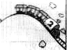
4. A. The train is down the hill.
B. The train is up the hill.
C. The train is near the house.

5. A. It will snow in December.
三月
B. It will rain in March.
C. It will be warm in June.

九、下列单词用正确的格式填写在相应的四线三格中。(8分)

row
play
listen
wash
1.We’re going to a boat.

2.--Can you clothes?

--Yes, I can.

3.Daming is going to to music.

4.Liping can football very well.

十、读一读，判断对错，用“✓”或“✗”表示。（6分）

Sam: What are you doing, Daming?

Daming: I’m running. I’m going to run the 100 meters for Sports Day.

Sam: Can you run fast?

Daming: Yes, I can. But I’m hungry.

Sam: Do you want some bananas?

Daming: Yes, please. Thank you.

1. Daming is running. ( )

2. Daming is going to run the 200 metres for Sports Day. ( )

3. Daming can run fast. ( )

4. Daming wants some chocolates. ( )

十一、读一读，选一选，将单词填入句子中。（6分）

reading writing watching taking

1.Mother is TV.

2.Grandma is a letter.

3.Father is a book.

4.Granda is pictures.

