小学英语四年级(下)期末英语试卷
（满分为100分 考试时间为60分钟）
班级 姓名 总分

（一）听力部分(50分)
一、根据所听到的内容，圈出正确的答案。9%

1、 2、
A. B.
A. B.


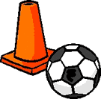


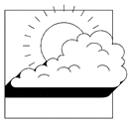
3、 4、
A. B.
A. B.




A. B.
A. B.
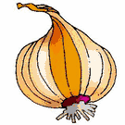
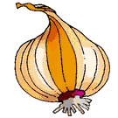
5、 6、



23
100

二、根据所听到的内容，选出正确的答案，并将答案写在横线上。12%
1．Is this a library? No, it’s not. It’s the_________.
A: teacher’s office B: computer room C: washroom
2. It’s eight o’clock. It’s time to __________.
A: go to school B: get up C: have breakfast
3. Where is my _________? Oh, it’s on the sofa.
A: skirt B: shirt C: dress
4. It’s ______ today. Put on your coat.
A: hot B: cool C: cold
5. Look at the T-shirt. It’s _______.
A: pretty B: cheap C: expensive
6. How many horses are there? There are________.
A: twenty B: thirteen C: twelve

7. Oh, it’s_________. It’s time to go to bed.
A: 8：50 B: 9：35 C: 9：45
8．Can I wear my______ in the classroom? No, you can’t.
A: slippers B:sandals C: boots
三、根据所听到的内容，选出正确的句子。10%
- ( ) Let’s go to the playground play football.
( ) Let’s go to the gym play football.
- ( ) I like the T-shirt. It’s colourful.
( ) I like the jeans. They are cheap.
- ( ) It’s rainy in London . Put on your boots.
( ) It’s windy in New York. Put on your jacket.
- ( ) Are these sheep? No, they aren’t.
( ) Are those sheep? No, they aren’t.
- ( ) I like tomatoes. Juicy and red.
( ) I like carrots. Yummy and orange.
四、根据所听到的内容，将下列句子排序，并将序号写在句子前的括号里。9%
（ ）They are too small.
（ ）No, they aren’t.
（ ）Are they your shoes?
（ ） what colour are they?
（ ）They are colourful.
（ ）Where are my shoes?
五．根据所听到的内容，在横线上写出单词。10%
A: What can you see in the picture?
B: I can see a , a , a a

and a .

（二）读写部分（50分）


五．看图片，将单词补充完整。12%
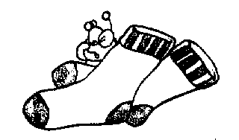
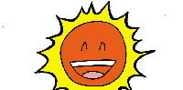
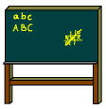

s __ nny __ oar__ so__ __ s __ __ __ ture

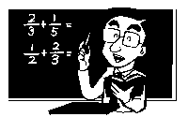
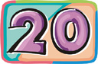
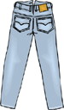


m __ th __ __ enty w__ __ m j __ __ s六．根据句子的意思，选出正确的答案，并将答案写在括号中。9%
1．Let’s go to the _______, have some chicken.
A: TV room B: canteen C: art room
2. Can I wear my _____ today? Yes, you can. It’s very hot.
A:T-shirt B: jacket C: sweater
3. It’s ________ today. Let’s make a snowman.
A: sunny B: snowy C: cloudy
4. Look at the pants. They are 10 yuan. They are ________。
A: cheap B: pretty C: expensive
5. I don’t like ______. They are smelly and white.
A: tomatoes B: potatoes C: onions
6. Put your Chinese book in your bag. We have the ________ today!
A: English class B: music class C: Chinese class
七．读句子，连线。9%
What time is it? No，they aren’t
Is this the washroom? It’s 99 yuan.
How much is it? It’s sunny.
What’s the weather like today? I have 100.
Are they cows？ Yes, it is.
How many donkeys do you have? It’s 10 A.M.
八．用书写体抄写下列句子。5%

It’s 8:30. It’s time for English class.

What color is it? It’s white.

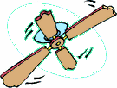
九、看图片完成句子。9%

1．I can see a and a in the room.

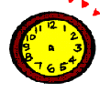


2. It’s o’clock. It’s time for class.

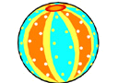

3. Oh, the ball is so .




4. I like s and s. They are yummy!

十、根据短文判断下面的句子是否正确，对的打√ ,错的打 。6%

Dear Jack,
It’s hot in London. I wear my yellow T-shirt and pretty white skirt. It’s sunny today. I go to the farm with my mother. The farm is beautiful. There are twelve cows, fifteen hens, eleven sheep and thirteen lambs at the farm.
How about you?
Love,
Jenny

- It’s sunny and hot in London. ( )
- Jenny wears a white T-shirt. ( )
- Jenny’s skirt is pretty. ( )
- There are fourteen hens and eleven sheep at the farm. ( )

