小学五年级英语5B Unit6单元检测题
一． 成功写字板上请你来翻译。（10’）
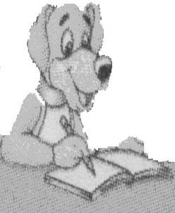
1.他们的手 _________________ 2.抬起 _____________________
3.右边 __________________ 4.感觉累 ____________________
5.右腿 __________________ 6. on my finger ________________
7. lie on your bed ______________ 8. follow the orders____________
9.this big grape _________________ 10.try to ... __________________

二、你和下面的介词是好朋友吗？快来填填看。(10’)
with, in, on, at, to,

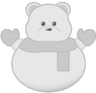
1. You can put the towel __________your shoulder.
2. Touch your ears _____________ your hands.
3. Stand _________a line.
4. Move your head __________the left.
5. He often does some exercise _____________ the weekends.
三．选择填空。聪明的你一定掌握了很多知识，请在这里大显身手吧！（10’）
（ ）1. Stand __________ a line, please.
A. in B. on C. at
（ ）2. Now stand ____________ everybody!
A. up B. on C. in
（ ）3. ________ up your left leg and ________ it with your right hand.
A. Touch...lift B. Lift...touch C. Lift...put
（ ）4. The boy is ______________ on the man's shoulders.
A. stand B. standing C. stands
（ ）5. ---Where are the girls? ---___________in the __________ hall.
A. They, sport B. She’s, sports C. They’re, sports
四．“有求必应”，你比谁都行！（10’）
1. It has two heads, four hands and eight fingers. (对画线部分提问)
_________________________________________?

2. They are having a PE lesson. (对画线部分提问)
_________________________________________?
3. Touch it with your right hand. (改为否定句)
_________________________________________.
4. Is the man putting the plate on the finger. (改为陈述句)
_________________________________________.
5. I feel tired. (改为一般疑问句)
_________________________________________?
五．单词俱乐部，快来将他们排成句子吧！（10’）
1. the, on, girl, knees, is, the, sitting, woman’s
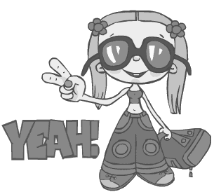
_________________________________________.
2. play, they, day, basketball, every
_________________________________________.
3. your, bend, knees
_________________________________________.
4. on, you, mouth, grapes, your, can, this, put
_________________________________________.
5. times, do, three, it.
_________________________________________.

六.看图完成下面对话，每空一词。（10’）
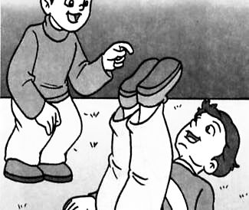
1．A: Lie on your ,now.
B: OK.
A: Can you lift up your ?
B: Yes, I can. Look!
www.2xxyy.com 江苏省中小学英语教学提供
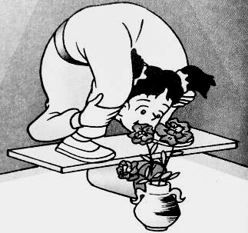
2．A: Look! What is the girl doing?
B: She is _______ the flowers with her ________.
A: Can she _______ the flowers _______ her head?
B: I’m not sure. Perhaps she _______!

3．The students are _______ a ______ lesson. The teacher is _______ orders and the
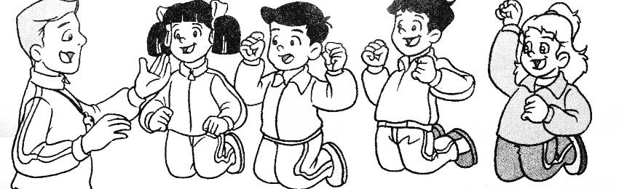
students are trying to ________ them.

“Now let’s do some ____________. Put your feet t_______ first, and then jump
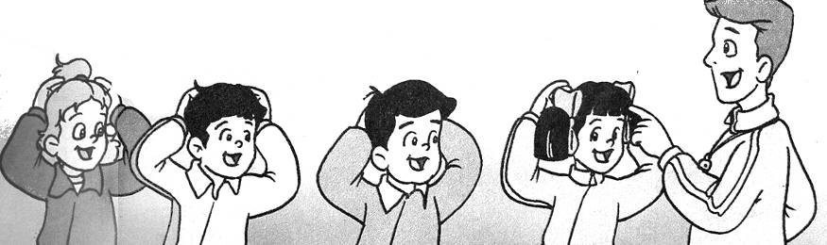
_____ and ______ ten ________.”

“Now _______ your hands _______ your head and turn _______ and ______.
七、阅读短文，做个小判官，并在正确的句子前写T，错误的句子前写F。（10’）
This is an Art lesson. Miss Li is teaching her students drawing. Now she is giving orders.
“Let's draw a big boy. He has two small eyes, a big mouth, a small nose, two big hands, two long arms and legs.”
“Now, let’s put an apple on the boy's head and a grape in his mouth. Draw a book on his left hand and an orange on his right hand. And then draw a ball under his left foot.”

1．（ ）The students are having a PE lesson.
2．（ ）The boy has short arms.
3．（ ）There will be an apple on the boy’s head.
4．（ ）They will draw a book on the right hand.
5．（ ）The boy likes playing with balls.

