小学五年级英语下册第三单元测验卷_试题_试卷

听力部分略

笔试部分
- 请根据每组对话上下文的意思或图片的提示，在空格中填上适当的单词，使句子完整。（每空格只准填上一个单词，10分）
1. A: _______ has a birthday _______ January?
B: Me.
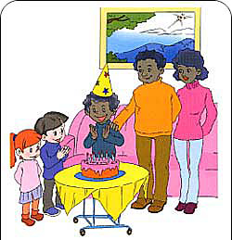

2. A: I like ________ best. 2.
B: _________ do you like it?
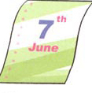
A: Because my __________ is in it. 3.
3. My brother’s birthday is _________ ________.
4. A: _______ do you do on the weekend?
B:_______ go hiking.
5. Sunday is the ________ day of a week.
- 补全对话，根据上下文的意思，在空格中填上适当的句子，使对话完整。 （10分）
A: Excuse me , can I ask you some questions?
B: Sure.
A: ______________________________________________?
B: My birthday is October 6th.
A: _____________________________________________?
B: I usually climb mountains.
A: _____________________________________________?
B: My favourite food is chicken.
A: __________________________________ like it?
B: Because __________________.
A: Thank you for telling me.
B: You are welcome.
- 请用5句话，写一写你的生日是在哪个月份哪一天，在那天你经常做些什么事情，吃些什么东西，和谁在一起，心情怎样。
______________________________________________________
______________________________________________________
__________________________________________________________________________________________________________________________________________________________________

- 看图回答下列问题。（详细回答）
  - What’s the date today?
____________________________________________.

  - Is your mother’s birthday in December?
__________________________________________.

  - What day is it today?
_________________________________________.
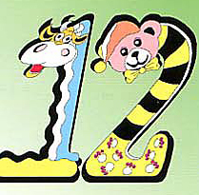
  - How old are you?
________________________________________.

  - Does she have a computer?
_______________________________________.
- 阅读理解：阅读短文，然后判断后面的句子是否与短文内容相符，相符的打“√”，不相符的打“X”。 （10分）
Hello, friends! I’m Lisa. I am an active girl. I have many friends and they’re my classmates. Today is National Day. And it’s my birthday, too. I get up early and clean my room. I invite（邀请） my friends Amy, Joy and Sarah to my home. We have a birthday party. I know Amy’s birthday is in next month. Joy’s birthday is in December. Sarah’s birthday is January 1st.
( )1. Lisa is a quiet and strict girl.
( )2. Today is October 1st.
( )3. Lisa’s birthday is in December.
( )4. Amy’s birthday is in November.
( )5. Sarah’s birthday is New Year’s Day.

