小学五年级下册英语复习题_试题_试卷
一、听句子，填上句子所缺的单词。
1. A:__________ Mrs Li doing ? B: She is _________ a letter .
2. A: Can you wash the _________ ? B: No , I ________ .
3. ________ is reading books in the _________ .
4. A: Is your birthday ________ 21st . B: No , it’s Sept. _______ .
5. I like ___________ . Because I can _________ .
6. A: What are the lions doing ?
B: ________ ___________ __________ .
7. A: Can monkeys _______ ___________ ? B: Sure .
8. A: _________ do you eat breakfast ? B: At ________ .
9. I read books on ________ __________ .
10. A: __________ animal do you like __________ ? B: Dog .
二、听问句，选答语。
( ) 1. A. I fly kites . B. I’m playing games . C. I can do the dishes.
( ) 2. A. We play sports . B. They’re singing. C. You’re talking.
( ) 3. A. We are reading books . B. She’s cooking dinner .
C. He’s drawing pictures.
( ) 4. A. Yes , you can . B. Yes , I can . C. Yes , I do .
( ) 5. A. My mother . B. Tom’s . C. Me .

( ) 6. A. I plant trees . B. I plant trees in the park .
C. I plant trees in the morning .
( ) 7. A. I like winter . B. English is my favourite class .
C. Mrs Wang .
( ) 8. A. Yes , I can . B. Yes , I do . C. No , they can’t .
( ) 9. A. They’re swing . B. It’s jumping .
C. The monkeys are swing .
( ) 10. A. I clean the room . B. I see some books .
C. I can see many birds .
三、听录音选单词，每空一词（选择字母编号）
1. That cool goose is wearing my ________ . ( A. boots B. books )
2. You ate soup with my _________ . ( A. group B. grow )
3. Twenty trains tried to trek ________ . ( A. three B. trees )
4. A glass of ants are inside my _______ . ( A. pants . B.pass )
5. It’s hard to ______ a car on a star . ( A. B. park )

四、根据图片回答回答问题：

1. What are you doing , Chen Jie ?
____________________________
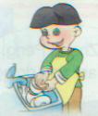
2. What is Zhang Peng doing ?
____________________________
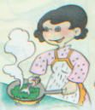
3. What is your mother doing ?
_____________________________
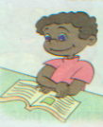
4. What is John doing ?
_____________________________
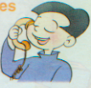
5. What is your cousin doing ?
______________________________
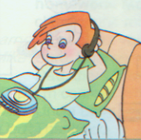
6. What is Mike doing ?
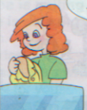
______________________________
7. What is your aunt doing ?
______________________________
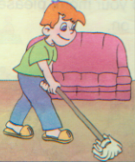
8. What is your brother doing ?
______________________________
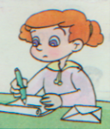
9. What is your sister doing ?
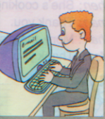
______________________________
10. What is your father doing ?
______________________________
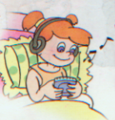
11. Are you listening to music ?
______________________________
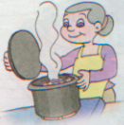
12. Are you washing the clothes ?
______________________________
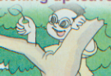
13. Is he picking up leaves ?
______________________________

14. Is he watching insects ?
______________________________
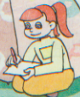
15. Is she writing a report ?

______________________________
16. Is she counting insects ?
______________________________
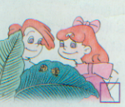
17. Are they catching insects ?
______________________________
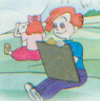
18. Are they taking pictures ?
______________________________
19. Is John reading a book ?
______________________________
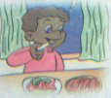
20. Is John eating lunch ?
______________________________
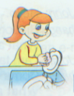
21. Is Sarah doing the dishes ?
______________________________
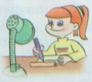
22. Is Sarah doing housework ?
______________________________
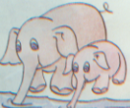
23. Can you see the elephants ?
______________________________
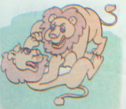
24. Can you see the monkeys?
______________________________
五、根据上下文意思，填上适当的词，每空一词。
1. A: _________ are you doing ? B: I’m _________ pictures .
2. A: _______ you want to go to the park ? B: Yes , I _______ .
3. A: ________ I speak to your brother , please ?
B: ________ . Please hold on .
4. A: ________ is she doing ? B: ________ walking .
5. A: Look at the elephant . What is ______ doing ?
B: _______ running .
6. A: What _______ the pandas doing ?
B: _________ climbing .

