小学五年级下册英语第四单元测验卷_试题_试卷
听力部分略
笔试部分
- 结合上下文的意思在下面的短文的空格上填写适当的单词，将短文补充完整。（每空格只准填上一个单词，10分）
Today is __________ ________, our National Day. My family is busy now. Look, I’m __________ the floor. My sister Lily is _________ the flowers. Mom is cooking __________. Brother is doing ____________ in the study. Dad __________ writing an _____________ to Uncle Li. __________ is younger sister Lucy doing? She __________ doing any homework. She is __________ computer games.
- 补全对话，根据上下文的意思，在空格中填上适当的句子，使对话完整。 （10分）
Mike: Hello!
Larry: Hello, Mike! _________________________. How’s everybody doing?
Mike: Just fine.
Larry: __________________________________________?
Mike: I’m cleaning the room.
Larry: __________________________________________?
Mike: My dad is reading the newspaper in the study.
Larry: __________________________________________?
Mike: Sure. Hold on, please. _________________________________.
Dad: I’m coming. Who’s that?
Mike: Uncle Larry.

- 写话：看图写一写图上的人正在做什么，写5句话。（10分）





I Wu Yifan Amy Mike John
__________________________________________________________________________________________________________________________________________________________________________________________________________________________________________________________________________________________________________________________________________________________________
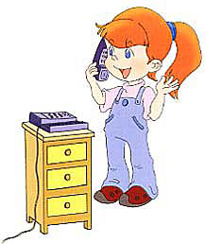
- 看图详细回答下列问题。（10分）
1. A: What are you doing?
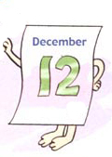
B: _________________________________________.

2. A: When is your father’s birthday?
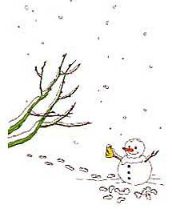
B: _________________________________________.

3. A: Which season does Mike like best?
B: _________________________________________.
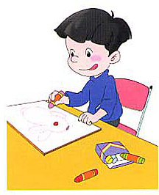
4. A: What is Zhang Peng doing?
B: _________________________________________.
- A: Is the boy doing the dishes?
B: ________________________________________.
- 阅读理解：阅读短文，然后选择相应的答案，把字母编号写在相应的括号里。 （10分）
It’s a Sunday morning. It’s sunny. There are many people in the park. Some students are playing games over there. Two boys are playing football. A girl is flying a kite. Two children are running on the grass.
There is a house near the lake. Beside the house two men are working. A woman is watering the flowers. The flowers are very beautiful.
( ) 1. Where are the students?
A. They are playing game. B. They are near the park.
C. In the park.
( ) 2. What is the girl doing?
A. I’m flying a kite. B. She’s flying a kite.
C. She’s playing football.
( ) 3. Is there a lake near a house?
A. Yes, there is. B. Yes, it is. C. No, there isn’t.
( ) 4. Are the men walking?
A. Yes, he is. B. Yes, they are. C. No, they aren’t.
( ) 5. What’s the weather like on Sunday morning?
A. It’s sunny. B. It’s Sunday. C. It’s summer.

