小学五年级下册英语第六单元测验卷_试题_试卷
听力部分略
笔试部分
- 读短文，选择最佳的词语填空。（10分）
( eating, are, he’s catching, in, sweet, sunny, pictures, happy, do )
It’s a _________ day. Look! There are many people ________ the woods. Zhang Peng is __________ butterflies, Sarah is taking __________. What is Mike doing? ________ watching insects. Sarah and Amy ________ playing chess. They are very ___________. __________ you see any ants? Yes! They are ________ honey. Mmm, it’s _________.
- 根据上下文意思，补充下列对话。（10分）
A: Hello! How are you?
B: ____________________________________.
A: ____________________________________?
B: Wu Yifan is in the woods.
A: ____________________________________?
B: He is watching insects.
A: ____________________________________?
B: No, Amy is drawing pictures.
A: ____________________________________?
B: Oh! John and Mike are playing chess.
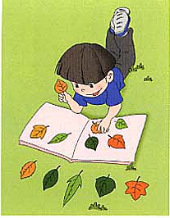
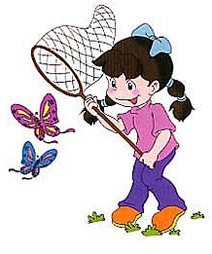
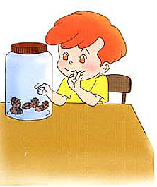
- 看图作文， 至少写5句。（10分）
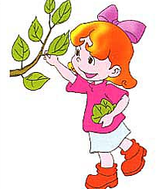
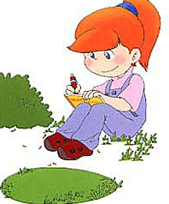
-

_________________________________________________________
_________________________________________________________
_________________________________________________________
_________________________________________________________
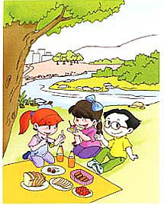
- 根据图意，写出最合适的问答句。（10分）
- What are they doing?
__________________________________________

2. Is Chen Jie watching insects now?
__________________________________________
3. What’s your favourite colour? (按实际情况回答)

__________________________________________
4. What is Zhang Peng doing?
__________________________________________
5. Which month do you like best? (按实际情况回答)
__________________________________________
- 阅读理解（10分）
It’s a nice day. We are having a good time. We are going on a field trip. Listen! The birds are singing. Look! My father is doing an experiment. My mother is catching butterflies. My grandparents are playing chess. My brother is running on the grass. What am I doing then? I am taking pictures.
( )1. My grandma is playing chess.
( )2. My brother is running.
( )3. My sister is catching butterflies.
( )4. I am taking pictures.
( )5. The birds are flying.

