五年级（下册）期终测试卷
听力部分 略
I. choose and write.（请你为下列图片选择正确的词组，注意书写规范）（6分）
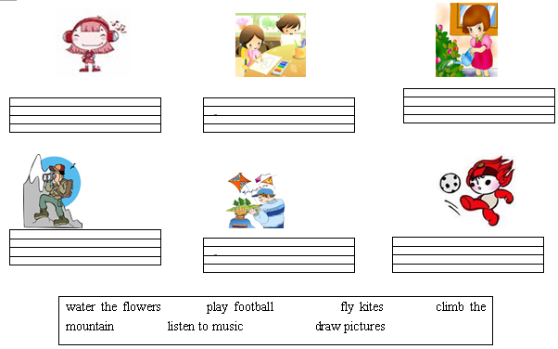
II. Read and fill in blanks. (根据所给首字母，用单词的正确形式填空)（10分）
1. Zhang Peng is m________ a snowman.
2. I often p_______ sports with my friends.
3. In spring, we can f______ kites.
4. When's y______ birthday?
5. W______ season do you like best？
III. Choose the correct answer. （选择正确的答案）（10分）
（ ）1. ----What's your favourite season?
----____________
A. I like fall best. B. February is my favourite. C. I swim in summer.
（ ）2. My parents usually get up ________ 6:40.
A. on B. in C. at
（ ）3 . ----What's the date today?
----____________
A. It's Tuesday. B. It's cool C. It's April 1st.
（ ）4 . ----Is Amy answering the phone?
----____________
A. Yes, he does. B. No, she is writing a letter. C. No, he isn't.
（ ）5. August is the ________ month of the year.
A. seven B. ninth C. eighth
（ ）6. ---- What is Mike doing?
---- He ____________
A. running B. swims in the river C. is walking
（ ）7. ----______ do you like summer?
----______ I can swim in the river.
A. Why, Because B. Why, And C. Which, Because
（ ）8. There is a call ____ you.
A. for B. on C. at
（ ）9. ----__________?
----They are listening to music.
A. What do they do?
B. What are you doing?
C. What are your grandparents doing?
（ ）10. Apples are sweet _______ fall.
A. on B. in C. at
IV. Read and choose.（读一读，选择正确的答句）（5分）
( ) 1. What do you do on the weekend? A. No, I'm going hiking.
( ) 2. When is Children's Day? B. I'm doing homework.
( ) 3.Which season do you like best? C. June 1st.
( ) 4. Are you climbing the mountain? D. Winter. I can play with snow.
( ) 5. What are you doing? E. I often do homework and go hiking.
V. Read and write. (连词成句)（10分）
1. I, leaves, on, pick, the, up, weekend, often, (.)
2. he, making, is, snowman, a, (?)
3. season, like, do, best, which, you (?)
4. birthday, my, is, in, June, grandpa’s, (.)
5. is, dinner, cooking, in, brother, kitchen, the, my, (.)
VI. Reading comprehension. (阅读理解)（9分）
(A)
Mike: Hello. This is Mike. Is that Wu Yifan?
Wu: Yes, this is Wu Yifan. What are you doing, Mike?
Mike: I'm watching TV. What are you doing? And how is everybody doing?
Wu: Just fine. I'm doing the dishes. My father is writing an e-mail in the study. My mother is sweeping the floor. And my brother is playing chess with my sister.
Mike: What do you do on the weekend?
Wu: I visit grandparents and go shopping.
Mike: Do you want to go to the nature park?
Wu: Sure. What time?
Mike: At 1:30.
Wu: OK. See you later.
Mike: Bye.
根据短文内容，判断正（T）误（F）。.
( ) 1. Wu Yifan is watching TV and Mike is doing the dishes.
( ) 2. Wu Yifan's father is writing an e-mail in the bedroom.
( ) 3. Wu Yifan visits grandparents and goes shopping on the weekend.
( ) 4. Wu Yifan wants to go to the Children's Park at 1:30 with Mike.
(B)
My name is Amy. I'm from Canada. I usually get up at 6:30, and I often go hiking on the weekend. I like spring best. It's windy and warm. And I like winter, too. Because my birthday is in December, and I can play with snow. Today my parents are going shopping. My brother is swinging in the garden. I'm watching TV. Do you want to be my friend. My QQ is 408981124, and my telephone number is 6678115.
根据短文内容，选择正确答案。
( ) 1. Amy often goes hiking______.
A. on Sunday B. in spring C. on the weekend.
( ) 2. Which is Amy's favourite season?
A. Spring. B. Winter. C. Spring and winter.
( ) 3. ----Why does Amy like winter?
----Because_______.
A. her birthday is in December B. she can play with snow C. A and B
( ) 4. Is Amy's brother going shopping?
A. Yes, he is. B. No, he isn't. C. Yes, he is swinging in the garden.
( ) 5. What's Amy's telephone number?
A. 408981124 B. 6678115 C. 408981124 and 6678115

VII. 根据图片自由发挥，写一篇8句话以上的短文。题目：In the park。（10分）


太棒了！恭喜你们已顺利完成了今天的知识旅行！！

