京翰教育温馨提示：同学们，在过去的学期里，我们曾付出了辛勤的汗水，今天就让我们尽情采摘成功的果实吧！
英语期末测试（一）
听力部分（44%）
一、听、选出不同发音的单词。（6%）
1、（ ）A boot B goose C cool D door
2、（ ）A soup B house C group D coup
3、（ ）A bear B stair C swear D pear
4、（ ）A flight B right C fight D high
5、（ ）A ward B cart C hard D smart
6、（ ）A clean B seat C sheep D season
二、听、写。（12%）
1、Today is ___________ . Let’s __________________ .
2、Hello! ____________________________. Can I speak to your ________ ?
3、What are you _____________ ? I’m ___________________ .
4、Look! There is a kangaroo. It’s ____________
5、When is your __________. It’s in ________________.
6、__________ comes . Let’s ____________________.
7、What are they doing ? They are __________________ .
三、听，连线。（5%）
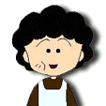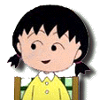

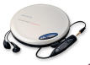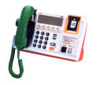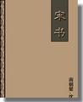
四、再听一次，完成填空。(5%)
1、Chen jie is ________________________________
2、Her mother is ______________________________
3、Her father is _______________________________
4、Her grandpa is ______________________________
5、Her grandma is ______________________________
五、听并选择。(6%)
( ) 1、A picking up leaves B catching butterflies C playing chess D taking photos
( ) 2、A Feb.9th B Aug.9th C Feb.19th D Aug.19th
( ) 3、A jumping B fighting C climbing D running
( ) 4、A fly kites B plant trees C go hiking D swim
( ) 5、A 9:15 B 9: 30 C 9: 50 D 9:13
( ) 6、A writing an e-mail B cooking dinner C watching TV D read newspaper
六、听，标序号。(10%)
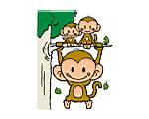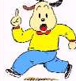
( ) ( ) ( ) ( ) ( )

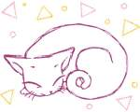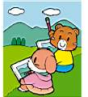
（ ） （ ） ( ) ( ) ( )

笔试部分（56%）
七、连词成句。（12%）
1、 speak , please Can to mom ? I your
__________________________________________________________________________________________
2、 doing is ? baby What kangaroo the
__________________________________________________________________________________________
3、 they playing in often ? Are classroom chess the
__________________________________________________________________________________________
4、 has in Who a ? August birthday
__________________________________________________________________________________________
5、 you on weekend ? do What the do
__________________________________________________________________________________________
6、 can snowman winter . I a in make
__________________________________________________________________________________________
八、选择填空。(5%)
（ ）1、 is Sarah? She is in the car.
A What B Where C That
（ ）2、The elephants often ________ water with ________ trunks .
A drinking it’s B drinking their C drink their
( ) 3、_______ Zhang Peng and Mike playing chess in the room ?
A Does B is C are
( ) 4、What is the rabbit doing ? It’s _______________.
A running B climbing C swimming
( ) 5、_______ monkeys can ________ in the tree..
A The swing B Does swing C The swinging
九、看图写句子。（12%）
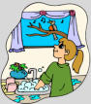________________________________ 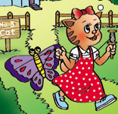 ________________________________ 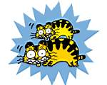_____________________________ 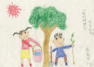_____________________________
 _____________________________ 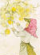 _________________________________
十、读短文，回答问题。（14%）
Man: Hello.
John: Hello. Can I speak to Sarah, please?
Man: Hold on, please! She is watching TV.
Sarah: Hello. This is Sarah.
John: This is John . I’m a reporter for daily report. Can I ask you some questions?
Sarah: Sure!
John: Which season do you like best? Why?
Sarah: I like winter best. Because I can play with snow and skate .
John: That sounds good. I think your birthday is in November .
Sarah: No, my birthday is in August. My father’s is in November.
John: I’m sorry. What is your family doing in this evening ?
Sarah: My father is reading a newspaper. My mother is doing the dishes.
John: What about your grandparents?
Sarah: They are having a walk in the garden. And my pet cat is catching butterflies in the garden.
John: Great! Thank you!
Sarah: You’re welcome!
1、Which season do you like best? Why?
________________________________________________________________________________
2、Who has a birthday in November ?
________________________________________________________________________________
3、What is Sarah doing before she answering the phone ?
________________________________________________________________________________
4、Is her father reading a book ?
________________________________________________________________________________
5、What is her mother doing ?
________________________________________________________________________________
6、Where is her grandparents ? What are they doing ?
________________________________________________________________________________
7、_____________________________________________________________________________
It’s catching butterflies in the garden.
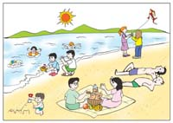
十一，看图写作文。（7%）
______________________________________________________________________________________________________________________________________________________________
_________________________________________________________________________________________________________________________________________________________________________________________________________________________________________________________________________________________________________________________________________________________________________________________________________________________________________________________________________________________

