京翰主编点评：
同学们，这个学期很快就要结束了，想知道你英语学的怎么样吗？那就认真完成这张试卷吧，记得要仔细审题哦，祝你考出好成绩.
2010---2011学年度第一学期期末考试
学校 年级 班 姓名

小学五年级英语试题 （时间40分钟）
题目 | 一 | 二 | 三 | 四 | 五 | 六 | 七 | 八 | 九 | 十 | 合计
得分
一、听力部分
听音选单词。
1、( ) A. chick B. chess C. chess
2、( ) A. playground B. people C. pupil
3、( ) A. find B. firemen C. farm
4、( ) A. matter B. miss C. meet
5、( ) A. secret B. should C. shouldn’t
6、( ) A. hold B. hear C. hers
7、( ) A. bored B. badly C. bell
8、( ) A. mine B. miss C. them
9、( ) A. team B. tea C. show
10 ( ) A. farm B. food C. fantastic
二、听音选出与所听句子相同的选项。
1、( ) A、Where did you go? B、When did you go?
2、( ) A、She can’t catch the ball. B、She can control the ball.
3、( ) A、She gets up at seven o’clock. B、She gets up at ten o’clock.
4、( ) A、She fells sad. B、She fells surprise.
5、( ) A、This sweater is hers. B、This sweater is his.
三、听问句选择答语。
1、( ) A、Yes, he can. B、No, she can.
2、( ) A、I like apples. B、half a kilo.
3、( ) A、No, I don’t. B、Yes, I should.
4、( ) A、At seven o’clock. B、I go to school by bus..
5、( ) A、It’s Sam . B、It’s mine.
四、听短文选词填空,填序号。
A. find B. people C. hear D. help E. firemen
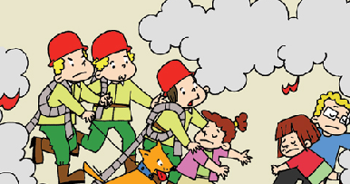
There is a fire. There are many _____ the house. The ______ can’t see the people, they can’t ____the people. The people are very dangerous. But they had a special dog, it can____ the people, It _____ the people, then whey were safe.
第二部分 笔试
五、补全单词,填序号。
（ ）1、bl__nd A、a B、i C、e
（ ）2、ch__ __se A、ea B、ae C、ee
（ ）3、s__ us__ ge A、e，e B、a，e C、a，a
（ ）4、t__ __m A、ue B、ai C、ea
（ ）5、cr__ss A、e B、a C、o
六、选词填空，后和汉语意思连线。
in fast about with hello
say______ to 跑得快
skip ______me 向……问好
walk ______the road 关于……的节目
run______ 和我跳绳
programme ______ 在路上走
七、选择填空。
1、( ) Yesterday, I _____to Sam and Amy’s school.
A. went B. go C. going
2、( ) _______ cheese do you want?
A. how many B. how much C. how
3、( )This girl is_____ , she can’t hear.
A. blind B. firemen C. deaf
4、( )Can you catch the ball ? _________
A. Yes, she can. B. Yes, I can. C. Yes, I can’t.
5、( )Today we won a football game, we feel ____.
A. happy B. angry C. sad
6、( )_______ do you get up? I get up at 7 o’clock.
A. Who B. What C. What time
7、( )You ______walk in the road. It’s dangerous.
A. can B. shouldn’t C. should
8、( )It’s raining and I can’t go out to play , I feel ____.
A. happy B. sad C. bored
9、( ) She _____ swim, so her mother helps her.
A. can B. can’t C. does
10、( ) She _____ eat fruits, it’s good for her.
A. should B. shouldn’t C. does
八、看图, 把句子的序号填到对应图片下。
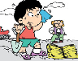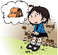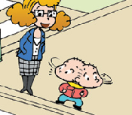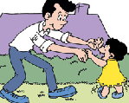
( ) ( ) ( ) ( ) ( )
- This girl can’t walk . Her father helps her.
- I helped my grandfather on the farm all day, I fell tired.
- You should look then cross the road.
- Lingling lost her bag and she can’t find it , she feels sad.
- I get up at half past seven.
八、选择答语,填序号。
( )1、When did you come back? _____ A、Yes, he can.
( )2、Where did she go? _____ B、half a kilo.
( )3、Whose bag is this? _____ C、She went to London.
( )4、Can Sam catch the ball? _____ D、I came back last Monday.
( )5、How much rice do you want? ____ E、It’s hers.
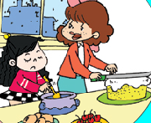
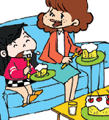
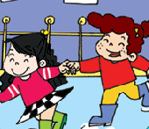
十、阅读理解。

（ ） （ ） （ ）
Yesterday was Saturday, Zara got up at seven o’clock. But it was raining and she couldn’t go out to play, she felt bored. She helped her mum male a cake. After that she was hungry. She ate the cake with mum. That’s delicious. She was very thirsty, so she drank some water. Then the rain stopped. Zara went out to play, she was very happy.
- 请按照短文顺序给上图标号。
- 判断，对的写T，错的写F。
Yesterday was Sunny. ( )
Zara got up at 8 o’clock. ( )
She didn’t help mum. ( )
After she helped mum, she was angry. ( )
She drank some water. ( )
(3)猜测一下,文中框出的单词thirsty什么意思呢? ( )
A、饥饿的 B、口渴的 C、高兴的
(4)选择:---Did she eat cake？_____ ( )
A、Yes, she can. B、Yes, she did. C、No, she didn’t.

