小学五年级英语第一学期模拟试题
班级 姓名 学号 得分
听力部分 50%
- Listen and choose.(听音，选择正确的单词)（10%）
( )1、A、 bean B、beef ( ) 2、A、cow B、brown
( ) 3、A、 boat B、road ( ) 4、A、tall B、small
( ) 5、A、skirt B、girl ( ) 6、A、river B、farmer
( )7、A、sweep B、sweet ( ) 8、A、table B、vegetable
( )9、A、 dishes B、fish ( ) 10、A、 housework B、homework
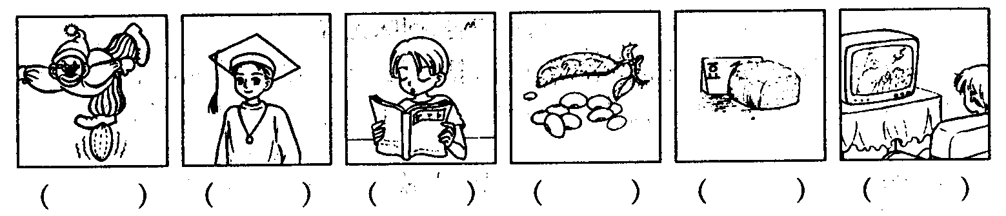
二、听音，将下面五幅图按听到的顺序编号。（6％）

- 看图，勾出你所听到的图片(12%)
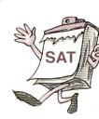
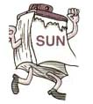
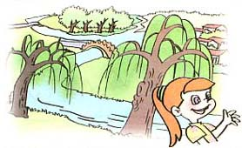
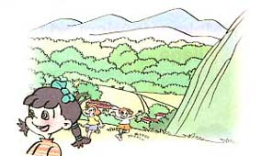
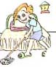
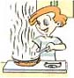
1、 2、 3、

（ ） （ ） （ ） （ ） （ ） （ ）
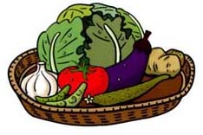
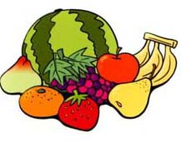
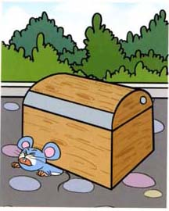
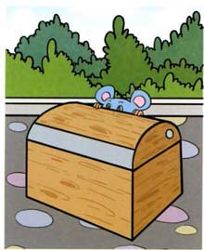


4、 5、 6、

( ) ( ) ( ) ( ) ( ) ( )

- 听音，将听到的食物和水果打“√”。（15%）

 | 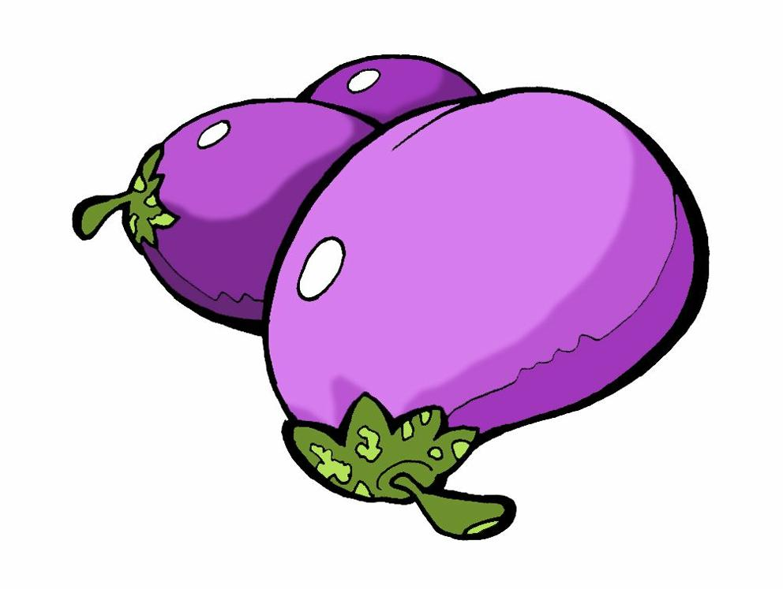 |  | 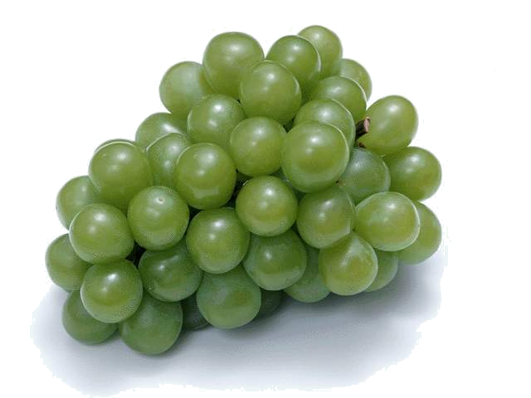 | 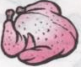 | 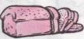 | 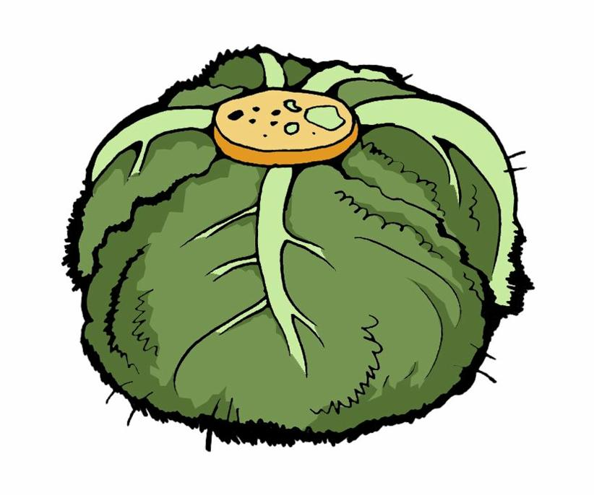 | 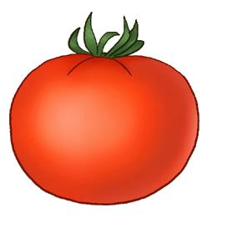 | 
Chen jie
Miss Li
Mr He
John
Sarah
五、听句子，圈出正确的答句的序号。（7%）
1、A、I can cook the meal.
B、I can clean the bedroom.
2、A、 Yes , I can.
B、 No, I can’t .
5、A、It’s Sunday.
B、It’s Saturday.
6、A、It’s on the bed.
B、It’s under the bed.
7、A、I have eggplant, potatoes and fish .
B、I have eggplant,tomatoes and tofu .
3、A、Yes, there is.
B、Yes, it is .
4、A 、He is short and strong.
B 、He is short and thin.

笔试部分 50%
六、找出下面单词中意思不同类的一个，把它的序号写到前面的括号里。6%
（ ）1、A. tasty B. sour C. thin D. salty
（ ）2、A. bedroom B. closet C. kitchen D. bathroom
（ ）3、A.village B. tree C. flower D. glass
（ ）4、A. in B. old C. on D. under
（ ）5、A. curtain B. trash bin C.fresh D. mirror
（ ）6、A. fish B. tofu C.tomato D.road
七、选出正确的答句，把序号填到问句前的括号里。（6%）。
（ ）1.Who’s your English teacher? A.He’s tall and strong
（ ）2.What’s he like ? B. Mr Carter
（ ）3.What do we have on Monday ? C. I often do homework
（ ）4.What do you do on Sunday? D.We have Chinese and English
（ ）5.What do you have for lunch? E. I like apple . They are sweet .
（ ）6.What’s your favourite food? F. We have tofu and fish .
八、读句子，选择最适合的答句。 （10％）
(1) ( ) What can you do?
A. I can make the bed. B. Yes, I can .
(2) ( ) What's he like?
A. She is strict but kind. B. He is strong.
(3) ( ) Is she young?
A. She's our principal. B. No, she's old.

(4) ( ) What do you have on Tuesdays?
A. It's Tuesday. B. We have computer, P.E. and math.
(5) ( ) What's your favourite fruit?
A. I like mutton very much. B. Grapes. It is very tasty.
(6) ( ) What would you like for lunch today?
A. I'd like some beef and two eggs, please B. I like onions and pork.
(7) ( ) What day is it today?
A. Thursday B. Birthday
(8) ( ) What do you do on Sundays?
A. I have math, English and Chinese. B. I watch TV and read books.
(9) ( ) Who's that young lady?
A. She's tall and thin. B. She's our principal.
(10) ( ) Are there any tall buildings in the village?
A. No, there aren’t . B. No, there isn’t.

九．排词成句。（10%）

例：can't no I No, I can't.
can't no I

1
mirror is where the big

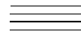 ?
2
tall pretty is Miss white and

.
In there a forest the is park
3
.
We Tuesdays English on have
4
.
5
helpful home at I’m

.


十．看一看，写一写。(8%)
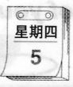
1．There is an near my bed.

2. My favourite day is .
3. There are some grass under the .
4. I like  very much.

十一．阅读短文，判断下列语句的正误。（10%）
Hello! My name is Tom. I like English very much.. My favourite food is beef, eggplant and tofu. I’m very helpful. I can do the dishes, set the table and water the flowers. Today is Saturday. I often read books, do my homework and watch TV on Saturdays. What do you do on weekends?
My home is near a river, there are some mountains behind my house. There is a road in front of my house, you can see two bridges over it .Welcome to my home .
( ) 1. Tom likes beef ,eggplant and tofu.
( ) 2. Tom can sweep the floor.
( ) 3. Tom often water the flowers on Saturdays.
( ) 4. There are some mountains in front of Tom’s house.
( ) 5. There are two bridges over the river.

听力材料
1.Listen and choose.(听音，选择正确的单词)（10%）
1、beef 2、brown 3、road 4、tall 5、girl 6、river
7、sweet 8、table 9、dishes 10、homework

2.听音，将下面五幅图按听到的顺序编号。（6％）
1. I like green beans 2. Zhang Peng often watches TV on Sundays.
3. My favourite food is tofu 4.he is a young university student .
5. He’s very funny . 6. Mike reads books on Saturdays.
3.看图，勾出你所听到的图片(12%)
1、What day is it today? It’s Sunday.
2、I can see so many mountains in the park.
3、What can you do, Mike ? I can clean my bedroom.
4、I like fruit. They are healthy.
5、Look at the mouse. It’s under the box.
6、Miss Li is our principal. She is very kind.
4.听音，将听到的食物和水果打“√”。（15%）
- What’s your favourite food, Chen Jie ? I like eggplants , noodles and bread.
- Do you like noodles , miss Li ? Yes , I like grapes and tomatoes, too.
- What’s your favourite food? I like chicken and green beans.
- What do you have for breakfast, john ?
I have bread and tamatoes. For lunch , I have chicken and cabbage.
- Do you like grapes, Sarah ?
No , I don’t like grapes. I like cabbages , chicken and tamatoes.

5、听句子，圈出正确的答句的序号。（7%）
- what can you do? I can clean the bedroom.
- can you set the table? Yes , I can .
- is there a river near your school? Yes, there is.
- what’s your Chinese teacher like?He is short and thin.
- what day is it today? It’s Sunday.
- where is my ball? It’s under the bed.
- what do you have for lunch? I have eggplant,tomatoes and tofu .

