小学六年级英语第七册第四单元测试题 (考试时间：40分钟 满分：100分) 第一部分 听力部分（30分）
一、听录音，圈出你所听到的字母组合。（5分） 1. bd pb 2. lk mh 3. JP GQ 4. USA UFO 5. each math
二、听录音，圈出与所听内容相符的图片。（8分） 1. A. 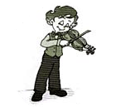 B. 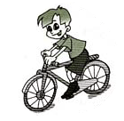 2. A. 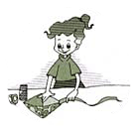 B.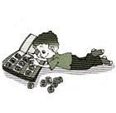
3. A. 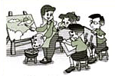 B. 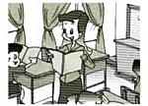 4. A. 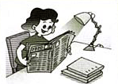 B. 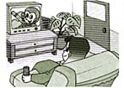
三、听录音，选出你所听到的单词或词组。（5分） （ ） 1.A.diving B. swimming C. playing （ ） 2.A.collecting stamps B. riding a bike C. making a kite （ ） 3.A.goes to work B. goes to bed C. goes home （ ） 4.A.in the city B. in the evening C. in the country （ ） 5.A.reading B. reades C. reads
四、听小对话,判断正确与否，对的在方框里打“√”，错的打“×”。（12分）
1. 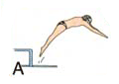 2. 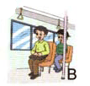 3. 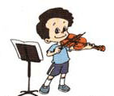

4. 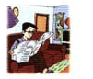 5.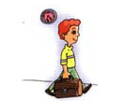 6. 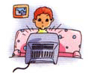

第二部分 笔试部分
一、仔细观察，按字母表顺序填充单词,注意用正确的形式书写. (10分) 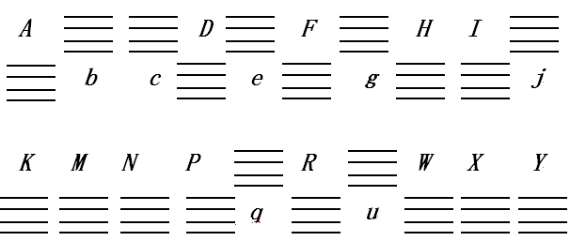 二、 看图片,选出正确的单词或短语.(5分)
1. 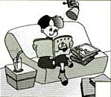 ( ) 2. 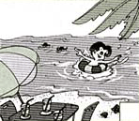 ( )
A. reads newspapers B. watches TV A. swimming B. diving 3. ( ) 4. ( ) A. collecting stamps B. playing the violin A. riding a bike B. making kites 5.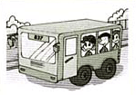 ( ) A. goes to work B. teaches English
三 、 选词填空. (12分) 1. I like ___________( A. ride B. riding) a bike. 2. My mother _____________(A. go B. goes) to bed early. 3. My father likes _________(A. teach English B. teaching English ) 4. Miss White _______________ (A. teachs B. teaches) Chinese. 5. I _____________(A. live B. lives) in the city. 6. Chen Jie likes _____________(A. draw B.drawing) picture.
四、从下列词组内找出与图片对应的词组,并正确书写在四线格上。(8分)
goes home goes to bed reads newspapers teaches math
1. 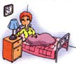 2.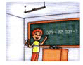3. 4. 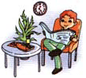

五、选择下列正确的答句. (10分) ( ) 1. ---What’s your hobby? -----_____________. A. I like riding a bike. B. I go to school by bike. ( ) 2. ----Does she teach English? ------_______________. A. No, she doesn’t B. She teaches English. ( ) 3. ----I like collecting stamps, what about you? ------______________. A. Me too. B. Yes, she dose. ( ) 4. I like the sports, but ___________________. A. she likes art. B. she likes sports. ( ) 5. He always ___________ in the evening. A. watches TV B. go to school ( ) 6. Her mother is a nurse, _________________. A. she works in a hospital . B. she work in a factory ( ) 7. ----Does Alice go to school by bus? ----_________________. A. Yes, he does. B. No, she doesn′t . ( ) 8. I like ______________________. A. playing the violin and writing emails B. play the violin and write emails ( ) 9. ----Does she like drawing picture? -----___________________. A. Yes, she is doing B. Yes, she does. ( ) 10. They are twins, _______________. A. they look same. B. they look the same.
六、 连词成句.(10分) 1. is hobby what your ? 2. she English does teach ? 3. like picture I drawing .
4. in lives she Beijing .
5. likes he stamps collecting too .
七.、判断句子中划线部分的时态运用,对的在□中打“√” 错的在□中打“×”. (5分) Milk is my good friend. He lives in Canada with his mother. □ His mother is a teacher, she works at school. □ She teaches English.□ Milk go to school with his mother . □ Milk is a good student, he always go home after school.□ He does his homework after dinner.□ After finishing the homework, sometimes he read newspapers.□ Sometimes he watch TV. □ He _go to bed_ at 10’o clock. □ Milk’s hobby is playing football, he usually play football at the park. □
八. 阅读短文，通过选择或书写的方式回答所提的问题。(10分) Dear Zhang Pen, I am happy to have a new pen pal. I live in England.I like playing the violin and making kites. My brother likes riding a bike and diving. I like art, but he likes sports. We look the same, but we don’t like the same things. Tell me something about you: what’s your hobby? Your new pen pal, Jim.
( )1. Does Jim live in England? A. Yes, he does. B. No, he doesn’t .C. I don’t know. ( )2.What is Jim’s hobby? A.Playing the violin. B. Making kites. C. Both A and B. ( )3.What is Jim’s brother’s hobby ? A. Riding a bike. B. Playing the violin and making kites. C. Riding a bike and diving. ( )4. Dose Jim and his brother look the same? A. Yes, they look the same. B. No, they doesn’t .C..Yes, he do. 5. Dose Jim know Zhang pen’s hobby? ______________________________________

附件1
听力材料：
- 听录音，圈出你所听到的字母组合。(本题读一遍) 1. pb 2.mh 3.GQ 4.UFO 5.m-a-t-h math
- 听录音，圈出与所听内容相符的图片。(本题读两遍) 1．--What’s your hobby? --I like playing the violin. 2. –I like making kites. What about you? -- Me,too. 3. –Does she teach art? ---Yes, she does. 4. My father often watches TV after dinner.
三、听录音，选出你所听到的单词或词组。（本题读两遍） 1．diving 2. making a kite 3. goes to bed 4. in the country 5. reads
四、听小对话,判断正确与否，对的在方框里打“√”，错的打“×”。(本题读两遍) 1.—What’s your hobby? ---I like diving. 2. ---How does your uncle go to work? ---He goes to work by bus. 3. ---I know Chencheng likes playing the violin. ----No, you’re wrong, Chencheng likes playing the piano. 4. ---What does your father do after dinner? ---- Let me see, he often reads newspapers. 5. ---What do you do after school? --- I usually go home . 6. --- This is Miss Yang speaking, Tim is very lazy, he didn’t finish his homework for several days. What does he do after dinner this weekend? --- Oh, he always watches TV after dinner.

附件2
参考答案和评分标准;
(听力部分) 一1. pb 2.mh 3.GQ 4.UFO 5. math 二1．A 2.A 3.A 4.B 三．1．A 2.C 3. B 4 .C 5. C 四. 1√.2.√3.×4.√5.√6.√ （笔试部分）一 (大写的一行)BCEGJQU, (小写的一行)adfhikmnprwxy (字母每个书写错误扣0.5分,每个字母最多扣0.5分) 二 1.A 2.A 3.A 4.B 5.A 三1.B 2.B 3.B 4.B 5.A 6.B 四 1. goes to bed 2.teaches math 3.goes home 4.reads newspapers (每小题两分,找到对应图片的单词,给1分,书写正确给1分,扣分亦如此) 五 1.A 2.A 3.A 4.A 5.A 6.A 7.B 8.A 9.B 10.B 六 1.What is your hobby? 2.Does she teach English ?3.I like drawing picture. 4.She lives in Beijing. 5.He likes collecting stamps,too.(首字母未大写,没有标点符号,个别单词书写错误均扣0.5分,一句话最多扣2分) 七 √√√××√×××× 八 1.A 2.C 3.C 4.A 5.No, he doesn’t.

