小学六年级英语上册模拟试卷
听力部分（共30分）
一、Listen and choose.（听录音，找出你所听到的一组字母，并将序号填入题前括号内 。）（5%）
( )1．A、cba B、ace C、bcd ( )2．A、wfg B、gwf C、fgc
( )3．A、oqt B、uqt C、qot ( )4．A、jgq B、gjp C、jpg
( )5．A、bus B、bike C、dog
二、Listen and circle.（仔细听对话，圈出你所听到的图片）（10%）
1、 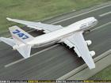 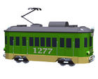 2、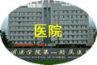 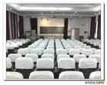
A B A B
3、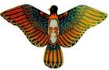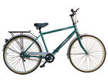 4、 
A B A B
5、 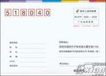
A B

三、Listen and draw “√”or “×”（根据听到的句子，判断图片正误,对的画“√”,错的画“×” ）（5%）

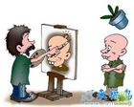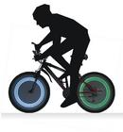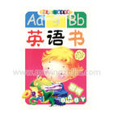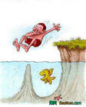
1( ) 2（ ） 3（ ） 4（ ） 5（ ）
四、Listening and choose （听对话，选出合适的答案）(10%)
（ ）1. A. by bus B. on foot C. by train
（ ）2.A. stop B. go C. wait
（ ）3.A. hospital B. cinema C. post office
（ ）4.A. going to the cinema B. reades newspapers C. take a trip
（ ）5.A. post card B. magazine C. comic book

笔 试 部 分 （70分）
Look and fill in the blanks.（按字母表顺序填充字母，注意区别大、小写形式）（5%）
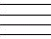
1、 d 2、 G 3、 L
4、 Q 5、 y

二、Look and choose. (看图片，选出相应的单词或短语) （10%）
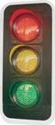
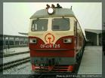
1、 2、 3、
A. plane
B. train
( )
A. traffic light
B. traffic rule
( )
A. policeman
B. engineer
( )

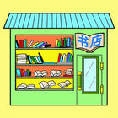
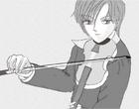
4、 5、
A. ride a bike
B. play the violin
( )
A. post office
B. bookstore
( )

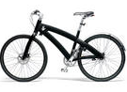
三、Choose the right word and fill in the blank(选词填空，请将右边框内的单词或词组填入横线中。) (5%)
cinema actress
comic book bike
playing the violin

1、I go to school by ___________.

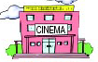
2、My mother is an ____________.
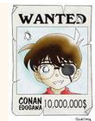
3、Where is the bookestor? Next to the __________________.
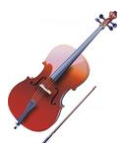
4、I am going to buy a _________________ this evening.
5、My pen pal likes __________________.

四、Choose and answer .（选出最恰当的答案，把序号写在左边括号里）（30%）
（ ）1．How do you go to school?
A. I go to school on foot. B. The school is next to the hospital. C.I am going to the cinema.
（ ）2.What is your hobby?
A.I like making kites. B.She goes to work by bus. C.Next to the hospital.
（ ）3. Does she watch TV at night?
A. Yes, she does. B. Yes, she goes to school on foot. C. No, I go to the park at night.
（ ）4.Turn left at the cinema, then __________. It’s on the left.
A.our school B.go straight C.green light
（ ）5. at the red light.
A. Stop B. Go C. Wait
( )6.Excuse me. Where is the cinema?
A..I am a cleaner. B. Next to the bookstore . C.I am going outside.
( )7.Tom’s mother teaches English. What does his mother do?
A.She is a policewoman . B.She is a teacher. C.She goes to work by car.
( ) 8. When does she go to school?
A.She works in Beijing. B. She goes to school at 7:30. C. Yes, she does.
( )9．What are you going to do this afternoon?
A Yes, he does. B. I am going to play football. C. He likes collecting stamps.
( ) 10.Does your pen pal live in Shanghai?
A. I like diving. B. He is tall and strong. C. Ye, he does.
( ) 11. Where is the post office?
A. It’s near the cinema. B. Yellow light means wait. C. I am going to buy a book.
（ ）12. I'm going to buy an English book .
A. magazine B. this afternoon C. at
( )13.What does your father do?
A.He goes to school by bike. B.He is a policeman. C.She is a cleaner.
（ ）14. Where are you going this afternoon?
A.Next to the shoe store. B. I’m going to the bookstore. C.He is going to visit grandparents.
（ ）15.Where does he work?
A.His hobby is painting. B.He works in the a car company. C.He is a singer.

五、Look at the pictures and choose the best words for the dialogues.(看图选词完成对话。)(10%)
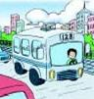
1. A: How do you go to school?
B:Usually I go to school .(on foot/by bus)
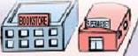
2. A:Where's the bookstore?
B:It's (next to/far from)the supermarket.
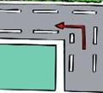
3．A：How can I get to the science museum?
B：Go straight then . （turn left/turn right）
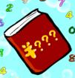
4．A:What are you going to do on the weekend?
B: I am going to .(buy a book/the cinema)
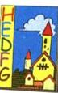
5. A:What are you going to buy?
B: I’m going to buy a .(post card/magazine)
六、Write.(抄写)(10%)
1、What’s your hobby? I like riding a bike.

2、How do you go to school, Sarch? I go to school on foot.

3、What are you going to do this weekend?

4、I am going to visit my grandparents this weekend.

5、What does your mother do? She is a TV reporter.

听力参考：
一、1B、ace 2 C、fgc 3 B、uqt 4 C、jpg 5 B、bike
二、1、How do you go to Shanghai? I go to Shanghai by bus.
2、Where is the hospital? Next to the post office.
3.How do you go to the park? I go to the park by bike.
4.What does your brother do? He is a singer.
5.What are you going to buy? I am going to buy a post card.
三、1.My pen pal likes painting.
2.Usually I go to school by bus.
3.I am going to buy a pair of shoes this afternoon.
4.He likes making kites.
5.The post office is next to the school.
四、1．How do you go to Nanjing? I go to Nanjing by bus.
2.Yellow light means wait. Red light means stop. Green light means go. What does the yellow light means?
3.How can get to the cinema? You can go by No.14 bus.
4.What does your father do? He reads newspaper.
5.What are you going to do on the weekend? I am going to buy a comic book in the bookstore.

