全国小学生英语竞赛(NECPS)六年级组竞赛样题
(时间:60分钟 总分:100分)
听力部分(共六大题,计40分)
(注：听力部分仅提供样题，无听力录音)
I. 听辨单词(Words) (共5小题, 计5分)
听音,选出所听到的单词.每个单词只读一遍.(答案涂在答题纸上)
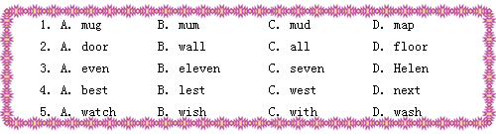
II. 听音, 选择(Multiple choice) (共10小题, 计10分)
A)听音,选出所听单词与下列图片不符的一项.每小题只读一遍.(答案涂在答题纸上)
6.
A. | B. | C.
 | 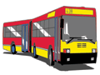 | 
7.
A. | B. | C.
 |  | 
8.
A. | B. | C.
 |  | 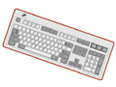
9.
A. | B. | C.
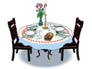 |  | 
10.
A. | B. | C.
 |  | 
B) 听句子,从下列图片中选出与所听内容相符的一项.每小题只读一遍.(答案涂在答题纸上)
11.
A. | B. | C. | D.
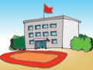 |  |  | 
12.
A. | B. | C. | D.
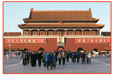 |  | 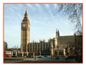 | 
13.
A. | B. | C. | D.
 |  |  | 
14.
A. | B. | C. | D.
 |  |  | 
15.
A. | B. | C. | D.
 |  |  | 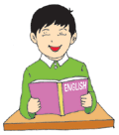
III. 听音,判断(Select right or wrong) (共5小题,计5分)
听音,判断下列图片与所听内容是 (T) 否 (F) 一致.每小题只读一遍.(答案涂在答题纸上)
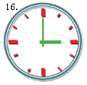 | 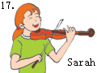 | 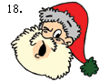
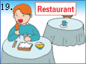 |  | 
IV. 听音,连线(Match the pictures) (共4小题,计5分)
根据你所听到的内容,把下列小动物与他们想吃的食物连接起来,只标号即可.短文读两遍.(答案写在答题纸上)
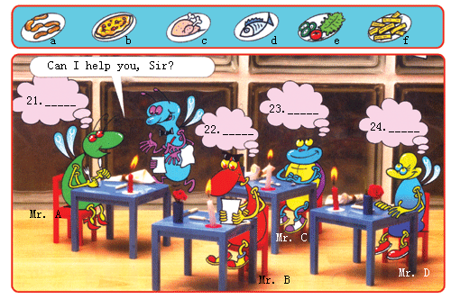
V. 听音,填空,翻译(Fill in the blanks and translate) (共5小题,计10分)
听音,补全句子,再翻译整句话.每小题读两遍.(答案写在答题纸上)
25. I am a ______ girl.
26. He is in Class 1, Grade ______ .
27. Sue ______ playing computer games.
28. You must ______ your hands before dinner.
29. It's Tommy's ______ .
VI. 听音,画图(Draw the pictures) (共5小题,计5分)
根据所听短文画出所缺的内容.短文读两遍.(将所缺内容画在答题纸上,共五处)
My Family Tree
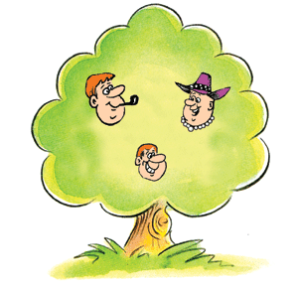
笔试部分(共六大题,计60分)
I. 单词与短语(Words and phrases) (共10小题,计10分)
A)选出与其它三项不属于同一类的一项.(答案涂在答题纸上)
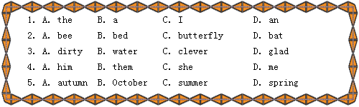
B)根据和图下所给出的字母,写出它们所表示的单词或词组.(答案写在答题纸上)
6. | 7. | 8. | 9. | 10.
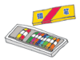 |  | 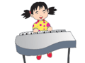 |  | 
oyrcnas | kcdu | hoiatlappyne | aechp | allberum
II.句子(Sentences) (共10小题,计10分)
A)把下列打乱的单词连词成句,并加上适当的标点.(答案写在答题纸上)
11. speaking is This Kate
12. Are any wall the pictures there on
13. waiting bus for the We are
14. much the How shirt is
15. English is than Her mine better
B)按要求完成下列各句.(答案写在答题纸上)
16. We are talking about that book.(就划线部分提问)
17. Li Hong is _______ (young) than Wang Xin. (用括号里所给词的适当形式填空)
18. Cathy is the _______ (two) one to get up in her family. (把括号内的基数词变序数词)
19. Jiu Zhaigou(九寨沟) is very beautiful.(变感叹句)
20. There are many _______ (sheep) on the farm.(用所给词的适当形式填空)
III. 情景会话(Dialogues) (共5小题,计10分)
看图,选择适当答语完成对话内容.(答案涂在答题纸上)
21.
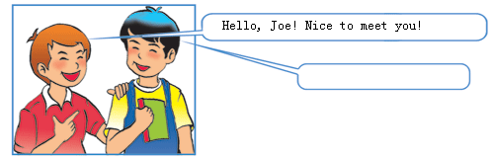

A. Nice to meet you, too! B. Thank you!
C. How are you? D. How do you do?
22.
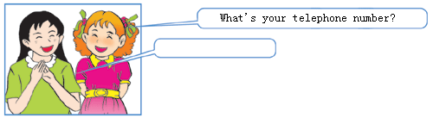
A. I am No.3. B. My room number is 203.
C. It is 7284676. D. I am in Class 1.
23.
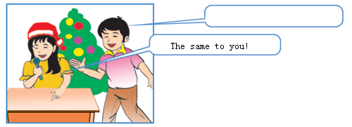
A. Happy birthday to you! B. Merry Christmas!
C. Thank you! D. Happy Teacher's Day.
24.
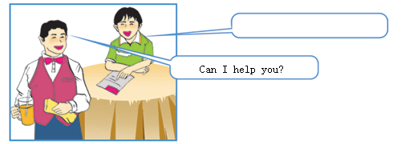
A. Here you are. B. This way, please.
C. I would like a cup of tea, please. D. No, thanks.
25.
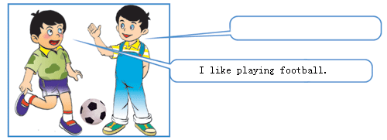
A. What do you like? B. What do you want?
C. What do you prefer, volleyball or football?
D. Why do you like playing volleyball?
IV. 阅读理解(Reading comprehension) (共10小题,计10分)
A)看图,根据图意回答下列各题.(答案写在答题纸上)
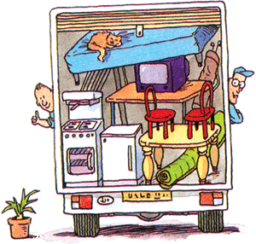
26. Are the two men putting the furniture(傢具)into a lorry(卡车)?
27. Where is the TV set?
28. How many chairs can you see in the picture?
29. What is sleeping on the bed?
30. Where is the nice cooker?
B)阅读短文,判断下列句子的正(T)误(F).(答案涂在答题纸上)
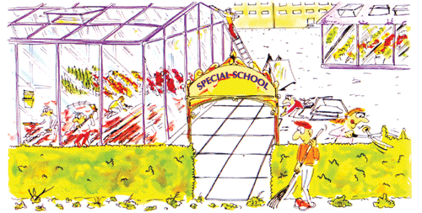
This is a special school. All the students at this school work on different things. The students in the science class are learning about plants and they are growing plants in a greenhouse.
Look! Some students are planting new flowers. They have been digging since this morning. Other students are cutting the bushes(树丛) around the school. The bushes are smaller now.
The students also build a new greenhouse because the old one is very small.
Next week, their parents are going to visit the new greenhouse, so some students are working to finish it. What will you do to make your school more beautiful?
31. The students in the science class are growing plants.
32. Some students have been digging since this morning to build the greenhouse.
33. The bushes are smaller.
34. The students don't build a new greenhouse.
35. Some students are working to finish the new greenhouse.
V. 智力测试(Intelligence Test) (共5小题,计10分)
按要求完成下列各题.(答案写在答题纸上)
36. 看图,写出其英语表达意思。
37. What does “cn” on the Internet stand for(代表)?
38. What can you find from the words and numbers?
4, 6 and 8 is not good.
You drink from 1, 2 and 3. 1 2 3 4 5 6 7 8
Don't 8, 7, 5 and 3 a glass, it will break. C U P B O A R D
39. How do you turn an odd number(奇数) into even(偶数) by removing(拿走) one letter?
40. This is a Lost and Found shop. Can you help them find what they lost?请仔细观察,找出这些人所丢失的物品.例如:A→e(至少四处)
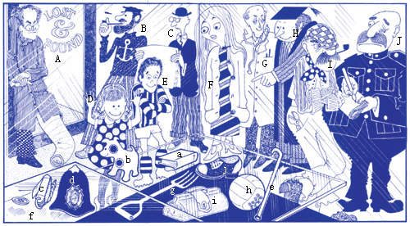
VI.小作文(Composition) (计10分)
提示:比较下列两幅图(图1, 图2), 请描写图2所表现的内容和描述图1和图2的几处不同(可选1处至2处).图中的小女孩叫Lisa, 以"Lisa's Photo"为题,写一篇小作文.
要求: 1. 条理清晰,意思明确、连贯,句子通顺,标点正确,书写工整、规范;
2. 要将图2中的内容基本体现在作文中;
3. 不少于70个单词;
4. 将作文写在答题纸上.
Lisa's Photo
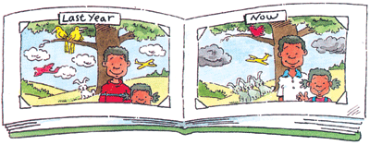
2004年全国小学生英语竞赛(NECPS)
六年级组竞赛样题参考答案
听力部分原文及参考答案(共六大题,计40分)
I. 听辨单词 (共5小题,每小题1分,计5分)
1. mug 2. wall 3. seven 4. best 5. wash (1—5 ABCAD)
II. 听音, 选择 (共10小题,每小题1分,计10分)
A) 6. A. plane B. bus C. train
7. A. lemon B. apple C. pear
8. A. computer B. mouse C. keyboard
9. A. bathroom B. bedroom C. living room
10. A. teacher B. dentist C. worker (6—10 CBAAA)
B) 11. I am going to the hospital.
12. She went to Beijing yesterday.
13. He turns left at the corner.
14. There are three bananas on the table.
15. It's a music class. (11—15 BACCA)
III. 听音, 判断 (共5小题,每小题1分,计5分)
16. It's 9 o'clock.
17. Sarah is playing the piano.
18. Merry Christmas!
19. Let's go shopping.
20. I am watching TV. (16—20 FFTFT)
IV.听音, 连线 (共4小题,每小题1.25分,计5分)
It's lunch time. Mr. A, B, C and D all go to the restaurant to have lunch. They like different food. When they sit at the different tables, one waiter comes to Mr. A and asks:"Hello, Sir. Can I help you?" Mr. A says:"I would like some fish, please." At this time, Mr. B looks at the menu. He wants some vegetables. Mr. C and Mr. D both think about what they will eat. Mr. C likes to eat sausages. Mr. D thinks the chicken is good. (21—24 deac)
V. 听音, 填空, 翻译 (共5小题, 每小题2分, 计10分)
25. I am a Chinese girl. 我是一个中国女孩。
26. He is in Class 1, Grade 6. 他在6年1班。
27. Sue likes playing computer games. 苏喜欢玩电脑游戏。
28. You must wash your hands before dinner. 你在饭前必须洗手。
29. It's Tommy's pencil case. 这是汤米的文具盒。
VI. 听音, 画图 (共5小题, 共5处, 每处1分, 计5分)
This is a family tree. There are 3 people in my family. The man with a pair of glasses is my dad. He has a beard. My mum has short curly hair. Her necklace is very beautiful. There is a flower on her hat. I am a boy, with very short brown hair. I wear a cap.
My Family Tree
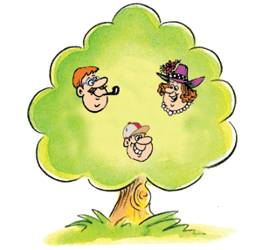
笔试部分(共六大题,计60分)
I. 单词与短语 (共10小题, 每小题1分, 计10分)
A) (1—5) CBBCB
B) 6. crayons 7. duck 8. play the piano 9. peach 10. umbrella
II. 句子 (共10小题, 每小题1分, 计10分)
A) 11. This is Kate speaking.
12. Are there any pictures on the wall?
13. We are waiting for the bus.
14. How much is the shirt?
15. Her English is better than mine.
B) 16. What are you doing?
17. younger
18. second
19. How beautiful Jiu Zhaigou is!/What beautiful Jiu Zhaigou it is!
20. sheep
III. 情景会话 (共5小题, 每小题1分, 计5分)
(21—25) ACBCA
IV. 阅读理解 (共10小题, 每小题1分, 计10分)
A) 26. No, they aren't. 27. It's on the table. 28. Two 29. A cat. 30. It's next to the fridge.
B) 31. T 32. F 33. T 34. F 35. T
V. 智力测试 (共5小题, 36—37题各1分,38题3分,39题1分,40题4分,计10分)
36. No Smoking! 37. China(中国) 38. bad, cup, drop 39. seven拿走s变成even (偶数)
40.B→g, C→j, D→b, E→h, F→i, G→f, H→a, I→c, J→d
VI. 小作文 (计10分)
Lisa's Photo
These are Lisa's photos. She is ten years old now. She is taller than last year. The boy next to her is her brother. He wears a white T-shirt. But he was dressed in a black sweater last year. She and her brother stand in front of the big tree. There are three rabbits beside the tree. They are looking at them. A plane is flying in the air. A bird is singing in the tree! They are so happy together. Don't you want to take a picture?(86 words)

