牛津小学英语六年级期中测试题
听力部分（30分）
一、听录音，选出你所听到的内容。 （听一遍）（5分）
（ ）1. A. tall B . ball C. small D. take
（ ）2. A. glad B. grass C. glass D. game
（ ）3. A. many B. monkey C. much D. my
（ ）4. A. park B. have C. dark D. public
（ ）5. A. whose B. who C. shoes D. what

二、听录音，根据对话内容选择正确答案。 （听两遍）（5分）
（ ）1. A. It’s the first of June. B. It’s the first of July.
C. It’s the first of January.
（ ）2. A. Liu Tao’s washing his face.
B. Liu Tao’s having breakfast.
C. Liu Tao’s playing football.
（ ）3. A. It is on the chair. B. It is on the bed.
C. It is on the ground.
（ ）4. A. You must stay away from the building.
B. You shouldn’t make noise here.
C. We shouldn’t park our car here.
（ ）5. A. In the study. B. In his bedroom. C. In the bathroom.

三、听录音，给下列图号。（听两遍） （8分）
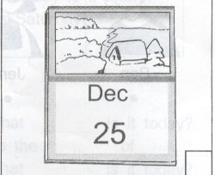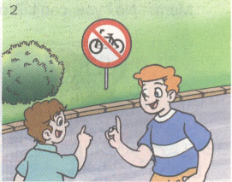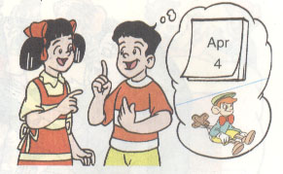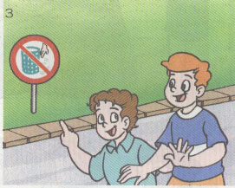
（ ） （ ） （ ） （ ）
四、听录音，填入所缺的词。（听三遍）（10分）
A: What________ is it _________, Kate?
B: It’s the _____ of _______.
A: Oh, my birthday’s ______ soon.
B: _______ your birthday?
A: It’s _____ the 25th of _________.
B: What _______ you like as a birthday present?
A: I’d like a ________.

笔试部分（70分）
一、翻译词组。（12分）
- blow out the candles ________ 2.go home together __________
- talk a walk _______________ 4. public signs
5 . take off 6.on the ground
7.一个生日礼物 8. 刚才
9. 十月六号 10. 寻找_______________
11. 严禁践踏草地_______ 12. 拍照片________________
- 选词填空。（５分）
am, is, are, was, were
1. —________ you a student?
－ No, I ______ not.
2.－________ he from China?
－No, he ______not.
3. You ______ my good friend.
4. Jim and I ________ in the teachers’ office a moment ago.
5. Where ______ his football just now?
6. I _______ a student some years ago but I _______ a teacher now.
7. The CDs ________ on the bookcase yesterday morning.
三、选择填空(10分)
( ) 1. Your watch was there _______.
A. now B. just now C. a moment
( ) 2. My key is on the floor. Can you ________ for me?
A. pick it up B. pick up it C. lift it up
( ) 3. The photos aren’t there_______, but they were there ______.
A. a moment ago, now B. just now, a moment ago
C. now, a moment
( ) 4. There _______ a pair of glasses under the newspaper a moment ago.
A. is B. were C. was
( ) 5. All the people are very _______ now.
A. excite B. exciting C. excited
( ) 6. She is_________ a _______ race in the playground.
A. watching, run B. looking, running C. watching, running
( ) 7. _______ your sister at home yesterday（昨天）?
A. Was B. Were C. Are
（ ）8. What ______ is it today? It’s Tuesday.
A. date B. time C. day D. week
（ ）9. Where ______ you a week ago? I _____ in Beijing.
A. was were B. were was C. was was D. were were
（ ）10. He is ____ Ben some questions ______ public signs.
A. asks to B. asks as C. asking about D. asking to

（ ）11. What does that sign mean? _________
A. It means you must keep from the grass.
B. It means you must keep off the grass.
C. They mean you shouldn’t keep off the grass.
D. They mean you should keep from the grass.
（ ）12. When’s your birthday, Liu Tao? My birthday’s __________.
A. of January B. in January C. on January D. in the January
（ ）13. Can I go to the park? _________
A. Yes, you can’t. B. No , I can’t. C. No, you can. D. Yes, you can.
（ ）14. It’s time _____ listen to some music.
A. to B. for C. with D. of
( )15. －Happy birthday to you!
－ _________.
A . Nice to see you. Ｂ. Thank you. Ｃ. All right.
( )16. My birthday is _______.
A . come Ｂ. coming Ｃ. comes
( )17. I’ll ______ a birthday cake for you
A . by Ｂ. buy Ｃ. bye
( )18. My birthday is on the _______ of November.
A . twelve Ｂ. twelveth Ｃ. twelfth
( )19. I’d like a big cake _______ lots of grapes _____ my birthday party.
A . of, for Ｂ. with, as Ｃ. with, for
( )20. －What does it ________?
－ It______ you shouldn’t touch it.
A . mean, means Ｂ. means, mean Ｃ. means, means
- 按要求完成句子。(10分)
1.are, very, all, excited, students, the (连词成句)
______ the students are ________ _________.
2.The films were in the bag. (对划线部分提问)
________ _______ the films?
3.It was Sports Day at school. (改成否定句)
It ______ Sports Day at school.
4. My birthday’s on the fifth of May .(对画线部分提问)
_____ is _____ birthday ?
5. I’d like a mask as my birthday present. (对画线部分提问)
_____ would _____ _____ _____ a _____ _____?
6. They were there just now.(改成同义句)
They there .
7. Is it in your bag?(否定回答) No,

五、根据中文意思完成句子。（23分）
1.今天是几月几日？6月6日。今天星期几？星期三。
_____ _____ is it today?______ ______sixth_____ ______.
_____ _____ is it today? It’s ________.
2.你的生日是什么时候？是４月２１日。
______ your birthday? It’s______ the 21st of______.
3．我的手机刚才还在照相机旁，可现在不在了。
My near the camera .
But it there .
4. 这个标志是什么意思？它的意思是你不可以在这里停放自行车。
_____ does_____ sign _____ ? It _____ you shouldn’t _____ your bikes here.
- 将下列句子排列成完整的对话。（12）
1. a. I’d like a bird’s cage.
b. When’s your birthday?
c. What would you like as a birthday present?
d. It’s on the third of August.
e. All right.

2. a. Thanks a lot.
b. Is it in your school bag?
c. It was on the desk just now.
d. I can’t find my crayon. Where is it?
e. Not at all.
f. Yes, it is. Thank you very much.
g. But it isn’t here now.

- 阅读理解，对的在括号内写 “T”, 错的在括号内写 “F”。(5分)
Today is Sunday. It’s seven thirty in the morning. It’s fine. Kate and her parents are going to the Great Wall. Kate’s father is a doctor. Her mother is a teacher. Now they’re getting on a big bus. There are twenty-two people in it. Some are English, and some are American and Japanese. They look very happy. They’re going to the Great Wall, too.
There are four Chinese on the bus. A young woman, she’s a driver. A young man, he’s a guide. My father and I are going to the Great wall, too.
( )1、It’s a fine Sunday morning.
( )2、Kate’s father and mother are teachers.
( )3、There are twenty-two people in the bus.
( )4、They are happy.
( )5、The driver is a young man.

