牛津小学英语六年级6A英语期终检测试卷
听力部分 (20%)

- 找出你所听到的字母、单词、数字、词组和句子。5%

( )1. A. b B. d C. p D. q
( )2. A. G B. A C. H D. J
( )3. A. 30 B. 13 C. 3 D. 30th
( )4. A. 5:15 B. 4:45 C. 5:50 D. 5:05


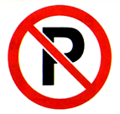

( )5. A. B. C. D.

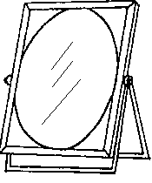
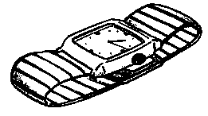
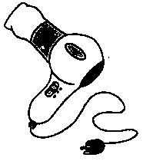
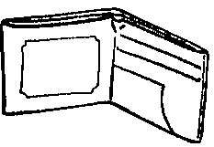
( )6. A. B. C. D.

( )7. A. 二月 B. 八月 C. 十月 D. 十二月
( )8. A. Christmas Day B. National Day
C. New Year’s Day D. Sports Day
( )9. A. eat rice dumpling B. eat delicious food
C. eat nice food D. eat moon cakes
( )10. A. Liu Tao often play football with his friends after school.
B. Liu Tao often plays football with his friends after school.
C. Liu Tao is playing football with his friends after school.
D. Liu Tao played football with his friends after school.

二、根据你所听到的内容，给下列图片标序号。5%

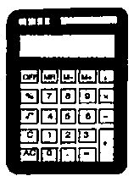
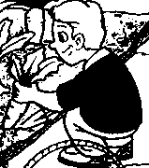

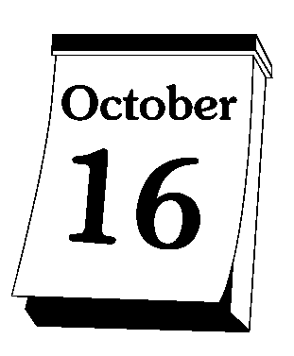

( ) ( ) ( ) ( ) ( )

三、根据你所听到的内容，判断下列图片正误。符合图意的画 ，不符合图意的画 。5%
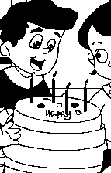
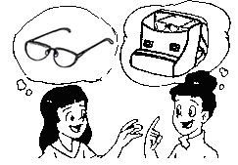


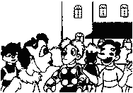

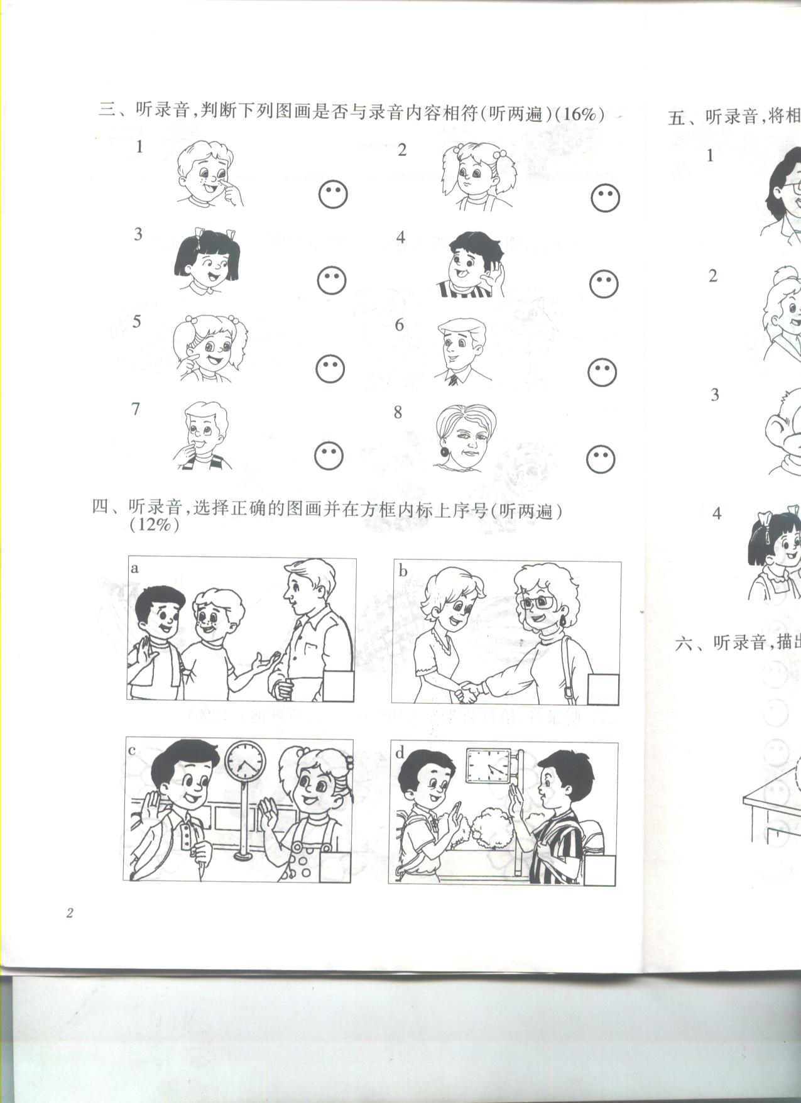

四、根据你所听到的问句，找出正确的应答。5%

( )1. A. It’s my. B. It’s mine C. It’s her.
( )2. A. Yes, I did. B. No, he didn’t. C. Yes, she did.
( )3. A. They are on the desk. B. They were on the desk. C. They were there just now.
( )4. A.Yes, it is. B. Yes, there is. C. Yes, they are.
( )5. A. I’d like a football. B. Yes, please. C. Sure.

笔试部分 (80%)

一、找出不属于同一类别的那个词。5%

A B C D
( )1. first second three fourth
( )2. my mine our his
( )3. am is are was
( )4. January March August Maths
( )5. Be quiet No parking No smoking look around
( )6. May Day National Day a dragon boat Christmas
( )7. climb comb mirror teapot
( )8. did had eat went
( )9. beside behind the under
( )10. glasses earphones CDs film

二、中、英词组互译。10%

1. Christmas Day _____________
2. get off _____________
3. make noise _____________
4. Dragon Boat Festival_____________
5. look around _____________

6. 在我的手机的前面_____________
7．儿童节 _____________
8．拉出 _____________
9．问许多问题 _____________
10．散步 _____________

三、从Ⅱ栏中找出与Ⅰ栏相对应的句10%
Ⅰ
( )1. What day is it today?
( )2. What date is it today?
( )3. What does this sign mean?
( )4. When’s your mother’s birthday?
( )5. Where’s my diary?
( )6. Did she watch TV yesterday evening?
( )7. What did the girl do last week?
( )8. Whose glasses are they?
( )9. Would you like a bike as a birthday present?
( )10. What do people usually do at
Spring Festival?

Ⅱ
A. Yes, she did.
B. It’s Thursday.
C. Yes, please.
D. It’s the 25th of May.
E. It’s on the first of July.
F. They eat delicious food.
G. They are mine.
H. It means ‘Danger’.
I. It’s in the desk.
J. She visited a farm with her family.

四、根据句意，选择正确的词填空。5%

A. looking for my mobile phone B. cooked nice food C. do housework

D. the sixth of January E. do their homework

- What date is it today? It’s ___________________________.
- What are you doing? I am___________________________.
- Do you ___________________at the weekends?
Yes, they do.
- What did your mother do yesterday? She ________________.
- Do Su Hai and Su Yang often _____________ after dinner?
Yes, she does.

五、根据句意，用所给词的正确形式填空。5%

1. My brother often _______ ( play / plays) football with his friends after school.
2. This sign means we _______ ( should / shouldn’t) be quiet in the library.
3. My birthday is coming. Would you like ______( coming / to come) to my birthday party? Sure.
4. This skateboard is yellow. It’s _______ (their / theirs ).
5. Last Sunday, I ______ ( visit / visited ) my grandparents with my parents.

六、选择填空。10%

( )1. There is _______ interesting storybook on the teacher’s desk.
A. a B. an C. the
( )2. There isn’t ______ water in the glass.
A. some B. any C. a
( )3. --What date is it today? -- It’s the ______ of January.
A. eleven B. 11rd C. 11th
( )4. At the weekends, Jim often _______ housework.
A. do B. does C. did
( )5. -- __________ months are there in a year?
-- There are 12 .
A. How much B. How old C. How many
( )6. Christmas is _____ the 25th of December.
A. at B. on C. in
( )7. -- _______ calculator is this? --It’s hers.
A. Who’s B. Which C. Whose
( )8. -- _______ you in the classroom just now?
-- Yes, we _______
A. Were… were B. Were… are C. Was… are
( 9. -- What does this sign ______?
-- It _______ ‘Danger’.
A. means… means B. mean… mean C. mean… means
( )10. Listen, the children ________ in the music room.
A. sing a song B. is singing a song C. are singing a song

七、将所给句子排成一段完整对话，将其序号填入括号内。5%

A. See you.
B. Yes, speaking.
C. Hi, Nancy. This is Helen. Today is my birthday.
D. Sure.
E. Thank you! Would you like to come to my birthday party this evening?
F. Hello, is that Nancy?
G. See you this evening.
H. Happy birthday to you!

F |  |  |  | E |  |  | A

八、选择符合图意的句子，将其序号填在图下括号内5%

A. This sign means ‘No eating or drinking’.
B. He collected eggs on the farm on Monday.
C. My favourite holiday is Mid-Autumn Festival.
D. Today is the sixth of May.
E. That black comb is mine on the desk.
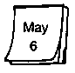
1.

2.

3.
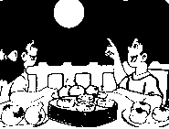

4.
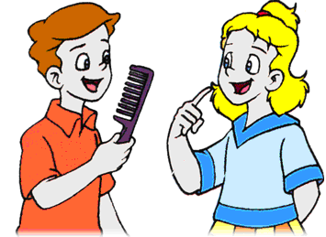

5.
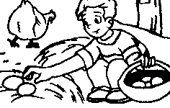

九、根据图意完成句子。5%

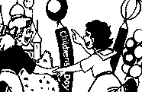

- A: _______ Children’s Day ?

B: It’s _______ the _______ of _______.

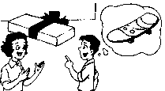
2. A: _______ in the box?
B: _______ _______ a skateboard.
_______ mine.

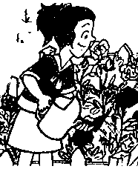

3. A: What _______ the girl do last Saturday?
B: She _______ flowers in the gardon.

十、根据情景，选择正确的句子。5%

( )1.你想告诉你的好朋友你最喜欢的节日是元旦,应该说:
A. I like New Year’s Day. B. I like Spring Festival.
C. My favourite holiday is New Year’s Day.
( )2.你的好朋友过生日,你想知道他想要什么礼物,你可以问:
- Would you like a kite as a birthday present?
- What would you like as your birthday present?
- Would you like to come to my birthday party?
( )3. 在校园的草地上,你看见有同学在上面走,你会对他说:
- What does that sign mean?
- You shouldn’t keep off the grass.
- You shouldn’t walk on the grass.
( )4. 你找不到你的计算器了,你会怎么问你的同学:
- Excuse me, where’s my calculator?
- Excuse me, where’s my diary?
- Excuse me, is that my calculator?
( )5. 你想知道现在几点了,你会问:
- What date is it today?
- What day is it today?
- What’s the time now?

十一、阅读理解。

（1）判断正误。正确的用T表示,错误的用F表示。5%

It’s the first day of school. Tom wants to go back to school. He wants to see his friends. He wants to meet his new teacher.

Tom gets up early in the morning. He washes and eats his breskfast. Then he rides his bike to school. He sees his friends on the playground. He plays hide-and seek(捉迷藏) with them. In the classroom, Tom meets his new maths teacher. Her name is Miss Green. Tom likes Miss Green.She can speak English very well. He thinks she is a nice teacher.

( )1. It’s the first day of the new year.
( )2. Tom doesn’t want to go back to school.
( )3.Tom goes to school on foot.
( )4. Miss Green is Tom’s English teacher.
( )5. Tom’s maths teacher can speak English.

（2）选择填空。5%

My cousin Jane’s birthday was last Sunday. She was 10 years old. Dad and Mum took me to her house. We went there by bus. She got many birthday presents. She liked them very much. I made a card for her. Her favourite present was a new bike from My parents. Her Dad gave a watch to her. Her Mum bought a beautiful dress for her. There were some presents from her friends. They are CDs ,pictures, flowers, a lots of cards and a big birthday cake. That day, we had a good time.

( )1. How old was Jane?
A. nine B.ten C. eleven
( )2. Who had a birthday party?
A. I B. Jane C. Jane’s friend
( )3. How did we go to the party?
A. On foot. B. By train. C. By bus.
( )4. What’s her favourite present?
A. A card. B. A watch C. A bike.
( )5. Did she have a good time?
A. Yes, she did. B. No, she didn’t. C. Yes, he did.

十二、跟据所学课文，用所给词的首字母填空。5%

It w the National Day h last week. The students were talking about their holidays. Nancy w a film with her parents on Wednesday. This film w a funny cartoon. Helen v a farm with her f on Monday and Tuesday. On Monday, they w trees and p up carrots. On Tuesday, they m cows, collected eggs, pick a lot of oranges and t them on the farm.

w | h | w | w | v | f | w | p | m | t

小学六年级英语期终检测试卷
2006.12
听力稿(20%)
一、找出你所听到的字母、单词、数字、词组和句子。5%
1.p 2. J 3.13 4. a quarter to five 5. No littering
6. a hairdryer 7. August 8.Christmas Day 9. eat delicious food
10. Liu Tao often plays football with his friends after school.
二、根据你所听到的内容，给下列图片标序号。5%
1. What date is it today? It’s the 16th of October.
2. Does this sign mean‘Be quiet’.
3. Whose calculator is this? It’s his.
4. What holiday do you like? I like National Day.
5. Did he water flowers yester day? No, he pulled up carrots.
三、根据你所听到的内容，判断下列图片正误。符合图意的画 ，不符合图意的画 。5%
1. A: Today is my birthday.
B: Happy birthday to you.
2. A: Where are my earphones?
B: They are in my school bag.
3. A: What did you do last week?
B: I played basketball and picked lots of apples.
4. A: Did you go to a party last Halloween?
B: Yes, we did.
5. A: What does this sign mean?
B: It means we shouldn’t eat or drink here.
四、根据你所听到的问句，找出正确的应答。5%
- Whose comb is this?
- Did the girl clean the classroom?
- Where were the books a moment ago?
- Is there any milk in the glass?
- What would you like as your birthday present?

小学六年级英语期终检测试卷
答案稿
听力部分
一、找出你所听到的字母、单词、数字、词组和句子。5%
1. C 2.D 3.B 4.B 5.D
6.B 7.B 8.A 9.B 10.B
二、根据你所听到的内容，给下列图片标序号。5%
2 3 5 4 1
三、根据你所听到的内容，判断下列图片正误。符合图意的画 ，不符合图意的画 。5%
1 2 3 4 5

四、根据你所听到的问句，找出正确的应答。5%
1.B 2. C 3. B 4.B 5.A

笔试部分

一、找出不属于同一类别的那个词。5%
1. C 2. B 3. D 4. D 5. D 6. C 7. A 8. C 9. C 10. D
二、中、英词组互译。10%
1. 圣诞节 2.下车 3.发出声音 4.端午节 5.环顾四周
6. in front of my mobile phone 7. Children’s Day 8. pull up 9. ask lots of question
10. take a walk.
三、从Ⅱ栏中找出与Ⅰ栏相对应的句10%
1.B 2.D 3.H 4.E 5. I
6.A 7.J 8.G 9.C 10.F
四、根据句意，选择正确的词填空。5%
1. D 2. A 3. C 4. B 5. E
五、根据句意，用所给词的正确形式填空。5%
1.plays 2.should 3.to come 4. theirs 5. visited
六、选择填空。10%
1.B 2.B 3.C 4.C 5. C
6.B 7.C 8.A 9. C 10.C
七、将所给句子排成一段完整对话，将其序号填入括号内。5%
F | B | C | H | E | D | G | A

八、选择符合图意的句子，将其序号填在图下括号内。5%
A. Today is the sixth of May.
B. This sign means ‘No eating or drinking’.
C. My favourite holiday is Mid-Autumn Festival.
D. That black comb is mine on the desk.
E. He collected eggs on the farm on Monday.
九、根据图意完成句子。5%

1. A: When’s Children’s Day?
B: It’s on the first of June.
2. A: What’s in the box?
B: There is a skateboard.
It’s mine.
3. A: What did the girl do last Saturday?
B: She watered flowers in the gardon.

十、根据情景，选择正确的句子。5%
1.C 2. B 3.C 4.A C
十一、阅读理解。
（1）判断正误。正确的用T表示,错误的用F表示。5%
1．F 2. F 3. F 4.F 5. T
（2）选择填空。5%
1. B 2. B 3. C 4. C 5. A
十二、跟据所学课文，用所给词的首字母填空。5%
1. was 2. holiday 3. watched 4. was 5. visited
6. family 7.watered 8. pulled 9.milked 10. tasted

