听力部分（30分）
一、听录音，选出你所听到的内容，听两遍。（5分）
( )1. A.ride a bike B.write a card C.fly a kite
( )2. A.contest B.concert C.country
( )3. A.6:45 B.7:15 C.6:15
( )4. A.machine B.match C.museum
( )5. A.envelope B.eleven C.elephant
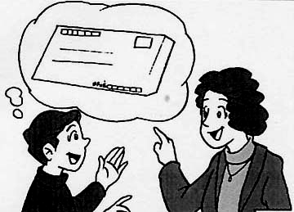
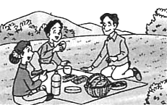
二、判断图意是否与所听内容相符。相符的写“T”，不相符的写“F”。（10分）
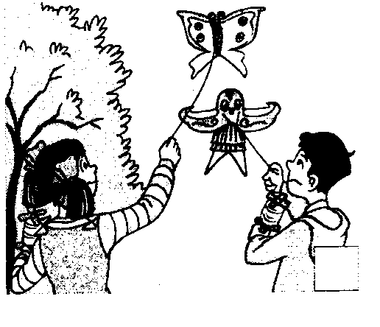
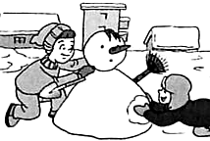
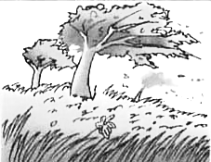

1. 2. 3. 4. 5.
( ) ( ) ( ) ( ) ( )
三、根据你所听到的内容，选择正确的答语，听两遍。（5分）
( )1.A.Yes,speaking B.Yes,I’m Nancy C.That’s Nancy speaking
( )2.A.Yes, I do. B.I like winter best. C. Yes, I like winter.
( )3.A.No, she isn’t. B. Yes, she can. C. No, she doesn’t.
( )4.A.On the hill. B. In spring. C. On foot.
( )5.A.It’s Thursday. B.I t’s the 17th of April.
C.It’s on the 17th of April.
四、听录音，根据短文内容选择正确的答案，听两遍。（10 分）
( )1. What subject does he study at school?
A. Piano. B. Art. C. PE.
( )2. When will he stop his study?
A. April. B. June. C. July.
( )3. What is he going to do in the evening?
A. To have dinner. B. To play the piano. C. To study Art.
( )4. How many hours will he sleep?
A. Four hours. B. Eight hours. C. Nine hours.
( )5. He will go home by _____.
A. bus B. bike C. taxi.
笔试部分（70分）
一、根据所给的图片，找出正确的句子，并用正确的格式抄写。（2分）
1、 The sign on the wall means “Danger”
2、 We are going to go on an outing this weekend.
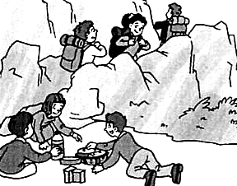

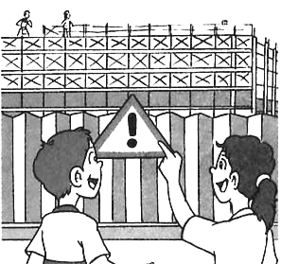
二、英汉互译。（10分）
1、在儿童节 2、have a chat
3、在五月三号 4、collect boxes
5、步行 6、a moment ago
7、去购物 8、get off
9、说汉语 10、go for a walk
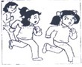
三、根据所给图片的提示，填入所缺的单词。（8分）
1、Helen than Nancy.

2. Listen,the girl is ,she is
a good
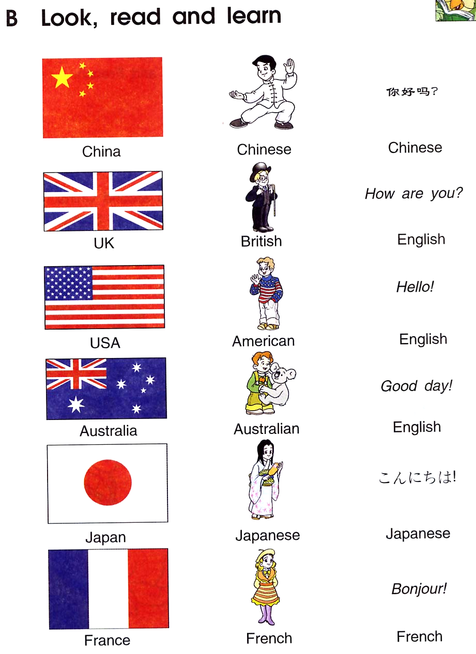
3. Where is Nancy from?

She is from the .
4. I carrots on the farm
last Sunday.
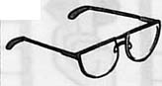
5. Where are my ?
They were on my desk just now.
四、选择题（10分）
( ) 1、---- Do you like ,Mike? ---- Yes, I do.
A. jog B. joging C. jogs D. jogging
( ) 2. My birthday is _______the 2nd of June .Nancy’s birthday is _____June ,too.
A. on,on B. in, on C. on, in D. in,in
( )3. After a football match, Jim is black and blue.”black and blue” means .
A.蓝色和黑色 B.青一块，紫一块 C. 黑白分明 D. 身上很脏
( )4.---- Thank you very much. ----
A.Thank you B.That’s right C.Oh,yes D.That’s all right
（ ）5. Do you have brothers sisters in your family?
A. some…and B. some…or C. any…or D. any…and
（ ）6. There is a lot of ________ in spring there.
A. rain B. rains C. rainy D. rainy
（ ）7.Mr Green is ______father.
A.Jim and Kate’s B.Jim and Kate
C.Jim and kates’ D.Jim’s and Kate’s
( )8.---Is this your pen, Nancy? ----Yes,
A.this is B.it’s C.it isn’t D.it is
( )9、His classroom is on the second floor . is on the third floor.
A. Their B. They C. Theirs D. They’re
( )10、The girl often home at 5:20.
A. go B. go to C. goes D. goes to
五、从Ⅱ栏中找到与Ⅰ栏相对应的答句。（4分）
Ⅰ Ⅱ
( )1.How do we go there? A.I’ve got a headache.
( )2.Are you Mr Brown? B.It’s in January or February.
( )3.Can I have your e-mail address? C.Her mane’s Mary.
( )4.What’s the matter? D.Thank you!
( )5.What’s your penfriend’s name? E.Yes,I am.
( )6.When’s Spring Festival? F.Sorry, wrong number.
( )7.Hello, may I speak to Gao Shan? G.Yes,of course.
( )8.Oh, your new dress is nice! H.By taxi.
六、看图完成对话，每空一词。（15分）
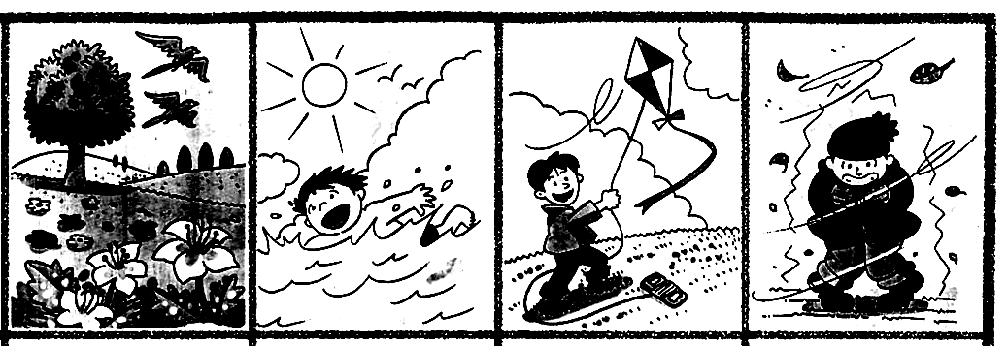
1、A: Which do you like ?
B: I like .
A: Why?
B: Because it’s , I can .

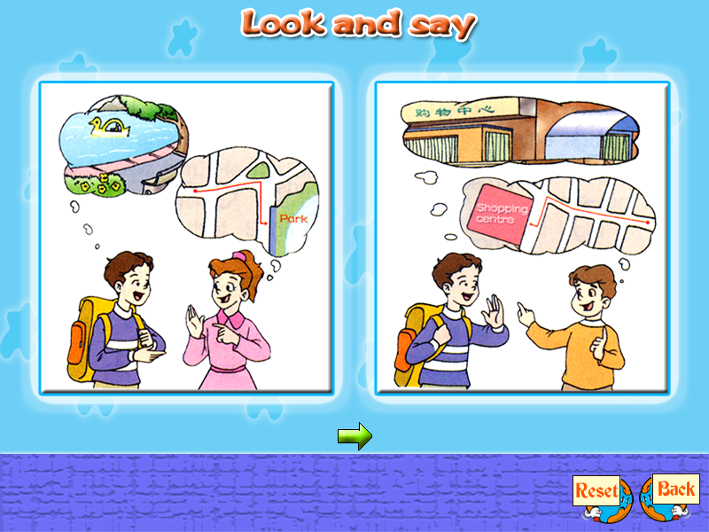
2、A: Excuse me, can you me the
to the park?
B: Go this street and at
the crossing.
A: How is it from here?
B: It’s about 5 kilometres away. You can NO.11.
A: Thank you very much.
B: You’re welcome.
七、情景选择。（5分）
( ) 1.当你想知道这个周六的天气如何时，问：
A. What is the Saturday? B. What is the weather like this Saturday?
C. It’s Saturday today？
( ) 2.当你想了解别人是否需要一杯茶时，问:
A. What are you looking for? B. What do you like best?
C. Would you like a cup of tea?
( ) 3.当你想了解别人多长时间去一次肯德基时，问：
A. How do you go to the KFC? B. How long do you go to the KFC?
C. How often do you go to the KFC?
( ) 4.当别人对你说：Happy New Year 时，你应该说：
A. Thank you B. That’s OK C. The same to you
( ) 5当你想知道这些桃子多少钱时，问：
A. How much are these peaches? B. How much are these peach?
C. How many peaches are there?
八 阅读，判断正误，回答问题并完成表格（10分）
Dear Mary
I saw your name in the newspaper, you asked for penfriends in China. I would like to be your penfriend.
I am twelve years old. I live in Nanjing. I am a student at Liuyuan Primary School. We study Chinese, English, Maths, Science, Art, PE and some other subjects. My favorite subjects are Maths and PE. I like playing the guitar, collecting stamps and taking photos. I like summer best because my favourite sport is swimming. I will finish primary school soon and go to a middle school this year.
My family is not so big. There are five people in it: my grandfather, my father, my mother, my little sister and I. My father is an engineer, my mother is a doctor. My grandfather was a policeman and now he is retired（退休）. My sister is a student of Grade（年级） 4 in my school. We live in an old house. Near our house, there is a beautiful park. Our family often take a walk in the park after supper.
I would like to know something about you and the UK. Please write to me soon. My e-mail address is Liuyuan@163.com. My fax and telephone number is 86-25-82011853.
With best wishes
Yu Ren
根据所给提示用英语完成虞仁同学的个人简历表
Name: |  |  |  | Age:
Telephone and fax number:
School:
Favourite subjects:
Hobbies:
Favourite sport:
Favourite season:
Favourite food:
Penfriend’s name
九、看图回答问题（6分）

1、When’s Children’s Day?

2、Do you like Children’s Day?

3、What do children usually do on Children’s Day?

听力稿：
一、听录音，选出你所听到的内容。听两遍。（5分）
1．Would you like to fly a kite with me?
2. There’s a concert in the school tomorrow afternoon.
3. We’re going to meet at a quarter to seven.
4. The museum is on the left.
5. Can I have an envelope?
二、听录音，判断图意是否与所听内容相符。相符的写“T”，不相符的写“F”。（听一遍）
1.The girl’s kite is higher than the boy’s.
2. I like winter,because we can stay at home.
3. Can I have some gule? Sure.
4. Today is windy.
5. We are going to have a picnic tomorrow.
三、根据你所听到的内容，选择正确的答语。听两遍。（5分）
1. I think you’ll get stronger soon.
2. Which season do you like best?
3. Does your sister dance better than you?
4. When do you usually plant trees every year?
5. What’s the date today?
四、听录音，根据短文内容选择正确的答案（听两遍）12 %
John Brown is an Art School student. He will leave the school in July this year. He is going to work in the evening. He is going to play the piano at the restaurant of the Star Hotel. After work he will have dinner. He will take a taxi home at three in the morning. He will go to bed at four and get up at one in the afternoon. He likes the work because he only works three nights a week.

