听力部分（30分）

一、听录音，找出你所听到的内容。（10分）
( ) 1. A. walk B. winter C. write
( ) 2. A. hungry B. hurry C. hundred
( ) 3. A. 2nd January B. 2nd June C. 2nd July
( ) 4. A. 12:15 B. 11:45 C. 11:15
( ) 5. A. pick apples B.pick oranges C. pick peaches
( ) 6. A. a snowball B. a brown ball C.a blue ball
( ) 7. A. at the first stop B. at the fifth stop C.at the third stop
( ) 8. A.contest B.concert C.country
( ) 9. A. Nancy does’t do well in PE B. Nancy does well in PE
C. Nancy ‘s doing well in PE
( )10. A. His telephone number is 68951765.
B. Her telephone number is 68851765.
c. His telephone number is 68951675.
二、根据所听内容，选择正确答案 (听两遍) (共10分)
( ) 1. A. Ben. B. Jim. C. We don’t know.
( ) 2. A. He went on an outing. B. He saw a play.
C. He saw a Beijing opera.
( ) 3. A. On foot. B. By bike. C. By bus.
( ) 4. A. She is from China. B. She is from the UK.
C. She’s from the USA.
( ) 5. A. No, he has a fax machine. B. Sorry , he doesn’t. C. Yes , he does.

三、根据听到的短文内容，填入所缺单词。（读三遍）（10分）
Dear Ben:
Thank you for your letter. I’m very glad to be your________.
I’m in Grade six. I’m eleven________old.I’m one year________than you. My hobbies are________stamps and reading. My favourite subject is English. I can________English stories now. And I like________English songs. How about you? I have a ________ of three: my father,my mother and me. My________ number is 6298779. My e-mail is liyang@river.com. Please to me soon.

Best wishes
Li Yang

笔试部分（70 分）

一、判断下列各组单词划线部分读音是否相同，相同的写T，不相同的写F. （5分）
（ ）1.young shout （ ）2. study student
（ ）3. shirt turn （ ）4. world doctor
（ ）5. great tea （ ）6. weather heavy
（ ）7. cool book （ ）8. cake black
（ ）9. three there （ ）10. child chair

二、英汉词组互译。（10分）
1、擅长于跑步_____________ 2、by the way ___________
3、去散步_____________ 4、ask for penfriends _________
5、在春天______________ 6、stop thief ___________________
7、比我强壮___________ 8、most of the time __________
9、写信 _______________ 10、every three days ___________

三、选择。（12分）
( ) 1. Wang Bing to the zoo last Sunday.
A. goes B. going C. went
( ) 2. Yang Ling jumps than the other girls .
A. fast B. high C. farther
( ) 3. walk on the grass .
A. No B. Not C. Don’t
( ) 4. My birthday is the first of June .
A. on B. in C. at
( ) 5. It often in summer.
A. rain B. raining C. rains
( ) 6. We can go on outing in autumn.
A. a, a B. an, an C. an, /
( ) 7. Where are your glasses ?
They there a moment ago .
A. were B. was C. are
( ) 8. How your mother spend weekend?
A. does she B. does her C. do her
( ) 9. I met Miss Li Beijing Street .
A. at B. in C. on
( )10. I’m sorry hear that .
A. to B. in C. on
( )11.What Jane ?
She’s writing an e-mail to her pen friend.
A. will,do. B. did,do C. is,doing
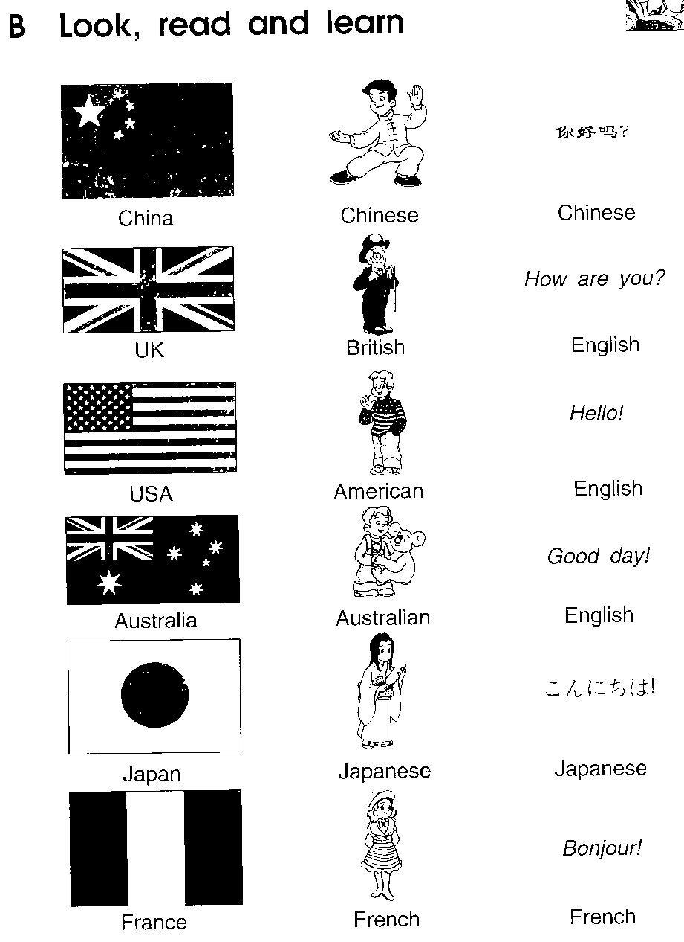
( )12.This is the national flag of .
A. the USA B. China C. the UK

四、用所给单词的适当形式填空。（8分）
1. He _____________(read) in the classroom now.
2. There ______ (be) some water in the glass yesterday.
3. Mary (go) to the cinema every Saturday.
4. I __________ (watch) TV last night.
5. The lamp on the desk is ______ ( I )
6. ----How many______ (peach) are there in the basket?
----There ______ (be) only one.
7. Liu Tao and I ( take ) part in the
sports meeting tomorrow.

五、改错，找出错误，并在横线上加以改正。（10分）
( ) 1 .The policeman stop the thief and I got my purse back yesterday.
A B C
（ ）2.Children’s Day is on the first of July.
A B C
( ) 3.Would you like coming to my birthday party? Yes , I’d love to.
A B C
( ) 4. My hair is longer than Nancy.
A B C
( ) 5. Tony White is British. He comes from the USA.
A B C
六、翻译句子。(10分)
1、本跳得没有迈克高。
Ben __________ jump as __________ as Mike.
2、--明天下午你们干什么？ --我们要去看一场演出。
-- What are you going to do ___________ afternoon?
-- We are going to see a ___________.
3、我想要去火车站，但是我不知道路。
I wanted to go to the train ___________, but I didn’t know the _____
4、在春天，树开始变绿了。
In ___________, the trees start to ____________ green.
5.昆明的大部分时间是很温暖的。
It is __________ ___________ of the time in Kunming.
七、阅读理解 （15分）
A
Liu Tao: I want to write a letter.
Mum: Who do you want to write to?
Liu Tao: Mike. I want to be his penfriend . I saw his name in the newspaper yesterday afternoon.
Mum: Who’s Mike?
Liu Tao: He’s an English boy. He lives in London.
- 根据上下文内容，填入适当的单词 （每空一词）5%
Mike is from __________ and lives in London. Liu Tao _______ to write a letter ________ him. He __________ about Mike in the newspaper yesterday afternoon. Liu Tao wants to _________ Mike’s penfriend.

B
阅读短文，并根据短文内容判断以下句子是否与短文内容相符，相符的用“T”,不相符的用“F”。
Tom is a little boy, and he is only seven years old. One day he went to the cinema. It is the first time for him to do that. He bought a ticket (买了票) and then went in. But after two or three minutes he came out, bought a second ticket and went in again. After a few minutes he came out again and bought a third ticket. Two or three minutes later, he came out and asked for another ticket. Then the girl in the ticket office asked him,” Why do you buy so many tickets? How many friends do you meet?” Tom answered, “ No, I have no friend here. But a big boy always stops me at the door and tear(撕) my ticket to pieces.”
（ ）1.Tom is seven years old.
（ ）2.It wasn’t the first time for Tom to go to the cinema alone(单独)
（ ）3.Tom bought three tickets before the girl asked him.
（ ）4.Tom met three friends that day.
（ ）5.The big was a worker in the cinema.

听力材料及答案

一、听录音，找出你所听到的内容。（10分）
1. walk 2. hurry 3. 2nd January
4. 11:45 5. pick peaches 6. a brown ball
7. at the fifth stop 8. contest 9. Nancy does well in PE
10. His telephone number is 68951765.
（A B A B C B B A B A）
二、根据所听内容，选择正确答案 (听两遍) (每小题1分, 共8分)
1. A: Does Jim jump farther than Ben ?
B: Yes, he does.
Q: Who jumps farther , Jim or Ben ?
2. A: Did you go on an outing last Sunday, Lin Tao ?
B: No, I didn’t. I went to see a Beijing opera show.
Q: What did Lin Tao do last Sunday?
3. A: Excuse me , is the zoo far from here ?
B: Yes, you can take bus No.3 there and get off at the fifth stop.
Q: How can the man go to the zoo ?
4. A: Yesterday Su Yang read about an American girl, Lily. Lily wanted a penfriend in China .
B: Oh, I see. Lily wanted to know something about this country.
Q: Where is Lily from ?
5. A: Can I have your fax number, David ?
B: Sorry. I don’t have a fax machine. I can tell you my mobile phone number .
Q: Does David have a mobile phone ?
( 1. B 2. C 3. C 4. C 5. C )

三、根据听到的短文内容，填入所缺单词。（读三遍）
Dear Ben:
Thank you for your letter.I’m very glad to be your penfriend.
I’m in Grade six.I’m eleven years old.I’m one year older than you. My hobbies are collecting stamps and reading. My favourite subject is English.
I can read English srories now.And I like singing English songs. How about you? I have a family of three: my father, my mother and me. My telephone number is 6298779. My e-mail is liyang@river.com. Please write to me soon
Best wishes
Li Yang

（penfriend years older collecting English read singing family telephone write）

一、F F T F F T F F F T
二、be good at running 顺便说一下
go for a walk 要求得到笔友
in spring 捉贼
stronger than me 大部分时间
write a letter 每三天
三、CCCAC CABBA CA
四、is reading , was , goes , watched , mine , peaches is
are going to take/ will take
五、1.A stopped 2. C June 3. B to come
4. C Nancy,s 5. C the UK
六、doesn’t high tomorrow play station way
spring turn warm most
七、A England wants to read be
B TFTFT

,

