六年级英语上册第一单元测试题
（考试时间：40分钟 满分：100分）
命题者：江口街道中心小学 王丹君
学校:__________________ _班级:_________ 姓名:__________________ 考生编号:_____________
听力部分（30%）

听录音，圈出你所听到的字母组合。（5%）
1． 2． 3．
bap
bad
HIK
HJK
str
srt
4．
5．
nml
mnl
AJGK

AHGK

二、听录音，圈出与你听到的内容相符的图片。（5%）
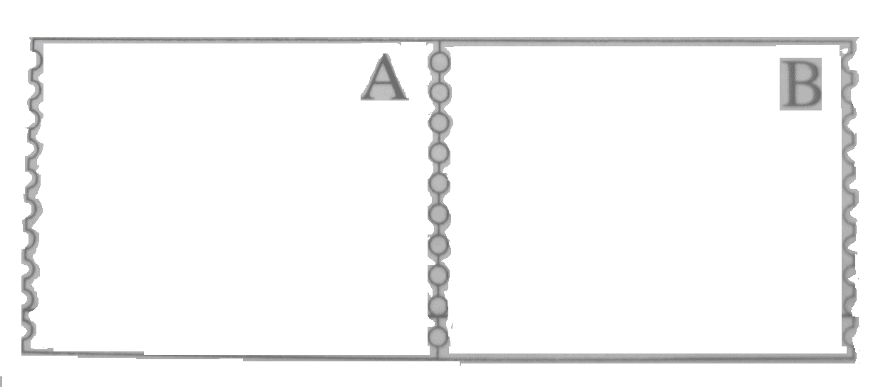
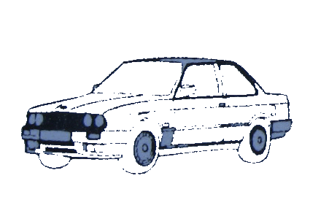
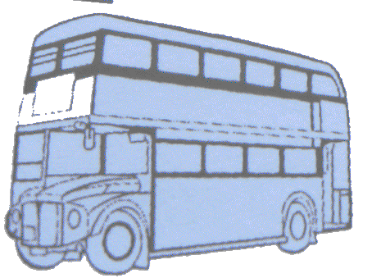
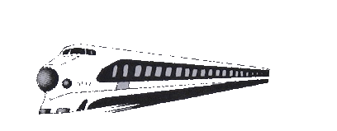
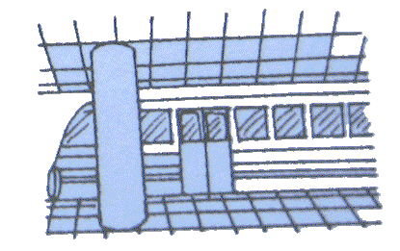
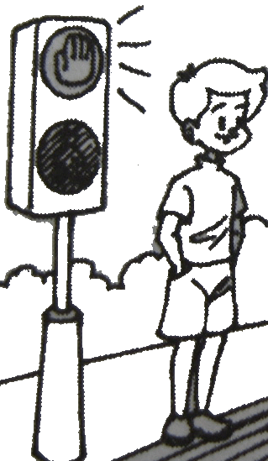
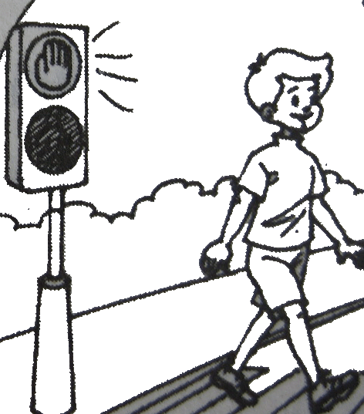
1. 2. 3.

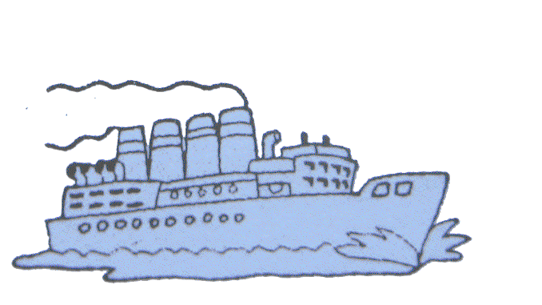
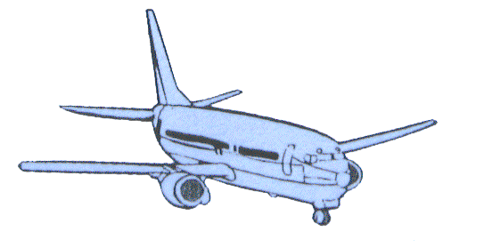
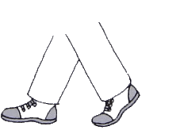
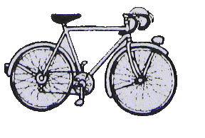
4. 5.

三、听录音，选出你所听到的单词，把代表该单词的字母序号写在右边括号里。（10%）
ship
train
bus
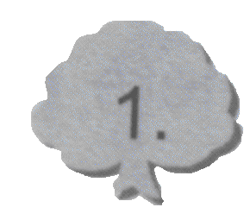
A B C ( )

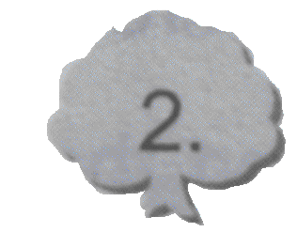
A B C ( )
stop
wait
go
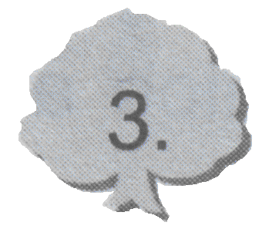
A B C ( )
traffic lights
traffic rules
green light

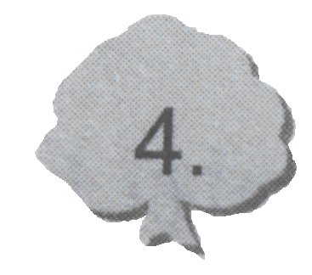
A B C ( )
red light
yellow light
green light

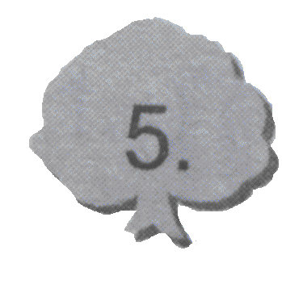
A B C ( )
far
near
fast

四、下面5个小对话，在与对话内容相符的图片下面打“√”，不相符的图片下打“×”。（10%）
1. 2. 3.

( ) ( ) ( )
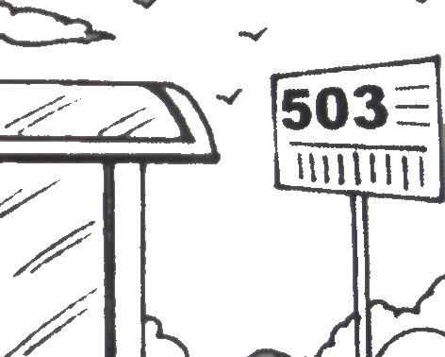
4. 5.

( ) ( )

笔试部分（70%）
一、仔细观察，把下面的字母组合大写形式改成小写形式，小写形式改成大写形式。（5%）
1． UP 2． gj 3． df 4．KY 5．ML

二、仔细观察，按字母表顺序填充字母，注意用小写形式书写。（10%）
1． 2． 3．
h j e m
4． 5． 6．
p r v y

三、看图片，圈出正确的单词。（5%）
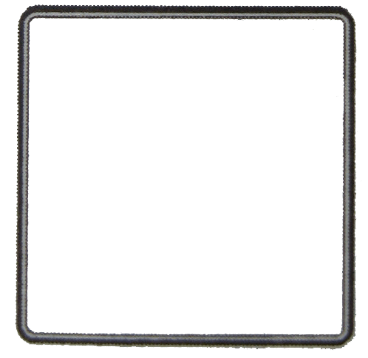
1． 2． 3．
A．by train
B．by ship

A．wait
B．go
A．by bike
B．by bus

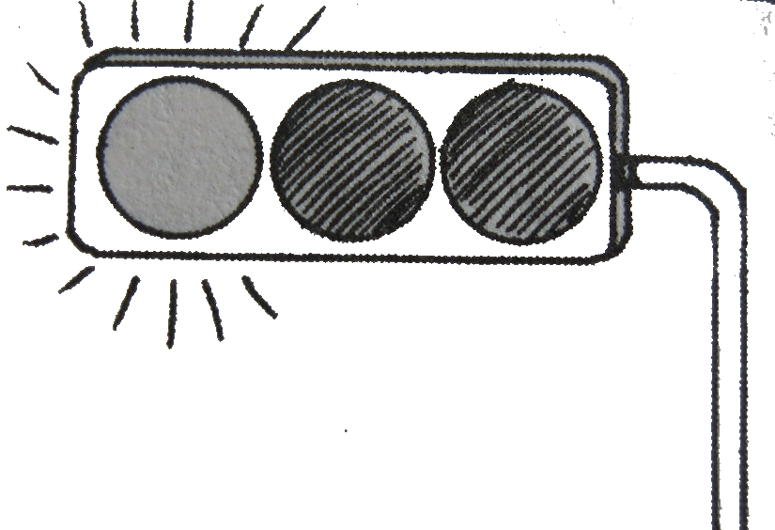
4． 5．
A．traffic lights
B．traffic rules
A．by plane
B．by subway

四、选出不同类的单词，并把序号写在括号里。（5%）
（ ） 1. A . ship B. light C. subway D. plane
( ) 2. A..red B.yellow C.green D.country
( ) 3. A. how B.wait C.stop D.go
( ) 4. A.China B.Hangzhou C.Australia D.England
( ) 5. A.sometimes B.usually C.where D.often
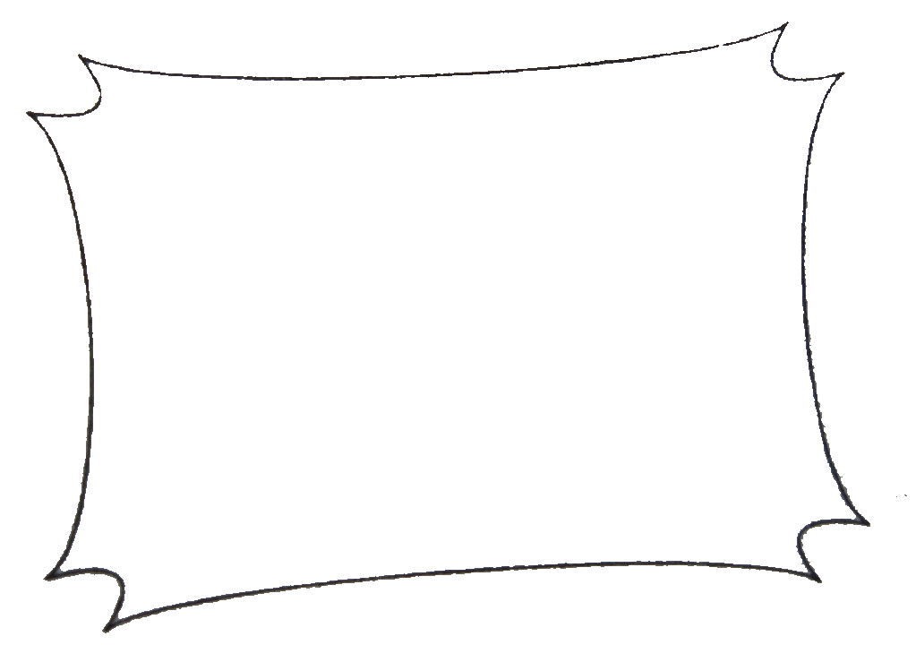
五、看图填词。（5%）
1. I go to Beijing . . ( by train ; by bus)

2. Look at the . (traffic rules; traffic lights )
3.
at a green light. (Go; Wait)
4.Go there . (by plane ; by ship)

5. Let’s go to the park . (on foot; by bike).

六、选择正确的句子。（5%）
（ ）1. 想询问对方是怎样去学校的,可以问:
A. How do you go to school? B. How can I go to school ?
( ) 2. 想询问对方“我”可以怎样去公园,可以这样问：
A. How do you go to the park? B. How can I go to the park?
( ) 3. 别人跟你说“Thank you！”，你应该这样回答：
A. You’re welcome. B. Ok..
( ) 4. “我可以走路去吗？”，应该这样问：
A. Can I go on foot ? B. Can I go by bike?
( ) 5. 想知道别人的名字可以这样问:
A. How are you ? B. What’s your name ?

七、连线成句。（10%）
1． How do you the traffic lights.
2. Wait by bike.
3. Look at go to the USA?
4. Sometimes I go at a yellow light.
5. How can I get to the zoo？
八、排列句子，注意标点符号。（15%）
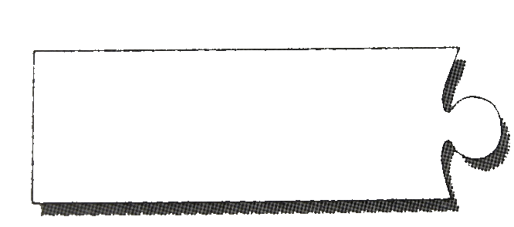
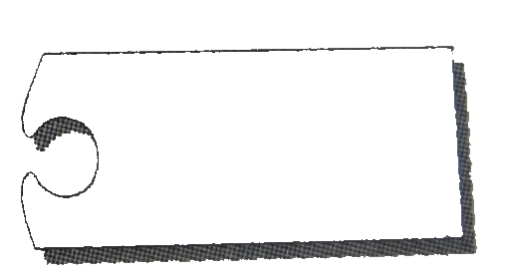
1．
you
to
how
do
schoolo
go

2.
Hangzhou
to
I
by
go
bus

3.
by
go
No.5
bus
can
you
the

4.
get
can
Binjiang park
to
how
I

5.
traffic
the
remember
rules

九、阅读理解。（10%）

Today is Betty’s birthday. Some friends will go to Betty’s home. They are Lucy,Tom,Mary and Jack.
Betty: Hello,Lucy! How do you go to my home?
Lucy: I go to your home by bike because it’s near.
Betty: How about you ,Tom?
Tom: I go there by bus .
Betty: Which bus can you take ?
Tom: I can take the No.18 bus.
Betty:How do you go to my home,Mary?
Mary: Oh, My home is quite far from yours. I go there by car. My father is free today. He can take me there.
Betty: Do you come to my home by bike or on foot, Jack?
Jack:Oh, I go there on foot.

( )1. Whose birthday is it?
A. It’s Betty’s. B. It’s Mary’s. C. It’s Lucy’s.
( )2.How does Tom go to Betty’s home?
A.By car. B. By bus. C. By bike.
( )3.Is Mary’s home far from Betty’s ?
A. Yes, it is. B. Yes, it isn’t. C.No, it isn’t..
( )4.How does Jack go to Betty’s home?
A. On foot. B.By bike. C.by car .
( )5.How many friends go to Betty’s home on foot ?
A. Two. B. One. C.Three.
听力材料：
一、1．bad 2．HIK 3．str 4．mnl 5．AJGK
二、1．by bus 2． by train 3．Stop at a red light. 4． by plane 5．on foot
三、1．train 2．go 3．traffic lights 4．green light 5．Near
四、1．How do you go to school ?
I go to school on foot .
2．How do you go to Shanghai ?
I go by bus .
3．How can I get to Beijing?
You can go by bus .
Can I go by plane ?
Sure , if you like.
4．How can I get to the zoo?
You can go by the No. 602 bus .
5．It’s a green light. Let’s go .
OK.

参考答案：
听力部分：
一、1．A 2．B 3．B 4．A 5．B
二、1．B 2．A 3．A 4．B 5．A
三、1．B 2．C 3．A 4．C 5．B
四、1．√ 2．× 3．√ 4．× 5．√
笔试部分：
一、（略）
二、（略）
三、1．A 2．B 3．B 4．A 5．A
四、1．B 2．D 3．A 4．B 5．C
五、1．by train 2．traffic lights 3．Go 4．by ship 5．on foot
六、1．A 2．B 3．A 4．A 5．B
七、（略）
八、1．How do you go to school ?
2．I go to Hangzhou by bus .
3．You can go by the No.5 bus .
4．How can I get to Binjiang Park ?
5．Remember the traffic rules.
九、1．A 2．B 3．A 4．A 5．B

