卷首语：亲爱的同学们，第一学期即将过去，在这里为期末考试练练兵，京翰教育预祝你期末考个好成绩！

牛津小学英语6A unit 1 —— unit 2 单元检测试卷

听力部分

一、听录音，选出你所听到的单词。10’
（）1 A park B pick C point
（）2 A cousin B costume C come up
（）3 A always B ask C away
（）4 A April B August C Aladdin
（）5 A January B July C June

二、听录音，按顺序给图片标上序号。10’
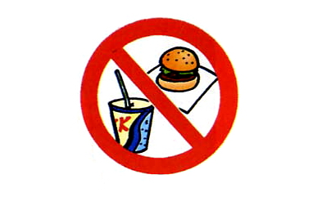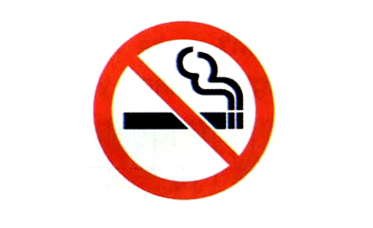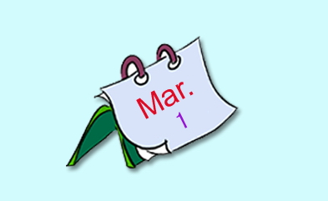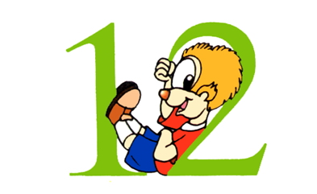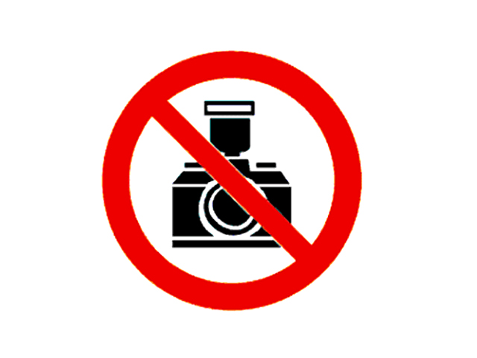
（ ） （ ） （ ） （ ） （ ）

三、听录音，补全对话。10’
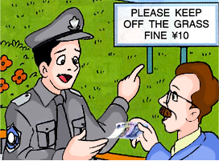
Early this ，Mr Smith is a in the park . Suddenly , he something on the grass .It is a ten-yuan . He is very happy and walks to it . He looks , there is no one nearby . So he it quickly . The park keeper to him ,points to the sign on the grass and says :”Please keep off the grass , fine ten-yuan.”
笔试部分
一、英汉互译。20’
1、公共标志 2、Don’t make noise
3、禁止乱扔垃圾 4、stay away from
5、举行生日派对 6、the twenty-first of May
7、在一月一日 8、talk about
9、在星期四的下午 10、as a present

二、选出最佳答案。20’
（ ）1、The sign on the wall ‘No smoking’.
A say B says C tell D tells

（ ）2、Mum，give ten yuan ，please！
A me B I C mine D my

（ ）3、Can I ,Dad ?
A watching TV B watches TV C watch TV D watch tv

（ ）4、Would you like to play basketball with me ？
.
A Yes，I like B Yes, I’d like .
C Yes, I’d like to D Yes, I would like .

( ) 5、Aladdin is his costume . It is Mike !
A taking off B putting off C taking out D putting away

( ) 6、On of June we have a good holiday .
A one B first C ones D the first

( ) 7、Mum’s coat is black . is white .
A He B Mine C Your D Her

( ) 8、Which is the first day of the week ?
A Monday B Saturday C Sunday D January

( ) 9、The boys books in the classroom now .
A are looking B are reading C are seeing D are looking at

( ) 10、It’s time breakfast .
A to B for C to having D for have

三、选出错误的选项，并在括号里改正。10’
( ) 1、There are a lot of sign in the street . A B C D

( ) 2、You must keeping quiet in the library .
A B C D
( ) 3、When’s your birthday？
A B
It’s in the Second of January .
C D
( ) 4、What date is it today .
A B C D
It’s Wednesday .
( ) 5、They are talk about Ben’s birthday .
A B C D

四、阅读短文，判断下列句子是否正确，正确的写（T），错误的写（F）。10’
Linda and Ann are classmates . They are American girls . Linda is tall . She has black hair , brown eyes and dark (深色的) skin . Ann is not tall .She has blonde(金色的) hair , blue eyes and fair(白皙的) skin . They both speak English .
Linda is twelve years old . She likes dancing . She dances well . Ann is thirteen . She can sing many Chinese songs .
They go to school together in the morning , and go home together after school .
Linda’s birthday is in January . Ann’s birthday is in September.
( )1、Linda and Ann are twins .
( )2、Ann has fair skin .
( )3、Linda is short . Ann is tall .
( )4、Linda’s birthday is in September .
( )5、Linda likes singing .

五、按要求改写下列句子。10’
1、It means ‘Do not touch ’ .(改成同意句)
It means ‘ No ’.
2、我妹妹只有六岁。但她却总有许多问题。（根据中文意思翻译句子）
My sister is only , but she
a lot of .
3、It means we shouldn’t walk on the grass . ( 对划线部分进行提问)
mean ？

听力材料及答案：
- 听录音，选出你所听到的单词，每个听两遍。
1、point 2、cousin 3、always 4、April 5、July
答案：c a a a b
- 听录音，按顺序给图片标上序号，每个听两遍。
- A：What does the sign on the wall mean ？
B：It means No smoking .
- A：What date is it today ？
B：It’s the first of March .
- A：Sir，Can’t you see the sign over there ？Please don’t take photos here .
B：I’m sorry .
- A：How many subjects do you have this term ？
B：Twelve .
5、A：The sign on the bird’s cage is interesting . What does it mean ？
B：It means ‘No eating or drinking’.
答案：51243
- 听录音，补全对话，听三遍。
Early this morning ，Mr Smith is taking a walk in the park . Suddenly , he sees something on the grass .It is a ten-yuan note . He is very happy and walk to it . He looks around , there is no one nearby . So he picks it up quickly . The park keeper comes up to him ,points to the sign on the grass and says :”Please keep off the grass , fine ten-yuan.”

笔试答案
一、英汉互译。
答案：1 public signs 2 不要发出喧闹声（不要制造噪音） 3 No littering
4 远离 5 have a birthday party 6 五月二十一日 7 on the first of January 8 谈论（讨论）9 on Thursday afternoon 10 作为礼物
二、选出最佳答案。
B A C C A D B C B B
三、选出错误的选项，并在括号里改正。
1 C signs 2 B keep 3 C on 4 B day 5 B talking
四、阅读短文，判断下列句子是否正确，正确的写（T），错误的写（F）。
F T F F F
五、按要求改写下列句子。
1 touching 2 six years old always ask questions 3 What does it

