卷首语：亲爱的同学们，第一学期即将过去，在这里为期末考试练练兵，京翰教育预祝你期末考个好成绩！

六年级英语试卷（Unit 1）
班级 姓名 学号
- 听录音，选出你所听到的单词或短语。（5分）
( )1. A litter B better C letter
( )2. A touch B much C watch
( )3. A talk B take C walk
( )4. A mask B ask C desk
( )5. A grass B class C glass

- 听录音，选出你所听到的内容。（5分）
( )1. A his cousin B her cousin
( )2. A on the dogs’ cage B on the birds’ cage
( )3. A come in B come up
( )4. A He always has a lot of questions . B. He always has lots of questions
( )5. A We can talk in the class. B. We can’t talk in the class.

- 听录音，给下列图片标上正确的序号。（5分）
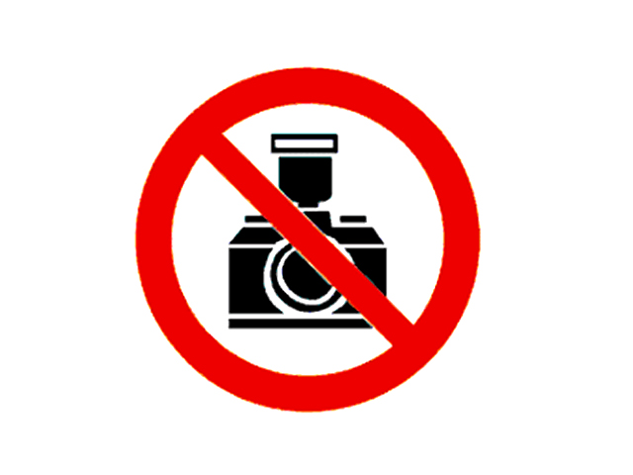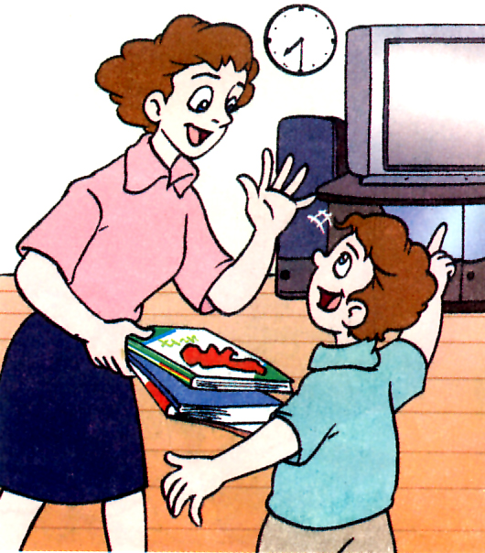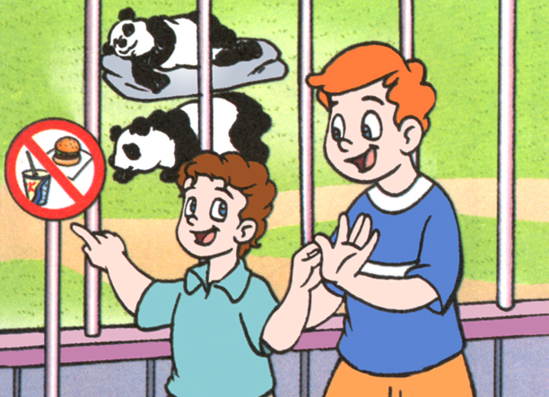
( ) ( ) ( )

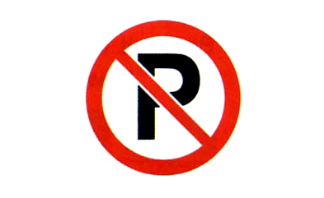
( ) ( )

- 听录音，选出正确的应答。(5分)
( )1. A. It’s a sign. B. It means you shouldn’t touch it.. C. It’s nice.
( )2. A. It isn’t. B. No, you don’t. C. No, you can’t.
( )3. A. Yes, a lot. B. They have different meanings. C. They are on the wall.
( )4. A. He is Mr. Smith. B. He is a park keeper. C. He is in the park.
( )5. A. I like football. B. I want to play football. C. Yes, I do. I like it.

- 听录音，完成填空。（10分）
It is __________. Nancy and her _________ , Mike, are in the park. Mike is ______ _________ years old, but he _________ a lot about ________ ________. He can see a sign on the _________. It ________ ‘_________’!

笔试部分
- 英汉互译。（20分）
1. 散步___________________________ 2. look around _______________ __
3. 制造噪音______________________ 4.No parking ________________ __
5. 在鸟笼上 ________________ ____ 6. some questions _______________
7. 禁止吸烟 __________________ 8. try again ____________ ______
9. 禁止乱扔垃圾 __________________ 10. different things______________

- 选择填空。（10分）
( )1.My uncle’s daughter is my ______.
A. sister B. aunt C. cousin
( )2. He is ____ Ben some questions ______ public signs.
A. asks to B. ask about C. asking about
( ) 3. Look, these different public signs .
A. mean different things B. means different things
C. mean the same things
( )1.Don’t speak loudly . ________, please.
A. No smoking B. No parking C. Be quiet
( )5. Your book is under the desk. Please ______________.
A. pick up it B. pick them up C. pick it up
( )6. The sign “No parking”.
A. mean B. means C. meaning
( )7. There is a house .
A. beside B. near C. nearby
( )8. Grandma is sleeping. We make noise.
A. should B. shouldn’t C. can
( )9. This is ruler. You should give to .
A. she, it, her B. she’s, her, it C. her, it, her
( )10. There _______ any water in the bottle.
A. are B. aren’t C. isn’t

三．用介词填空。（10分）
1. Can I go ___? No, you must stay away _______ the building.
2.There is a sign ____ the grass. It means ‘Keep _____ the grass’.
3. Ben is talking ______ Jack. They are talking ________hobbies.
4. It’s time ______ have breakfast. I have milk and bread _____ breakfast.
5. The boy ____ the green sweater is point _____ the door.

- 看图完成对话。（10分）
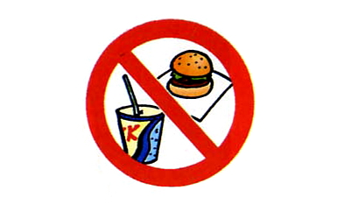
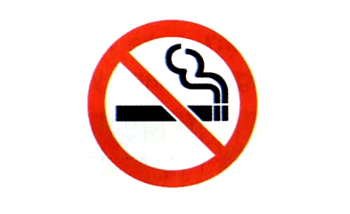
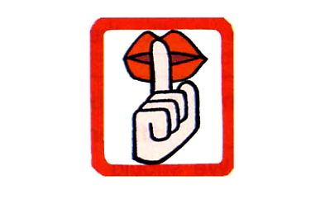

A: There are a _____ ______ signs in the library..
B: Look, there is a hamburger in it.
It ________ ‘_____ _______________’.
A: What ________ it _________?
B: It ________ you _________ _______ or _______.
A: The sign is interesting. What ______ it _______?
B: It ________ you ________ _________in the library.
A: There is a big mouth in the sign.
B: It ________ you _______ _______ quiet.
A: Oh, I see. _______ you.

- 根据首字母填空。

Mr. Smith is in the park. Suddenly, he s______ something on the grass. It is a t________
note. There is no o________ nearby. He w_________ to the note, and p_______ it up. Then a park keeper c______ up to h_________. He s________ to Mr. Smith, ‘C________ you see the sign over there, sir?’ Now you s__________ give me ten yuan.

- 阅读理解。（10分）
It is Sunday. Now Nancy is taking a walk with her good friend Yang Ling. There are many different public signs in the park. Nancy knows a lot about them. Suddenly she sees a short man walking on the grass. She points to the sign and says to him: “ Sir, Look at the sign! You can’t walk on the grass.” The man smiles and says: “ You’re right young men. But I ‘m the park keeper. I’m looking after the grass. I’m picking up the rubbish.”

1 What day is it today?
_________________________________________________________________
2 Where are Nancy and Yang Ling?
_________________________________________________________________
3 Does Nancy know about public signs?
_________________________________________________________________
4 Who is the short man?
_________________________________________________________________
5 What is he doing now?
_________________________________________________________________

附加题：
智力竞赛：你知道这些句子的意思吗？(20分)
No pains, no gains.
__________________________________________________
Like father, like son.
__________________________________________________
Love me, love my dog.
__________________________________________________
Many heads are better than one.
__________________________________________________
同学们试卷完成了，仔细检查吧！
听力答案：
听录音，选出你所听到的单词或短语。（5分）
1 A litter 2 C watch 3. C walk 4. B ask 5.C glass

听录音，选出你所听到的内容。（5分）
1. B her cousin 2. A on the dogs’ cage
3. B come up 4. B. He always has lots of questions
5. B. We can’t talk in the class.

听录音，给下列图片标上正确的序号。（5分）
- A: Mum, what time is it now?
B: It’ s half past two. You should go to school now.
- A: Ben, what does this sign mean?
B: It means ‘No eating or drinking’.
3. A: Look at the sign over there.
B: Oh, don’t take photos here, please.
4. A: Can I park my car here?
B: No, you can’t.
5. A: Mum, I want to watch TV.
B: No, you can’t., You must read books now.

听录音，选出正确的应答。(5分)
1. What does it mean?
2. Can I go in ?
3. Are there any public signs here?
4. What’s the man’s job?
5. Do you know a lot about American football?

听录音，完成填空。（10分）
It is Saturday. Nancy and her brother, Mike, are in the park. Mike is only twelve years old, but he knows a lot about public signs. He can see a sign on the building. It means ‘Danger’!

