京翰教育主编温馨提示：记得书写时一定要做到标准、规范、美观、大方哟！相信你的试卷能给人赏心悦目的感觉！
小学六年级上册练习卷D
Name______________ Class___________________
一、短文选词填空。（选择最恰当的词填在横线上，每空一词）
（orange, go, yellow, in , on, rulers, a, an, road, rules, boat, three, there, are, green , stop, )
You must know the traffic ______ if you walk ____ a city. There ___always _____ lights for the traffic lights. You can cross the street at a ______ light and you must ____ at a red light. The _____ light means “Wait’ . If you drive ___ car, you must drive ___ the right side of the _____.

二、根据上下文，选择正确的句子，并将字母编号写在相应的横线上。
A. Is it far from here? B. Is it near here? C. How can I go to the park?
D. Which bus can I take? E. Where’s the bus stop? F. Thank you.
Amy: Excuse me. __________________________?
Boy: You can go to the park by bus.
Amy:_____________________________?
Boy: Yes, it’s far.
Amy: ____________________________?
Boy: Go straight and you can see the bus stop on your left.
Amy: ___________________________?
Boy: You can take the No.12 bus.
Amy:___________________________.
Boy: You’re welcome.
三、从方框中选出适当的单词完成下面的短文。(15选10, 共10分)
do going evening learn homework day read shopping watch book Sunday by take tomorrow new

Hello, my name is Sarah. I am ________to the have a busy weekend. On Saturday, I am going to _________ a trip.I am going ________ bike. On_________,I am going to go _________ in the morning.I am going to buy a _________ T-shirt.In the afternoon, I am going to go to the library. I want to ________ Harry Porter(<<哈里波特>>)there.In the _________,I am going to do my________ after dinner.Then ,I am going to _________TV.That will be nice.

四、从方框中选出适当的单词完成下面的短文。(15选10, 共10分)

reading, reads, watching, watch, fly, plays, makes, with, is , bike, isn’t, ride, buy, by, for

Alice and her sister are twins. Every evening, Alice likes ________ books. Her sister Ann likes _________ cartoons on TV. Alice usually ________ at the park on Saturday. Ann usually ________ kites. Ann is going to ________ kites ________ Amy this weekend. But Alice ________ going to play at the park. She is going to _______ her bike. Tomorrow afternoon she is going to the _______ shop. She wants to _______ a new bike.

五、从方框中选出适当的单词完成下面的短文。(12选10, 共10分)
tall Chinese teach car bus like foot she teacher her teaches strong

This is my (1)___________teacher. He is (2)_________and (3)________. He is very active. We all (4)_________ him. He often goes to work by(5)_________. His car is blue. It’s beautiful. But sometimes he goes on (6)_________, because it’s good exercises. He has a sister. She is a (7)___________,too. She (8)_________English in my school. She goes to work by (9)________. Sometimes we are on a same bus. We like(10)_________,too.

六、从方框中选出适当的单词完成下面的短文。(15选10, 共10分)
sun water where again noon sprout soil on plant
under tell seeds how flower stream

Do you know to plant a tree? Let me you. First,put some in a pot. Then,put some into the pot. Put in some .Put it the sun. When it’s dry , water it. You can see the in a few weeks. Don’t forget to put it under the
everyday. Wait,you can see a big in several months.

七、选词填空：
on, in, are, there, green, there, three, red, yellow, right, left, a, rules, lights, stop
You must know the traffic ________ if you walk ____ a city. There _______ always _________ lights for the traffic lights. You can cross the street at the ________ light and you must stop at the _______ light. The _______ light means “Wait”. If you drive _______ car, you must drive on the _______ side of the road in China. But in England, people drive on the _______ side of the road.

八、看图,选词填空：
bus, stop, at, bookstore, house hospital
cinema take start west east minutes
Please come to my home on Sunday. Now let me tell you how to come. First, _____from the ______ _______ in front of your home. Then _______ the No. 17 bus. Get off _____the __________. Walk _____ for three _______. You will see a ___________. My _____ is on the left.
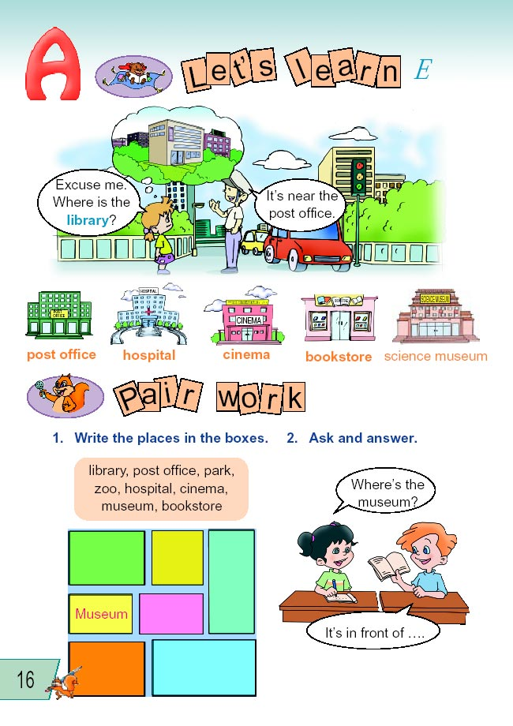
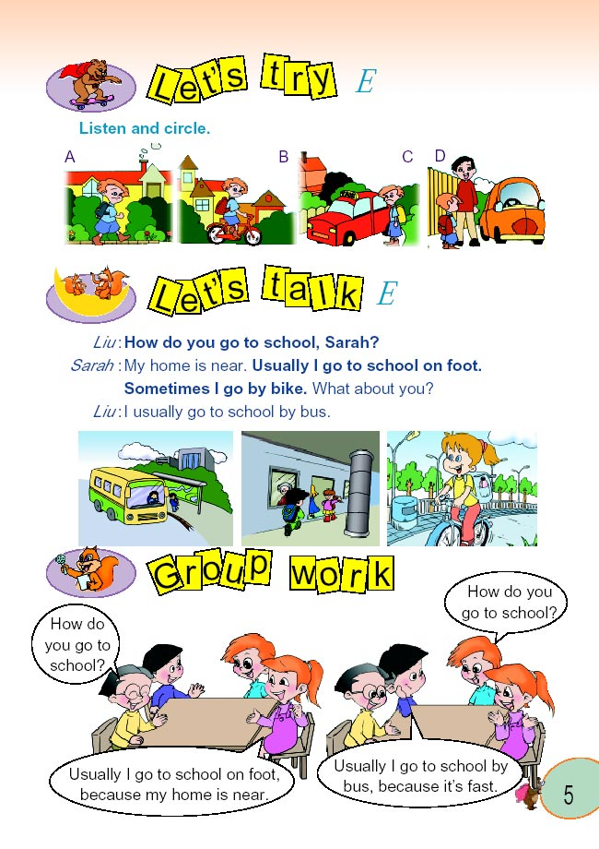

九、选词填空：
post, office, library, bookstore, supermarket, weekend, mother, father, some, this afternoon fun

I’m going to be very busy _________. First, I’m going to the __________ _________. I’m going to send a letter to my ________. He is in Beijing now. Then, I’m going to the ___________. I’m going to buy _______ books about computer. On Sunday, I’m going to the _________ in the morning. I’m going to buy some food for next _________. In the ___________, I’m going to the cinema with my friend. That will be _________!

