六年级英语上册期末阶段性测试题
听力部分（20％）
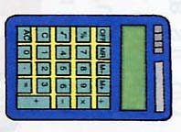
一 听录音，选出你所听到的内容（听两遍）
1  （ ） |   A | 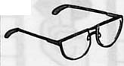  B | 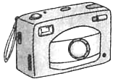  C | D

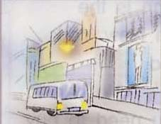  2  （ ） | 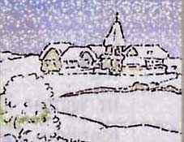  A | B | 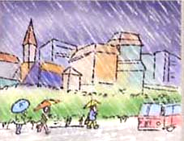  C | 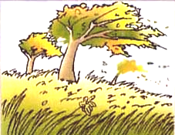  D

3  （ ） | 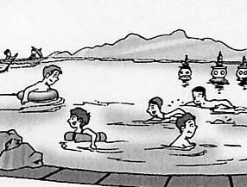  A | 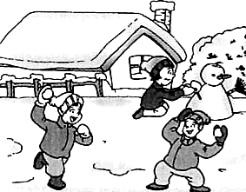  B | 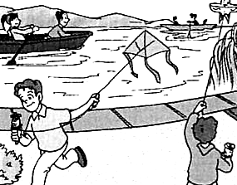  C | 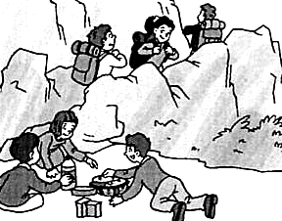  D
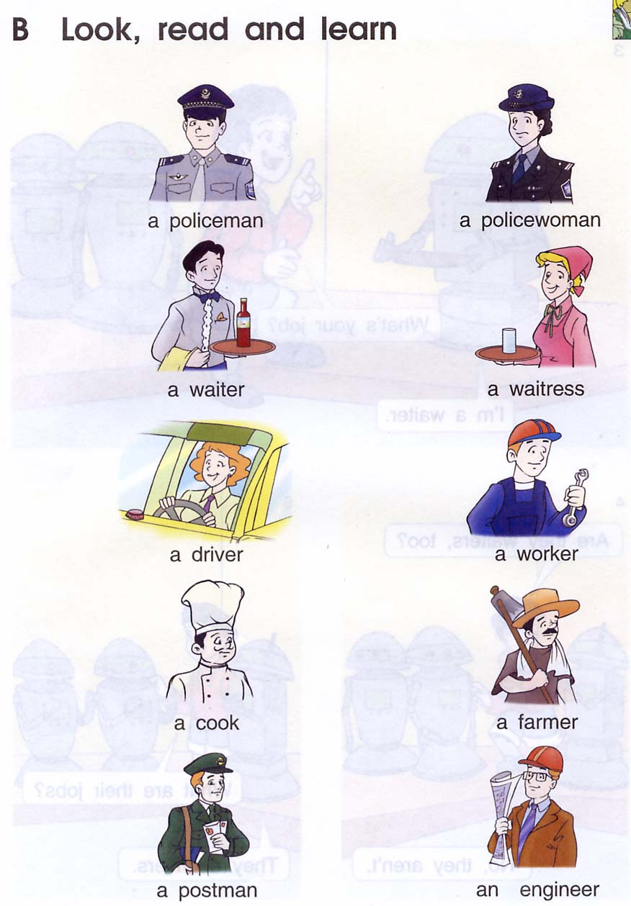
4  （ ） | 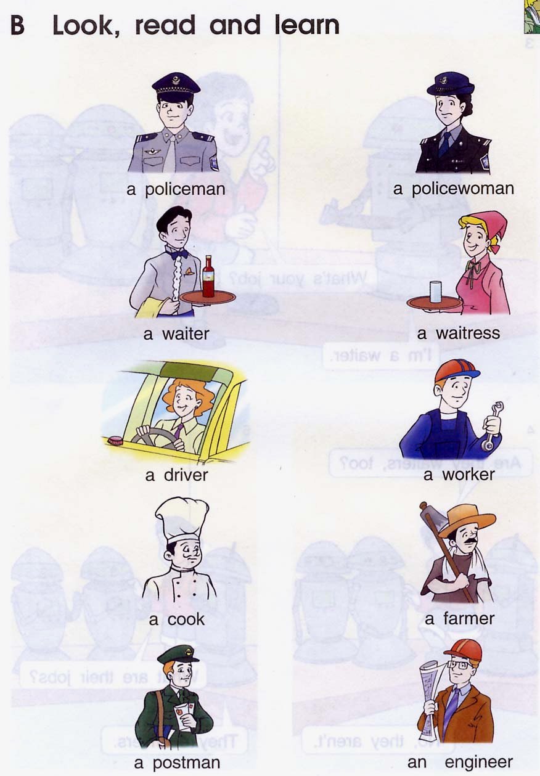  A | 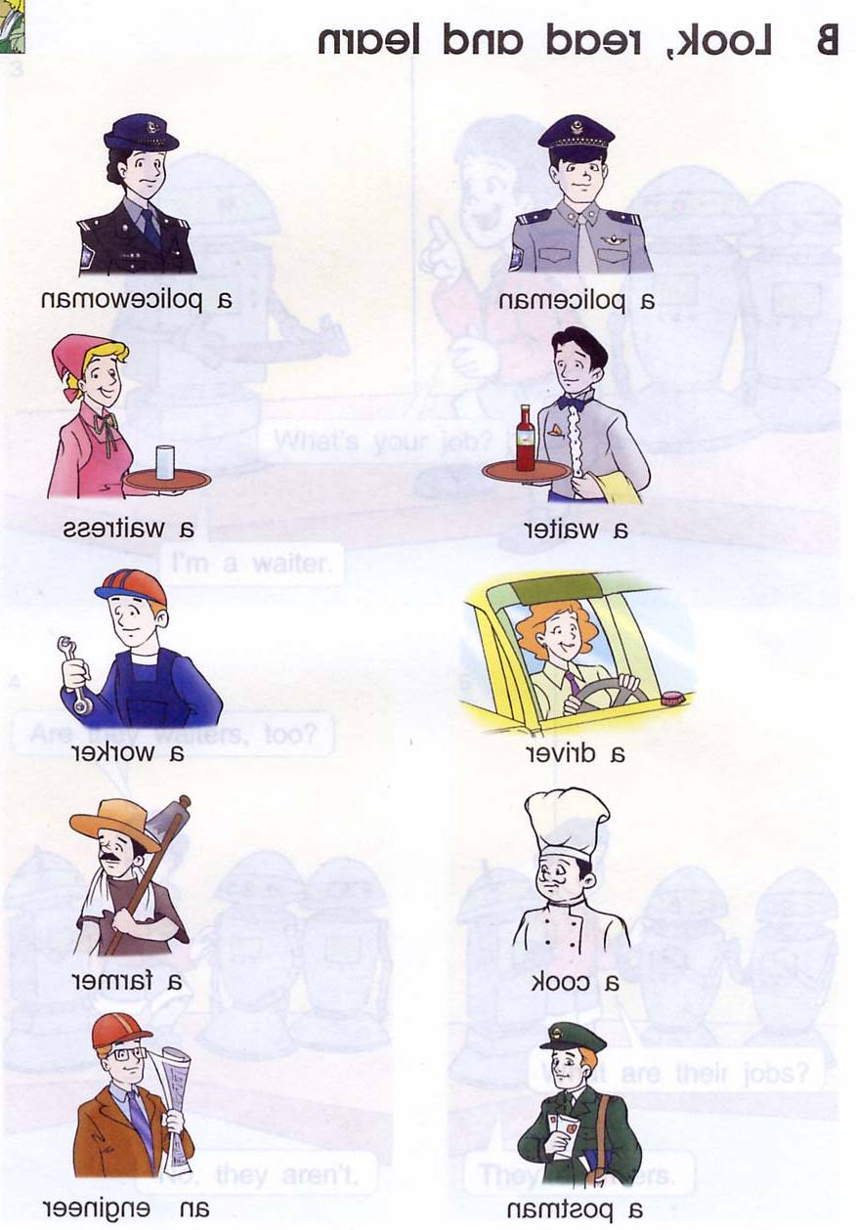  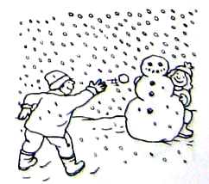  B | C | D
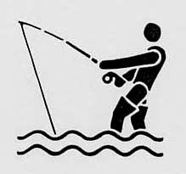
5  （ ） | A |   B | 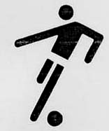  C | 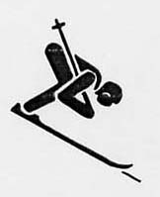  D
6  （ ） | 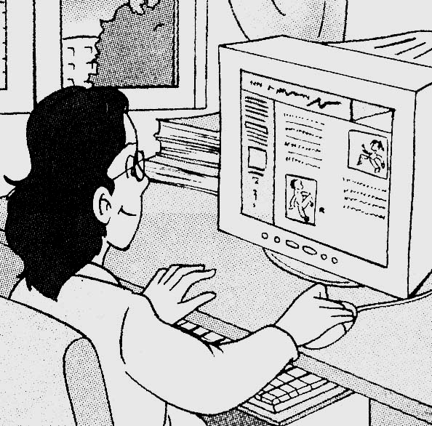  A | 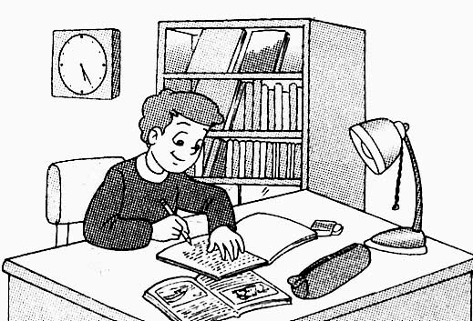  B | 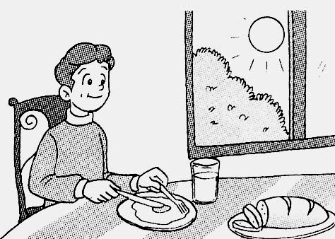  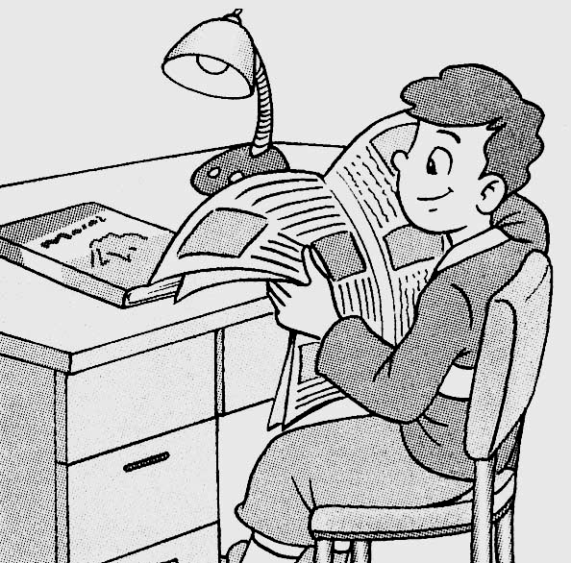  C | D
二 听录音，按所听内容顺序编序号（听两遍）
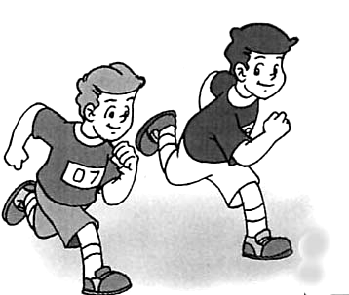  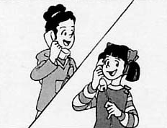 |  | 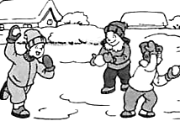 | 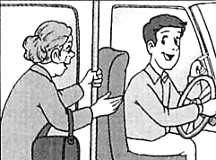
（ ） | （ ） | （ ） | （ ）

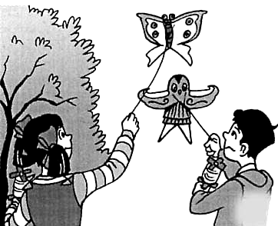 | 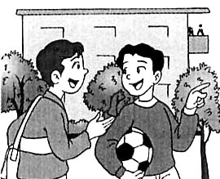 | 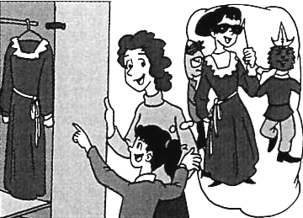 | 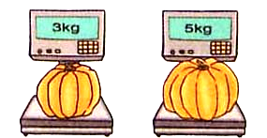
（ ） | （ ） | （ ） | （ ）

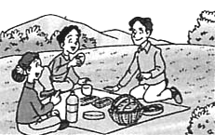
三 听录音，判断正误，用“T”表示正确，“F”表示错误（听两遍）
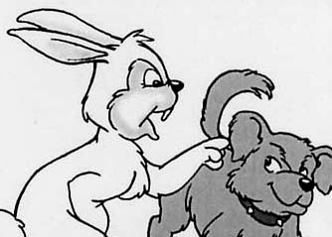 | 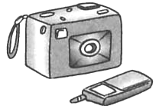 | 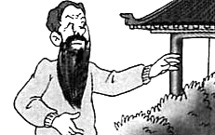 | 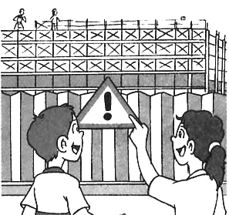
1（ ） | 2（ ） | 3（ ） | 4（ ） | 5（ ）

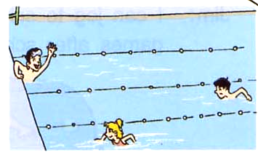  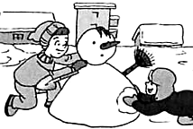 | 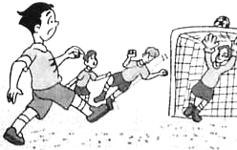 | 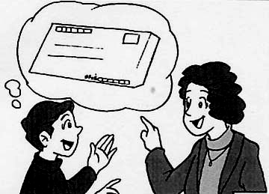 | 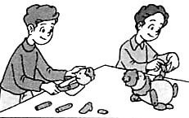
6（ ） | 7（ ） | 8（ ） | 9（ ） | 10（ ）
四听录音,根据所听内容将序号填入相应的括号内。（听两遍）
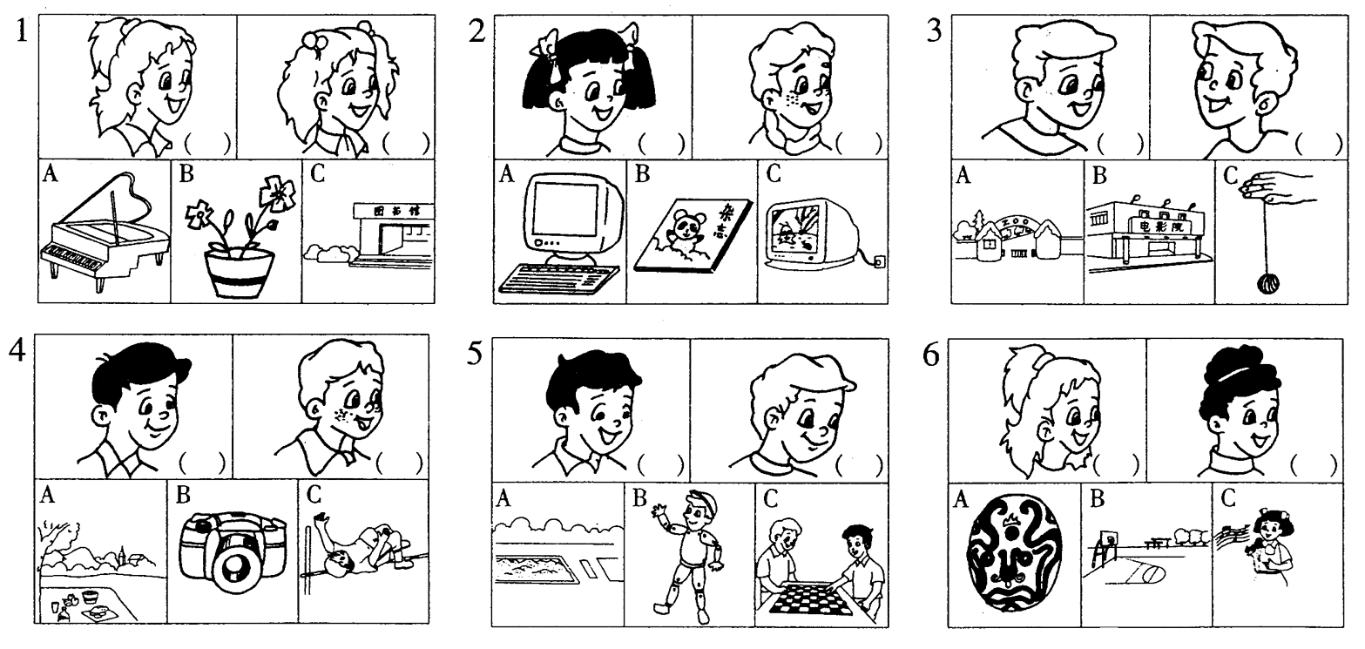

笔试部分（80％）
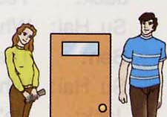
一 根据提示写词，完成句子（每空一词）
1The woman’s t________ but the man’s t________.
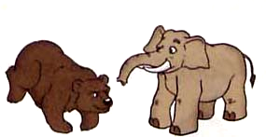
2The bear’s b_______ but the elephant’s _________.
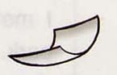
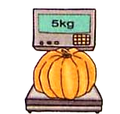
3The paper’s l________ and the pumpkin’s h________.

4This sign ________ ‘_______’! You must stay away.
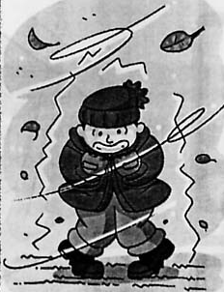
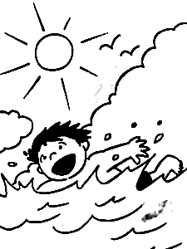
5It’s very h______ in s________ in Nanjing and
it’s very c________ in w________, too.
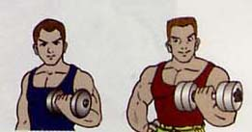
6This man’s ________ ________ PE, so
he’s very s________.
二在下栏中找出上栏适当的应答，将序号写在题前的括号内
（ ） 1. When’s Children’s Day? A. They’re from Grandparents.
（ ） 2. Yesterday was my birthday. B. My grandma likes it too.
（ ） 3. It’s the 10th of September. C. We also went to see Mr Green.
（ ） 4. What date is it today? D. It’s on the 1st of June.
（ ） 5. I like drinking green tea. E. We went to the park to fly kites.
（ ） 6. What else did you do? F. It’s hers, I think.
（ ） 7. Who are these apples from? GSorry, I didn’t know. Did you have a party?
（ ） 8. Whose watch is it? H. It’s the 3rd of January.
（ ） 9. What did you do on Sunday? I. Shall we buy some presentsfor our Chinese teacher?（ ）10. You are late, Jim. What time did you get up?J.I got up at 6:30
三 选择填空
( ) 1. Look, there are ________ many people in this zoo!
A. very B. more C. so D. much
( ) 2. There is a storybook ________ you ________ Mr Green.
A. for, from B. from, to C. to, from D. for, with
( ) 3. Usually, our _____ arms are ______ than the ______ ones.
A. right, stronger, left B. right, as, left
C. left, heavier, right D. left, stronger, right
( ) 4. Jim’s family ________ not at home yesterday.
They went to the park.
A. is B. are C. was D. were
( ) 5. A: ________ a beautiful skirt you’ve got! B: Thanks a lot.
A. It B. They C. How D. What
( ) 6. Would you like to show us how to ________ a horse?
A. draw B. drew C. draws D. drawing
( ) 7. We have no lessons ________ Saturdays or Sundays.
A. in B. at C. on D. every
( ) 8. Nancy is ________ a dance lesson now. She ________
Chinese dances every Friday afternoon.
A. having, learns B. having, learn
C. has, learning D. have, learns
( ) 9. A: Thank you for your help. B: ___________
A. Really? B. No thanks.
C. Thank you. D. You’re welcome.
( ) 10. A: ________ is the book from? B: It’s from Mike.
A. Whose B. When C. Who D. What
( ) 11. A: Who ________ the my desk? B: Perhaps Tom did.
A. clean B. cleans C. cleaned D. is cleaning
( ) 12. A: Does your father like drawing? B: Yes, ________.
A. he does B. he is C. he did D. he likes
( ) 13. A: How do you go to school every day?
B: ________ by bike, but ________ on foot.
A. Usually, often B. Usually, sometimes
C. Sometimes, often D. Often, usually
( ) 14. A: __________ B: I’d like some tea.
A. Would you like some tea? B. What can I do for you?
C. What’s your hobby? D. I like tea.
四看图完成对话，每空一词。
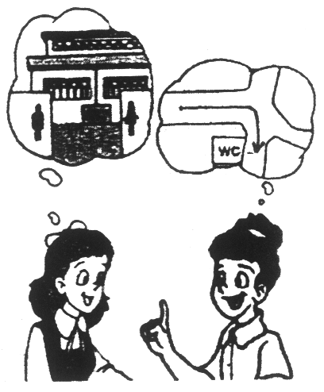
1.A:Can you me the way to the
?
B:Yes.Go the street and turn
at the crossing.
A:Thank you.

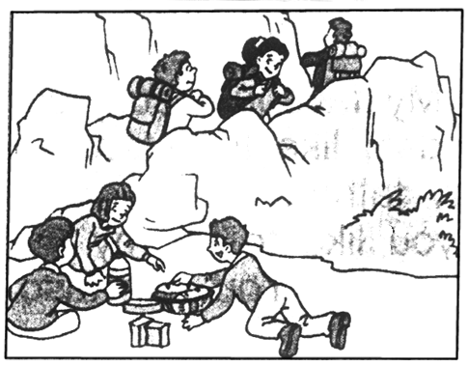
2.A: season do you like ?
B:Autumn is my favourite season.
A: ?
B:Because it's cool and usually sunny.
We can go and picnics.
五阅读对话，回答问题 (每小题2分, 共8分)
A) Home: New York Age: 14
Subjects: English, French, Maths, Computer Studies, Science, Art, PE Hobbies: Play football.
Family: father, mother, two sisters E-mail: David @newyork.Com
Near the house: some shops and a zoo with many animals Telephone: 84933833
( )1.David studies Social Science at school.
( )2.David likes playing basketball.
( )3.There is a zoo near David's house.
( )4.Collecting stamps is one of David's hobbies.
( )5.David is an American boy.
B) Mr. King lived in a small town, but he has a job in a big city, so he moved there with his wife and his children last Tuesday.
On that day Mr. King took his new car out of the garage(车床) and washed it. A neighbour(邻居) came and looked at the new car for a minute. Then Mr. King turned and saw him.
“That's a new car. Is it yours?”The neighbour asked.
“Sometimes,”Mr. King answered.
The neighbour was surprised.“Sometimes?”he said.“What do you mean?”
“Well,”answered Mr. King slowly,“when there's a party in town, it's my daughter's. Where there's a football game, it belongs to(属于) my son. When I washes it and it looks very nice and clean, it belongs to my wife. And when it needs gas(汽油)，it's mine.”
( )1.There are people in the story.
A.three B.four C.six D.five
( )2.Mr. King worked in .
A.a small town B.a big city C.the garage D.the gas atation
( )3.When Mr. King was washing the new car, his neighbour came to ask him .
A.if(是否) the car is new B.what car it is
C.if the car is Mr. King's D.how much is the car
( )4.“Sometimes”in the story means that .
A.when there is a party in town, the car belongs to his daughter.
B.when there is a football game, it is his son's.
C.when the car looks nice and clean, it's his wife's.
D.when the car wants gas, it belongs to him.
《牛津小学英语6B》听力内容及参考答案
听力内容
一 听录音，选出你所听到的内容（听两遍）
- a camera 2. windy 3. winter 4. a snowman 5. go skiing
6. surf the Internet

二 听录音，按所听内容顺序编序号（听两遍）
- I can run faster than him.
- This bus is for the supermarket, granny.
- I’d like this dress for the party, Mum.
4. The teachers’ office is over there, near the library.
- We like having snowball fights with our friends in winter.
- The pumpkin on the left is lighter than the one on the right.
- My kite flies low but yours flies lower.
- We are going to plant trees tomorrow morning. I’d like you to join us.
三 听录音，判断正误，用“T”表示正确，“F”表示错误（听两遍）
- A: The rabbit’s ears are longer.
B: Yes, and the dog’s ears are shorter.
2. A: What did you do yesterday? B: We worked on a farm.
3. A: Where’s my mobile phone?
B: It was beside your CD Walkman a moment ago.
- A: Does your grandfather like doing exercise?
B: Yes, he likes doing exercise in the park every morning.
- A: What does that sign mean?
B: It means we should stay away from that building.
- A: Do you like making snowmen in winter?
B: Yes, very much.
- A: Who runs faster in your class?
B: Liu Tao does, I think.
- A: What are the girls doing now?
B: They are playing football in the playground.
- A: Mum, can I have an envelope? B: What for, dear?
A: I’m going to write a letter. B: OK, here you are.
10. A: Are you making model planes? B: No, we’re making puppets.
A: Are you going to give a puppet show?
B: Right, we are going to give it tomorrow afternoon.
四 听录音，选择正确答案（听三遍）

参考答案
听力部分（20分）
一 （6分） 1C 2D 3B 4C 5D 6A
二 （4分） 1，8，5，2，7，4，3，6
三 （5分） 1. T 2. F 3. F 4. T 5. T 6. T 7. F 8. F 9. T 10. T
四 （5分）
笔试部分（60分）
一

二 （15分） 1. tall, taller 2. big, bigger 3. light/lighter, heavy/heavier 4. means, ‘Danger’ 5. hot, summer, cold, winter 6. good, at, strong
三 （10分）1.D 2.G 3.I 4.H 5.B 6.C 7.A 8.F 9.E 10.J
四 （7分）1.C 2.A 3.A 4.D 5.D 6.A 7.C 8.A 9.D 10.C 11.C 12.A 13.B 14.B
五 （12分）1. can, tell, me, the, way, turn, left, at, on, right
2. What, date, was, Did, What, did, do, friends/classmates, presents, made/cooked, ate, had, sang, played

