六年级英语模拟试卷
一．单项选择（10分）
( )1.Mum,please have some tea. --________
A.Thank you. B.Here you are. C.You’re welcome.
( )2.______ is your dress? --It’s twenty-six dollars.
A.How many B.How much C.Where
( )3. Don’t cross the road. It’s now.
A. green B.red C.rain
( )4._______ are you going to go to the theatre?
-----Tomorrow morning.
A. Where B.When C.Who
( )5.Did Daming have a birthday party? --________
A.Yes, he did. B.No, I didn’t. C.Yes, he do.
二．连词成句。（10分）
1.how many books, on the desk , are there (?)
_____________________
2.are , the ducks, in the water, swimming (.)
_______________________
3. are going to , we , have a picnic(.)
________________________
4.talk, in the library ,don’t（!）
___________________________________
5. wrote a book, she ,about herself (.)
_____________________________
三．连线。请将正确答案的序号写在括号内。（10分）
( )1.Who can help the girl? .
( )2.Where were you born?
( )3.How do you go home every day?
( )4.What’s the weather like today?
( )5.Are you going to go to middle school?
A.In sanya B.Yes,I’m really excited. C.Sorry,I can’t.
D.On foot. E.It’s sunny.

四．补全对话：根据下面的内容补全对话使对话意思完整。（10分）
Jim: Where did you go last Saturday?
Kate: _________1____________ . We watched a baseball game.
Jim: Really?
Kate: Yes.________2___________
Jim: Did you see your favourite team?
Kate: _________3_________. They played very well and they won.
Jim: Great! _________4____________ ?
Kate: We ate hot dogs and drank colas.
Jim: ____________5_________ ?
Kate: At half past eleven. We had a good time last Saturday. xkb1.com
A: It was a great game!
B: I went to the park with Mary.
C : What did you eat and drink?
D: Yes, we did.
E: When did you go back home?

五．选词填空。（10分）

excited emails middle school speak study

Daming is going to go to ________ this September. He is very ______. He is going to ______ Physics,Chemistry, History. Amy and Sam are going to start a new school , in Enland. And they’re going to ______ Chinese there. Daming will write lots of ____ to them. They will miss each other.
六、看图选句子(10分)
1. We’re going to have a party at half past six.
2. In this photo,the man is sitting under the tree.
______3. This book looks interesting. It’s about animals.
4. Helen Keller was a model for blind people.
5. The children are laughing. They have got cups on their heads.
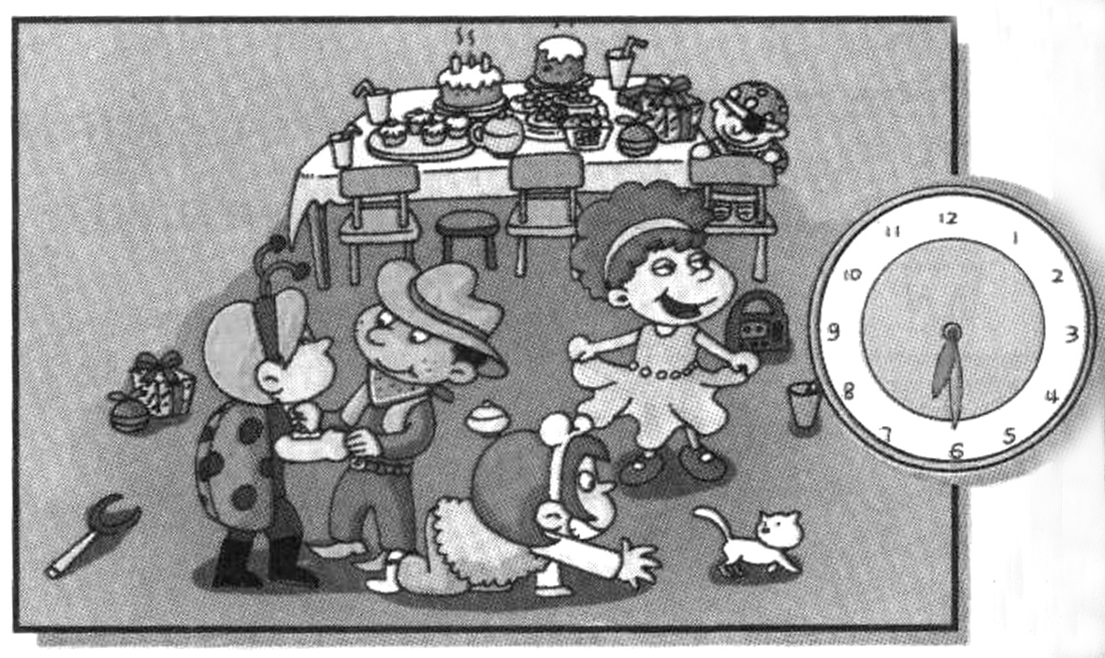
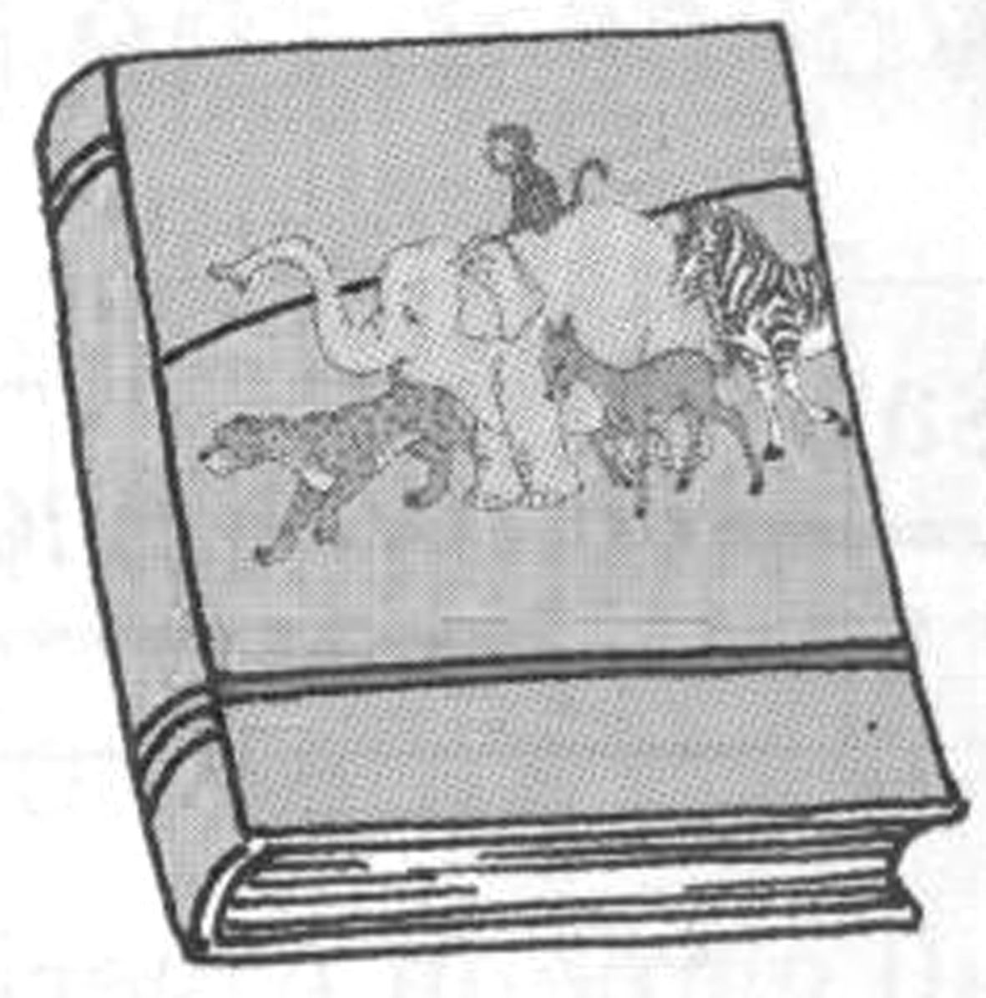
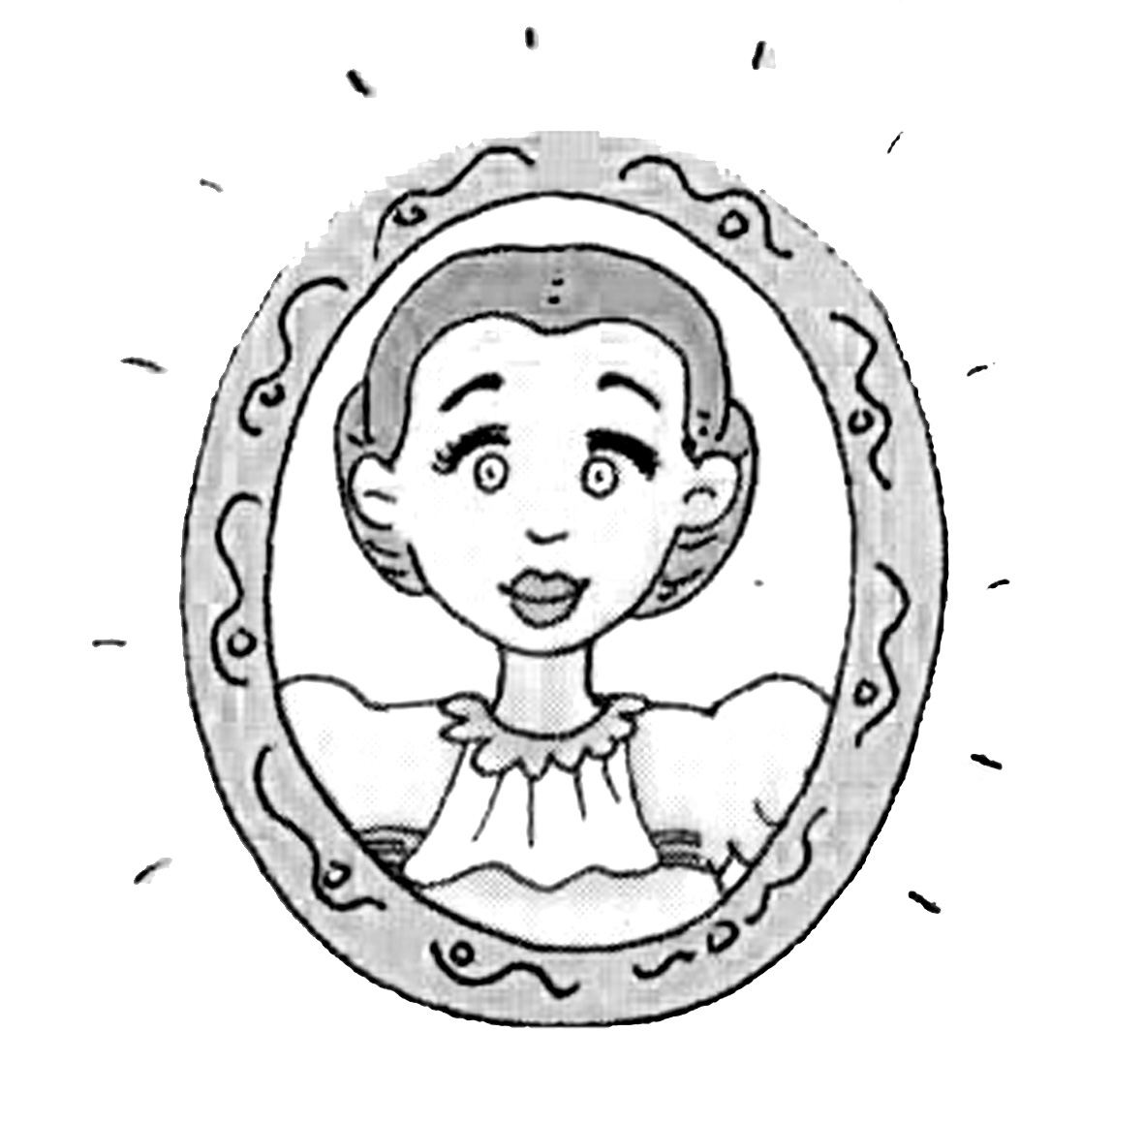
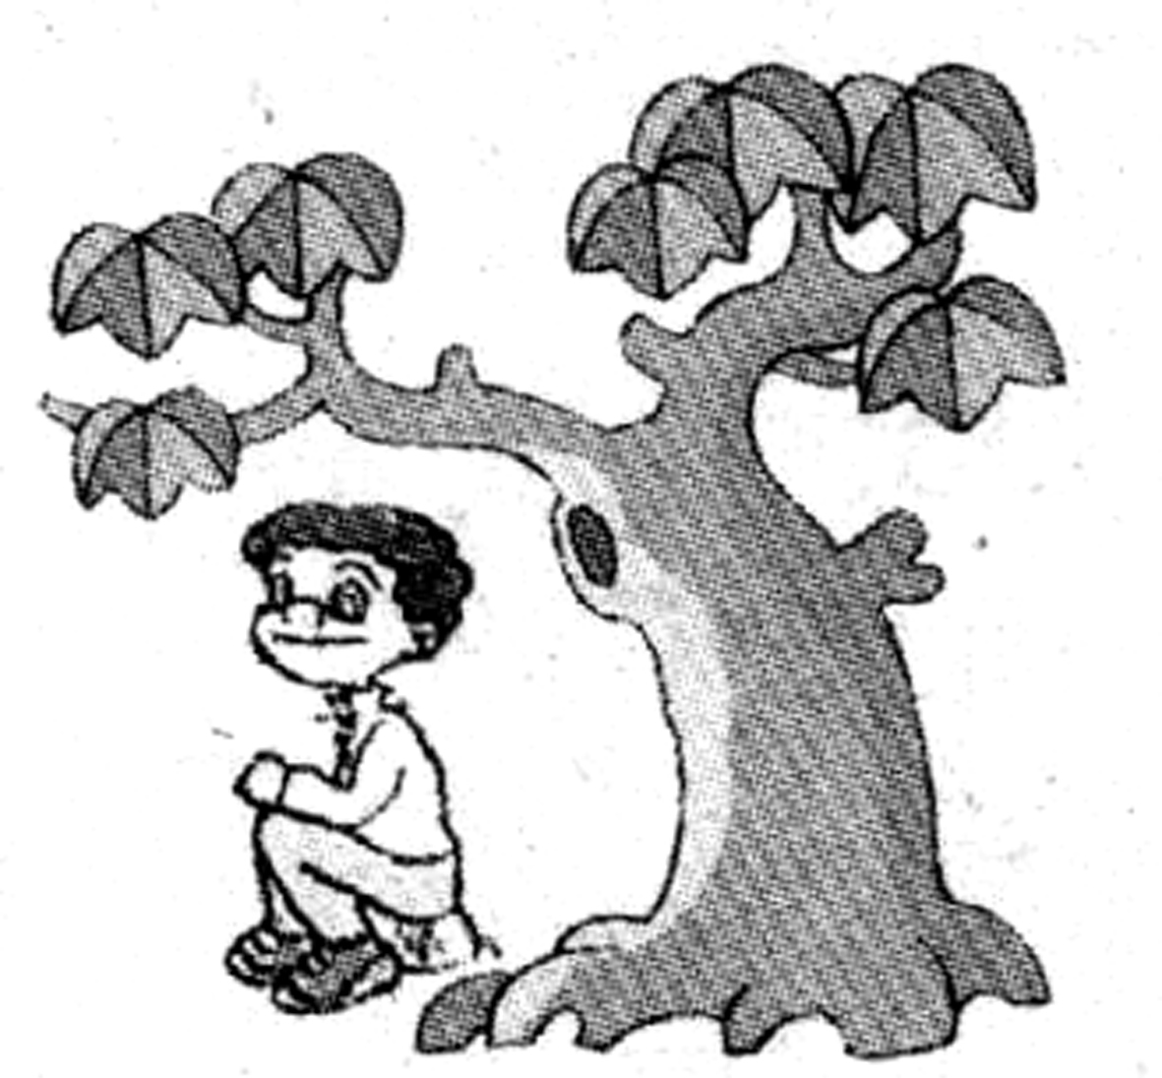
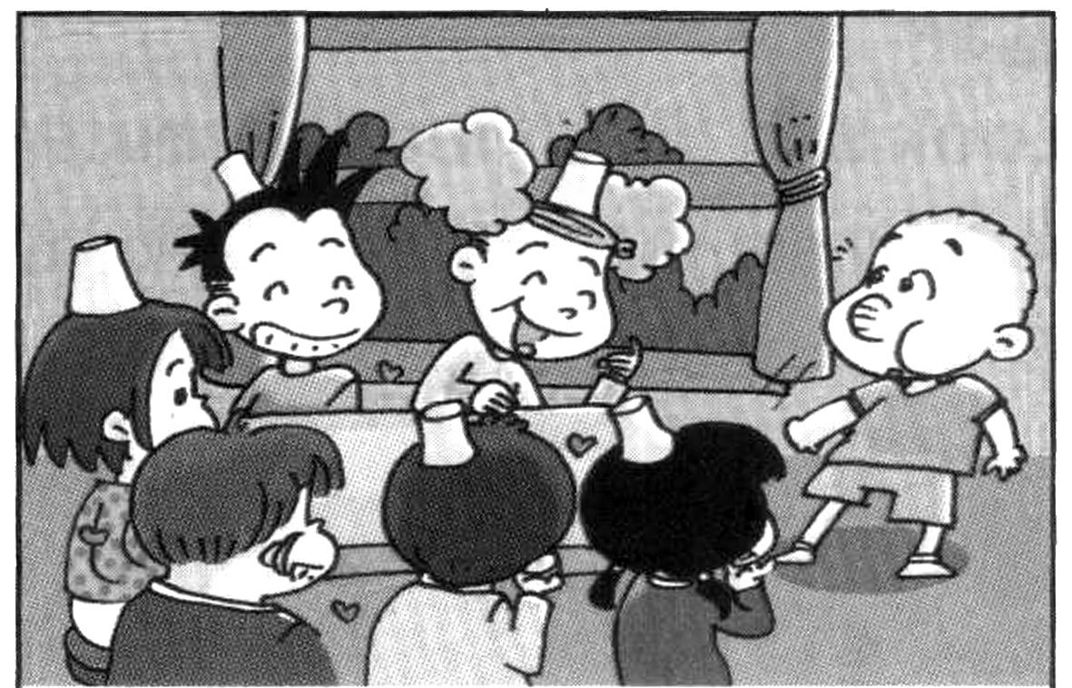

A
B
C
D
E

七．为下列图片找到合适的短语。（10分）
ride bikes sleep don’t walk
play computer games make a snowman

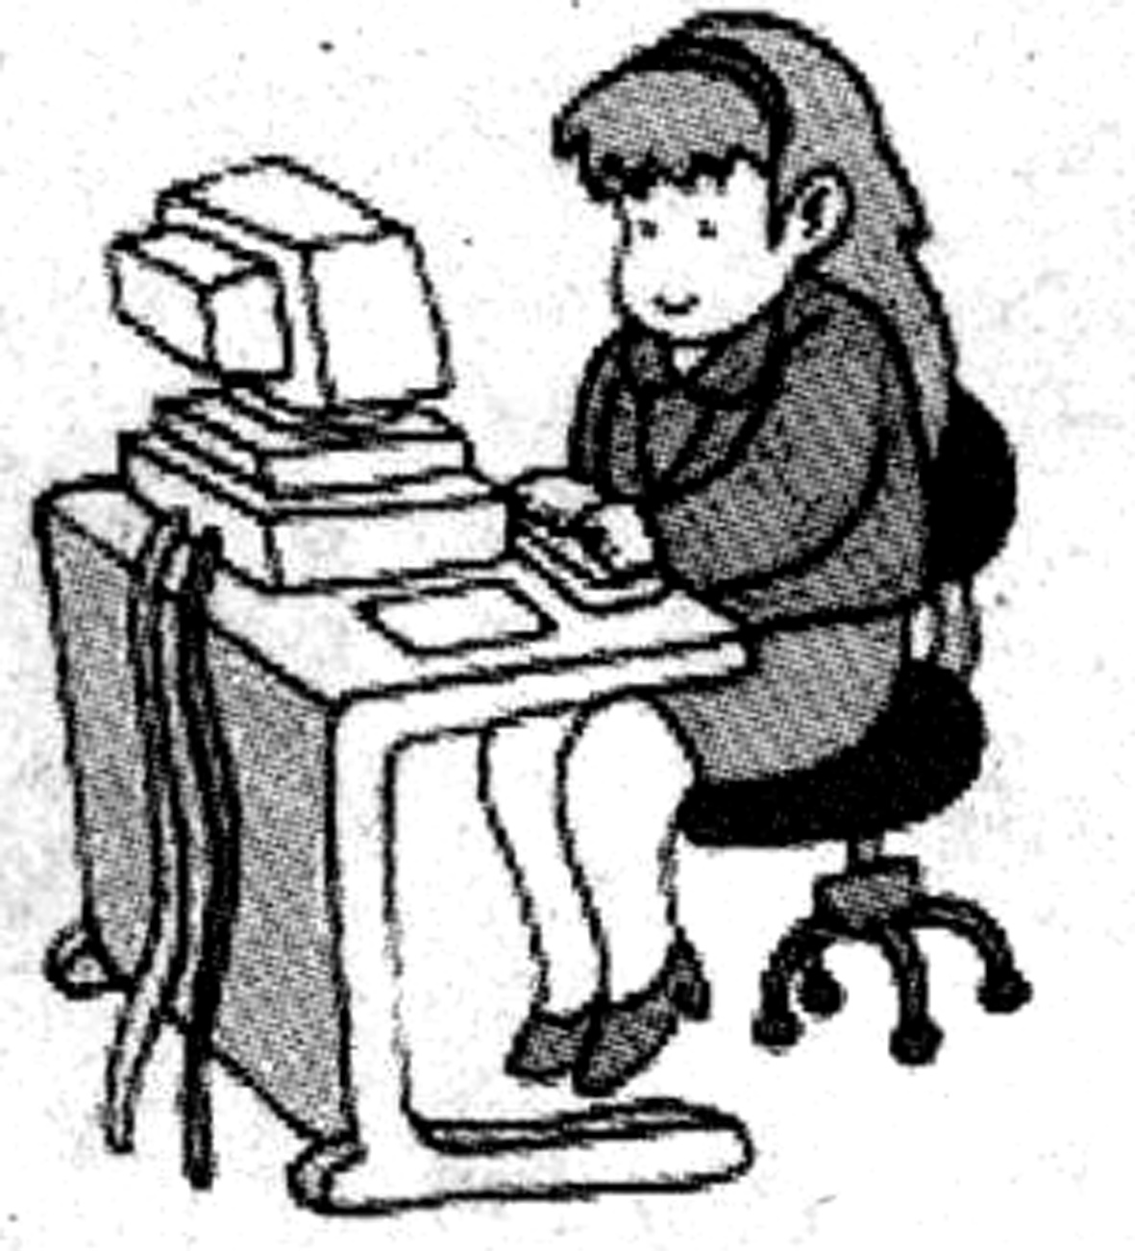
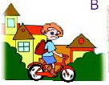
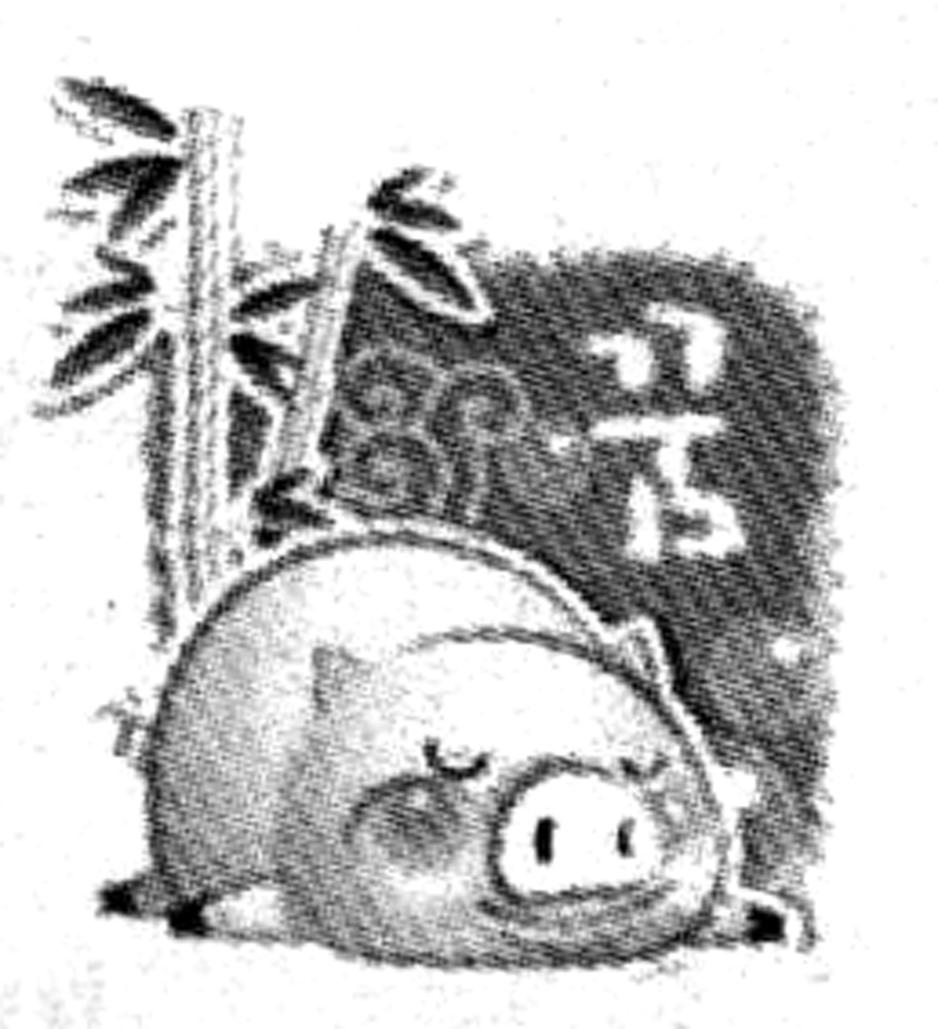
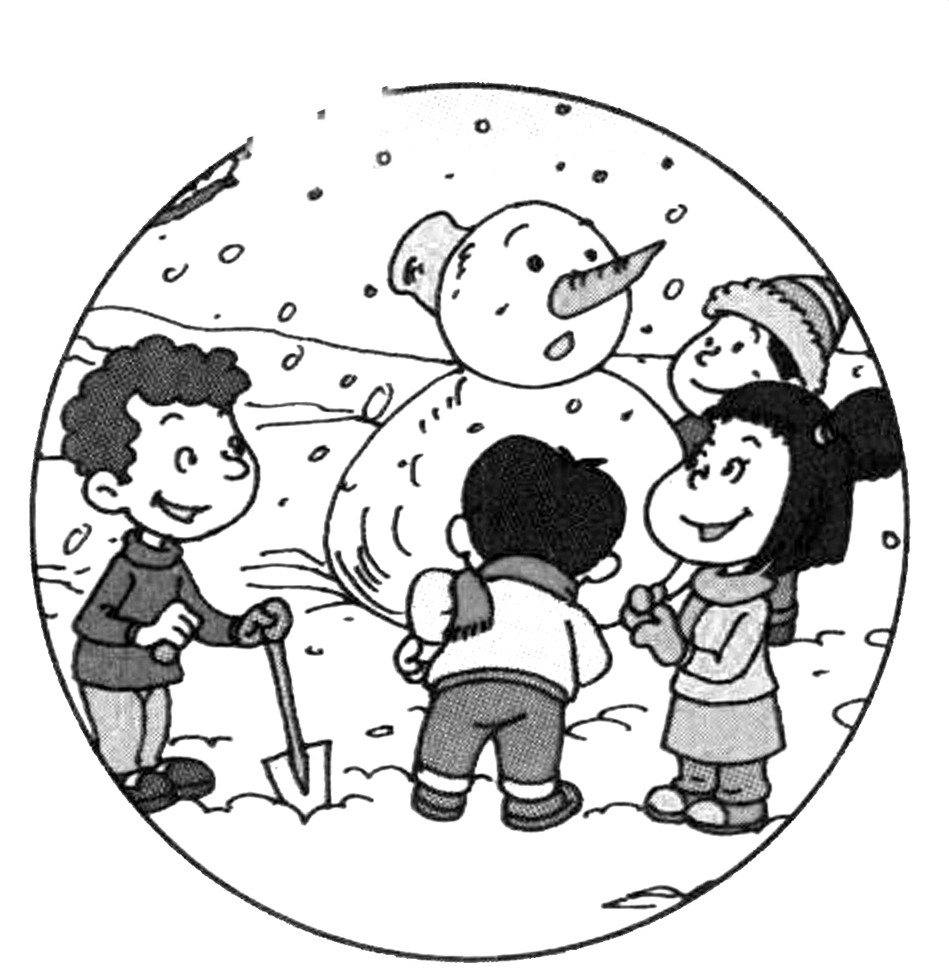
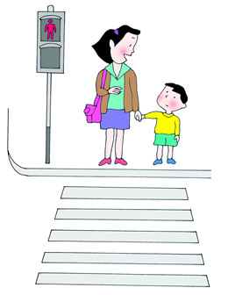

__________ __________ __________ _________ __________

八．阅读（20分，每题10分）
（A）
把正确答案的序号写在括号内新 课 标第 一 网
It was Sunday yesterday. Kim was very happy. It was his birthday. Kim’s mother had a big party for him yesterday evening. Kim called his good friends to come. First, Kim went to a supermarket to buy some food, fruits, juice and a birthday cake with his mother. Then he helped his mother do the cooking. Before 7o’clock,supper was ready. At about 7:30,Kim’s friends arrived. They gave Kim some nice gifts. Junny gave him an interesting story-book. Jack bought a new hat for him, and Tom gave him a new T-shirt. Kim’s parents bought a computer for him. Kim thanked everyone very much.
( )1.Kim had abirthday party on_____.
A.June 2 B.Sunday C.Saturday
( )2.When was the supper ready?--________
A.Before 7:00 B.At 7:00 C.At 7:30
( )3.What did jack give kim?---___________
A .book. B.a hat. C.a t-shirt.
( )4.How many friends came to the party?---___________
A.Two B.Three C.Four
( )5.What does Kim think of his birthday?---_____________
A.He feels sad. B.He feels boring. C.He feels happy.
(B)
判断正误，正确的写“T”,错误的写“F”
This is Bill’s room. It’s small. In the middle of the wall there is a big window. Beside(在…旁边) the window is a small bed. There are some other things in the bedroom. A picture is on the wall. A desk and a chair are beside the window. A ball is under the chair. A bag ,some books and pencils are on the desk. Some pictures of his family and his friends are on the wall ,too. The door is open, his shoes and socks are below the bed. Bill’s mother doesn’t like his room. She wants Bill to clean his room every day.

( )1.Bill’s room is very big.
( )2.The big window is in the middle of the room.
( )3.There is no desk and chair in his room.
( )4.The pictures of his family and his friends are on the desk.
( )5.Bill’s father doesn’t like Bill’s room.
九．作文（10分）
以“My good friend”为题，介绍一位你的好朋友。要求介绍你朋友的年龄，外貌，爱好等，字数不少于40个单词。
________________________
_________________________________________________________________________________________________________________________________________________________________________________________________________________________________________________________________________________________________________________________________________________________
十．附加题，根据图画内容，完成下列各句。(10分)
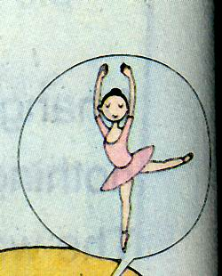
- ---What is she doing?
---She is _________now.
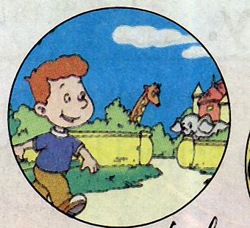
2. ---Where are you going?
--- To the .

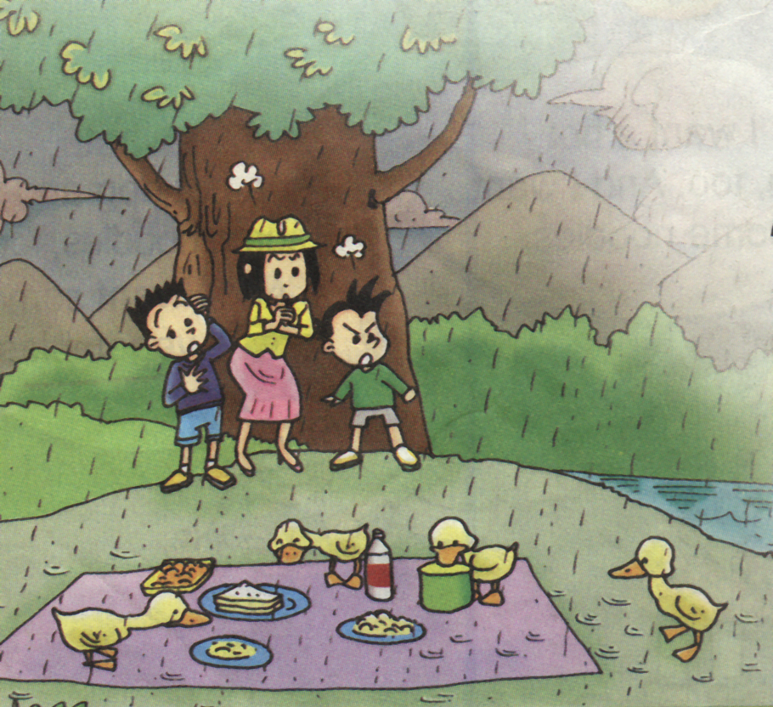
3 It’s ______. They are under the tree

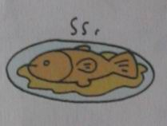
4. -- Do you want some ?
-- Yes, please . xkb1.com

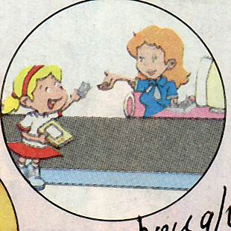
5.Amy________a book in the bookshop yesterday.

