《牛津小学英语6B》期末测试卷
姓名 成绩
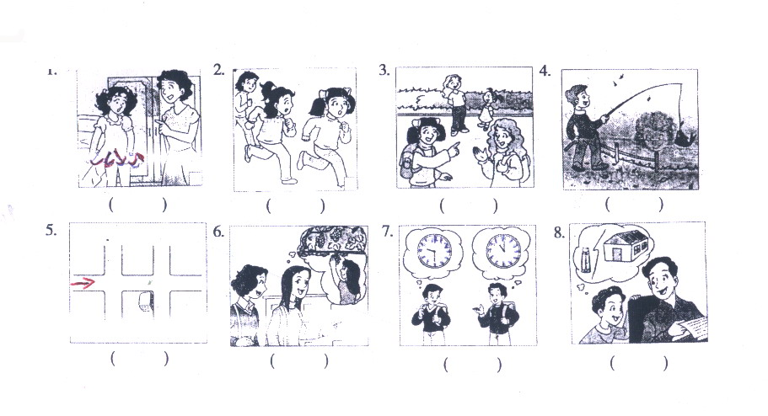
听力部分 （30%）
- 据所听内容在相应的图下括号内标出序号 (听两遍) (每小题1分, 共8分)

二、根据所听对话，判断下列句子是否与所听内容相符，相符的在括号内写(T)，不相符的在括号内写(F) (听两遍) (每小题1分, 共6分)
( )1. Mike is going to play the piano at the concert this evening.
( ) 2. Nancy likes autumn better than spring.
( ) 3. David had some bread for his breakfast at home today.
( ) 4. Helen is going to the cinema to watch a film with her friends.
( ) 5. Yang Lin wants to buy some birthday presents for her mother.
( ) 6. Peter doesn’t have any brothers or sisters.
三、根据所听内容，选择正确答案 (听两遍) (每小题1分, 共8分)
( ) 1. A. Ben. B. Jim. C. We don’t know.
( ) 2. A. He went on an outing. B. He saw a play. C. He saw a Beijing opera.
( ) 3. A. On foot. B. By bike. C. By bus.
( ) 4. A. He wants a letter. B. He wants a stamp. C. He wants an envelope.
( ) 5. A. He is going to watch a football match. B. He is going to play football.
C. He is going to play a football match.
( ) 6. A. She is from China. B. She is from the UK. C. She’s from the USA.
( ) 7. A. Yes, she is. B. No, she is taller than Li Hong.
C. No, she is shorter than Li Hong.
( ) 8. A. No, he has a fax machine. B. Sorry , he doesn’t. C. Yes , he does.
四、根据所听短文内容答题 (听三遍) (共8分)
(A) 判断下列句子是否与所听内容相符，相符的在括号内写(T)，不相符的在括号内写( F ) (每小题1分, 共4分)
( ) 1. It is Sunday tomorrow.
( ) 2. Jane is watching TV with her parents in the sitting room now.
( ) 3. Tom and Jane are cousins.
( ) 4. Jane and Tom will meet at the park gate tomorrow morning.
(B)回答问题 (每小题2分, 共4分)
1. Where are they going tomorrow ?
______________________________________________
2. How many people are going there tomorrow ?
______________________________________________
笔试部分 （70%）
五、英汉互译（20%)
1．邮局_________ 2 参加，参与_________
3 球类游戏__________________ 4 一所小学__________________
5 传真机__________________ 6 Bank of China__________________
7 a bottle of glue__________________ 8 ask for a penfriend__________________
9 with best wishes__________________ 10 go on an outing__________________
11 前天___________________________ 12 她的地址__________________
13 thirtieth(基数词) __________________ 14 good（反义词）______________
15 son(对应词) __________________ 16 same （反义词）______________
17 that(复数) __________________ 18 plus （反义词）_______________
19 France(形容词) ______________ 20 right （反义词）_______________
六、选择填空 (每小题1分, 共10分)
( ) 1. Do you have ____________ to read ?
A. anything else B.something else C.else anything D.anything some
( ) 2. Mr Green ________ a play last Sunday.
A. see B. sees C. saw D.is seeing
( ) 3. Mike is very fat. He is _________ than Liu Tao.
A. older B. heavier C. younger D clever
( ) 4. Whose dresses are these? They are _____________ .
A. twins B.twins’ C. twin’s D twin
( ) 5. The clock has two hands .The _______ hand is the hour hand.
A.long B.short C. longer D other
( ) 6. My aunt has a brother.He is not my uncle.Who is he ? He is your _________.
A.brother B sister C father D mother
( ) 7.The birds are singing _______________.
A. happy B. happyly C. happily D very much happy
( ) 8. Jack, go to bed . It’s ___________ twelve.
A. on B. in C at D.about

( ) 9. _______ do you want to ________?
A. Whose; write B. Who; write to C. Who; write D which ; write with
( ) 10. There are __________ on the floor.
A.three bag of rice B. three bags of rice C. three bags of rices D three bag of rice
七、根据句意，从方框中选择恰当的词填空 (每个空格1分, 共8分)
Need, postcard, bookshop, cold, warm, Let’s, hotel, envelope

1. We often buy books in the ________.
2. Lanlan, please post the _________ for me.
3. Mr Black is from the UK. He’s living in a _______ in Nanjing.
4. —Can I have the stamp on the ________?
—Yes, here you are.
5. It’s a _______ day today. _______ go to the countryside to pick apples.
6. It’s ____ in Beijing most of the time in January. You _____to buy some warm clothes.
八、将下列句子重新排列，组合成对话，将序号填在所给的横线上 (每个空格0.5分,
共10分)
1. A. Does Jim jump as high as Mike?
B. Really? But Jim is taller than Mike.
C. No, Mike jumps higher than Jim.
D. Yes, Mike jumps higher than all his classmates.
__________ ___________ ___________ __________
2. A. Yes, I’d love to.
B. I’m going to play cards with my friends.
C. What are you going to do this afternoon?
D. Would you like to go with us?
__________ ___________ __________ __________-
3. A. I usually go to the farm to pick oranges. What about you?
B. What’s the weather like in autumn?
C. It’s cool and cloudy. It’s sometimes rainy.
D. I usually go rowing.
E. What do you usually do in the season?
__________ __________ __________ ___________ ____________
4. A. How about this blue one?
B. Yes, I’d like a coat for my daughter.
C. Can I help you?
D. It’s very nice. I‘ll take it.
E. It’s pretty, but it’s too big.
F. How about this yellow one? It’s smaller than the blue one.
G. Do you have any smaller ones?
_______ _______ ________ ________ ________ _______ _______
九、完形填空 (每小题1分, 共10分)
Last Sunday afternoon, Nancy 1 in a bookshop. She wanted to buy a book 2 animals. Suddenly she saw a short man behind 3 . The man stole her purse and ran 4 the shop. She followed him along the street, but he
5 than her. She shouted,“ Stop thief! Stop thief!” At that time a policeman came to help. Then a woman came and told them, “ I saw him. He ran 6 the street and 7 left at the 8 crossing.” The policeman started to run. He ran faster than the 9 . Soon he stopped the thief and I got my 10 back.
( ) 1. A. is B. be C. was
( ) 2. A. about B. in C. for
( ) 3. A. she B. her C. hers
( ) 4. A out B. out of C. into
( ) 5. A. runs faster B. ran faster C. run fast
( ) 6. A. along B. at C. behind
( ) 7. A. turned B. turn C. turning
( ) 8. A. one B. first C. a
( ) 9. A. thief B. girl C. woman
( ) 10. A. book B. bag C. purse
十、阅读短文，根据短文内容，完成下列句子 (每个空格0.5分, 共6分)
Dear Helen,
I’m on the farm in America now. Every day it’s sunny and warm. There are a lot of children on the farm. I work and play games with them. Now I’m writing the letter in the house. Jack is learning to swim. Terry is lying (躺) in the sun. John is reading a newspaper and some children are playing football near the house. We are going to milk cows tomorrow, so we have to get up earlier tomorrow morning.
We enjoy (享受) the holiday very much.
See you soon.
Love,
Janet
1. ___________ is in America now.
2. It’s __________ and _________ there every day.
3. She ___________ __________ a letter in the ___________.
4. The children are on the__________(度假) on the _________.
5. They are going to _________ _________ tomorrow. So they should get up _______.
6. They are ____________ a good time there.
十一、改错 （6%）（圈出并在横线改正）
1 We two are all students. ___________________
2 They are in different class. ___________________
3 Today is Teacher’s day. ____________________
4 The girl in the red bike is Wang Fang. ___________________
5 How many water do you have ? ____________________
6 Let he have a look at your book. ____________________

听力内容及参考答案
一、根据所听内容在相应的图下括号内标出序号 (听两遍) (每小题1分, 共8分)
1. A: Hello, Nancy. Is that tall girl your sister ?
B: Yes. She is two years younger than me. She’s 5 centimetres shorter than me .
2. A: What are the girls doing ?
B: They’re having a running race .
A: Who runs faster, Nancy or Yang Ling ?
B: Yang Ling .
3. A: Dad, can I have that glue ?
B: What for ?
A: I want to make a model house .
B: Sure, here you are .
4 .A: Where are you going this weekend ?
B: I’m going to a farm .
A: What are you going to do there ?
B: I’m going to pick grapes .
5. A: Excuse me, where is the museum ?
B: It’s on Zhongshan Road .
A: How can I get there ?
B: Go along this street ant turn right at the second crossing. You’ll see the museum on your right .
6. A: Gao Shan, when did you finish your homework yesterday evening ?
B: I finished it at half past nine. How about you ?
A: I finished my homework at 11 o’clock .
7. A: It’s a fine day, isn’t it ?
B: Yes. What are you going to do ?
A: Let’s go fishing, OK ?
B: That’s a good idea .
8. A: Mum, where’s my red skirt ?
B: It’s in the box, under the bed .
A: Look! Mum, the skirt is too short. I need a longer one .
B: Let’s go and buy one tomorrow .
( 8 2 1 7 5 4 6 3)
二、根据所听对话，判断下列句子是否与所听内容相符，相符的在括号内写(T)，不相符的在括号内写(F) (听两遍) (每小题1分, 共6分)
1. A: What’s your brother going to do this evening, Mike ?
B: He is going to play the piano at the concert.
2. A: Hi, Nancy. Do you like spring ?
B: Yes, but it’s too short. I like autumn best.
3. A: Mum, I’m late for school. I have no time for breakfast.
B: Don’t worry, David. Take some bread with you.
4. A: What are you doing , Helen ?
B: I’m looking for my camera. I’m going to take photos with my friends in the park.
5. A: Where are you going, Yang Lin ?
B: I’m going to the shopping center. I want to buy some presents for my mother. It’s her birthday tomorrow.
6. A: Hello, Peter. What’s the weather like in London in summer ?
B: It’s not very hot. It’s usually sunny. I often go swimming with my brother and sister .
( 1. F 2. T 3. F 4. F 5. T 6. F )
三、根据所听内容，选择正确答案 (听两遍) (每小题1分, 共8分)
1. A: Does Jim jump farther than Ben ?
B: Yes, he does.
Q: Who jumps farther , Jim or Ben ?
2. A: Did you go on an outing last Sunday, Lin Tao ?
B: No, I didn’t. I went to see a Beijing opera show.
Q: What did Lin Tao do last Sunday?
3. A: Excuse me , is the zoo far from here ?
B: Yes, you can take bus No.3 there and get off at the fifth stop.
Q: How can the man go to the zoo ?
4. A: Hi, Lisa. Do you have any writing paper ?
B: What for, Mike ?
A: I want to write a letter to my grandpa.
B: Oh, here are some for you.
Q: What does Mike want ?
5. A: There is a football match this afternoon. Are you going to watch it, Wang Bing ?
B: Of course.
Q: What’s Wang Bing going to do this afternoon ?
6. A: Yesterday Su Yang read about an American girl, Lily. Lily wanted a penfriend
in China .
B: Oh, I see. Lily wanted to know something about this country.
Q: Where is Lily from ?
7. A: Li Hong is Li Ling’s twin sister. Do you know ?
B: But she is taller than Li Ling.
Q: Is Li Ling as tall as Li Hong ?
8. A: Can I have your fax number, David ?
B: Sorry. I don’t have a fax machine. I can tell you my mobile phone number .
Q: Does David have a mobile phone ?
( 1. B 2. C 3. C 4. C 5. A 6. C 7. C 8. C )
四、根据所听短文内容 (听三遍) (共8分)
It is Saturday evening. Jane and her parents are sitting in the sitting room. They’re talking about their plans for tomorrow. They are going to the Blue Hill Park. Jane is excited. Jane’s cousin Tom is going to go with them. He is going to fly kites with Jane. They will meet at half past seven at the park gate.
A: 1. T 2. F 3. T 4. T
B: 1. They are going to the Blue Hill Park .
2. Four .
五、1. good 2. number 3. summer 4. bus stop 5. Spring (每个空格1分, 共6分)
六、1. B 2. C 3. B 4. A 5. C 6 .A 7.C 8. A 9. B 10. C
(每小题1分, 共10分)
七、1. bookshop 2. postcard 3. hotel 4. envelope 5. warm 6. Let’s 7. cold 8. need (每个空格1分, 共8分)
八、1. ACBD 2. CBDA 3. BCEAD 4. CBAEGFD (每个空格0.5分, 共10分)
九、1. C 2. A 3. B 4. B 5. B 6. A 7. A 8. B 9. A 10. C
(每小题1分, 共10分)
十、1. Janet 2. sunny, warm 3. is writing, house 4. holiday, farm 5. milk cows, earlier
6. having (每个空格0.5分, 共6分)

