PRACTICE 5
Vocabulary (5 marks)
Choose the most suitable answer and write its number in the brackets provided. (5*1=5 marks)

( ) 1. Yacob looked at the aggressor without battling a/an __________.
A. ear B. lips C. eyelid D. nostril
( ) 2. The _________ of elephants are stacking heavy logs.
A. bevy B. herd C. flock D. shoal
( ) 3. Despite her many successes, Tenzin remains ___________.
A. humble B. beautiful C. proud D. silly
( ) 4. We were struck by the _________ of his character.
A. shame B. beauty C. model D. attraction
( ) 5. People on the street are staring at that lady's ___________.
A. neat B. sutiable C. clean D. strange

Grammar (35 marks)
Underline the correct word in each of the brackets. (14*1=14 marks)

6. Pulau Rendang has developed ( in, into, on ) a tourist attraction.
7. The twins ( is, are, have ) going to visit their grandmother later.
8. Of all the children, only three ( wear, wears, wearing ) spectacles.
9. A salad ( is, are, am ) a mixture of fresh fruits and vegetables.
10. Are there ( any, much, a ) cookies in the jar?
11. Fruits and nuts ( is, are, am ) good for our body.
12. The coconut tree is useful to ( us, our, ours ).
13. My friends ( like, likes, liking ) my stickers.
14. The bottle of mineral water ( is, are, am ) almost empty.
15. Mingmei returned the book to me as it was ( I, me, mine ).
16. There isn't ( enough, few, some ) flour to bake cookies.
17. Weiling does not ( like, likes, liking ) to eat meat.
18. Brush your teeth ( before, during, after ) sleeping.
19. We ( give, gave, giving ) David the gift yesterday.
20. Wax ( is, are, am ) used to make candles.

Rearrange the words to form correct sentences and end each sentence with a full-stop. (10*2 = 10marks)

21. make being I my parents by happy good boy a
______________________________________________________________________
______________________________________________________________________
22. sense of lost The campers their and direction are lost
the forest in
______________________________________________________________________
______________________________________________________________________
23. never should matches Children play with they are as
dangerous
______________________________________________________________________
______________________________________________________________________
24. in front of does friends like My sister not to her sing
______________________________________________________________________
______________________________________________________________________
25. brother jogging My prefers to swimming
______________________________________________________________________
______________________________________________________________________
26. smoke given out A lot of is a volcano when erupts
______________________________________________________________________
______________________________________________________________________
27. the climbed the thief window through bedroom into the
______________________________________________________________________
______________________________________________________________________
28. a we a day ourselves of hard work rest gave after
______________________________________________________________________
______________________________________________________________________
29. all the time cousins with my each other quarrel
______________________________________________________________________
______________________________________________________________________
30. beatuiful rainbow looks the like a the sky bridge
across
______________________________________________________________________
______________________________________________________________________

Vocabulary Cloze (10 marks)
Fill in the blanks with the correct words from the box.

organised | harmful | prize | classroom | personal
cleanliness | importance | excited | winning | pleased

Last week, we attended a health talk on hygienic habits. Mr Yeo, our headmaster, spoke about the (31) __________ of keeping our body and (32) __________ belongings clean. He said that (33) __________ is the key to healthy living. He warned us of (34) __________ germs taht cause disease. A contest was (35) _________ to select the cleanest (36) __________. Mr Yeo was (37) __________ with the efforts that we had put in for the past one week. We were all (38) _________ about the results of the competition as a (39) __________ would be awarded to the (40) _________ class.

Comprehension MCQ (14 marks)
Read the passage carefully. Then choose the correct answer and write its number (A,B,C or D) in the brackets.

It was raining cats and dogs. Jane was waiting at the shelter for the rain to stop. She did not have an umbrella with her. Jane was worried as she was late for work.
"Do you want to cross over to the other side?" a lady asked. Turning around, Jane came face to face with a middle-age lady who was carrying a big bag in one hand and an umbrella in the other.
"Yes, please. Which way are you going?" Jane asked.
"To the right," the lady answered. Jane declined the offer as she was going towards a different direction. She would be left without a shelter if they crossed over to the other side. "You can have my umbrella," the lady said, "I'll get my husband to pick me up."
Jane accepted the lady's kindness. She was very amazed and touched by such kindness a person can show to a stranger.

( ) 41. It was ____________.
A. drizzling B. a sunny day C. windy D. raining heavily
( ) 42. Jane was going ___________.
A. home B. to school C. to work D. to play
( ) 43. A middle-age lady is ___________.
A. a teenager B. an old lady C. a youth D. a lady in her forties
( ) 44. Jane ______________.
A. did not take the lady's umbrella
B. threw the umbrella away
C. shared the umbrella with the lady
D. took the lady's umbrella
( ) 45. The word "declined" means ___________.
A. said 'no' B. said 'yes' C. felt happy D. felt disappointed
( ) 46. The lady's husband was going to __________.
A. pick her up in a car
B. bring an umbrella to her
C. give her money for the taxi fare
D. leave her alone at the bus-stop
( ) 47. Jane was _________ what the lady had done for her.
A. angry with
B. disappointed with
C. surprised and touched by
D. sorry for

Comprehension OE (16 marks)
Read the passage carefully and answer the questions that follow.

We had our computer lesson yesterday. The teacher taught us how to use the software 'Powerpoint' to create multimedia presentation slides. A multimedia slide consists of text, graphics, animation, video and sound. Texts are simply words. Graphics are drawings or pictures. After we had created the text and put in the graphics, we were taught how to animate or to move them around. All of us were happy to be able to create our own slide shows. It was certainly better to have a multimedia presentation slide than a plain text slide which consisted only of words.
A multimedia presentation slide is more interesting and gives more information.

48. What lesson did the children have?
_________________________________________________________________________
49. Which software did they use to create multimedia presentation slides?
_________________________________________________________________________
50. What are texts?
_________________________________________________________________________
51. What does a multimedia presentation contain?
_________________________________________________________________________
52. What are graphics?
_________________________________________________________________________
53. Give a word in the passage which means to 'move something around on a screen'.
_________________________________________________________________________
54. How did the children feel about creating their own slide shows?
_________________________________________________________________________
55. Why is it better to have a multimedia presentation slide than a plain text
slide?
_________________________________________________________________________

Guided Writing (20 marks)
Write a story based on the pictures below. You may use the words and phrases in the box.

A Puppy
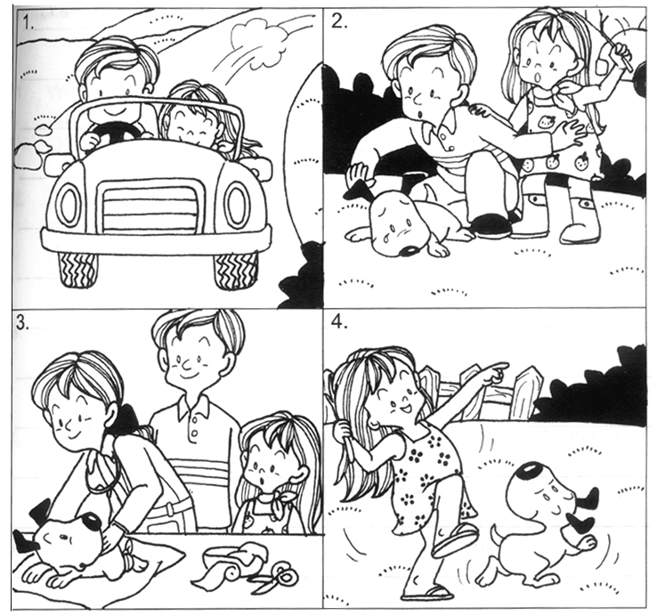

injured | pitiful | veterinarian
examined | deserted road | parked the car
recovered

____________________________________________________________________________
____________________________________________________________________________
____________________________________________________________________________
____________________________________________________________________________
____________________________________________________________________________
____________________________________________________________________________
____________________________________________________________________________
____________________________________________________________________________
____________________________________________________________________________

ANSWERS
Primary 2 English
Practice 5

1. C | 2. B | 3. A | 4. B | 5. D

6. into | 7. are | 8. wear | 9. is | 10. any
11. are | 12. us | 13. like | 14. is | 15. mine
16. enough | 17. like | 18. before | 19. gave | 20. is

21. I make my parents happy by being a good boy.
22. The campers lost their sense of direction and are lost in the forest.
23. Children should never play with matches as they are dangerous.
24. My sister does not like to sing in front of her friends.
25. My brother prefers jogging to swimming.
26. A lot of smoke is given out when a volcano erupts.
27. The thief climbed into the bedroom through the window.
28. We gave ourselves a rest after a day of hard work.
29. My cousins quarrel with each other all the time.
30. The rainbow looks like a beautiful bridge across the sky.

31. importance | 32. personal | 33. cleanliness | 34. harmful | 35. organised
36. classroom | 37. pleased | 38. excited | 39. prize | 40. winning

41. D | 42. C | 43. D | 44. D | 45. A | 46. A | 47. C

48. They had a computer lesson.
49. They used the software 'Powerpoint' to create a multimedia presentation slide.
50. They are words.
51. It contains texts, graphics, animation, video and sound.
52. They are drawings or pictures.
53. The word is 'animate'.
54. They felt happy.
55. A multimedia presentation slide is more interesting and gives more
information.

